Attachment K – Postcard recruiting

YOUR CHILD MAY BE ELIGIBLE TO PARTICIPATE IN A RESEARCH STUDY

Westat is recruiting children (ages 6-12) for a study measuring proper seat belt fit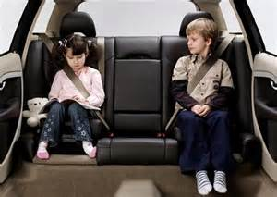
Participants will receive $50.

For more information:
Please call Westat at 1-855-583-5987

Child Safety Seat Study
Westat
https://www.westat.com/

