Attachment L – Flyer child recruiting

Child Participants Needed - Receive $50
Seat Belt Fit Study
Westat is recruiting children (ages 6-12) for a Seat Belt Fit Study. No special skills or knowledge required.
For more information: Please call Westat at 1-855-583-5987

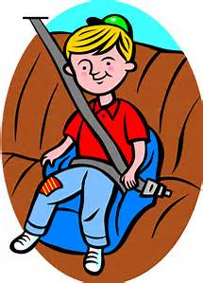

Westat Child Seat Belt Fit Study  Call us at 1-855-583-5987 | Westat Child Seat Belt Fit Study  Call us at 1-855-583-5987 | Westat Child Seat Belt Fit Study  Call us at 1-855-583-5987 | Westat Child Seat Belt Fit Study  Call us at 1-855-583-5987 | Westat Child Seat Belt Fit Study  Call us at 1-855-583-5987 | Westat Child Seat Belt Fit Study  Call us at 1-855-583-5987 | Westat Child Seat Belt Fit Study  Call us at 1-855-583-5987 | Westat Child Seat Belt Fit Study  Call us at 1-855-583-5987 | Westat Child Seat Belt Fit Study  Call us at 1-855-583-5987 | Westat Child Seat Belt Fit Study  Call us at 1-855-583-5987 | Westat Child Seat Belt Fit Study  Call us at 1-855-583-5987 | Westat Child Seat Belt Fit Study  Call us at 1-855-583-5987 | Westat Child Seat Belt Fit Study  Call us at 1-855-583-5987 | Westat Child Seat Belt Fit Study  Call us at 1-855-583-5987 | Westat Child Seat Belt Fit Study  Call us at 1-855-583-5987 | Westat Child Seat Belt Fit Study  Call us at 1-855-583-5987 | Westat Child Seat Belt Fit Study  Call us at 1-855-583-5987 | Westat Child Seat Belt Fit Study  Call us at 1-855-583-5987

