Attachment M – Directions to Study Site

Directions to Westat Child Seat Belt Fit Study
(15819 Gaither Drive, Gaithersburg, MD 20877)
from MD I-270:

- Take I-270 to Shady Grove Rd. (exit 8) East.
- Continue 0.5 mile on Shady Grove Rd.
- Turn left at Gaither Rd.
- Continue 0.3 mile on Gaither Rd.
- Turn left at Gaither Dr. into the “Shady Grove Development Park” (before you reach the stop sign, just after Monster Mini Golf).
- Follow the “Child Seat Belt Fit Study” signs to the parking area (or red arrows on the detailed facility map).
- Ring the doorbell and the experimenter will let you in.

* The backside of this page has a more detailed map of the facility.
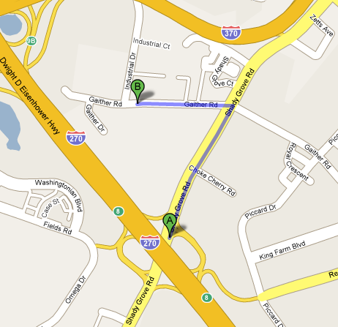

See area detail on next page

Please bring these directions with you to your session.
For assistance with directions, call 301-212-3795.
Shady Grove Development Park detail:

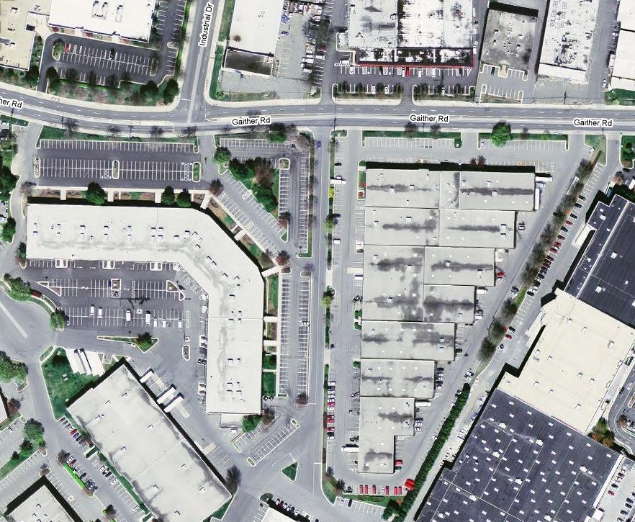

Parking
Sign for “Shady Grove Development Park”
ATV
Study Entrance

Facility Address:
15819 Gaither Drive, Gaithersburg, MD 20877

Please bring these directions with you to your session.
For assistance with directions, call 301-212-3795.

