Attachment F
Urine Collection Directions

Urine Specimen
Collection Directions

Important:
- Place the provided cold packs in the freezer as soon as you return home.
- Do not eat seafood during the 3 days prior to collecting your urine specimen.
- The urine specimen must be collected first thing in the morning on Day 4 (right after you wake up).
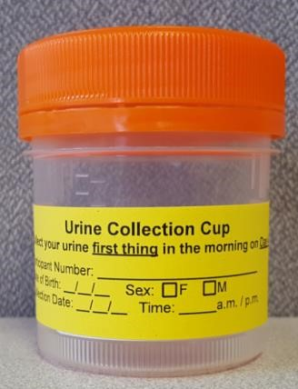

Urine Collection Directions
- Prepare to collect the specimen first thing in morning on Day 4 (right after you wake up).
- Confirm your information is on the sterile cup.
- Write the date and time of collection on the label next to your information.
- Using the sterile cup, fill halfway with urine (to the 50mL line).
- Secure lid. Wash hands with soap and water.
- Place urine specimen in the provided specimen bag (clear bag with “Urine Collection Cup” orange and black labeling).
- Complete the Urine Test Requisition form. Fold the form and put it in the outside pocket of the specimen bag. Do not put it inside the bag with the urine specimen.
- Place urine specimen/test form in the cooler with ice packs.
- Investigation staff will pick up the urine specimen during your interview.

But wait! I have questions!
Please contact <state Study Coordinator> with questions. You can also learn more about how to collect your urine specimen on our website at http://www.dhhs.nh.gov/dphs/lab/biomonitoring.htm.

