Supporting Statement: Part B

An Assessment of the State Public Health Actions (“1305”) Program

Supported by:

National Center for Chronic Disease Prevention and Health Promotion
Centers for Disease Control and Prevention
U.S. Public Health Service
Department of Health and Human Services

May 26, 2016

Government Project Officer:

Rachel Davis, MPH
Health Scientist
Applied Research and Evaluation Branch
Division for Heart Disease and Stroke Prevention
National Center for Chronic Disease Prevention and Health Promotion
Centers for Disease Control and Prevention
4770 Buford Hwy NE, MS-F75
Atlanta, GA 30341-3717
OFFICE: 770-488-4825
FAX: 770-488-8305
Table of Contents

Part B: Collection of Information Employing Statistical Methods
B1. Respondent Universe and Sampling Methods
B2. Procedures for Collection of Information
B3. Methods to Maximize Response Rates and Deal with Nonresponse
B4. Tests of Procedures or Methods to be Undertaken
B5. Individuals Consulted on Statistical Aspects and Individuals Collecting and/or Analyzing Data

Attachments
1 Authorizing Legislation: Public Health Service Act, Research and Investigation
2a Federal Register Notice
2b Summary of Public Comments and CDC Response
3 State Public Health Actions 1305 Logic Model
4 Evaluation Questions, Indicators, and Synergy Survey Topics
5 Screenshots of State Synergy Survey
6a Advance Notice Blast Email Template
6b Participant Email Template
6c Reminder Email Template
7 IRB Approval Letter

Part B: Collection of Information Employing Statistical Methods

B1. Respondent Universe and Sampling Methods

CDC will conduct an assessment of health departments currently funded through the State Public Health Actions 1305 cooperative agreement, including all 50 states and the District of Columbia. The purpose of the assessment is to increase CDC’s understanding of funded programs’ partnerships and synergy. Staff in funded states will be recruited to complete the State Synergy Survey, a 32-item questionnaire designed to explore funded programs’ partnerships and synergy (Attachment 5).

Using purposive sampling, CDC will recruit the principal investigator (PI) from each funded program to participate in the survey. In addition, the PI will be provided with detailed guidance to share the survey web link with only those relevant program leaders and staff who are directly involved in planning and/or implementation the State Public Health Actions program to also complete the survey. Relevant staff will include chronic disease directors, evaluators, epidemiologists, and program staff with subject matter expertise in one or more of the four categorical areas (i.e., diabetes; heart disease and stroke; nutrition, physical activity, and obesity; school health). A total of approximately 8 program leaders and staff per site will complete the survey. To obtain a variety of perspectives on program implementation issues, information will be collected from individuals in a variety of roles.

Two cycles of information collection will be conducted over a 2-year period. The first cycle is scheduled for summer/fall 2016 and the second cycle is scheduled for spring 2018. The annualized number of responses is 408 responses, as summarized in Table B1.

Table B1: Number of Respondents per Cycle of Survey Administration, by Type of Respondent; Total Number of Responses Over the 2-Year OMB Approval Period; and Annualized Number of Responses

Type of Respondents |  | Number of Respondents in 2016 | Number of Respondents in 2018 |  | Total Number of Responses Over 2 Years |  | Annualized Number of Responses
Principal Investigators |  | 51 | 51 |  | 102 |  | 51
Chronic Disease Directors |  | 51 | 51 |  | 102 |  | 51
Program Evaluators |  | 51 | 51 |  | 102 |  | 51
Epidemiologists |  | 51 | 51 |  | 102 |  | 51
Program Staff with Subject Matter Expertise |  | 204 | 204 |  | 408 |  | 204
TOTAL | 408 |  |  | 408 |  | 816 | 408

B2. Procedures for Collection of Information

The State Synergy Survey will be administered online. CDC and ICF International will work together to identify PIs within each funded program to complete the survey. Exhibit B2 provides an overview of data collection activities.

Identify Target Staff
ICF International will work with CDC to identify PIs within each funded program. ICF will compile names and contact information for each principal investigator confirm with CDC prior to recruitment. Contact information for PIs will be confirmed and verified prior to recruitment to facilitate efficient recruitment efforts.

Send Initial Contact Emails
Upon OMB approval, CDC will send an advance notice blast email (Attachment 6a) to the PI within each funded program to provide them with detailed information about the assessment and purpose of the State Synergy Survey. Within one week ICF will send a participant email (Attachment 6b) to the PIs that provides additional details and deadlines related to study participation, and includes a web link to the web-based State Synergy Survey. The email will also include guidance for the PI to share the survey web link with all relevant program staff who are directly involved in the planning and/or implementation of the State Public Health Actions 1305 program (e.g., evaluators, program staff with subject matter expertise) to also complete the survey. Respondents will be given two weeks to complete the survey.

Send Reminder Emails
A reminder email (Attachment 6c) will be sent to PIs at non-responsive state health departments at two time points: one week before the deadline, and two days before the deadline. ICF will follow the same protocol to implement the survey in program years 4 and 5. The goal will be to achieve an 80% response rate in both program years 4 and 5.

Exhibit B2. Flowchart of State Synergy Survey Data Collection Activities
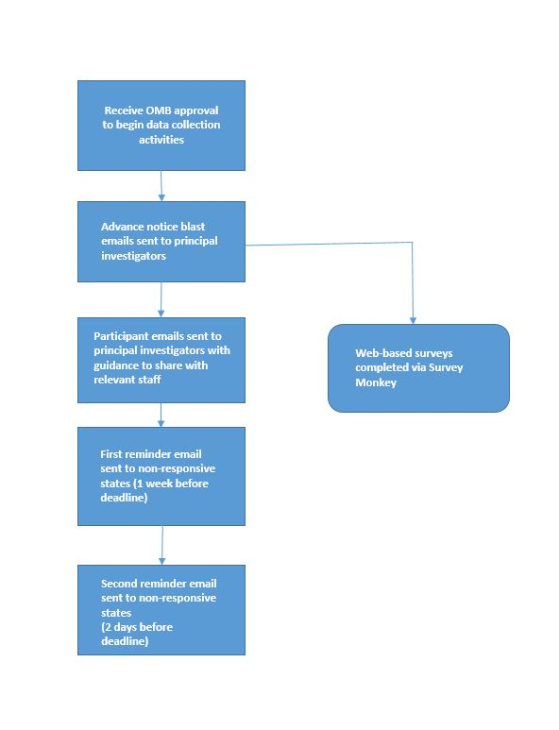

B3. Methods to Maximize Response Rates and Deal with Nonresponse

Upon OMB approval, ICF will implement the approved State Synergy Survey data collection protocol. ICF will take the following steps to maximize responses:
- Identification of Key Personnel. ICF and CDC will work closely together to identify and confirm contact information for principal investigators within each funded state health department. PIs will be asked to share the survey with only those relevant staff who are directly involved in planning and/or implementing the State Public Health Actions 1305 program, and provided with a list of potential staff roles for inclusion.
- Advance Notice Blast Email to All State Public Health Actions 1305 Awardee Point of Contacts. As a part of the regular correspondence with State Public Health Actions 1305 awardee Point of Contacts, an advance notice email will be sent by CDC personnel and will serve as the initial contact with states for the survey. Initial contact by CDC will maximize recognition among funded states, who are familiar with CDC team members.
- Reminder Emails. ICF will send a series of reminder emails to principal investigators at programs that do not have at least one respondent at two time points – one week before the deadline, and 2 days before the deadline.

B4. Tests of Procedures or Methods to be Undertaken

The State Synergy Survey was adapted from a questionnaire developed by Jones and Barry (2011) measuring synergy and dimensions of partnerships in health promotion. Additional questions were added to understand states’ ability to work in the different chronic disease areas and the four domains, challenges and benefits, and measurable positive outcomes. Lastly, questions about the respondents’ position, years of experience, expertise areas, demographics were included in the instrument. Survey content was informed and refined based on discussions with CDC project officers and other CDC staff members to ensure that all questions asked can only be answered by grantee staff members.

B5. Individuals Consulted on Statistical Aspects and Individual Collecting and/or Analyzing Data

CDC will provide overall direction for the State Synergy Survey, directing regular planning and coordination meetings with ICF staff, including the data collection protocol and data reporting.

The implementation contractor, ICF International, will recruit and collect survey data from select program leaders and staff members within funded states. ICF will also analyze and report survey results.

The principal contacts for each organization are below.
Staff Name | Study Area | Contact Information
CDC
Rachel Davis, MPH  Health Scientist | Project Design | Phone: 770-488-4825  Email: bkf4@cdc.gov
ICF International
Isabela Lucas  Technical Specialist | Data Collection | Phone: 404-321-3211  Email: Isabela.Lucas@icfi.com
Donoria Evans  Senior Associate | Data Analysis | Phone: 404-321-3211  Email: Donoria.Evans@icfi.com

Rachel Davis, MPH
Health Scientist
Applied Research and Evaluation Branch
Division for Heart Disease and Stroke Prevention
National Center for Chronic Disease Prevention and Health Promotion
Centers for Disease Control and Prevention
4770 Buford Hwy NE, MS-F75
Atlanta, GA 30341-3717
OFFICE: 770-488-4825
FAX: 770-488-8305

Information will be collected and analyzed by CDC’s contractor, ICF International.

