Form Approved

OMB No: 0920-New

Exp. Date: XX/XX/XXXX

Evaluation of Enhancing HIV Prevention Communication and

Mobilization Efforts through Strategic Partnerships

**Attachment 3a:**

**Screenshots of Metrics Database**

Public reporting burden of this collection of information is estimated to average 18 hours per response, including the time for reviewing instructions, searching existing data sources, gathering and maintaining the data needed, and completing and reviewing the collection of information. An agency may not conduct or sponsor, and a person is not required to respond to a collection of information unless it displays a currently valid OMB control number. Send comments regarding this burden estimate or any other aspect of this collection of information, including suggestions for reducing this burden to CDC/ATSDR Reports Clearance Officer; 1600 Clifton Road NE, MS D-74, Atlanta, Georgia 30333; Attn: OMB-PRA (0920-New)

Here, partners are only required to select the type of data they wish to enter as shown in the box with the right-facing arrow. Partners are unable to run reports or use the approval system, administrative functions, or export data tool that are shown. These are for CDC’s use only, and partners do not see these selections when they log in.

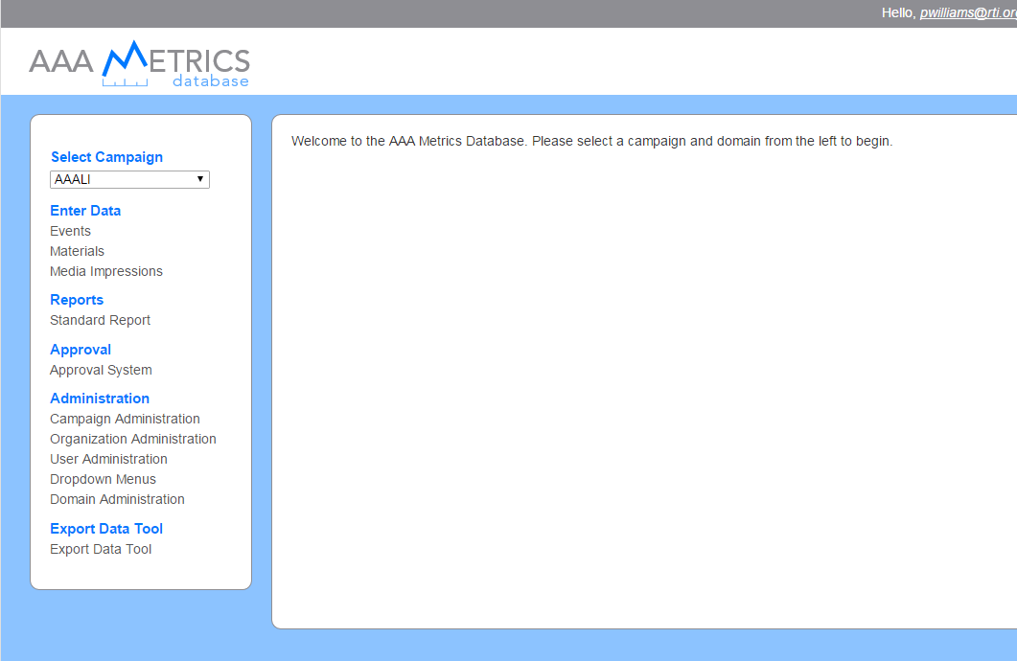

This screenshot shows what the interface looks like when the “Events” data type is selected. Here, they can edit or delete an entry or create a new event by clicking the “Add” button.

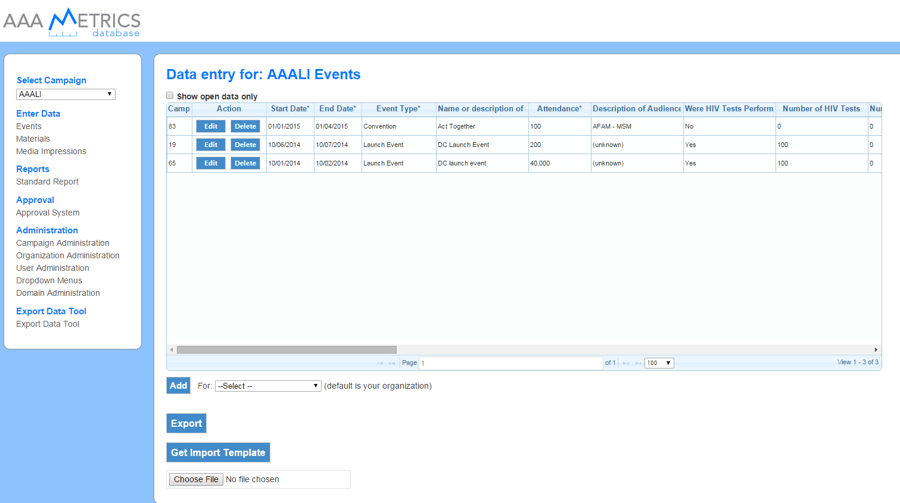

When “Add” is selected, partners are asked to enter event details in the pop-up window. In this example, a new entry is created for a convention held on May 11-12, 2015.

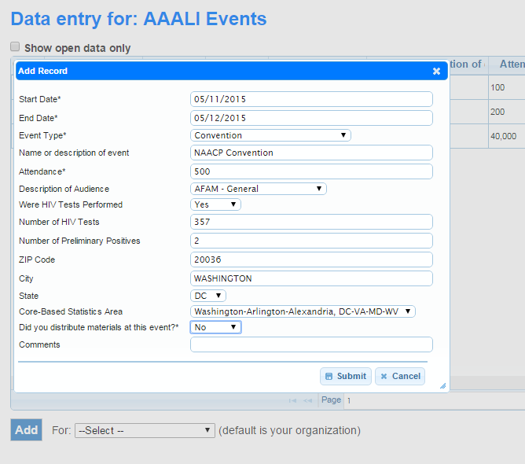

Once the “submit” button is clicked, the new record is added to the data set.

