CDC STUDY WEBSITE

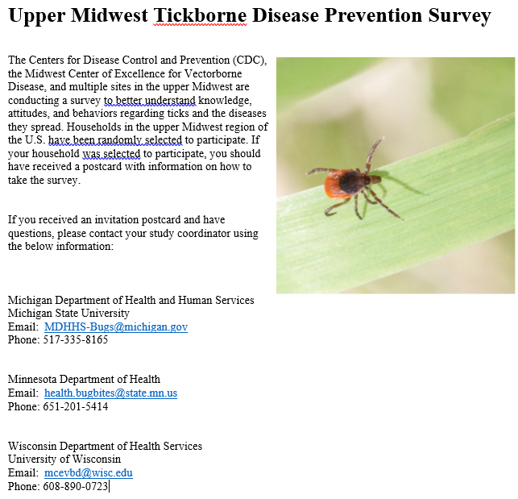

This study is protected by a federal Certificate of Confidentiality, and all participant responses are strictly confidential. For more information, please see:

<https://www.cdc.gov/od/science/integrity/confidentiality/ChangestoCoC.htm>