**Appendix D: QCDR Self-Nomination Form**

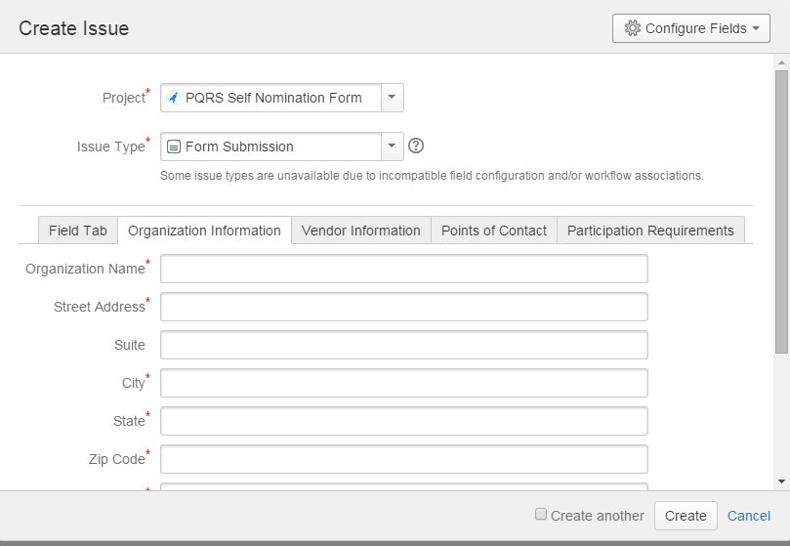

MIPSD