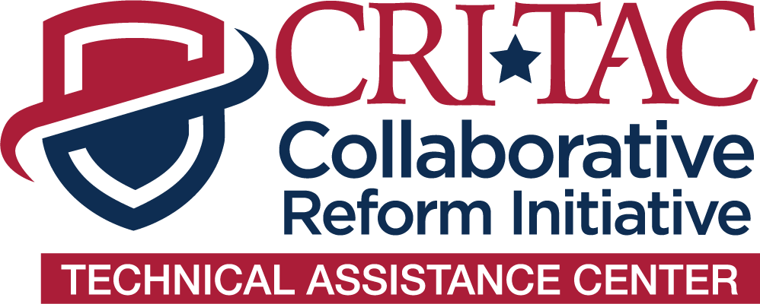

**CRI-TAC Training Evaluation Survey**

*Thank you for participating in the Collaborative Reform Initiative Technical Assistance Center (CRI-TAC).* The purpose of this survey is to gather information about your experience relating to the training received and to collect information that will better enable us to assess the delivery of training. Survey responses will be summarized in aggregate, statistical form and your personal identifying information cannot be linked to your survey responses. There are no known risks in participating in this survey. Your participation is completely voluntary: you may choose not to answer certain questions, or not to participate in the survey at all, without penalty. *We appreciate your feedback!*

**Date:**

**Course:**

**Agency:**

1. **Please provide the most accurate response to each of the statements below by marking (x), as it reflects to your knowledge, skills, and abilities in this subject.**

|  |  |  |  |  |  |
| --- | --- | --- | --- | --- | --- |
| **Statement** | **Advanced** | **Intermediate** | **Basic** | **Little** | **None** |
| Before participating in this course, my knowledge, skills, and abilities in this subject. |  |  |  |  |  |
| After completing this course, my knowledge, skills, and abilities in this subject. |  |  |  |  |  |

**Use the open text box below provide any additional comments on these items.**

1. **Please provide the most accurate response to each of the statements below by marking (x), as it reflects to the course content.**

| **Statement** | **Strongly Agree** | **Agree** | **Neutral** | **Disagree** | **Strongly Disagree** |
| --- | --- | --- | --- | --- | --- |
| The training *objectives* were explicitly stated and understandable. |  |  |  |  |  |
| The training *outcomes* were explicitly stated and understandable. |  |  |  |  |  |
| The course provided the knowledge and skills I need to accomplish the job for which I am receiving training. |  |  |  |  |  |
| The course content is appropriate for someone within my *professional field*. |  |  |  |  |  |
| The course content is appropriate for someone with my *level of experience*. |  |  |  |  |  |

**Use the open text box below provide any additional comments on these items.**

1. **Please provide the most accurate response to each of the statements below by marking (x), as it reflects the course delivery.**

| **Statement** | **Strongly Agree** | **Agree** | **Neutral** | **Disagree** | **Strongly Disagree** |
| --- | --- | --- | --- | --- | --- |
| The instructor(s) were prepared*.* |  |  |  |  |  |
| The instructor(s) used instructional time effectively. |  |  |  |  |  |
| The instructor(s) demonstrated thorough knowledge of course content. |  |  |  |  |  |
| The instructor(s) were able to answer questions clearly and understandably. |  |  |  |  |  |
| The instructor(s) conducted the course in a skilled and competent manner. |  |  |  |  |  |
| The instructor(s) encouraged student participation. |  |  |  |  |  |
| The instructor(s) fostered a positive and stimulating learning environment. |  |  |  |  |  |
| The instructor(s) covered all of the course learning objectives. |  |  |  |  |  |
| Overall, the performance of the instructor(s) met my needs and expectations. |  |  |  |  |  |

**Use the open text box below provide any additional comments on these items.**

1. **Please provide the most accurate response to each of the statements below by marking (x), as it reflects your overall experience.**

|  |  |  |  |  |  |
| --- | --- | --- | --- | --- | --- |
| **Statement** | **Strongly Agree** | **Agree** | **Neutral** | **Disagree** | **Strongly Disagree** |
| Overall, the course met my needs and expectations. |  |  |  |  |  |
| Overall, the course is effective in meeting the goals and objectives of the course. |  |  |  |  |  |

**Use the open text box below provide any additional comments on these items.**

**In your own words, please take the time to provide qualitative feedback on the training course your agency received below.**

1. Do you believe this training course will help to improve your organization? Why or why not?
2. If this is a train-the-trainer, does your agency have plans for providing further training to your agency? If so, please describe. If no, why not?
3. Do you have any additional feedback on your training experience?

The technical assistance to your agency was provided by the International Association of Chiefs of Police (IACP) and approved by the Office of Community Oriented Policing Services (COPS Office). If you have any questions or concerns about your technical assistance experience or this survey, please contact the COPS Office at [technicalassistance@usdoj.gov](mailto:technicalassistance@usdoj.gov).