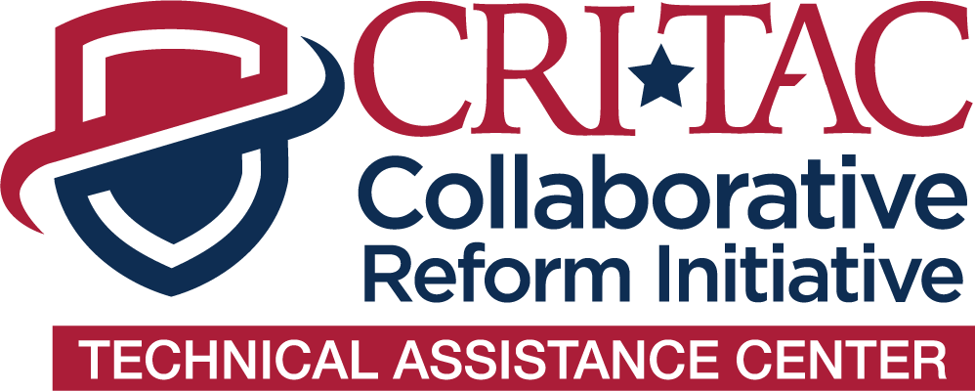

**Long-Term Post Impact Survey**

*Thank you for participating in the Collaborative Reform Initiative Technical Assistance Center (CRI-TAC).* The purpose of this survey is to gather information about your knowledge, perceptions, and outlooks relating to the technical assistance (TA) received and to collect information that will better enable us to assess the delivery of technical assistance. Survey responses will be summarized in aggregate, statistical form and your personal identifying information cannot be linked to your survey responses. There are no known risks in participating in this survey. Your participation is completely voluntary: you may choose not to answer certain questions, or not to participate in the survey at all, without penalty. *We appreciate your feedback!*

BY TAKING PART IN THIS SURVEY YOU INDICATE YOUR CONSENT FOR YOUR ANSWERS TO BE USED IN FUTURE REPORT SUMMARIES.

**Date:**

**Name (optional):**

**Title:**

**Agency:**

1. Have you used the information provided through the TA in any way?

Yes No

If you responded yes, please provide a brief explanation in the text box below.

1. Have you changed any policies, procedures, or other practices because of the TA provided?

Yes No

If you responded yes, please provide a brief explanation of the policies, procedures, or other practices that have been changed in the text box below.

1. Does your agency have follow-up plans from the information provided to you during this TA?

Yes No

If you responded yes, please provide a brief explanation of the follow-up plans in the text box below.

1. What is your timeframe for changes you will make because of the TA provided?
2. Do you need any additional assistance related to your original request?

Yes No

If you responded yes, please provide a brief explanation of your additional assistance needed in the text box below.

The technical assistance that was provided to this agency was approved by the International Association of Chiefs of Police (IACP), and the Office of Community Oriented Policing Services (COPS Office). If you have any questions or concerns about this survey, please contact the CRI-TAC team at [CRITAC@theiacp.org](mailto:CRITAC@theiacp.org).