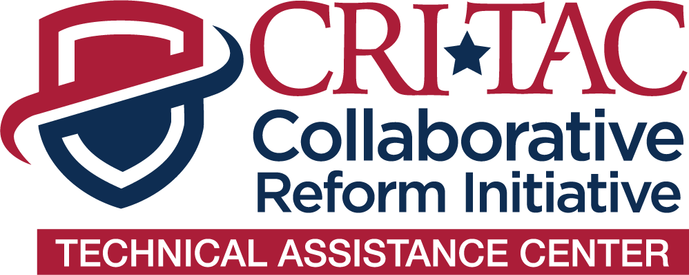

One-Week Post-Satisfaction Survey

Thank you for participating in the Collaborative Reform Initiative Technical Assistance Center (CRI-TAC). The purpose of this survey is to gather information about your knowledge, perceptions, and outlooks relating to the technical assistance (TA) received and to collect information that will better enable us to assess the delivery of technical assistance. Survey responses will be summarized in aggregate, statistical form and your personal identifying information cannot be linked to your survey responses. There are no known risks in participating in this survey. Your participation is completely voluntary: you may choose not to answer certain questions, or not to participate in the survey at all, without penalty. We appreciate your feedback!

BY TAKING PART IN THIS SURVEY YOU INDICATE YOUR CONSENT FOR YOUR ANSWERS TO BE USED IN FUTURE REPORT SUMMARIES.

Date:
Name (optional):
Title:
Agency:

- My agency received assistance in a timely manner.

Strongly Agree Agree Neutral Disagree Strongly Disagree

- The services provided to my agency met our needs.

Strongly Agree Agree Neutral Disagree Strongly Disagree

- The services provided will help address the problem identified by my agency.

Strongly Agree Agree Neutral Disagree Strongly Disagree

- The staff and subject matter experts we worked with met our expectations.

Strongly Agree Agree Neutral Disagree Strongly Disagree

- What information learned from this TA has been most relevant to your job?

- How do you believe this technical assistance will help to create organizational change?

- What is your jurisdiction’s follow-up plans with the information provided to you during this TA?

- What is your timeframe for changes you will make because of the TA provided?

- What additional assistance or information, if any, do you require?

- Do you have any additional feedback?

The technical assistance that was provide to this agency was approved by the International Association of Chiefs of Police (IACP), and the Office of Community Oriented Policing Services (COPS). If you have any questions or concerns about this survey, please contact the CRI-TAC team at CRITAC@theiacp.org.

