U.S. Department of Homeland Security
Arlington, VA 20598

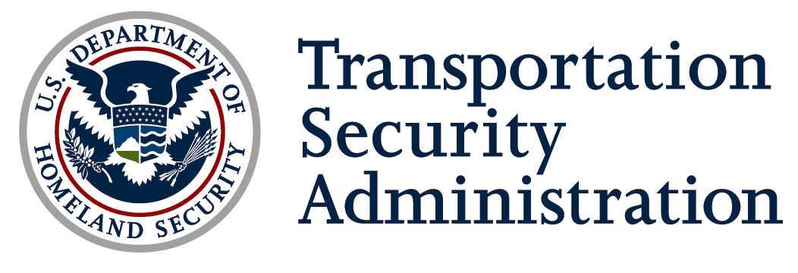

DATE: June 29, 2016

TO: Shannon Joyce
Office of Information and Regulatory Affairs
Office of Management and Budget

THRU: Tyrone Huff,
Office of the Chief Information Officer
Department of Homeland Security

FROM: Christina Walsh
Office of Information Technology
Transportation Security Administration

SUBJECT: OMB Terms of Clearance
OMB Control Number 1652-0062
Highway Baseline Assessment for Security Enhancement (BASE) Program

Purpose
This memo serves as a notification of compliance with the OMB Terms of Clearance for OMB Control Number 1652-0062 Highway Baseline Assessment for Security Enhancement (BASE) Program, issued February 29, 2016.

OMB Terms of Clearance
OMB Terms of Clearance for the Highway BASE Program are as follows:

- Information from this collection shall not be used for program evaluation purposes.

Compliance with OMB Terms of Clearance
TSA has complied with the OMB Terms of Clearance for the Highway BASE collection:
- The Office of Security Operations at Transportation Security Administration has not used the information collected from the Highway BASE Program for program evaluation purposes.

