U. S. Department of Education
Office of Career, Technical, and Adult Education
* * * * * * * * * * *
The Carl D. Perkins Career and Technical Education Act of 2006

GUIDE FOR THE SUBMISSION OF STATE PLANS

OMB Control Number: 1830-0029
Expiration Date: 08/31/201X

Public Burden Statement:

According to the Paperwork Reduction Act of 1995, no persons are required to respond to a collection of information unless such collection displays a valid OMB control number. Public reporting burden for this collection of information is estimated to average 40 hours per response, including time for reviewing instructions, searching existing data sources, gathering and maintaining the data needed, and completing and reviewing the collection of information. The obligation to respond to this collection is required to obtain or retain benefit (Carl D. Perkins Career and Technical Education Act of 2006). Send comments regarding the burden estimate or any other aspect of this collection of information, including suggestions for reducing this burden, to the U.S. Department of Education, 400 Maryland Ave., SW, Washington, DC 20210-4537 or email ICDocketMgr@ed.gov and reference the OMB Control Number 1830-0029. Note: Please do not return the completed State Plans to this address. If you have comments or concerns regarding the status of your individual submission of this form, write directly to: Dr. Edward R. Smith, Chief, Program Administration Branch, Division of Academic and Technical Education, Office of Career, Technical, and Adult Education, U.S. Department of Education, 550 12th Street, SW, Potomac Center Plaza, Room 11060, Washington, DC 20202-7241.

TABLE OF CONTENTS

INTRODUCTION 4

COVER PAGE 7

CHECKLIST OF STATE PLAN SUBMISSION REQUIREMENTS 6

PART A: STATE PLAN NARRATIVE 8

Planning, Coordination, and Collaboration Prior to Plan Submission 9
Program Administration 11
Provision of Services for Special Populations 15
Accountability and Evaluation 17
Financial Requirements 21
EDGAR Certifications and Other Assurances 24

PART B: BUDGET FORMS 27

PART C: ACCOUNTABILITY FORMS 31

Definitions of Student Populations …………………………………………………… 32

Identification of Measurement Definitions/Approaches……………………………… 32

Baseline Data………………………………………………………………………….. 32

Performance Levels…………………………………………………………………… 32
State Confirmation of Final Agreed Upon Performance Levels……………………… 33
Final Agreed Upon Performance Levels (FAUPL) Form…….. ……….…… 35

INTRODUCTION

The Office of Career, Technical, and Adult Education (OCTAE) developed this guide to assist you in preparing your State plan under the newly authorized Carl D. Perkins Career and Technical Education Act of 2006 (Act), 20 U.S.C. 2301 et seq. as amended by P.L. 109-270. Sections 122(a)(1) and 201(c) require each eligible agency desiring assistance under Titles I and II, respectively, for any fiscal year to prepare and submit to the Secretary a State plan for a 6-year period. As the original period of authorization for Perkins has passed, States currently request extensions of, and submit any revisions to, their Perkins State Plans consistent with this Guide.

The framework for the guide is based on the requirements in the Act and a renewed vision of career and technical education (CTE) programs for the 21st century. Signed into law on August 12, 2006, the Act represents nearly three years of work on the part of Congress and the U.S. Department of Education (Department), in cooperation with other Federal agencies and the State and local agencies affected by its policies, to provide continuing Federal support for rigorous CTE programs that prepare students for today’s competitive workforce. The Act envisions that all students will achieve challenging State academic and technical standards and be prepared for high-skill, high-wage, or high-demand occupations in current or emerging professions. The Act provides an increased focus on the academic achievement of career and technical education students, improves State and local accountability, and strengthens the connections between secondary and postsecondary education.

This guide is organized into three parts. Part A outlines the required State plan narrative for the State plan in seven key areas: planning, coordination, and collaboration prior to State plan submission; program administration; provision of services to special populations; accountability and evaluation; tech prep programs; financial requirements; and EDGAR certifications and other assurances. For each of these areas, the statutory requirements are provided, along with other U.S. Department of Education (Department) requirements. Each section of the guide also includes procedural suggestions and planning reminders to help you prepare your State plan narrative, although these items are not required as part of your State plan submission. Upon approval of the State Plan submission requirements for each subsequent year will consist of an extension request, budget submission and any revisions to the State Plan, consistent with the requirements in this Guide. States are required to update performance levels annually for the core indicators of performance described in section 113(b) of Perkins IV. See Part C of the State Plan Guide.

Part B includes the required budget form. Information and directions for completing the budget form are provided in the financial requirements section (VI) of Part A.

Part C includes the required accountability form. Information and directions for completing the accountability form are provided in the accountability and evaluation section (IV) of Part A.

As indicated above, each State has several options in preparing its State plans. A State may complete a new multi-year State Plan, revisions to its previously approved State plan, or a Combined State Plan under Section 103 of the Workforce Innovation and Opportunity Act (WIOA) (P.L. 113-128). Each State that submits revisions to a previously approved State Plan must complete each item relevant to the revision in this Guide. Any State that wishes to submit a Combined State Plan must follow any instructions and submission requirements provided by the Employment and Training Administration, U.S. Department of Labor. For further information, please contact Heather Fleck at fleck.heather@dol.gov or (202)-693-2956.

The Department will issue, via program memorandum, each year its timeline for receiving State plan revisions and issuing grant awards.

Submission Instructions

You must submit your State plan, including the Cover Page, (revisions and budget for post State Plan approval years) no later than close of business (5:00 pm EST) in accordance with EDGAR 76.703 (b)(3)(ii), of each submission year. State plans may be entered into the electronic Perkins IV State Plan Database www.perkinsinfo.com/stateplans20 (year of submission).

You must submit, in hard copy to the address below, signed originals of any pages within the document that require a signature. This includes the Cover Page, EDGAR certifications, and other assurances.

Submission Address

Edward R. Smith, Branch Chief
Program Administration Branch
Division of Academic and Technical Education
Office of Career, Technical, and Adult Education
U.S. Department of Education
550 12th Street, SW
Potomac Center Plaza, Room 11060
Washington, DC 20202-7241

Publication Information

The Department may publish your State plan, in whole or in part, on our Web site or through other means available to us.

We look forward to reviewing your State plans and your initiatives to implement the new Act in the coming years. Staff of the Division of Academic and Technical Education (DATE), particularly your State Liaisons and Regional Accountability Specialists, are available at any time to answer questions that arise as you prepare your plan.

U. S. Department of Education
Office of Career, Technical, and Adult Education
* * * * * * * * * * *
The Carl D. Perkins
Career and Technical Education Act of 2006
STATE PLAN COVER PAGE
State Name: ______________________
Eligible Agency Submitting Plan on Behalf of State:

Person at, or representing, the eligible agency responsible for answering questions on this plan: ___________________________________________________________
Signature:
Name:
Position:
Telephone: ( )
Email:
Type of State Plan Submission (check one):
___ 6-Year Full Plan – FY 2007 – FY 2013 with annual extensions and updates
___ Submit a completely new multi-year State Plan
___ A WIOA Combined State Plan
Special Features of State Plan Submission (check all that apply):
___ WIOA Combined State Plan - Secondary and Postsecondary
___ WIOA Combined State Plan - Postsecondary Only
___ Title I only (All Title II funds have been consolidated under Title I, as applicable)
___ Title I and Title II, as applicable.

CHECKLIST OF STATE PLAN SUBMISSION REQUIREMENTS

State Plan Items | Six Year Plan 2007 or 2008 | Year 2009 | Year 2010 | Year 2011 | Year 2012 | Year 2013 | Year 2014 | Year 2015 | Year 2016 | Year 2017
PART A: STATE PLAN NARRATIVE
Planning, Coordination, and Collaboration Prior to State Plan Submission | Revisions if any | Revisions if any | Revisions if any | Revisions if any | Revisions if any | Revisions if any | Revisions if any | Revisions if any | Revisions if any | Revisions if any
Program Administration | All items required | Only items A2(a-l); A8; B1; & B2 required | Revisions if any | Revisions if any | Revisions if any | Revisions if any | Revisions if any | Revisions if any | Revisions if any | Revisions if any
Provision of Services for Special Populations | All items required | Only items A1(a-c) required | Revisions if any | Revisions if any | Revisions if any | Revisions if any | Revisions if any | Revisions if any | Revisions if any | Revisions if any
Accountability and Evaluation | All items required | All items required, except for the baseline data & performance levels | Revisions for negotiations on performance levels for years 2009-2010 & 2010-2011. | Revisions if any | Revisions for negotiations on performance levels for years 2011-2012 and 2012-2013. | Revisions if any | Revisions for negotiations on performance levels for 2014 | Revisions for negotiations on performance levels for 2015 | Revisions for negotiations on performance levels for 2016 | Revisions for negotiations on performance levels for 2017
Financial Requirements | All items required | All items required | Revisions if any & new Budget in Part C. | Revisions if any & new Budget in Part C. | Revisions if any & new Budget in Part C. | Revisions if any & Budget in Part C. | Revisions if any & new Budget in Part C. | Revisions if any &new Budget in Part C. | Revisions if any & new Budget in Part C. | Revisions if any & new Budget in Part C.
State Plan Items | Six Year Plan 2007 or 2008 | Year 2009 | Year 2010 | Year 2011 | Year 2012 | Year 2013 | Year 2014 | Year 2015 | Year 2016 | Year 2017
EDGAR Certifications and Other Assurances | All items required | All items required | Only for Revisions that impact the Certifications and Assurances | Only for Revisions that impact the Certifications and Assurances | Only for Revisions that impact the Certifications and Assurances | Only for Revisions that impact the Certifications and Assurances | Only for Revisions that impact the Certifications and Assurances | Only for Revisions that impact the Certifications and Assurances | Only for Revisions that impact the Certifications and Assurances | All items required
PART B: BUDGET FORMS
Title I – Basic Grant | All items required | All items required | All items required | All items required | All items required | All items required | All items required | All items required | All items required | All items required
PART C: ACCOUNTABILITY FORMS
Definitions | All items required | All items required
 |  |  | Any revisions | Any revisions | Any revisions | Any revisions | Any revisions | Any revisions | Any revisions | Any revisions
Final Agreed Upon Performance Levels (FAUPL) Form – Secondary Level | All items required | Revisions for performance levels for years 2009-2010 and 2010-2011 | Revisions if any | Revisions for performance levels for years 2011-2012 and 2012-2013 | Revisions if any | Revisions for performance levels for year 2014 | Revisions for performance levels for years 2015 | Revisions for performance levels for year 2016 | Revisions for performance levels for year 2016 | Revisions for performance levels for year 2017

PART A: STATE PLAN NARRATIVE

I. PLANNING, COORDINATION, AND COLLABORATION PRIOR TO PLAN SUBMISSION
A. Statutory Requirements

- You must conduct public hearings in the State, after appropriate and sufficient notice, for the purpose of affording all segments of the public and interested organizations and groups (including charter school authorizers and organizers consistent with State law, employers, labor organizations, parents, students, and community organizations), an opportunity to present their views and make recommendations regarding the State plan. [Sec. 122(a)(3)]

- You must include a summary of the above recommendations and the eligible agency’s response to such recommendations in the State plan. [Sec. 122(a)(3)]

- You must develop the State plan in consultation with academic and career and technical education teachers, faculty, and administrators; career guidance and academic counselors; eligible recipients; charter school authorizers and organizers consistent with State law; parents and students; institutions of higher education; the State tech prep coordinator and representatives of tech prep consortia (if applicable); entities participating in activities described in section 111 of Public Law 105-220; interested community members (including parents and community organizations); representatives of special populations; representatives of business and industry (including representatives of small business); and representatives of labor organizations in the State. You also must consult the Governor of the State with respect to development of the State plan. [Sec. 122(b)(1)(A)-(B)]

- You must develop effective activities and procedures, including access to information needed to use such procedures, to allow the individuals and entities listed in item 3 above to participate in State and local decisions that relate to development of the State plan. [Sec. 122(b)(2)]

- You must develop the portion of the State plan relating to the amount and uses of any funds proposed to be reserved for adult career and technical education, postsecondary career and technical education, tech prep education, and secondary career and technical education after consultation with the State agency responsible for supervision of community colleges, technical institutes, or other 2-year postsecondary institutions primarily engaged in providing postsecondary career and technical education, and the State agency responsible for secondary education. If a State agency finds that a portion of the final State plan is objectionable, the State agency must file its objections with you. You must respond to any objections you receive in the State plan that you submit to the Secretary. [Sec. 122(e)(3)]

B. Procedural Suggestions and Planning Reminders

1. You should maintain a record of the public hearings that includes copies of the notices for the hearings, what media were used to publicize the hearings, mailing lists used for notification, where the hearings were held, and attendance levels. See section 122(a)(3).

2. You should develop and implement policies and procedures for the framework of consultations required by section 122(b)(1)(A-B) and section 122(b)(2) of the Act; moreover, you should maintain appropriate records for these mandated consultations.

3. Postsecondary career and technical education programs assisted under Perkins IV are mandatory partners in the one-stop career center delivery system under WIOA. (WIOA Sec. 121(b)(1)(B)(iv)) You are encouraged to collaborate with your State Workforce Investment Board and other one-stop partners as you plan for the participation of postsecondary career and technical programs in your State’s one-stop career center delivery system.

4. Public hearings and other consultation activities should address all aspects of the State plan, including the reservation of funds under section 112(c) of the Act, if any, and the amount and uses of funds reserved for services that prepare individuals for nontraditional training and employment under section 112(a)(2)(B) of the Act.

II. PROGRAM ADMINISTRATION

A. Statutory Requirements

- You must prepare and submit to the Secretary a multi-year State plan,
a completely new State Plan, or a WIOA Combined State Plan
States must submit a plan that addresses all of the items below.

2. You must describe the career and technical education activities to be assisted that are designed to meet or exceed the State adjusted levels of performance, including a description of—

(a) The career and technical education programs of study, that may be adopted by local educational agencies and postsecondary institutions to be offered as an option to students (and their parents as appropriate) when planning for and completing future coursework, for career and technical content areas that—

i. Incorporate secondary education and postsecondary education elements;

ii. Include coherent and rigorous content, aligned with challenging State academic standards, and relevant career and technical content in a coordinated, non-duplicative progression of courses that align secondary education with postsecondary education to adequately prepare students to succeed in postsecondary education;

iii. May include the opportunity for secondary education students to participate in dual or concurrent enrollment programs or other ways to acquire postsecondary education credits; and

iv. Lead to an industry-recognized credential or certificate at the postsecondary level, or an associate or baccalaureate degree;

(b) How you, in consultation with eligible recipients, will develop and implement the career and technical programs of study described in (a) above;

    - How you will support eligible recipients in developing and implementing articulation agreements between secondary education and postsecondary education institutions;

    - How programs at the secondary level will make available information about career and technical programs of study offered by eligible recipients;

(e) The secondary and postsecondary career and technical education programs to be carried out, including programs that will be carried out by you, to develop, improve, and expand access to appropriate technology in career and technical education programs;

(f) The criteria that you will use to approve eligible recipients for funds under the Act, including criteria to assess the extent to which the local plan will—

i. Promote continuous improvement in academic achievement;

ii. Promote continuous improvement of technical skill attainment; and

iii. Identify and address current or emerging occupational opportunities;

(g) How programs at the secondary level will prepare career and technical education students, including special populations, to graduate from secondary school with a diploma;

(h) How such programs will prepare career and technical education students, including special populations, academically and technically for opportunities in postsecondary education or entry into high-skill, high-wage, or high-demand occupations in current or emerging occupations, and how participating students will be made aware of such opportunities;

(i) How funds will be used to improve or develop new career and technical education courses—

i. At the secondary level that are aligned with rigorous and challenging State academic standards and measured by the State determined levels of achievement on the academic assessments described in section 1111(b)(2) of the Elementary and Secondary Education Act (ESEA), as amended by Every Student Succeeds Act (ESSA);

ii. At the postsecondary level that are relevant and challenging; and

iii. That leads to employment in high-skill, high-wage, or high-demand occupations;

(j) How funds will be used effectively to link academic and career and technical education at the secondary level and at the postsecondary level in a manner that increases student academic and career and technical achievement; and

(k) How you will report on the integration of coherent and rigorous content aligned with your State’s challenging academic standards in career and technical education programs in order to adequately evaluate the extent of such integration. [Sec. 122(c)(1)(A)-(L)]

3. You must describe how comprehensive professional development (including initial teacher preparation and activities that support recruitment) for career and technical teachers, faculty, administrators, and career guidance and academic counselors will be provided, especially professional development that—

(a) Promotes the integration of coherent and rigorous academic content standards and career and technical education curricula, including through opportunities for academic and career and technical teachers to jointly develop and implement curricula and pedagogical strategies;

(b) Increases the percentage of teachers that meet teacher certification or licensing requirements;

(c) Is high quality, sustained, intensive, and focused on instruction, and increases the academic knowledge and understanding of industry standards, as appropriate, of career and technical education teachers;

(d) Encourages applied learning that contributes to the academic and career and technical knowledge of the student;

(e) Provides the knowledge and skills needed to work with and improve instruction for special populations; and

(f) Promotes integration with professional development activities that the State carries out under Title II of the Elementary and Secondary Education Act of 1965, as amended, and Title II of the Higher Education Act of 1965, as amended. [Sec. 122(c)(2)(A)-(G)]

4. You must describe efforts that your agency and eligible recipients will make to improve—

(a) the recruitment and retention of career and technical education teachers, faculty, and career guidance and academic counselors, including individuals in groups underrepresented in the teaching profession; and

(b) the transition to teaching from business and industry, including small business. [Sec. 122(c)(3)(A)-(B)]

5. You must describe efforts that your agency and eligible recipients will make to improve the transition of sub-baccalaureate career and technical education students into baccalaureate degree programs at institutions of higher education. [Sec. 122(c)(4)]

6. You must describe how you will actively involve parents, academic and career and technical education teachers, administrators, faculty, career guidance and academic counselors, local business (including small businesses), and labor organizations in the planning, development, implementation, and evaluation of career and technical education programs in your State. [Sec. 122(c)(5)]

7. You must describe efforts that your agency and eligible recipients will make to—

(a) Improve the academic and technical skills of students participating in career and technical education programs, including by strengthening the academic and career and technical components of career and technical education programs through the integration of academics with career and technical education to ensure learning in--

i. a well-rounded education (as defined in section 8101 of the ESEA, as amended by ESSA); and

ii. Career and technical education subjects;

(b) Provide students with strong experience in, and understanding of, all aspects of an industry; and

(c) Ensure that students who participate in career and technical education programs are taught to the same challenging academic proficiencies as taught to all other students. [Sec. 122(c)(7)(A)-(C)]

8. You must describe how you will provide local educational agencies, area career and technical education schools, and eligible institutions in the State with technical assistance. [Sec. 122(c)(15)]

9. You must describe how career and technical education in your State relates to your State’s and regional occupational opportunities. [Sec. 122(c)(16)]

10. You must describe the methods you propose for the joint planning and coordination of programs carried out under this legislation with other Federal education programs. [Sec. 122(c)(17)]

11. You must describe the procedures you will develop to ensure coordination and non-duplication among programs listed in sections 112(b)(8) and 121(c) of the Workforce Innovation and Opportunity Act (Public Law 113-128) concerning the provision of services for postsecondary students and school dropouts. [Sec. 122(c)(20)]

Other Department Requirements

- You must submit a copy of your local applications or plans for secondary and postsecondary eligible recipients, which will meet the requirements in section 134(b) of the Act.

- You must provide a description of your State’s governance structure for career and technical education, including the approximate number of eligible recipients at both secondary and postsecondary levels.

- You must provide a description of the role of postsecondary career and technical education in the one-stop career center delivery system established by Title I of WIOA.

C. Procedural Suggestions and Planning Reminders

It may be helpful to you in understanding the responsibilities with regards to one-stop participation to visit: http://www.careeronestop.org/.

III. PROVISION OF SERVICES FOR SPECIAL POPULATIONS

Statutory Requirements

1. You must describe your program strategies for special populations listed in Section 3(29) of the Act, including a description of how individuals who are members of the special populations—

- Will be provided with equal access to activities assisted under the Act.

(b) Will not be discriminated against on the basis of their status as members of special populations; and

(c) Will be provided with programs designed to enable the special populations to meet or exceed State adjusted levels of performance, and how you will prepare special populations for further learning and for high-skill, high-wage, or high-demand occupations. [Sec. 122(c)(9)(A)-(C)]

2. You must describe how you will adequately address the needs of students in alternative education programs, if you have such programs. [Sec. 122(c)(14)]

- You must describe how funds will be used to promote preparation for high-skill, high-wage, or high-demand occupations and non-traditional fields. [Sec. 122(c)(18)]

- You must describe how funds will be used to serve individuals in State correctional institutions. [Sec. 122(c)(19)]

- You must describe how you will require each applicant for funds to include in its application a description of the steps the applicant proposes to take to ensure equitable access to, and participation in, its Federally-assisted program for students, teachers, and other program beneficiaries with special needs as contained in section 427(b) of the General Education Provisions Act as amended. For further guidance and examples, see the Notice to All Applicants at:

http://www.ed.gov/fund/grant/apply/appforms/gepa427.doc.

Other Department Requirements

There are no other Department requirements for this section of the State plan narrative.

C. Procedural Suggestions and Planning Reminders

  - Be sure that your local applications or forms seek complete information from eligible recipients on their proposed programs, services, and activities for special populations. See section 134(b)(8)(A)-(C), and 134(b)(9)-(10).

2. The Act eliminated “individuals with other barriers to educational achievement” from the definition of special populations. See section 3(29).

3. Under the State leadership set-aside, there is a cap of not more than one percent of the funds allotted to you under section 111 of the Act that can be used to serve individuals in State institutions. See section 112(a)(2)(A).

4. You may wish to refer to Program Memorandum OVAE/DVTE 99-13 for additional background information concerning the reservation and use of State leadership funds for activities related to non-traditional training and employment.

5. Your accountability system must be able to disaggregate data for each of the core indicators of performance under section 113(b)(2) of the Act for the subgroups of students described in section 1111(h)(1)(C)(i) of the Elementary and Secondary Education Act of 1965, as amended, and section 3(29) of the Act that are served under the Act. See section 113(c)(2)(A).

IV. ACCOUNTABILITY AND EVALUATION

A. Statutory Requirements

- You must describe procedures you will use to obtain input from eligible recipients in establishing measurement definitions and approaches for the core indicators of performance for career and technical education students at the secondary and postsecondary levels, as well as for any other additional indicators of performance identified by the eligible agency. [Sec. 113(b)(1)(A)-(B), sec. 113(b)(2)(A)-(C)]

- You must describe the procedures you will use to obtain input from eligible recipients in establishing a State adjusted level of performance for each of the core indicators of performance for career and technical education students at the secondary and postsecondary levels, as well as State levels of performance for any additional indicators of performance identified by the eligible agency. [Sec. 122(c)(10)(A), sec. 113(b)(3)(B)]

- You must identify, on the forms in Part C of this guide, the valid and reliable measurement definitions and approaches that you will use for each of the core indicators of performance for career and technical education students at the secondary and postsecondary/adult levels, as well as any additional indicators of performance identified by the eligible agency, that are valid and reliable. You must describe how your proposed definitions and measures are valid and reliable. [Sec. 113(b)(2)(A)-(B)]

Section 113(b) of the Act describes the measures that a State must use for student attainment of challenging State academic content standards and student academic achievement standards in reading/language arts and mathematics (1S1 and 1S2, respectively) and student graduation rates (4S1). Based on our non-regulatory guidance, we have prepopulated the measurement definitions on the Final Agreed Upon Performance Levels (FAUPL) form for your convenience. You do not need to describe how these definitions and measures are valid and reliable in your State plan narrative. A State that chooses to propose other student definitions and measurement approaches in its new State plan would have to describe how its proposed definitions and measures would be valid and reliable.

- You must describe how, in the course of developing core indicators of performance and additional indicators of performance, you will align the indicators, to the greatest extent possible, so that information substantially similar to that gathered for other State and Federal programs, or for any other purpose, is used to meet the Act’s accountability requirements. [Sec. 113(b)(2)(F)]

- On the forms provided in Part C of this guide, you must provide, performance levels for each of the core indicators of performance. For performance levels that are required, the States’ performance levels, at a minimum, must be expressed in a percentage or numerical form, so as to be objective, quantifiable, and measurable; and require the State to continually make progress toward improving the performance of career and technical education students. [Sec. 113(b)(3)(A)(i)-(II)]

Section 113(b)(2) of the Perkins Act requires a State to develop valid and reliable core indicators of performance, to propose performance levels in its State plan, and to reach agreement with the Department on “adjusted performance levels” for each of the core indicators. In so doing, the Perkins Act prescribes the measures that a State must use for some of the core indicators.

        - Section 113(b)(2)(A)(i) of the Perkins Act requires a State to measure career and technical education students’ attainment of “the challenging State academic content standards… and measured by the State determined levels of achievement on the academic assessments described in section 1111(b)(2) [of the ESEA as amended]. Thus, a State’s core indicators must include career and technical education students’ proficiency in reading/language arts, mathematics, and science, as measured under 1111(b)(1) and (2) of the ESEA, as amended. Accordingly, under the Perkins Act, a State must report the number or percent of its career and technical education students who score at the proficient level or above on the State’s assessments in reading/language arts, mathematics, and science administered under the ESEA as amended, to measure the academic proficiency of secondary career and technical education students against the ESEA standards.

To measure attainment of these standards, a State must develop and reach agreement with the Department on “adjusted performance levels,” which constitute the State’s performance targets for a program year. Permissible targets (i.e. “adjusted performance levels”) would be a State’s Title I Accountability System goals developed under section 1111 of the ESEA as amended by ESSA. Under the Perkins Act, a State may propose different performance levels (targets) instead of its goals as discussed below.

        - Section 113(b)(2)(A)(iv) of the Perkins Act requires a State to identify a core indicator to measure for its career and technical education students at the secondary level “student graduation rates (as described in section 1111 (c)(4)(A)(i)(I)(bb) of the [ESEA]).” Thus, a State must report the number or percent of its career and technical education students whom the State includes as graduated in its graduation rate described under the ESEA as amended.

The Department strongly encourages your State to reach agreement on “adjusted performance levels” required under section 113 of the Perkins Act for the core indicators discussed in (a) and (b) above.

- You must describe your process for reaching agreement on local adjusted levels of performance if an eligible recipient does not accept the State adjusted levels of performance under section 113(b)(3) of the Act and ensuring that the established performance levels will require the eligible recipient to continually make progress toward improving the performance of career and technical education students. [Sec. 113(b)(4)(A)(i)(II); sec. 122(c)(10)(B)]

- You must describe the objective criteria and methods you will use to allow an eligible recipient to request revisions to its local adjusted levels of performance if unanticipated circumstances arise with respect to an eligible recipient. [Sec. 113(b)(4)(A)(vi)]

- You must describe how you will report data relating to students participating in career and technical education programs in order to adequately measure the progress of the students, including special populations and students participating in tech prep programs, if applicable, and how you will ensure that the data reported to you from local educational agencies and eligible institutions, and the data that you report to the Secretary, are complete, accurate, and reliable. [Sec. 122(c)(13); sec 205].

- You must describe how your State plans to enter into an agreement with each consortium receiving a grant under Perkins IV to meet a minimum level of performance for each of the performance indicators described in section 113(b) and 203(e) of the Act. [Sec. 204(e)(1)]

- You must describe how you will annually evaluate the effectiveness of career and technical education programs, and describe, to the extent practicable, how you are coordinating those programs with other Federal programs to ensure non-duplication. [Sec. 122(c)(8)]

B. Other Department Requirements

1. You must provide all the information requested on the forms provided in Part C of this guide to report accountability data annually to the Secretary under section 113(c)(1)-(2), including:

    - The student definitions that you will use for the secondary core indicators of performance and the postsecondary/adult core indicators of performance;

    - Baseline data for the core indicators of performance under section 113(b)(2) using data from the most-recently completed program year, except that, for the indicators for which your State must use your State’s standards, assessment, and graduation rates adopted under Title I of the ESEA, as amended by ESSA if your State chooses to use its goals under the ESEA, you will not need to submit baseline data; and

    - Proposed performance levels as discussed above, except that, for the indicators for which your State must use your State’s standards, assessments, and graduation rates adopted under Title I of the ESEA, if your State chooses to use its goals under the ESEA as amended, you will only have to confirm this information with your Regional Accountability Specialist. Upon your request, the Regional Accountability Specialist will pre-populate the forms in Part C with your State’s goals for the applicable program years and send the forms for you to finish completing.

2. You must identify the program areas for which the State has technical skill assessments, the estimated percentage of CTE students who take technical skill assessments, and the State’s plan for increasing the coverage of programs and students reported in future program years.

3. Your State’s grant approval letter will incorporate your State’s final agreed upon adjusted performance levels (FAUPL) into your State plan, as required by section 113(b)(3)(iii) and (v). If your State misses meeting at least 90% of any adjusted performance level, for three or more consecutive years, the Secretary may condition your State’s subsequent grant on your submission of periodic reports on your State’s progress toward meeting its adjusted performance levels and implementing its improvement plan under section 123(a).

Procedural Suggestions and Planning Reminders

- The Secretary will approve a State plan, or a revision to an approved State plan, unless the Secretary determines that the State plan, or revision, respectively, does not meet the requirements of the Act. These requirements include that a State must develop valid and reliable measures for the core indicators of performance and establish levels of performance on the core indicators of performance are sufficiently rigorous to meet the purposes of the Act. See section 122(e)(1)(A)-(B); section 113(b)(2).

2. If your State has developed, prior to the date of enactment of the Act, performance measures that meet the requirements of section 113 of the Act, as amended by Public Law 109-270, the State may continue to use such performance measures to measure the progress of career and technical education students. See section 113(b)(2)(D).

3. You will be required to prepare and submit annually to the Secretary a report on the progress of the State in achieving the State adjusted levels of performance on the core indicators of performance; and information on the levels of performance achieved by the State with respect to the additional indicators of performance, including the levels of performance for special populations. See section 113(c)(1).

4. With respect to future reports, your accountability system must be able to disaggregate data for each of the core indicators of performance under section 113(b)(2) and 203(e) of the Act, if applicable, for the subgroups of students described in section 1111(h)(1)(C)(i) of the ESEA as amended and section 3(29) of the Act that are served under the Act. See section 113(c)(2)(A). The Department will issue further guidance to States on non-duplication of data. See section 113(c)(3).

5. If your State does not consolidate all of its tech prep funds into its Title I grant, the State will be required to disaggregate data for each of the core indicators of performance under section 113(b)(2) of the Act for tech prep students.

6. You will be required to identify and quantify any disparities or gaps in performance between any category of students described in section 1111(h)(1)(C)(i) of the ESEA as amended and section 3(29) of the Act and the performance of all students served by the eligible agency under this Act, which must include a quantifiable description of the progress each such category of students served by the eligible agency under this Act has made in meeting the State adjusted levels of performance. See section 113(c)(2)(B).

7. The Department will make the information contained in reports submitted by States under section 113(c) and 205 of the Act available to the general public through a variety of formats, including electronically through the Internet, will disseminate State-by-State comparisons of the information, and will provide the appropriate committees of Congress with copies of such reports. See section 113(c)(5)(A)-(C) and section 205.

8. Your State is responsible for identifying, using national, state, or regional data, the career and technical education programs that lead to non-traditional fields. See section 113(b)((2)(A)(vi) and section 113(b)(2)(B)(v). The U.S. Department of Labor’s Bureau of Labor Statistics and Women’s Bureau, and the National Association of Partners in Education are several sources of information and data to assist States in this effort. See http://www.bls.gov/home.htm, http://www.dol.gov/wb/factsheets/nontra2005.htm, and http://www.napequity.org.

9. Your State is responsible for identifying, using national, state, or regional data, the occupations, or professions that it will classify as high-skill, high-wage, or high-demand. See section 113(b)(2)(B)(iv). The U.S. Department of Labor, Bureau of Labor Statistics, offers a wealth of information and data to assist States in this effort. See http://www.bls.gov/home.htm, as well as the Department’s Web site at http://www.edcountability.net.

V. FINANCIAL REQUIREMENTS

NOTE: States no longer receive funding under Title II of Perkins IV (Tech Prep Education Grants), therefore States should not submit paperwork related to Title II grants.

A. Statutory Requirements

States must complete this entire section.

You must describe how your agency will allocate funds it receives through the allotment made under section 111 of the Act. You must describes how funds received by the eligible agency

- Will be allocated among career and technical education at the secondary level, or career and technical education at the postsecondary and adult level, or both, including the rationale for such allocation. [Sec. 122(c)(6)(A)]

    - You must provide the specific dollar allocations made available by the eligible agency for career and technical education programs under section 131(a)-(e) of the Act and how these allocations are distributed to local educational agencies, area career and technical education schools, and educational service agencies within the State. [Sec. 131(g)]

3. You must provide the specific dollar allocations made available by the eligible agency for career and technical education programs under section 132(a) of the Act and how these allocations are distributed to postsecondary institutions within the State. [Section 122(c)(6)(A)]

4. You must describe how your agency will allocate any of those funds among any consortia that will be formed among secondary schools, and how funds will be allocated among the members of the consortia, including the rationale for such allocation. [Sec. 122(c)(6)(B)]

5. You must describe how your agency will allocate any of those funds among any consortia that will be formed among postsecondary institutions, and how funds will be allocated among the members of the consortia, including the rationale for such allocations. [Section 122(c)(6)(B)]

6. You must describe how you will adjust the data used to make the allocations to reflect any change in school district boundaries that may have occurred since the population and/or enrollment data was collected, and include local educational agencies without geographical boundaries, such as charter schools and secondary schools funded by the Bureau of Indian Affairs. [Sec. 131(a)(3)]

7. You must provide a description of any proposed alternative allocation formula(s) requiring approval by the Secretary as described in section 131(b) or 132(b) of the Act. At a minimum, you must provide an allocation run for eligible recipients using the required elements outlined in section 131(a) and/or section 132(a)(2) of the Act, together with an allocation run using the proposed alternative formula(s). Also you must include a demonstration that the alternative secondary formula more effectively targets funds on the basis of poverty, as described in section 131(b)(1) of the Act; and/or, in the case of an alternative postsecondary formula, a demonstration that the formula described in section 132(a)(2) of the Act does not result in a distribution of funds to eligible recipients that have the highest numbers of economically disadvantaged individuals and that an alternative formula would result in such a distribution.

B. Other Department Requirements

1. You must submit a detailed project budget, using the forms provided in Part B of this guide.

- You must provide a listing of allocations made to consortia (secondary and postsecondary) from funds available under sections 112(a) and (c) of the Act.

- You must describe the secondary and postsecondary formulas used to allocate funds available under section 112(a) of the Act, as required by section 131(a) and 132(a) of the Act.

- You must describe the competitive basis or formula to be used to award reserve funds under section 112(c) of the Act.

- You must describe the procedures used to rank and determine eligible recipients seeking funding under section 112(c) of the Act.

- You must include a description of the procedures used to determine eligible recipients in rural and sparsely populated areas under section 131(c)(2) or 132(a)(4) of the Act.

C. Procedural Suggestions and Planning Reminders

      - Funds received under the Act may not be used to provide career and technical education programs to students prior to the seventh grade, except that equipment and facilities purchased with funds under this Act may be used by such students. See section 315.

      - States must meet maintenance of fiscal effort requirements, on either per student or aggregate expenditure basis. See section 311(b)(1)(A).

      - No funds made available under the Act may be used to require any secondary school student to choose or pursue a specific career path or major. See section 314(1).

      - No funds made available under the Act may be used to mandate that any individual participate in a career and technical education program, including a career and technical education program that requires the attainment of a federally funded skill level, standard, or certificate of mastery. See section 314(2).

      - All funds made available under the Act must be used in accordance with the Act. See section 6.

      - Funds made available under the Act for career and technical education activities may supplement, and not supplant, non-Federal funds expended to carry out career and technical education activities and tech prep activities. See section 311(a).

      - No funds provided under the Act may be used for the purpose of directly providing incentives or inducements to an employer to relocate a business enterprise from one State to another State if such relocation will result in a reduction in the number of jobs available in the State where the business enterprise is located before such incentives or inducements are offered. See section 322.

      - The portion of any student financial assistance received under the Act that is made available for attendance costs may not be considered as income or resources in determining eligibility for assistance under any other program funded in whole or in part with Federal funds. See section 324(a).

      - Funds made available under the Act may be used to pay for the costs of career and technical education services required in an individualized education program developed pursuant to section 614(d) of the Individuals with Disabilities Education Act and services necessary to the requirements of section 504 of the Rehabilitation Act of 1973 with respect to ensuring equal access to career and technical education. See section 324(c).

VI. EDGAR CERTIFICATIONS AND OTHER ASSURANCES

EDGAR Certifications

- You must provide a written and signed certification that—

  - The plan is submitted by the State agency that is eligible to submit the plan. [34 CFR 76.104(a)(1)] [Note: The term ‘eligible agency’ means a State board designated or created consistent with State law as the sole State agency responsible for the administration, or the supervision of the administration, of career and technical education in the State. See Sec. 3(12).]

  - The State agency has authority under State law to perform the functions of the State under the program. [34 CFR 76.104(a)(2)]

  - The State legally may carry out each provision of the plan. [34 CFR 76.104(a)(3)]

  - All provisions of the plan are consistent with State law. [34 CFR 76.104(a)(4)]

  - A State officer, specified by title in the certification, has authority under State law to receive, hold, and disburse Federal funds made available under the plan. [34 CFR 76.104(a)(5)] [Note: If a State wishes for the Department to continue sending the grant award documents directly to the State director, this individual’s title needs to be listed on this portion of the assurance.]

  - The State officer who submits the plan, specified by title in the certification, has authority to submit the plan. [34 CFR 76.104(a)(6)]

  - The agency that submits the plan has adopted or otherwise formally approved the plan. [34 CFR 76.104(a)(7)]

  - The plan is the basis for State operation and administration of the program. [34 CFR 76.104(a)(8)]

B. Other Assurances

1. You must submit a copy of the State plan to the State office responsible for the Intergovernmental Review Process if your State implements that review process under Executive Order 12372. [See 34 CFR Part 79]

- You must provide a complete and signed ED Form 80-0013 for certifications regarding lobbying; [See 34 CFR Part 82]. To download ED Form 80-0013, and the SF LLL Form (Disclosure of Lobbying Activities) referred therein, See: http://www.ed.gov/fund/grant/apply/appforms/appforms.html

- You must provide a complete and signed Assurance for Non-Construction Programs Form. [See http://www.ed.gov/fund/grant/apply/appforms/appforms.html]

- You must provide a signed assurance that you will comply with the requirements of the Act and the provisions of the State plan, including the provision of a financial audit of funds received under the Act which may be included as part of an audit of other Federal or State programs. [Sec. 122(c)(11)]

- You must provide a signed assurance that none of the funds expended under the Act will be used to acquire equipment (including computer software) in any instance in which such acquisition results in a direct financial benefit to any organization representing the interests of the acquiring entity or the employees of the acquiring entity, or any affiliate of such an organization. [Sec. 122(c)(12)]

- You must provide a signed assurance that your State will waive the minimum allocation as required in section 131(c)(1) in any case in which the local educational agency is located in a rural, sparsely populated area or is a public charter school operating secondary school career and technical education programs and demonstrates that it is unable to enter into a consortium for purposes of providing services under the Act. [Section 131(c)(2)]

- You must provide a signed assurance that your State will provide, from non-Federal sources for the costs the eligible agency incurs for the administration of programs under this Act, an amount that is not less than the amount provided by the eligible agency from non-Federal sources for such costs for the preceding fiscal year. [Sec. 323(a)]

- You must provide a signed assurance that your State and eligible recipients that use funds under this Act for in-service and pre-service career and technical education professional development programs for career and technical education teachers, administrators, and other personnel shall, to the extent practicable, upon written request, permit the participation in such programs of career and technical education secondary school teachers, administrators, and other personnel in nonprofit private schools offering career and technical secondary education programs located in the geographical area served by such eligible agency or eligible recipient. [Sec. 317(a)]

- You must provide a signed assurance that, except as prohibited by State or local law, that an eligible recipient may, upon written request, use funds made available under this Act to provide for the meaningful participation, in career and technical education programs and activities receiving funds under this Act, of secondary school students attending nonprofit private schools who reside in the geographical area served by the eligible recipient. [Sec. 317(b)(1)]

- You must provide a signed assurance that eligible recipients that receive an allotment under this Act will consult, upon written request, in a timely and meaningful manner with representatives of nonprofit private schools in the geographical area served by the eligible recipient regarding the meaningful participation, in career and technical education programs and activities receiving funding under this Act, of secondary school students attending nonprofit private schools. [Sec. 317(b)(2)]

C. Procedural Suggestions and Planning Reminders

      - EDGAR regulations implementing the Drug-Free Workplace Act of 1988 (41 U.S.C. 701 et seq., as amended) are provided in 34 CFR Part 84, “Government-wide Requirements for Drug-Free Workplace (Financial Assistance).” Changes in this Government-wide requirement (adopted in the November 26, 2003 Federal Register Notice) now implement this as a condition of the award. See 34 CFR 84.400.

2. EDGAR regulations implementing Executive Orders 12549 and 12689 and Section. 2455 of the Federal Acquisition Regulation are provided in 34 CFR Part 85, “Government-wide Debarment and Suspension (Non-procurement).” Changes in this Government-wide requirement (adopted in the November 26, 2003 Federal Register Notice) now implement this as a condition of the award. See 34 CFR 85.440. You are also responsible for including a condition in any sub-grant and contract that meets the definition for a covered transaction a condition that the lower tier participant must comply with the regulations in part 85. See 34 CFR 85.330.

3. Under EDGAR regulations at 34CFR 85.320, your State is responsible for determining whether any of your principals of your covered transactions (i.e. sub-grants or contracts) is excluded or disqualified from participating in the transaction. See 34 CFR 85.320. You may decide the method and frequency by which you do so. You may, but are not required to, check the Excluded Parties List System at the following site: https://www.sam.gov/portal/SAM/#1.

PART B: BUDGET FORMS
I. 2016 PERKINS IV BUDGET FORMAT: Federal Funds Available Beginning on July 1, 2016

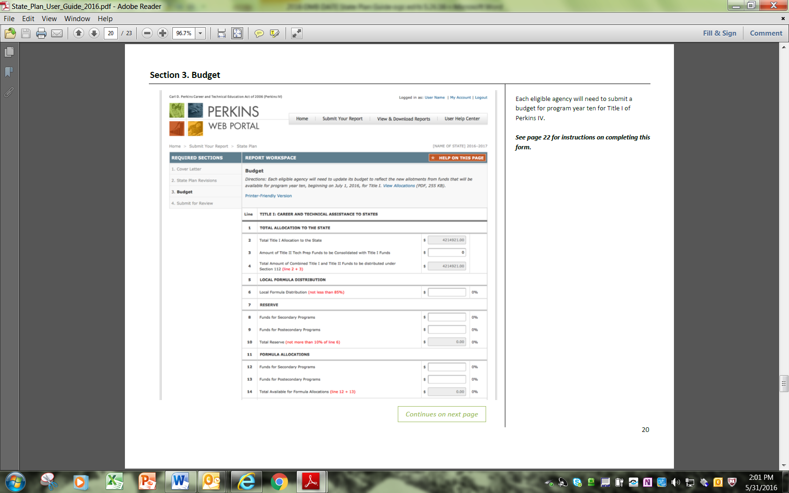

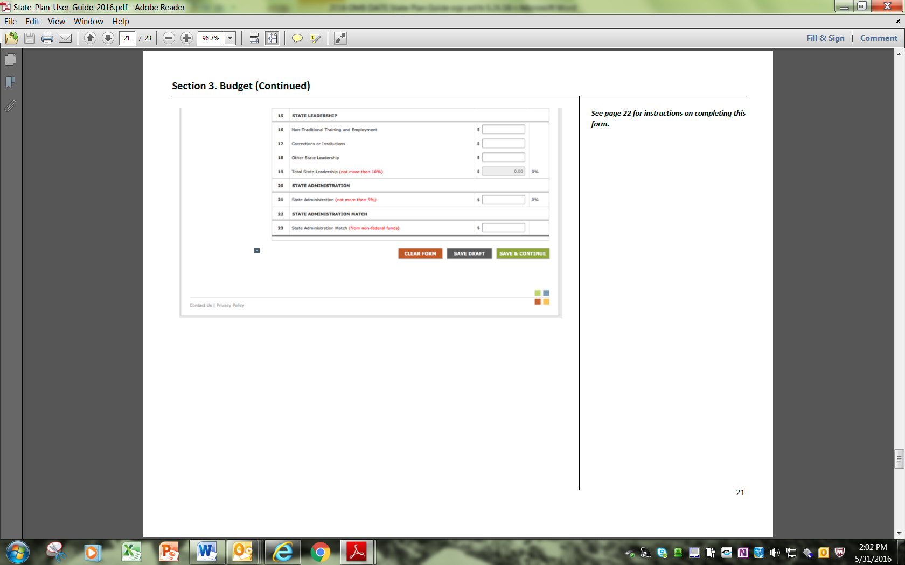
Budget Table Instructions

- Total Allocation to the State — Do not enter information in row 1.
- Total Allocation to the State — Do not enter information in row 2. Total Title I Allocation to the State will be pre-populated with the State’s most recent allocation.
- Amount of Title II Tech Prep Funds to be Consolidated with Title I Funds – Do not enter information in row 3. Due to the Continuing Resolution, Title II funds are displayed as ZERO.
- Total Amount of Combined Title I and Title II Funds to be distributed under Section 122 — Do not enter information in row 4. Total Amount of Title I and Title II Funds will be automatically calculated by adding row 3 and row 4.
- Local Formula Distribution — Do not enter information in row 5.
- Local Formula Distribution — Enter total amount of funds for Local Formula Distribution (not less than 85% of Total Title I Funds).
- Reserve — Do not enter information in row 7.
- Funds for Secondary Programs Enter the total amount of Reserve funds to be allocated to Secondary Programs.
- Funds for Posts Secondary Programs — Enter the total amount of Reserve funds to be allocated to Postsecondary Programs.
- Total Reserve — Do not enter information in row 10. Total Reserve will be automatically calculated by adding row 8 and row 9.
- Formula Allocations — Do not enter information in row 11.
- Funds for Secondary Programs – Enter the total amount of Formula Allocation funds for Secondary Programs.
- Funds for Postsecondary Programs — Enter the total amount of Formula Allocation funds for Postsecondary Programs.
- Total Available for Formula Allocations — Do not enter information in row 14. Total Available for Formula Allocations will be automatically calculated by adding row 12 and row 13.
- State Leadership — Do not enter information in row 15.
- Non-Traditional Training and Employment — Enter the total amount of State Leadership funds for Non-Traditional Training and Employment.
- Corrections or Institutions — Enter the total amount of State Leadership funds for Corrections or Institutions.
- Other State Leadership — Enter the total amount of Other State Leadership.
- Total State Leadership — Do not enter information in row 19. Total State Leadership will be automatically calculated by adding row 16, row 17, and row 18. State Leadership cannot exceed 10% of Total Title I Funds.
- State Administration — Do not enter information in row 20.
- State Administration — Enter the total amount of State Administration funds. State Administration cannot exceed 5% of Total Title I Funds.
- State Administration Match — Do not enter information in row 22.
- State Administration Match — Enter the total amount of non-federal funds for the State Administration Match.

NOTE: The eligible agency must provide non-federal funds for State administration of the Perkins IV, Title I grant in an amount not less than the amount it provided in the preceding year pursuant to section 323 of Perkins IV.

PART C: ACCOUNTABILITY FORMS
INSTRUCTIONS For Completion of the Definitions and Final Agreed Upon Performance Level (FAUPL) form:

(This information, which States have entered in previous years, is now carried forward year to year in the electronic FAUPL). FAUPL performance level negotiations are done on line and specific training and guidance is provided to States prior to each State Plan Submission.

Definitions of Student Populations

You must provide (page 52) the career and technical education (CTE) student definitions that you will use for the secondary and postsecondary/adult core indicators of performance, e.g., “CTE participants” and “CTE concentrators.” These are the students on which you will report data annually to the Secretary under section 113(c)(1)-(2) of the Act.

Identification of Measurement Definitions/Approaches

In Columns 2 and 3 of the “Final Agreed Upon Performance Levels” (FAUPL) forms on pages 53-55, you must provide your valid and reliable measurement definitions and approaches, respectively, for each of the core indicators of performance required under section 113(b) of the Act. Each definition must contain a description of the numerator (the number of individuals achieving an outcome) and a denominator (the number of individuals seeking to achieve an outcome). As discussed above in Part A, Section IV, A.3, based on our non-regulatory guidance, we have pre-populated the FAUPL form with the measurement definitions and approaches for the core indicators to measure student attainment of challenging State academic standards and academic achievement standards in reading/language arts, mathematics, and science under the ESEA, as amended by ESSA (1S1 and 1S2, respectively) and student graduation rates under the ESEA (4S1). A State may choose to propose other student definitions and measurement approaches, but it would have to describe in its new State plan how it’s proposed definitions and measures would be valid and reliable.

Baseline Data

In Column 4 of the FAUPL forms, you must provide baseline data, using data for the most recently completed program year as applicable, on the performance of career and technical education students on each of the core indicators of performance, except that, for the indicators for which your State must use your State’s standards, assessments, and graduation rates adopted under Title I of the ESEA as amended. You must supply baseline data for each core indicator and for each time you have an approved measurement or measurement approach change you must have a revised baseline.

Performance Levels

In Columns 5 - 10 of the FAUPL forms, you must provide proposed levels of performance for each of the core indicators of performance for the relevant program year(s) as required under section 113(b)(3)(ii) of the Perkins Act, except that, for the indicators for which the State must use its State’s standards, assessments, and graduation rates adopted under Title I of the ESEA as amended, a State must negotiate all its secondary and postsecondary/adult performance levels with its OCTAE Regional Accountability Specialist.

State Confirmation of Final Agreed Upon Performance Levels

After you reach agreement with the Department on your State’s final agreed upon adjusted performance levels for each program year, you will be asked to confirm these levels via e-mail submission of your State’s FAUPL form. See Part C of the State Plan Guide.

I. Student Definitions

A. Secondary Level

Participants –

Concentrators –

B. Postsecondary/Adult Level

Participants –

Concentrators –

FINAL AGREED UPON PERFORMANCE LEVELS FORM (FAUPL)

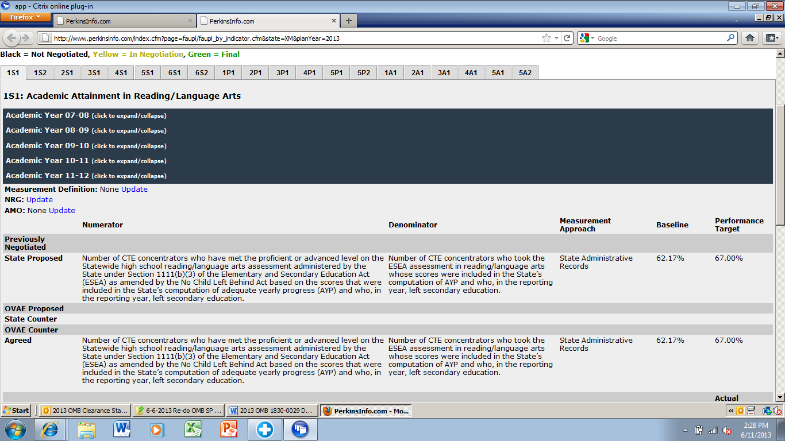

WELL-ROUNDED EDUCATION.—The term ‘‘well-rounded education’’ means courses, activities, and programming in subjects such as English, reading or language arts, writing, science, technology, engineering, mathematics, foreign languages, civics and government, economics, arts, history, geography, computer science, music, career and technical education, health, physical education, and any other subject, as determined by the State or local educational agency, with the purpose of providing all students access to an enriched curriculum and educational experience.

