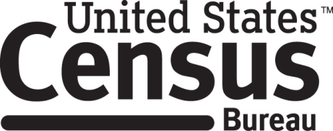

Consent Form

Food and Nutrition Service
Application for Free and Reduced Price School Meals

Each year the Census Bureau conducts many different research studies. For example, the Census Bureau routinely tests the wording, layout and behavior of application forms and surveys in order to obtain the best information possible.

You have volunteered to take part in a study to improve the usability of the 2016-2017 Application for Free and Reduced Price School Meals. In order to have a complete record of all comments, the interview session will be audio-recorded. The Census Bureau plans to use the tapes to make recommendations to improve the application form. Staff directly involved in this research project will have access to the recordings. Participation is voluntary and answers will remain strictly confidential.

This usability study is being conducted under the authority of Title 13 USC. The OMB control number for this study is 0607-0725. This valid approval number legally certifies this information collection.

I have agreed to participate in this Census Bureau research study, and I give permission for my tapes to be used for the purposes stated above.

____________________________ ___________________________
Participant's Signature Researcher's Signature

____________________________ ___________________________
Printed Name Printed Name

____________________________ ___________________________
Date Date

