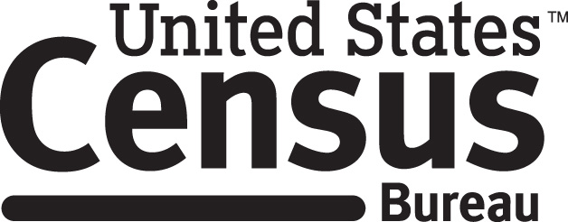

Consent Form

Current Population Survey,
Supplemental Civic Engagement and Volunteerism Survey

Each year the Census Bureau conducts many different surveys. The Census Bureau routinely tests the questions used on these surveys in order to produce the best information possible.

______________________ [NAME] consents to take part in a study to improve the questions that will be used in the Current Population Survey, Supplemental Civic Engagement and Volunteerism Survey. In order to have a complete record of your comments, your interview session will be recorded. The Census Bureau plans to use the tapes to improve the questionnaire. Only the staff directly involved in the questionnaire design research project will have access to the tapes. Your participation is voluntary and your answers will remain strictly confidential.

This study is being conducted under the authority of Title 13 USC. The OMB control number for this study is 0906000-000-000. This valid approval number legally certifies this information collection.

I have agreed to participate in this Census Bureau questionnaire design study, and I give permission for my recordings to be used for the purposes stated above.

__________________________ ____________________________
Participant's Signature Researcher's Signature

__________________________ _____________________________
Printed Name Printed Name

_______________________ _________________________ Date Date

