Materials Shown to Respondents
Attachment A. GovDelivery Emails for Contact Frame Sample

Initial Email

From: U.S. Census Bureau <census@subscriptions.census.gov>

To:__________

Subject: 10-minute U.S. Census Survey

-----

The U.S. Census Bureau is conducting research to improve how we describe our policies and procedures to respondents. This research will help us understand how to communicate more clearly with you – members of the public.

Please complete the research study online at https://www.surveymonkey.com/r/censusmessaging

The survey will take 10 minutes or less to complete.

Your responses will not be shared with anyone in a way that could personally identify you. Your participation in this study is voluntary. The legal authority under which this information is being collected is Title 13 U.S.C. Chapter 5 Sections 141 and 193. This data collection is approved under OMB No. 0607-0978 and the approval expires 04/30/17. This data collection uses third-party web site to collect data. This survey does not collect personally identifiable information. The results from this survey will be used to conduct primary research to enhance planning efforts for current and future surveys and censuses.

U.S. Department of Commerce
Economics and Statistics Administration
U.S. Census Bureau
census.gov

First Reminder (Contact Frame Sample)

From: U.S. Census Bureau <census@subscriptions.census.gov>

To:__________

Subject: Reminder: Complete the U.S. Census Survey

-----

A few days ago, you should have received an email about completing an important U.S. Census Bureau survey. The survey will take 10 minutes or less to complete.

If you have not yet responded, now is the time to complete the survey online at https://www.surveymonkey.com/r/censusmessaging

Your responses will not be shared with anyone in a way that could personally identify you. Your participation in this study is voluntary. The legal authority under which this information is being collected is Title 13 U.S.C. Chapter 5 Sections 141 and 193. This data collection is approved under OMB No. 0607-0978 and the approval expires 04/30/17. This data collection uses third-party web site to collect data. This survey does not collect personally identifiable information. The results from this survey will be used to conduct primary research to enhance planning efforts for current and future surveys and censuses.

U.S. Department of Commerce
Economics and Statistics Administration
U.S. Census Bureau
census.gov

Final Reminder (Contact Frame Sample)

From: U.S. Census Bureau <census@subscriptions.census.gov>

To:__________

Subject: Final Reminder: Complete the U.S. Census Study

-----

About a week ago, you should have received a couple of emails about completing an important U.S. Census Bureau study. If you have not yet responded, this is your last chance to complete the survey online at https://www.surveymonkey.com/r/censusmessaging

The survey will take 10 minutes or less to complete.

Your responses will not be shared with anyone in a way that could personally identify you. Your participation in this study is voluntary. The legal authority under which this information is being collected is Title 13 U.S.C. Chapter 5 Sections 141 and 193. This data collection is approved under OMB No. 0607-0978 and the approval expires 04/30/17. This data collection uses third-party web site to collect data. This survey does not collect personally identifiable information. The results from this survey will be used to conduct primary research to enhance planning efforts for current and future surveys and censuses.

U.S. Department of Commerce
Economics and Statistics Administration
U.S. Census Bureau
census.gov

Attachment B. Text Shown on Mechanical Turk to Respondents
(Note: Character limits prevent us from being able to display the full text of the contact frame emails).
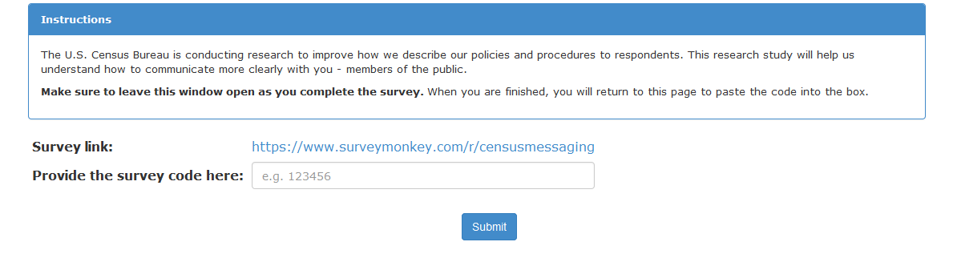
Attachment C. Survey Questions for Both Samples

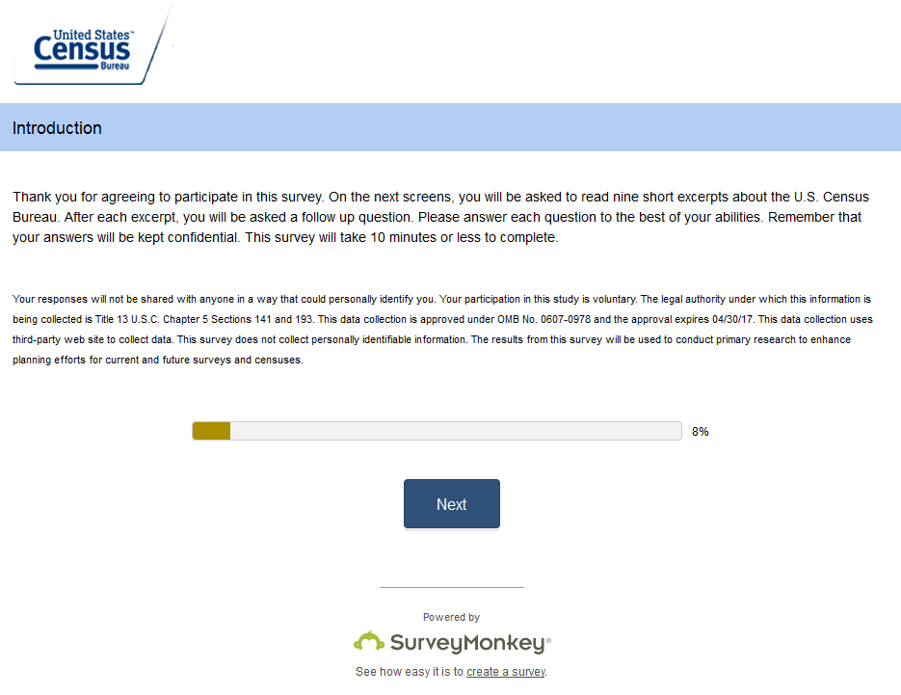

Example Message and Probe:
Respondents are shown 9 screens like this one with different messages.

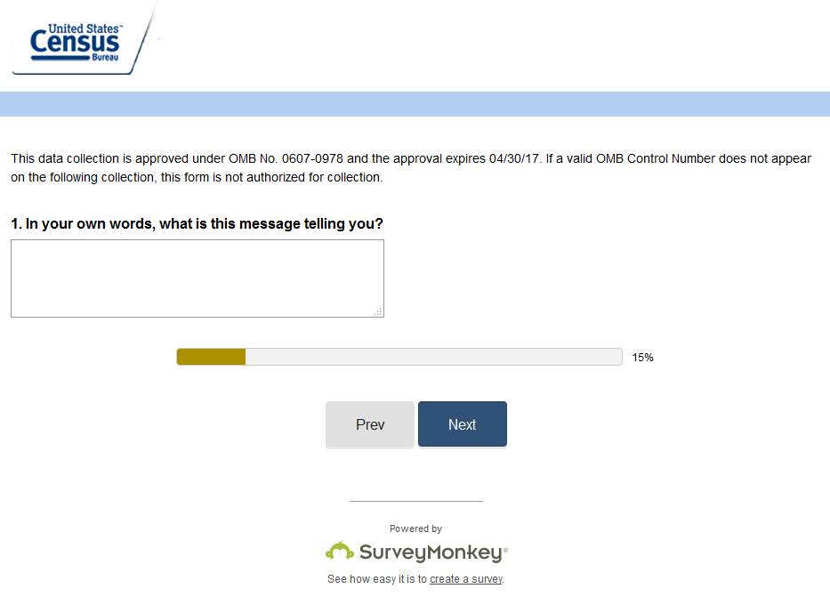

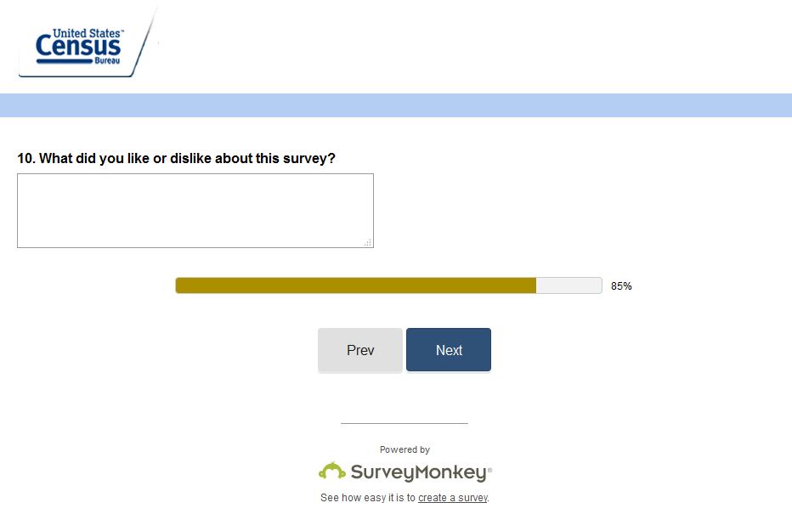
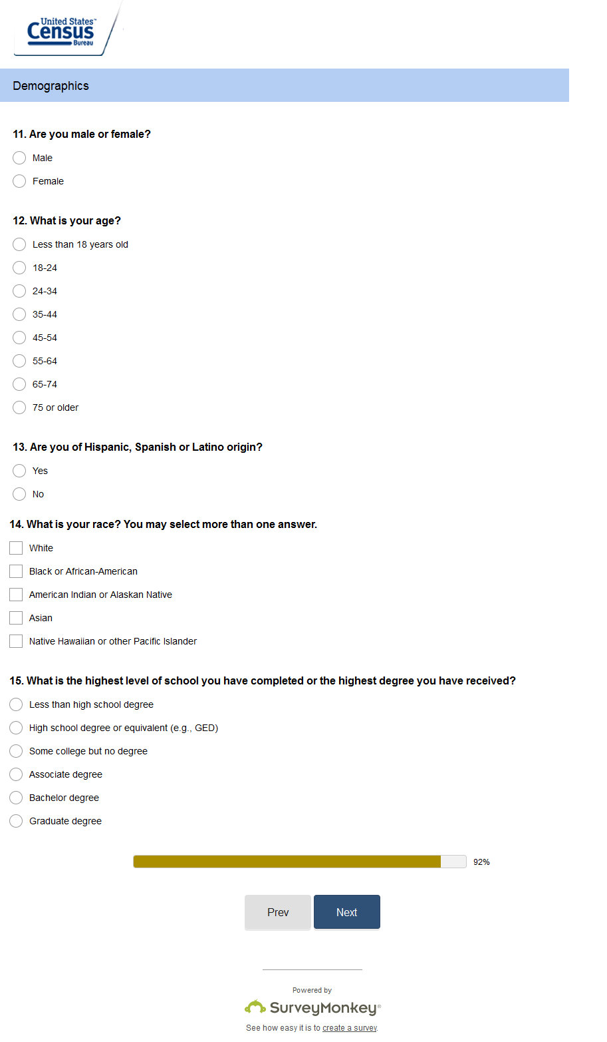
This screen is for Mechanical Turk respondents only:
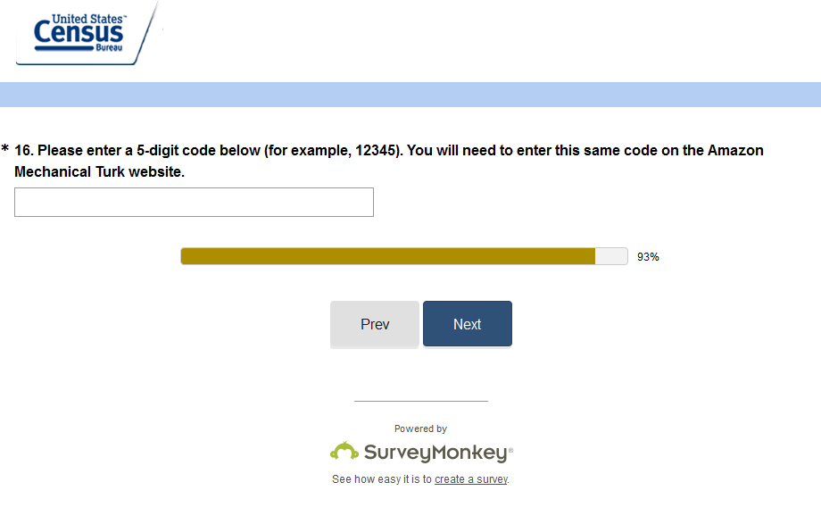

For all respondents:
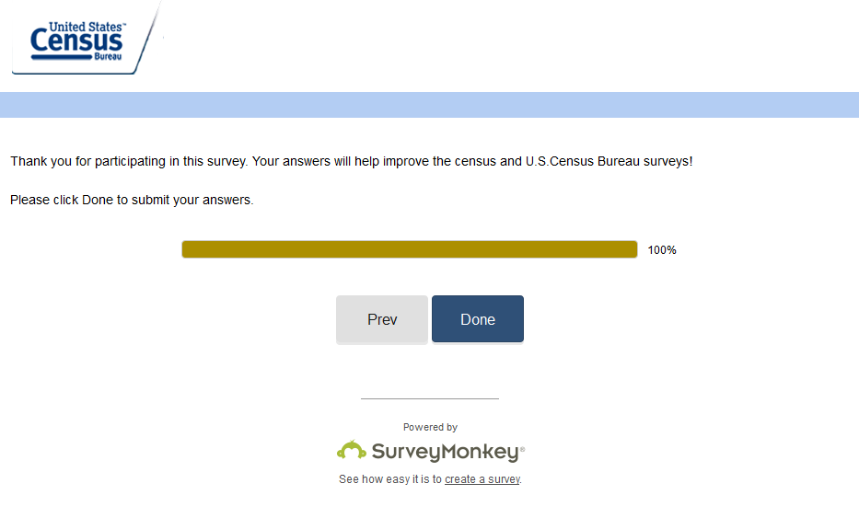

Attachment D: List of All Respondent Messages

Section 1: Official Census Bureau Business
Each respondent will be shown 5 at random.

- We make sure that the only people who can see your responses are those who need them to perform official Census Bureau duties.
- Only people working on official Census Bureau business can access your survey response.
- Only a very limited number of specially authorized people can ever see your information, and only for official Census Bureau business.
- The Census Bureau will:
  - Never share your responses with anyone who is not legally obligated to protect it
  - Never use your responses for anything other than statistical research
  - Never release your responses in any way that could identify you as an individual
- By law, your information is confidential and can not be seen by anyone other than:
  - the Census Bureau employees who collect and process it,
  - the statisticians who tabulate it, and
  - specially authorized statistical researchers.
- Your data are confidential, by law, and the people who see your responses are bound by law to protect them.
- We are required by law to protect your information.
- By law, the Census Bureau cannot share your data with law enforcement or allow it to be used for anything other than statistical purposes.
- By law, we only allow access to data to conduct research that would help carry out the Census Bureau’s mission and benefit the public good.
- By law, the only people who can see your responses are authorized researchers for approved statistical uses.
- Your answers can only be used for statistical research. They cannot be used for any other purpose.
- Your information is protected by law. It can only be used to produce statistics. It can never be used against you.
- Experts review all statistical results before they are released to make sure there is no information that could identify an individual
- The information we collect can only be used for statistical research.
- The Census Bureau will only use your responses for statistical research. Responses can never be used to determine whether a person is eligible for a social program or a government benefit.
- We will never share your information with law enforcement or allow it to be used to determine your eligibility for government benefits.
- Very few authorized individuals actually see your name or other personal information that could identify you. Most of the time, personal information that could identify you is removed from the file that contains your survey or census answers.
- Very few authorized people actually see names, addresses or other identifying information. Most of the time, personal information that could identify a person is removed from the file that contains the survey or census answers.
- Under tightly controlled circumstances, we sometimes share responses with other federal agencies to further the Census Bureau’s work. Those agencies must follow the same laws as the Census Bureau to protect your personal information.
- Sometimes, we give a limited number of employees at other federal agencies access to your data under tightly controlled circumstances. Even in these cases the data can only be used to produce statistics.

Section 2: PRA Required Language
Each respondent sees one message from each section.

Mandatory

- You are required by law to respond to the census.
- The census is required by law (Title 13 U.S. Code Sections 141 and 193).
- Collection of the information is Mandatory and is collected under Title 13 U.S. Code Sections 141 and 193.
Confidential
- The Census Bureau is required by U.S. law to keep your answers confidential. This means that the Census Bureau cannot give out information that identifies you or your household.
- The Census Bureau is required by U.S. law to keep your answers confidential. Your answers will only be used for statistical purposes, and no other purpose.
- The Census Bureau is required by U.S. law (Title 13, Section 193) to keep your answers confidential.
Burden

- Public reporting burden for this collection of information is estimated to average 12 minutes, including the time for reviewing instructions, searching existing data sources, gathering and maintaining the data needed, and completing and reviewing the collection of information.
- We estimate that completing the census will take 12 minutes on average.
PRA language
- This data collection is approved under OMB No. 0607-0978 and the approval expires 04/30/17. If a valid OMB Control Number does not appear on the following collection, this form is not authorized for collection.
- A federal agency may not conduct or sponsor, nor shall a person be subject to a penalty for failure to comply with a collection of information subject to the requirements of the Paperwork Reduction Act unless that collection of information displays a current valid OMB Control Number.
- You are not required to respond to this collection of information if it does not display a valid approval number from the Office of Management and Budget (OMB). The OMB Control Number for this information collection is 0607-XXXX and is located in the upper right hand corner of this form.
- This collection has been approved by the Office of Management and Budget (OMB). The eight-digit OMB approval number that appears at the upper right of the form or login screen confirms this approval. If this number were not displayed we could not conduct this survey.

