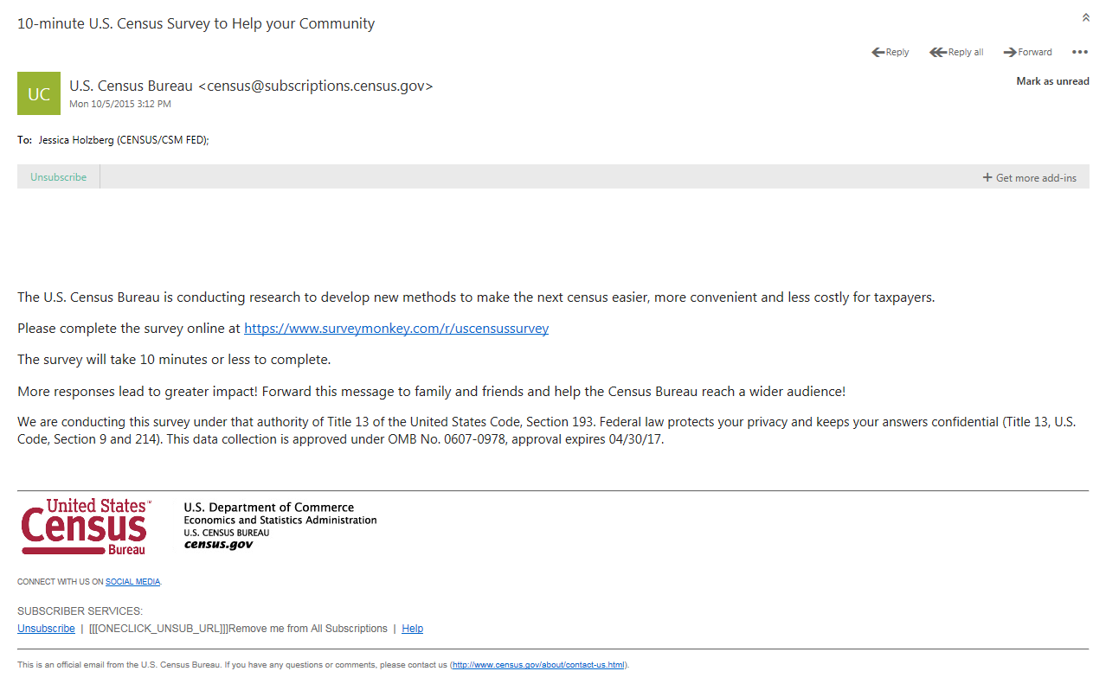
Figure 1: Initial email
NOTE: All survey URLs will be https://www.surveymonkey.com/r/censusstudy
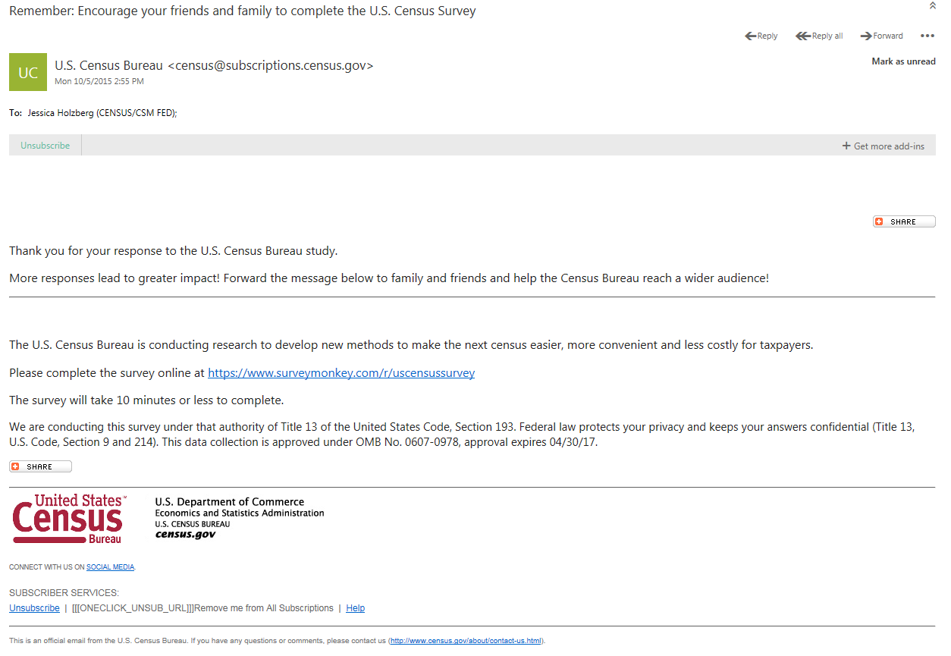Figure 2: First reminder (clicked initial email)
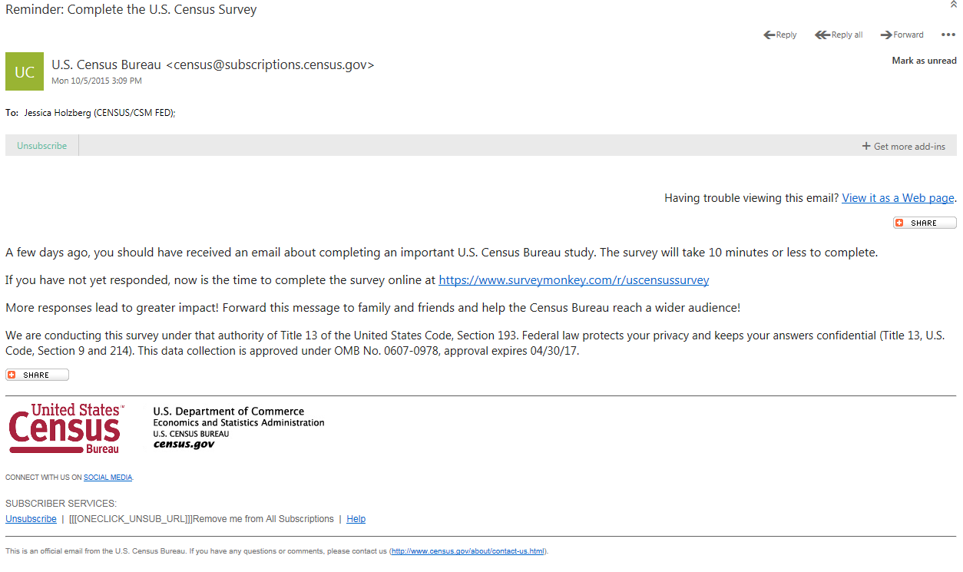
Figure 3: First reminder (did not click initial email)
Figure 4: Final reminder (clicked in one or both of previous emails)
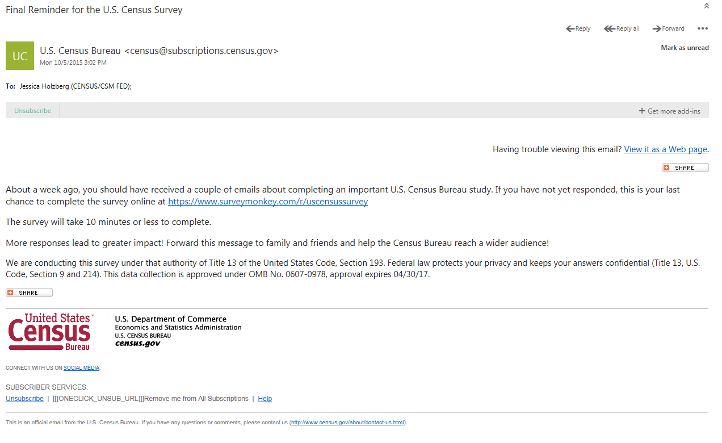
Figure 5: Final reminder (did not click in one of previous emails)

