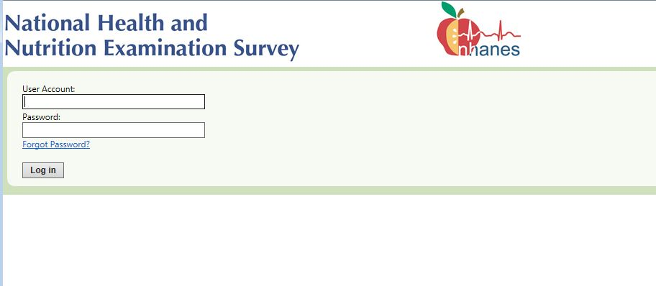
Logon screen. The respondent will use the user account and password included in their Web Screener advance letter to logon.

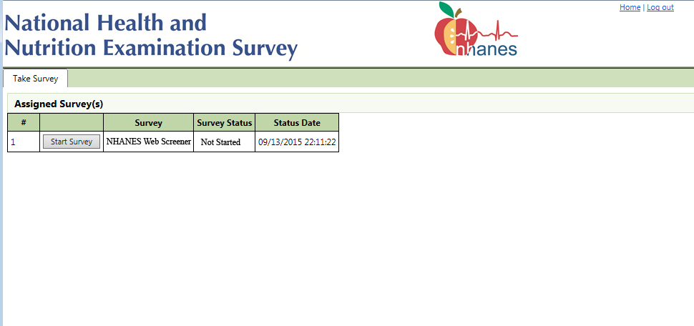
Once the respondent successfully logs on they will see the status of the web screener which, the first time through, will be “Not Started”. However this could change if they stop and come back later to complete the web screener.

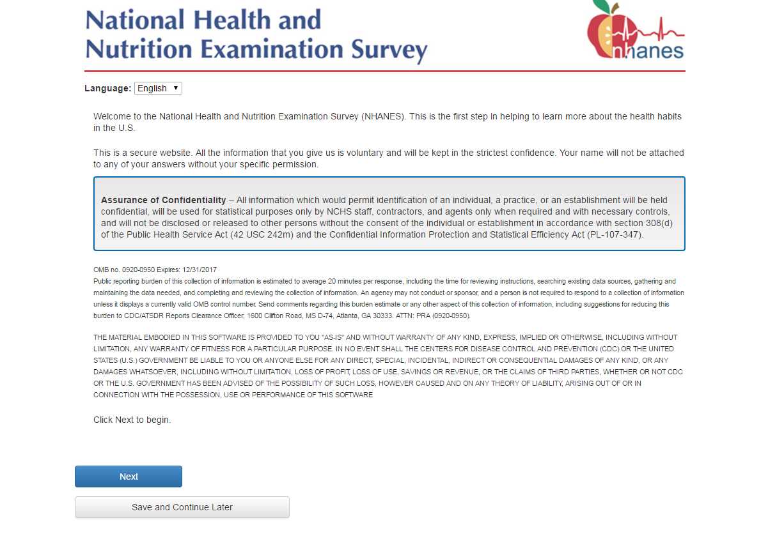
This introductory text contains the Assurance of Confidentiality and the OMB number and expiration date.

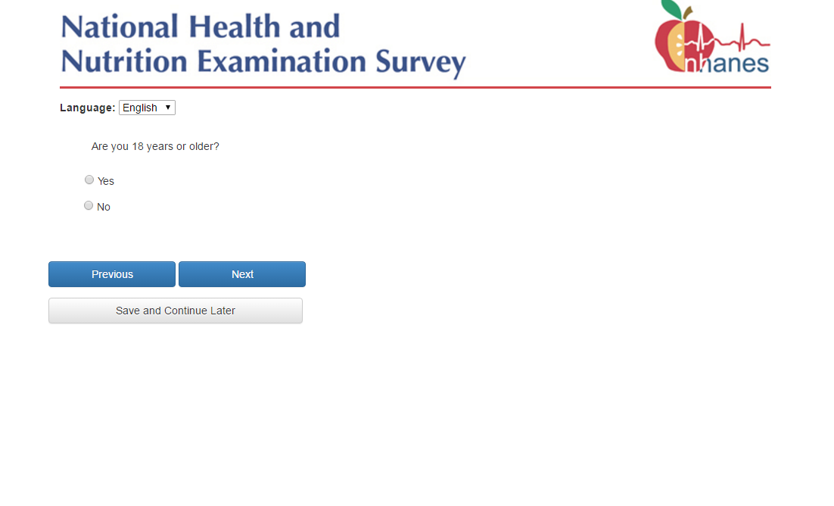
If the response is “No”, then the Web Screener will terminate because the respondent has indicated that he is not 18 years of age or older.

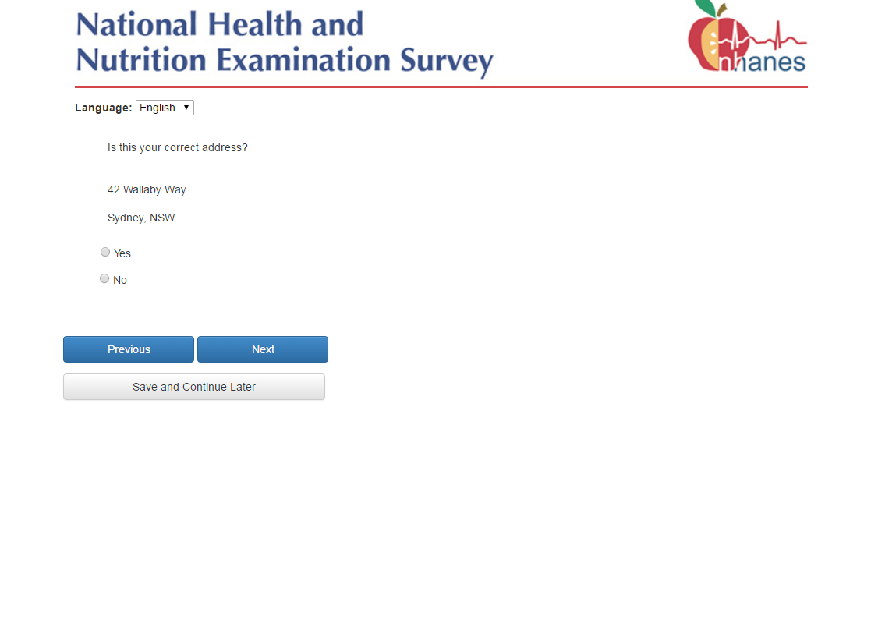
If the response is “Yes”, then the screen on page 12 is skipped.
If the response is “No”, then go to page 13.

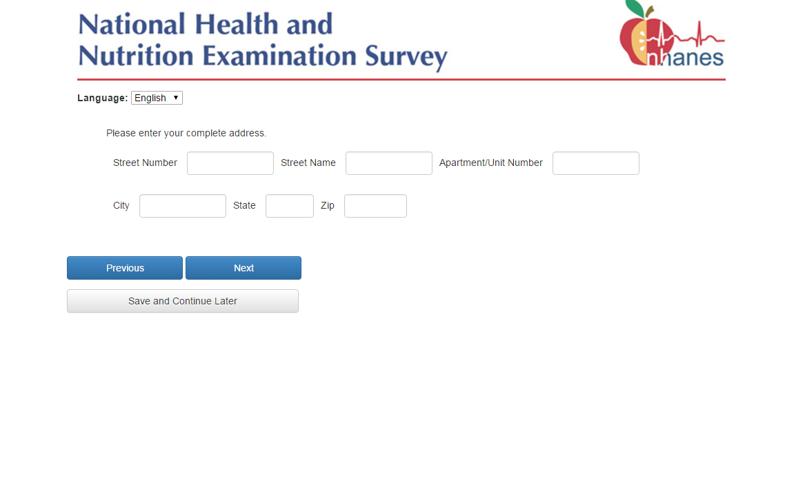
The respondent is asked to enter their correct address since they stated in the prior question that the address displayed was not correct.
If the address is changed in anyway a flag is set indicating that the field office needs to review the change prior to sending an interviewer to the household to complete the in person screener.
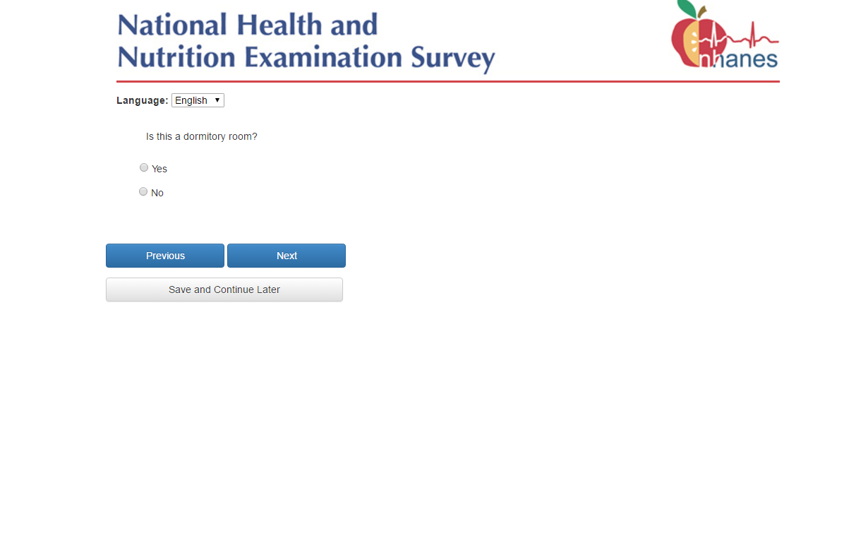
If the response is “Yes”, then the income question on page 32 is skipped.

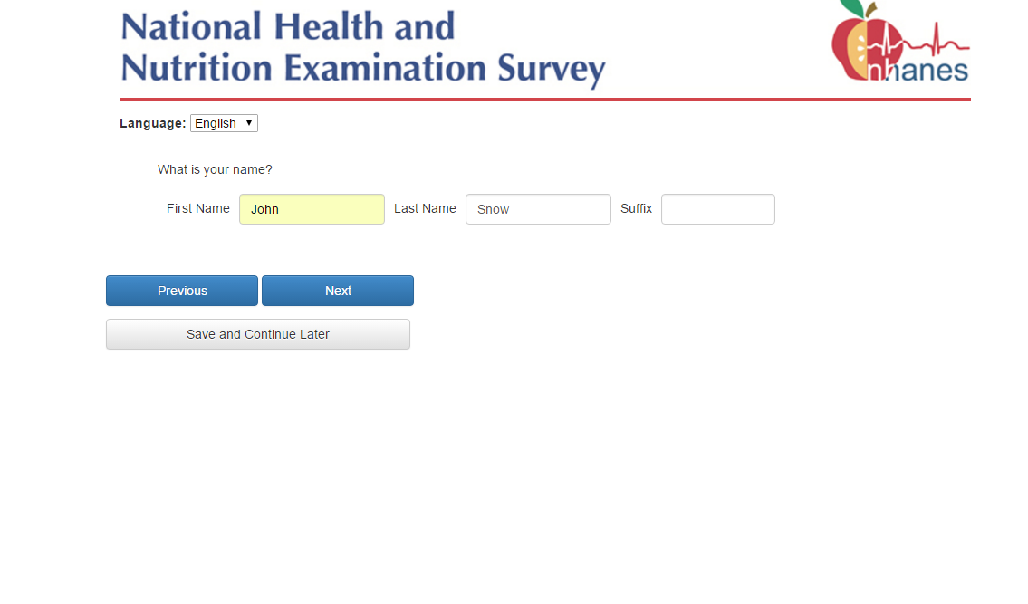

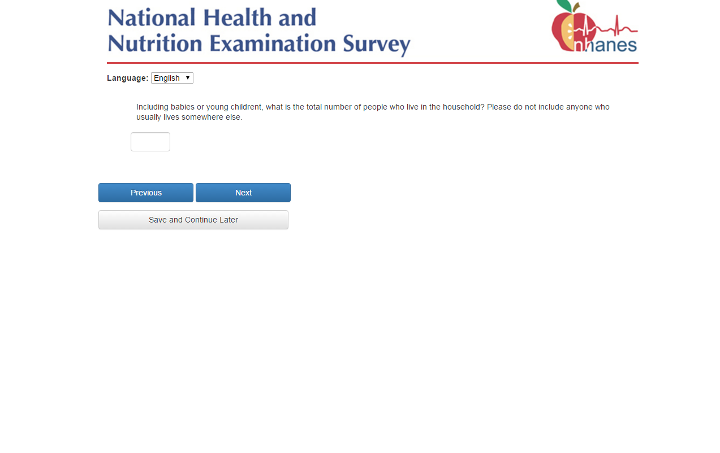

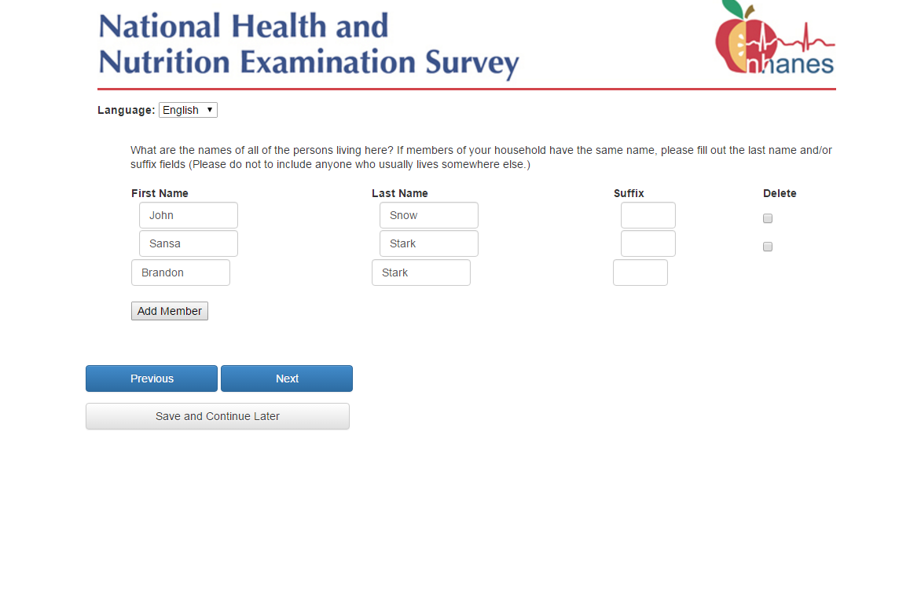
The respondent will click the “Add Member” button to create a new row for each member of the household that needs to be added.
If a person needs to be removed from the list, the respondent clicks the ‘Delete’ box and presses the ‘Next’ button.

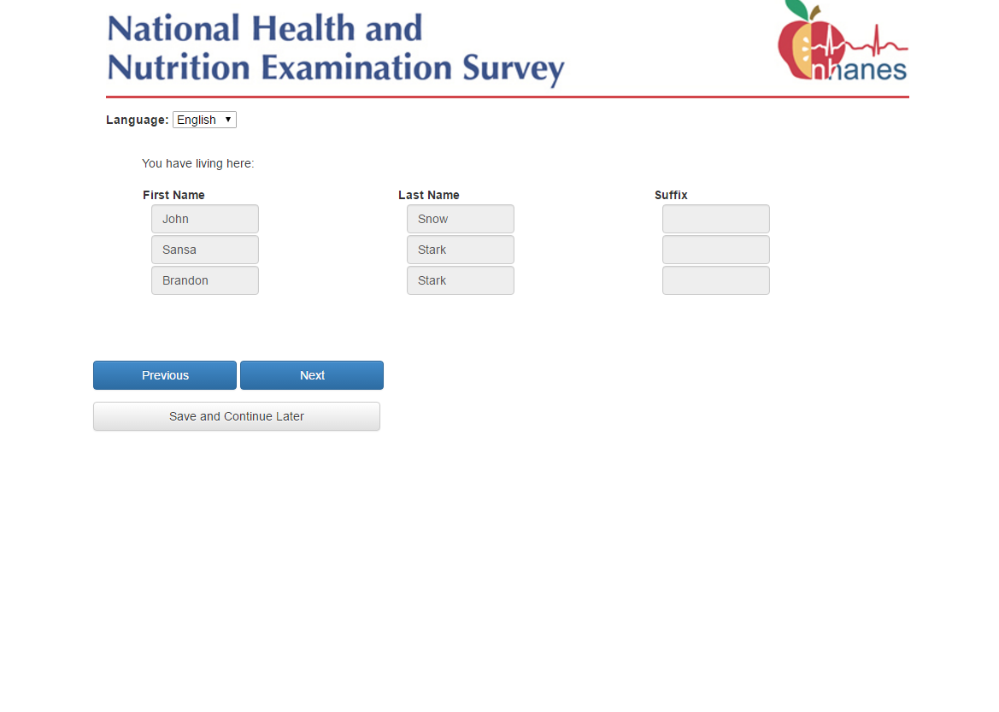
This is a confirmation screen which shows all of the household members entered on the roster.
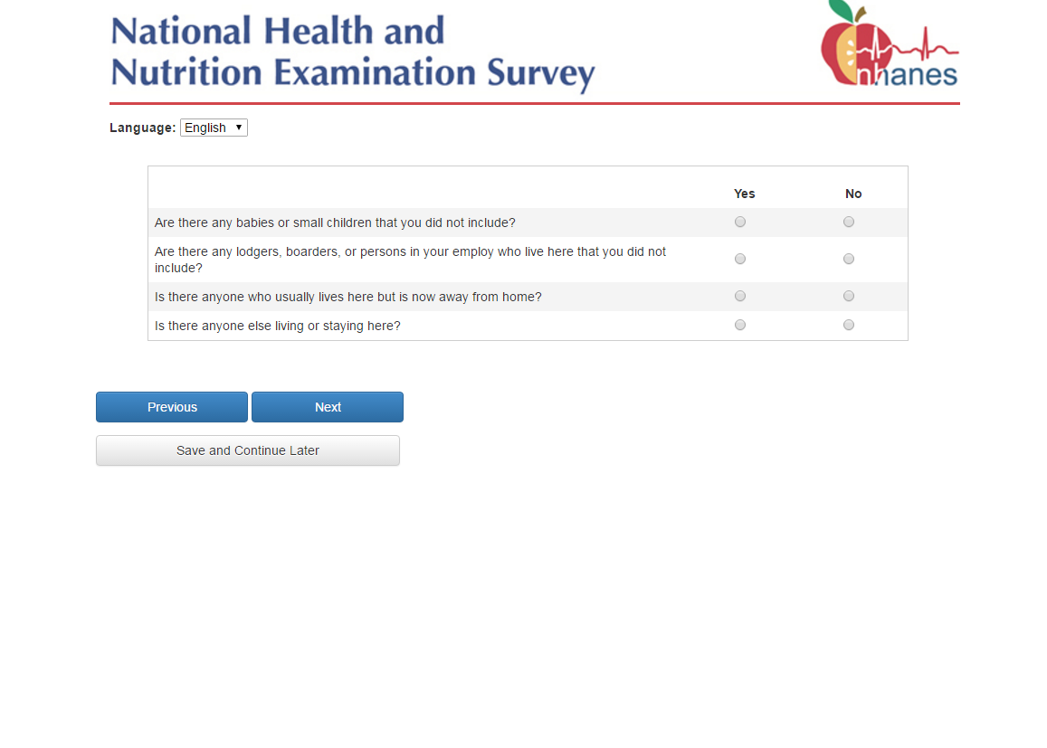
These questions confirm that all household members were entered and that the roster is complete. They are intended to help the respondent remember any household members whom they may have initially forgotten.
If any questions are marked “Yes”, then the Web Screener will go back to page 16 so that they can add to the roster. A blank row will be displayed for them to fill in the person missed.

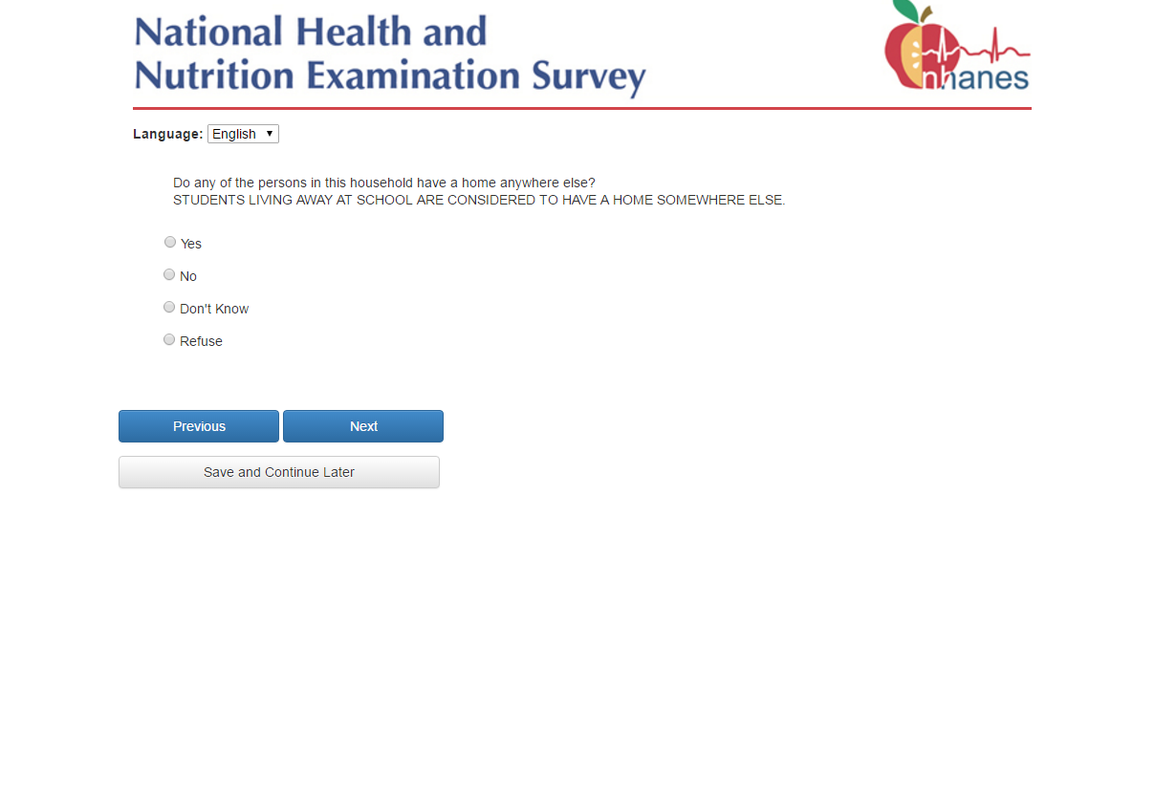
If the response is “Yes”, then go to page 20.
If the response is “No”, then go to page 21.

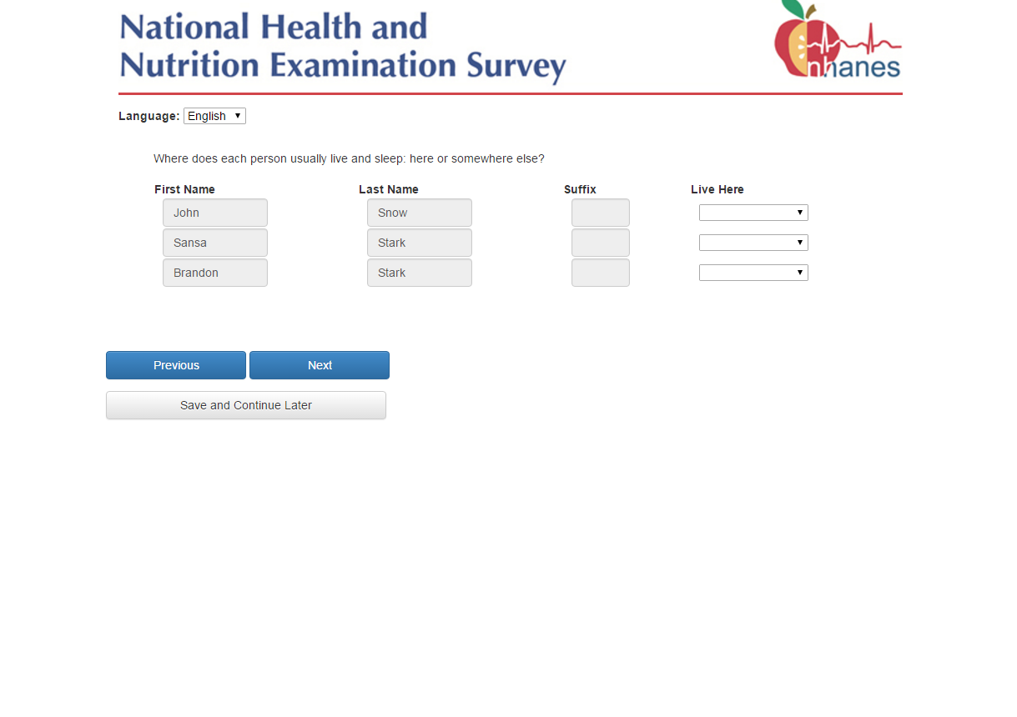
The respondent will select “Lives Here” or “Lives Elsewhere” for each household member listed on the roster.
If “Lives Elsewhere” is selected, the person is removed from the roster because it is assumed that he/she is not a member of the household and may be eligible at another address.

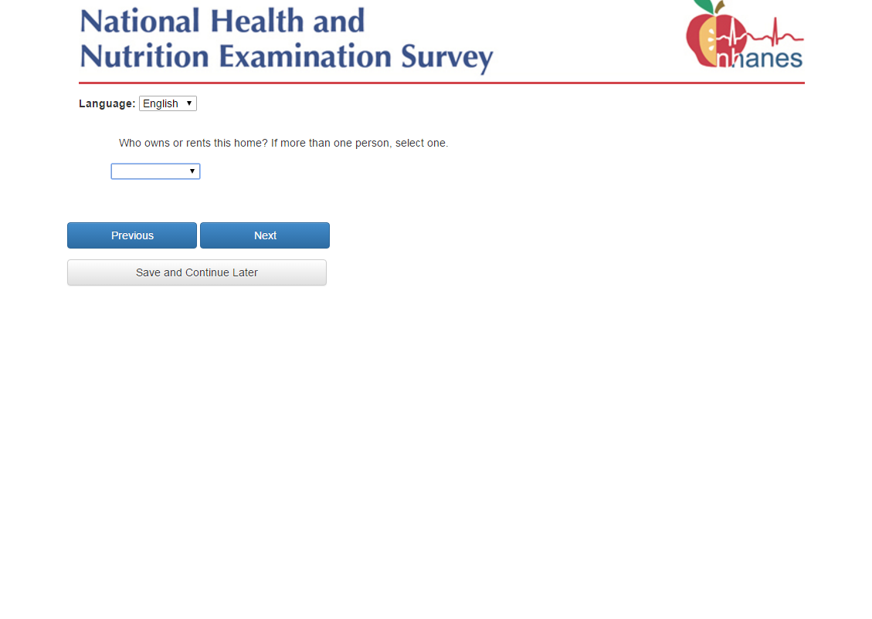
Household members will be displayed in the dropdown list. Selected household member is defined as the head of household. In subsequent questionnaires in the survey there are specific questions asked about the head of household.

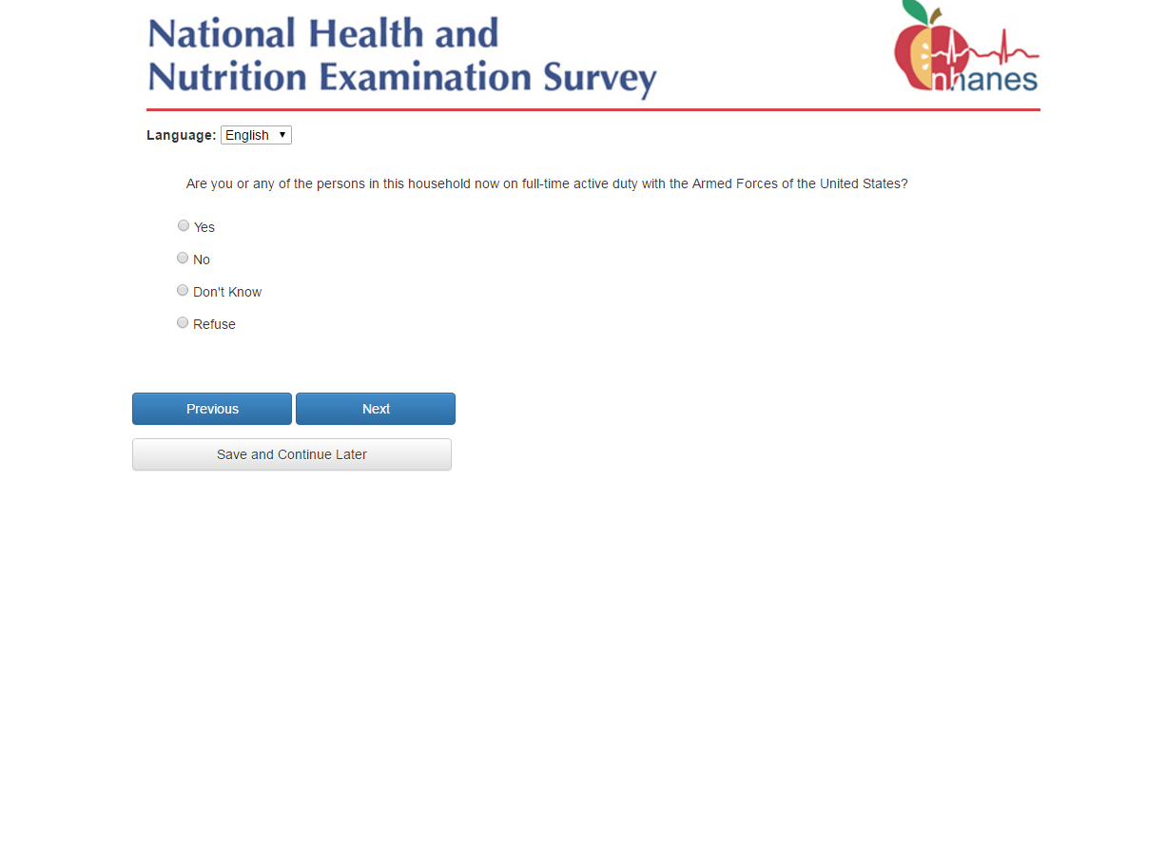
If the response is “Yes”, then go to page 23.
If the response is “No”, then go to page 25.

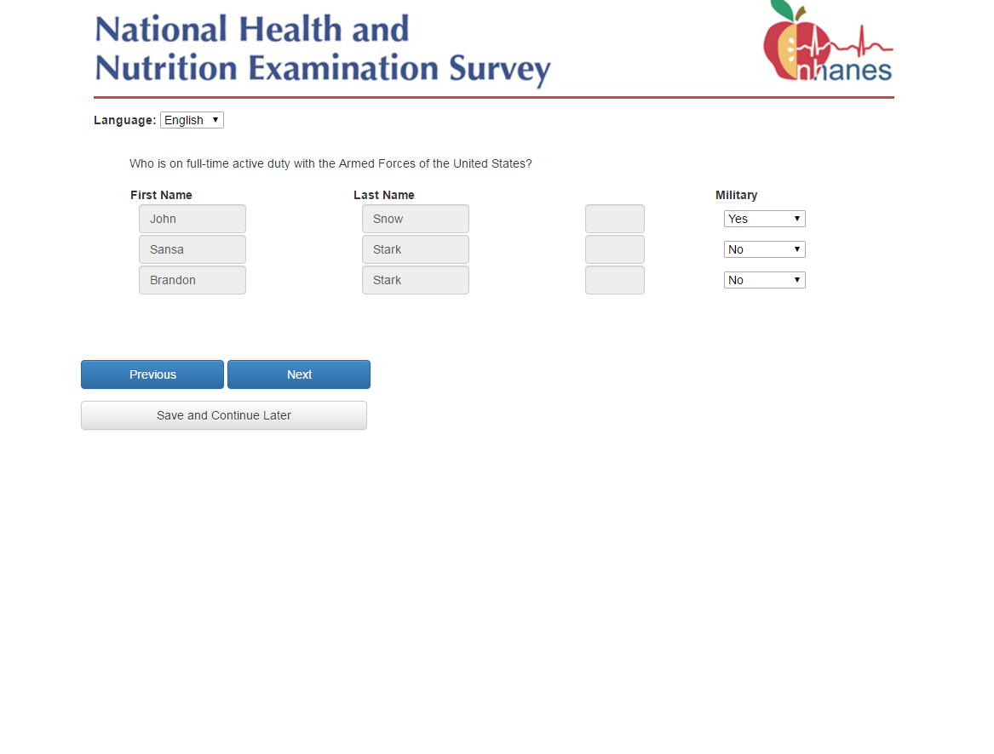
If the respondent indicates that someone in the household is on full-time active duty with the Armed Forces of the United States by marking the member with “Yes”, then go to page 24.
If all household members listed have a response of “No”. then go to page 25.

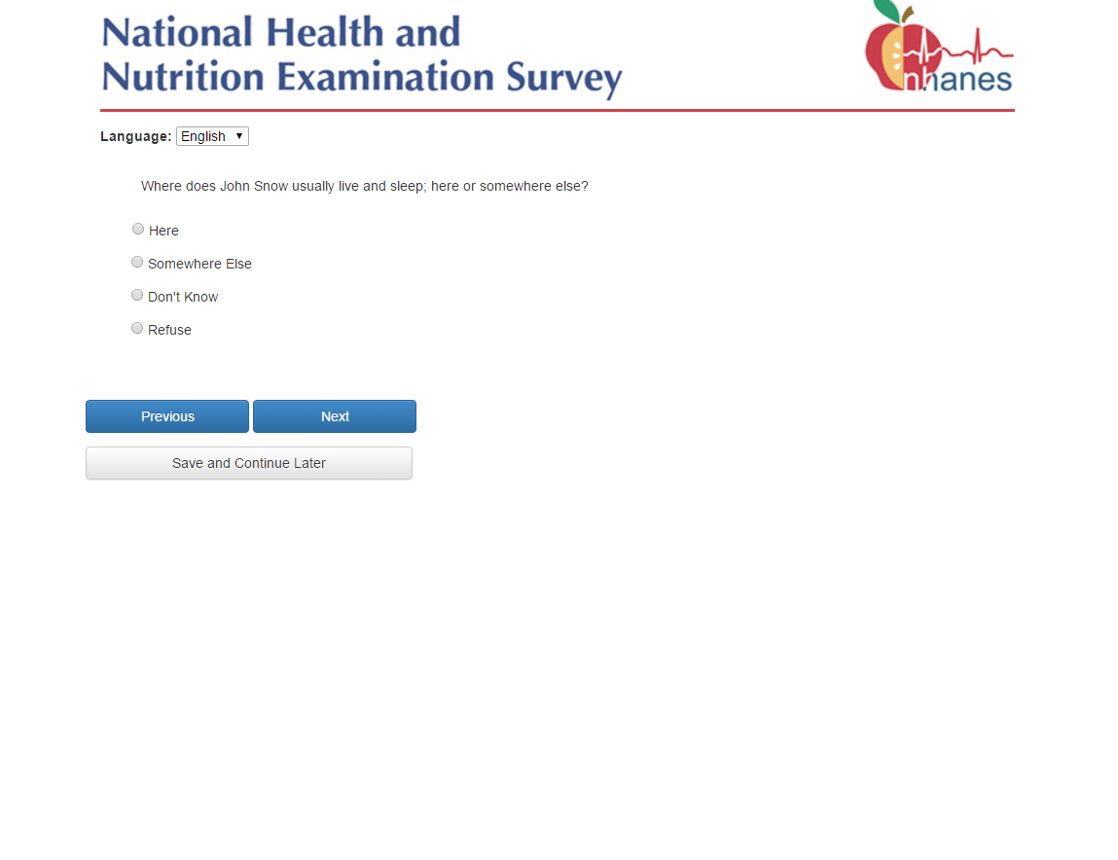
This question will cycle through for each member flagged as full-time active duty with the Armed Forces on page 23. If “Somewhere Else” is selected the person is removed from the roster because it is assumed that he/she is not a member of the household and could be eligible at another address.

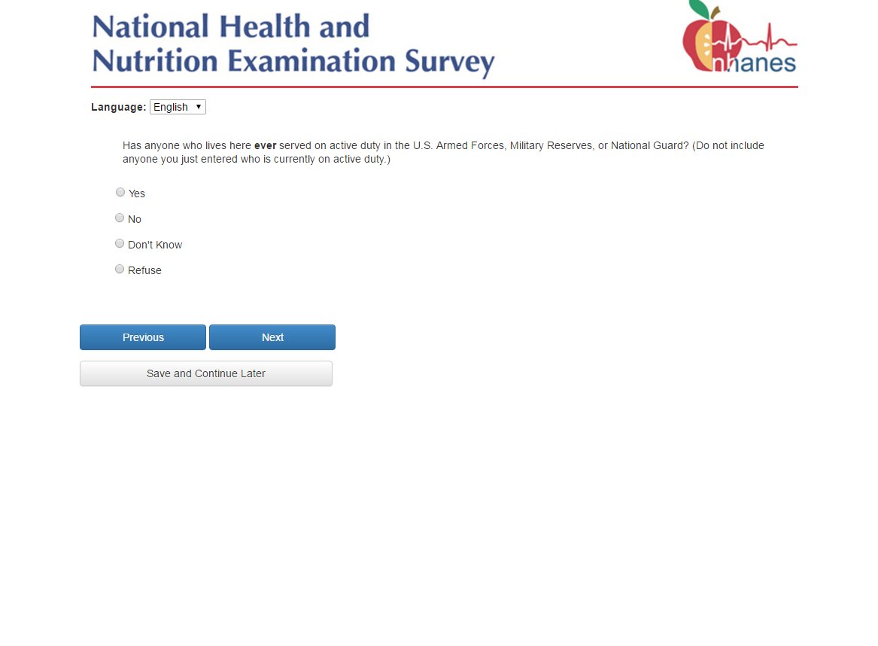
There are no skips or roster changes regardless of the answer to this question.

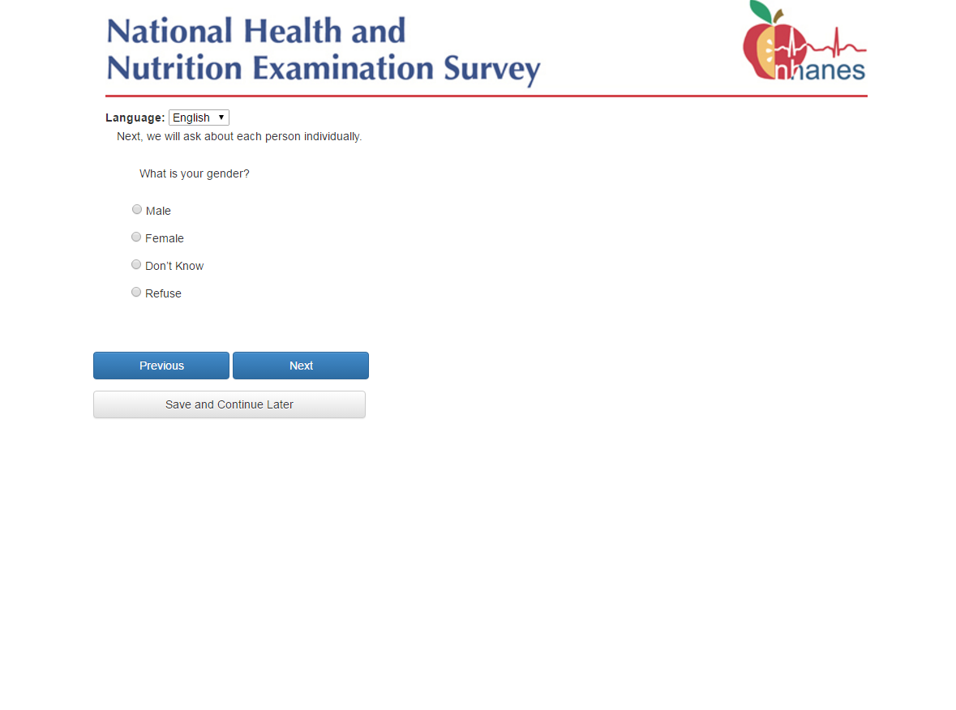
The questions on pages 26-31 are cycled through for each household member listed on the final household roster. The cycle begins with the respondent and continues down the list of household members inserting ‘you’ or the person’s name as needed.

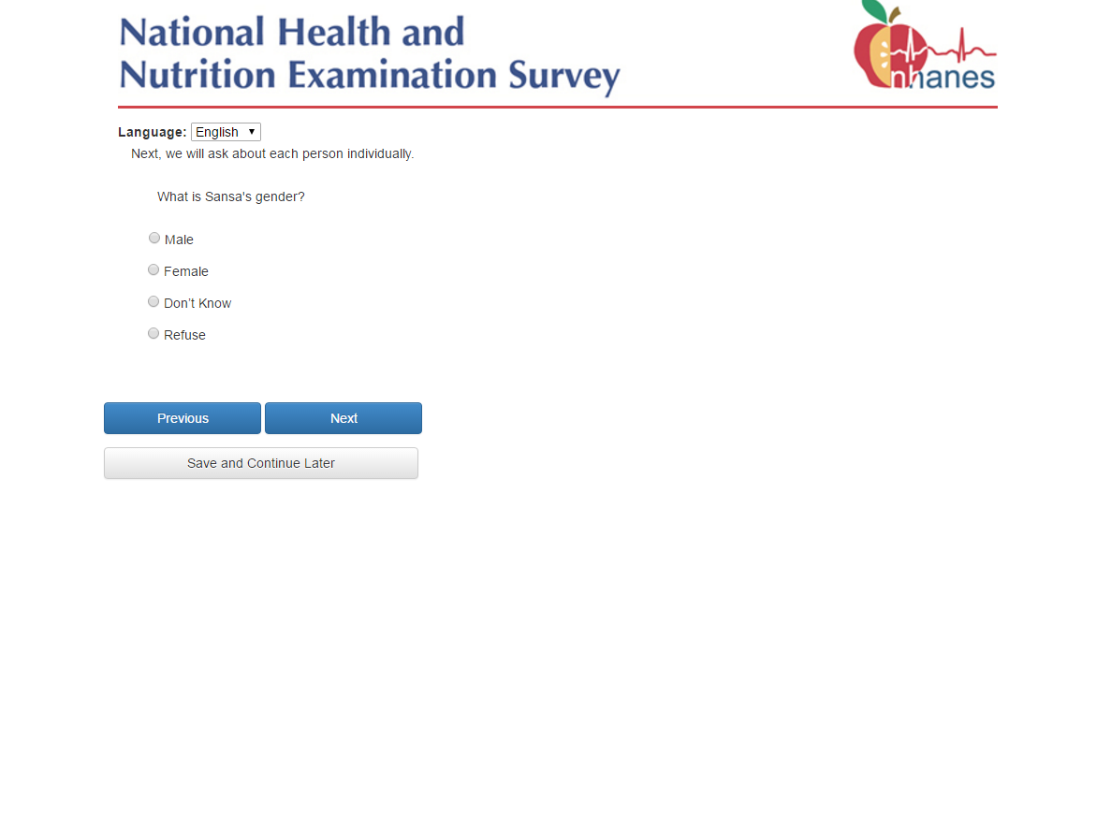
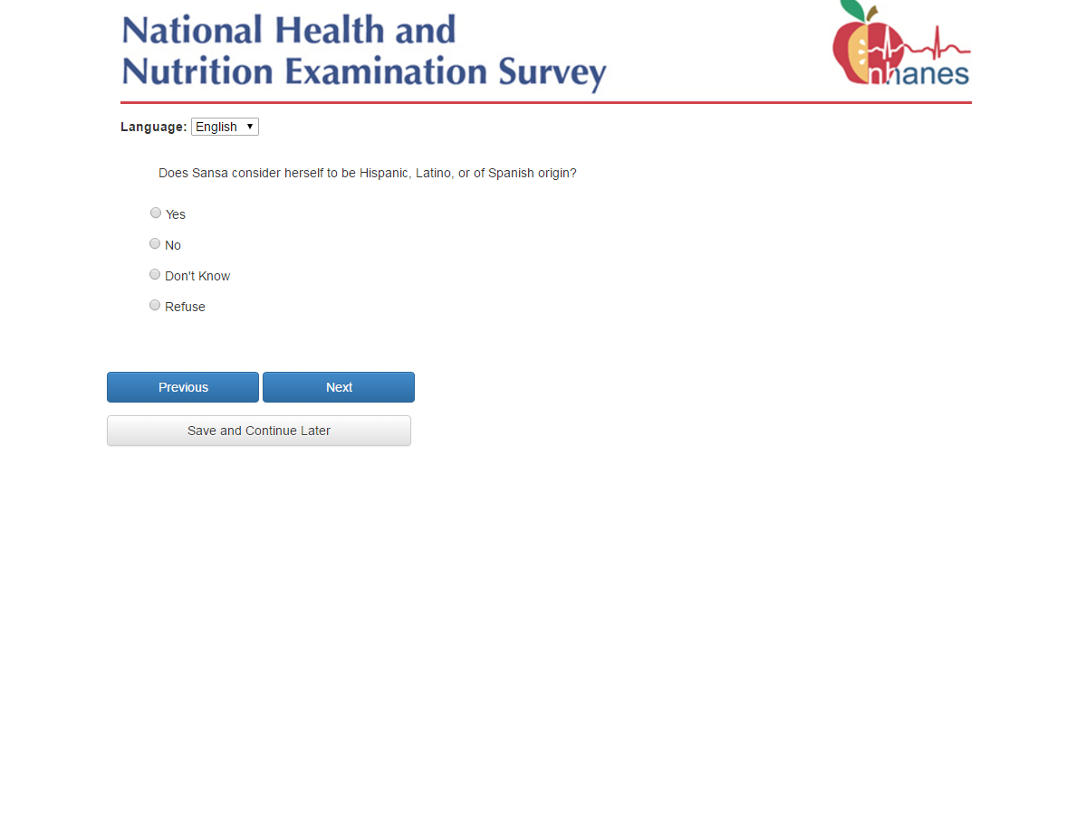
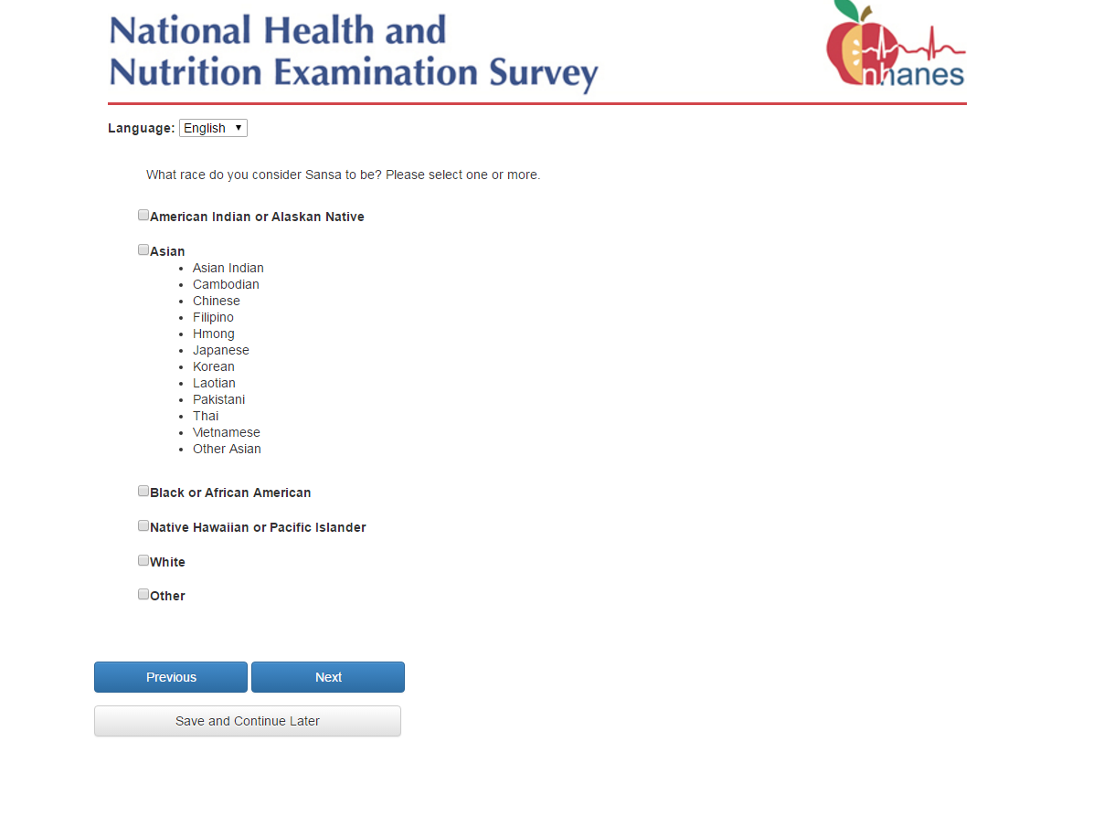
If ”Other” race is checked but “Asian” AND “Black” are not checked, then go to page 30.

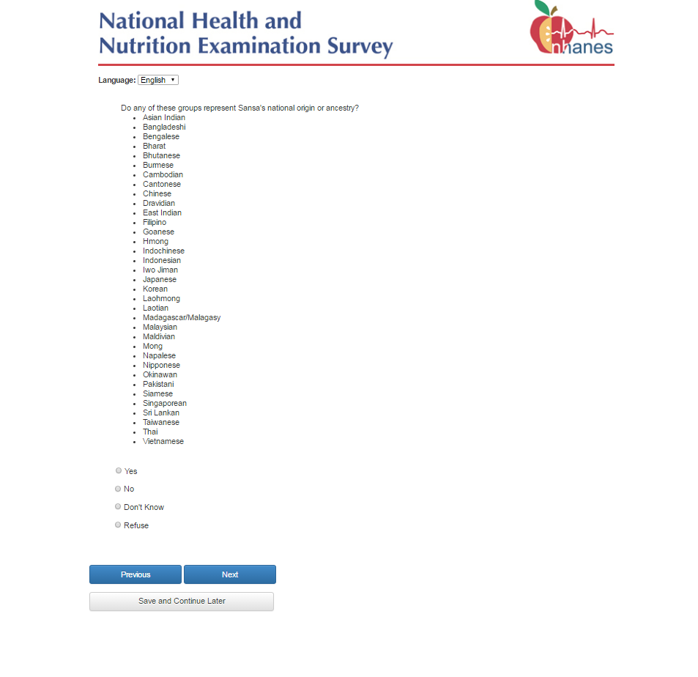
If the answer to this question is “Yes”, the person’s race is coded by the system as Asian. If “No”, “Don’t Know” or “Refused” is selected, the person’s race remains as ‘”Other”.
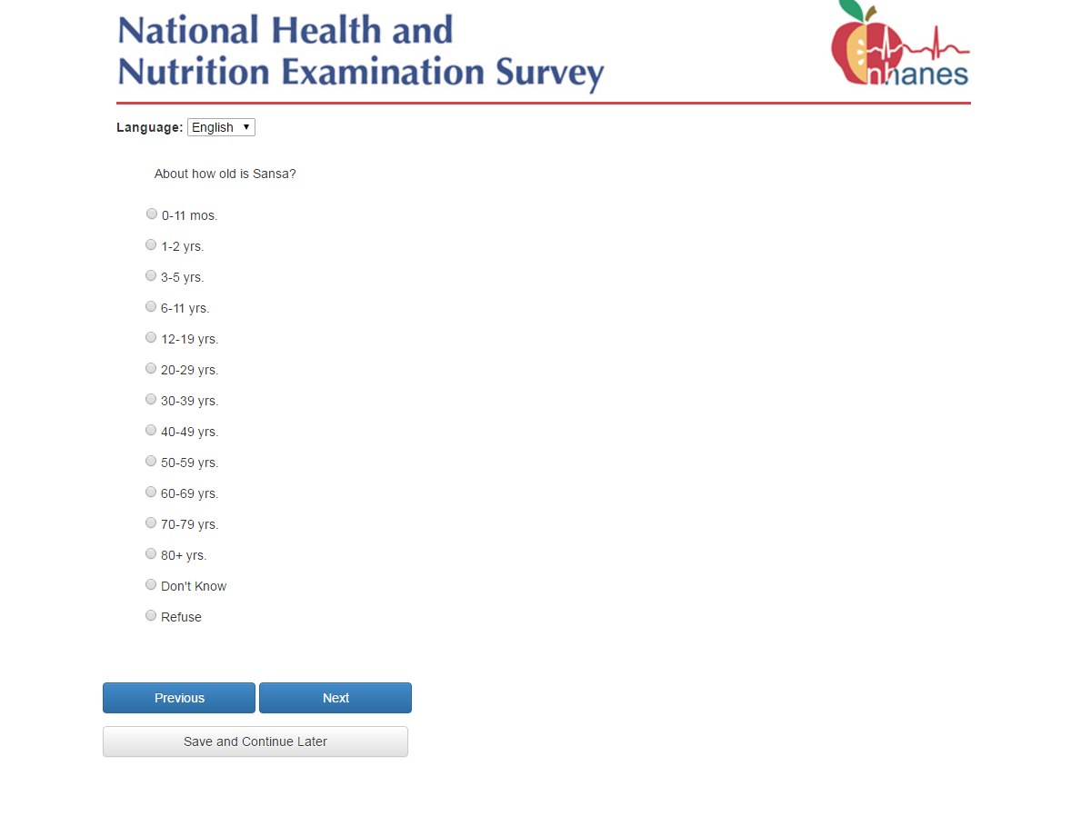
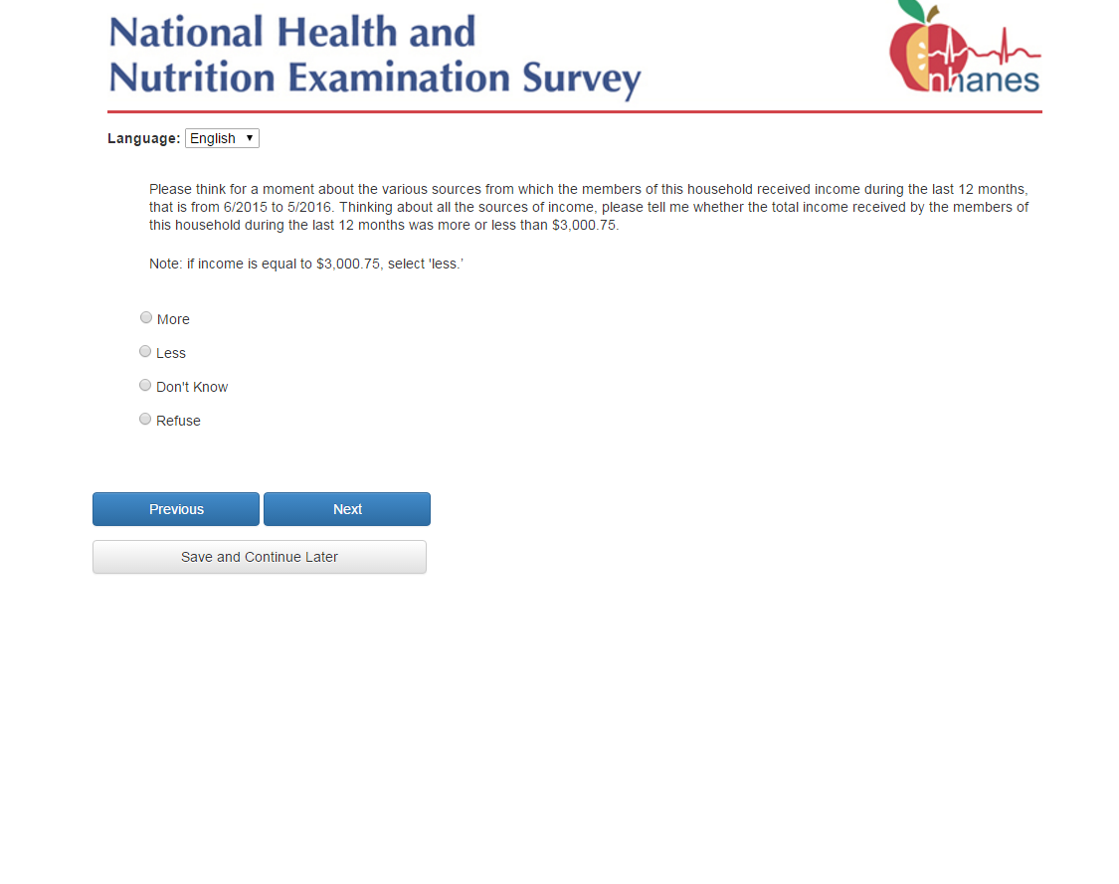
This question is asked of household where at least one household member is non-Hispanic, non-black, and non-Asian to select participants as part of the low-income white/other sample domain.

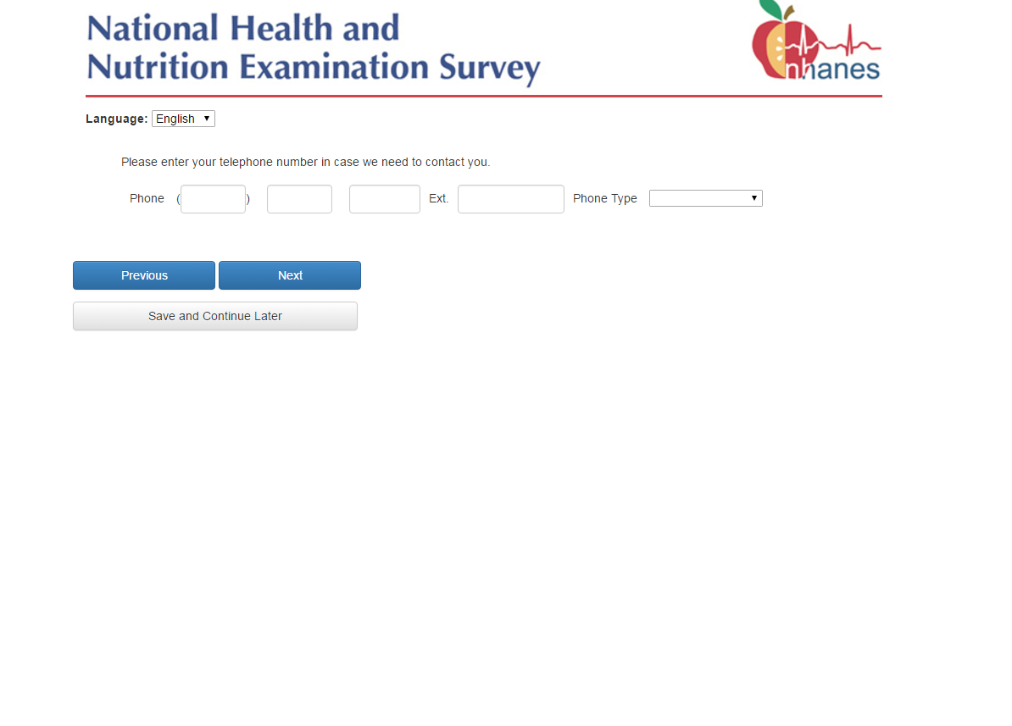
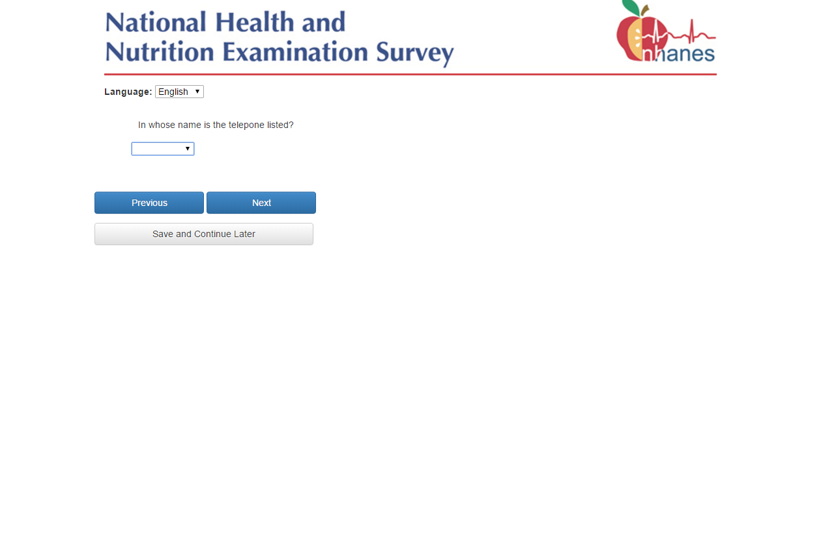

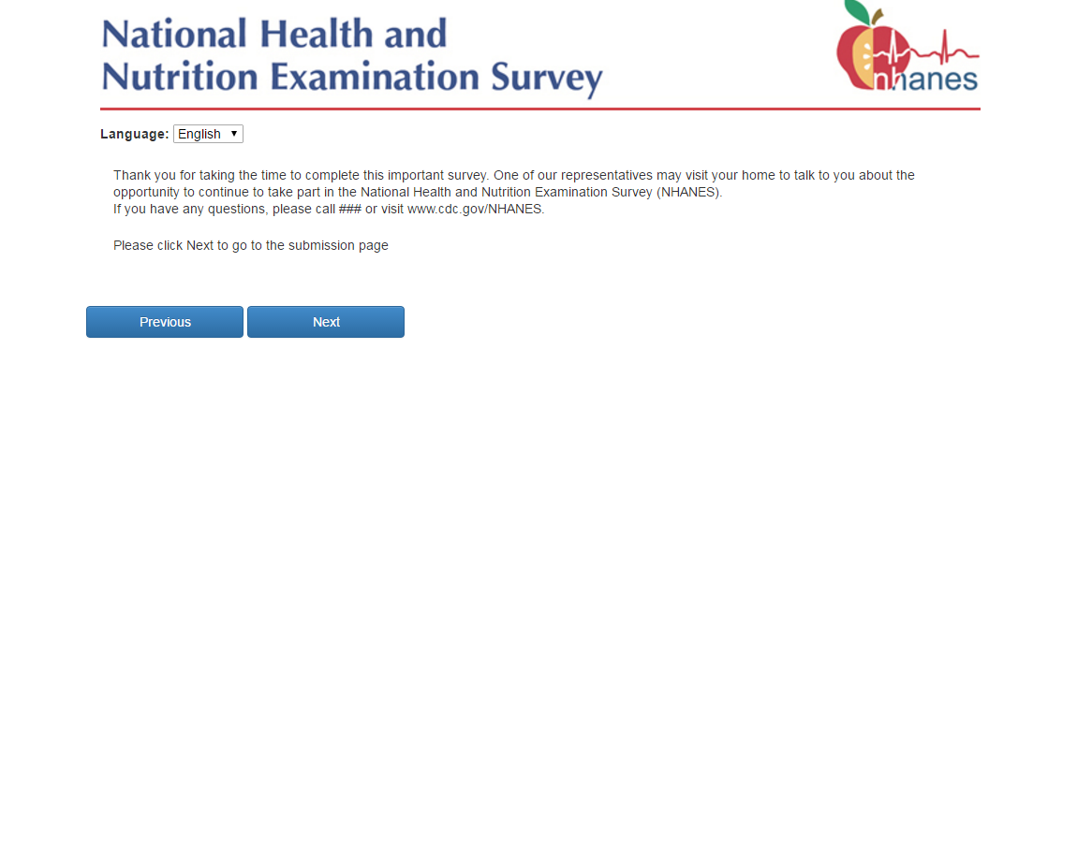

Note: For the pilot this screen will be updated to read “Thank you for taking the time to complete this important survey. One of our representatives may will visit your home to talk to you about the opportunity to continue to take part in the National Health and Nutrition Examination Survey (NHANES). If you have any questions, please call 1-800-452-6115 or visit www.cdc.gov/NHANES.”
