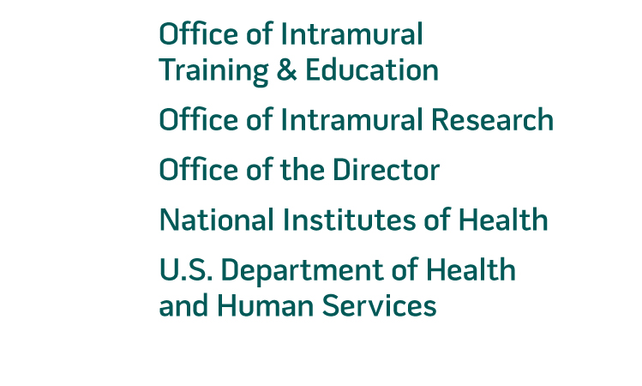 | July 6, 2016  TO: Office of Information and Regulatory Affairs  Office of Management and Budget  THRU: Department of Health and Human Services  Office of the Chief Information Officer  Office of Resources Management  FROM: Mikia Currie  Chief  Project Clearance Branch  SUBJECT: Non-Substantive Change Request for 0925-0299  Title: NIH Office of Intramural Training & Education Application  Expiration Date: June 30, 2019  The NIH Office of Intramural Training & Education (OITE) wishes to submit a non-substantive change request to our current OMB Clearance 0925-0299, expiration date June 30, 2019. This submission was recently approved for use by the OITE for the various training programs and opportunities offered to prospective intramural trainees: http://www.reginfo.gov/public/do/PRAViewICR?ref_nbr=201605-0925-001.  Recently, the NIH Office of Intramural Training & Education modified the eligibility requirements for the Postbaccalaureate Training Program (PBT) to roll the Technical Training Program into the same research opportunity. To reflect this change, the OITE wishes to modify the current PBT application form in the following manner:  - Remove the question “Bachelor’s Degree is from an Accredited US Institution”  - Remove the question “Master’s Degree Earned”  - Remove the question “Master’s Degree is from an Accredited US Institution”  - Add the question “I have been accepted into graduate or professional (medical, dental, pharmacy, veterinary, etc…) school and have written permission from my school to delay entrance for up to a year to pursue a biomedical research project at the NIH.”  The NIH/OITE estimates no change in the respondent burden for the proposed modification because this modification represents the merging of two training opportunities.  Currently Approved Respondent Burden  Enclosed you will find a copy of updated Postbaccalaureate Training Program (PBT) application. Should you have any questions or concerns regarding this request, please contact me at your earliest convenience.  - Please Note: All proposed changes take place on the first and second pages of survey instrument. Red-Italic text indicates text / fields that will be removed. Green-italic text indicates text / fields that will be added.  Best regards,  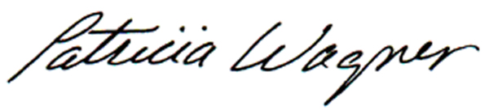  Patricia KM Wagner, PhD  Director of Admissions & Registrar  Graduate Partnerships Program  Office of Intramural Training & Education  Cell: 240-476-3619  Email: wagnerpa@od.nih.gov
  Type of Respondents | Number of Respondents | Participation Time | Burden (hours)
  Postbaccalaureate Training Program | 2,050 | 60 / 60 | 2,050
  Totals | 2,050 |  | 2,050

