# Attachment A

## Screen Shots and Description of Revisions to the

## SAMHSA SOAR Web-Based Data Form

**Registration Page for New Users to the System**

New users, who are caseworkers, agency directors, local or state leads need to complete and submit this registration form. In order to facilitate more immediate access, we have added a question related to “SOAR training I have attended.” For caseworkers who work for an agency that exists in the system and have attended a SOAR training can receive automatic approval. We added a question for “County” to better identify the location of users. We also added a question re “Funding Source” so that we can identify users who are funded through federal grants.

New questions:

* County
* Funding Source
* SOAR Training I have attended

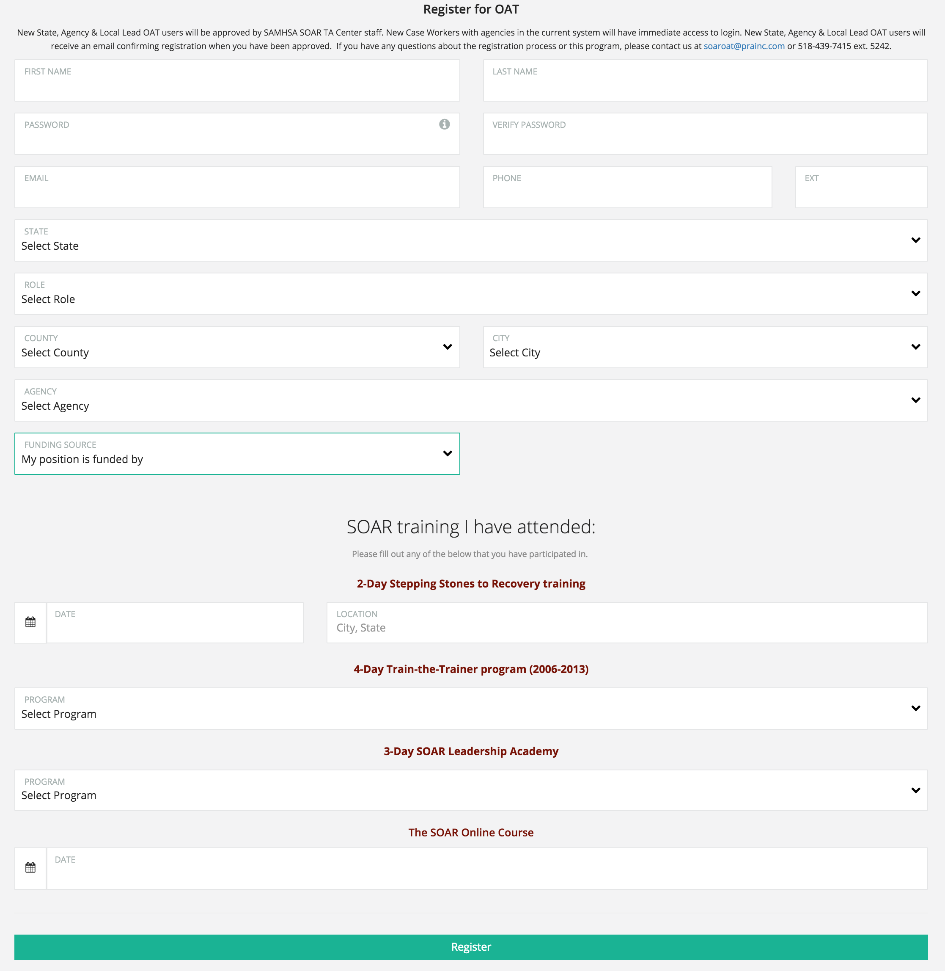

**Demographic Information**

The demographic information on each applicant is collected on this screen. The current system asks about Military Service. Due to an increase in applications for Veterans and use of the system by the Department of Veteran Affairs we have added two follow-up questions when the answer is “Yes”: “Discharge Status” and “Was the applicant receiving VA Disability Compensation at the time of the application?” Many SOAR programs focus on employment services and disability acquisition and so we also added one more follow-up question after “Was the applicant working during the application process?” If “Yes,” we ask: “Applicant Working Earnings per Month (in dollars)?” These new questions will not appear for most applicants, but will help provide clarifying information for those relevant applicants.

New questions:

* Discharge Status
* Was the applicant receiving VA Disability Compensation at the time of the application?
* Was the applicant working during the application process?
* Applicant Working Earnings per Month (in dollars)?

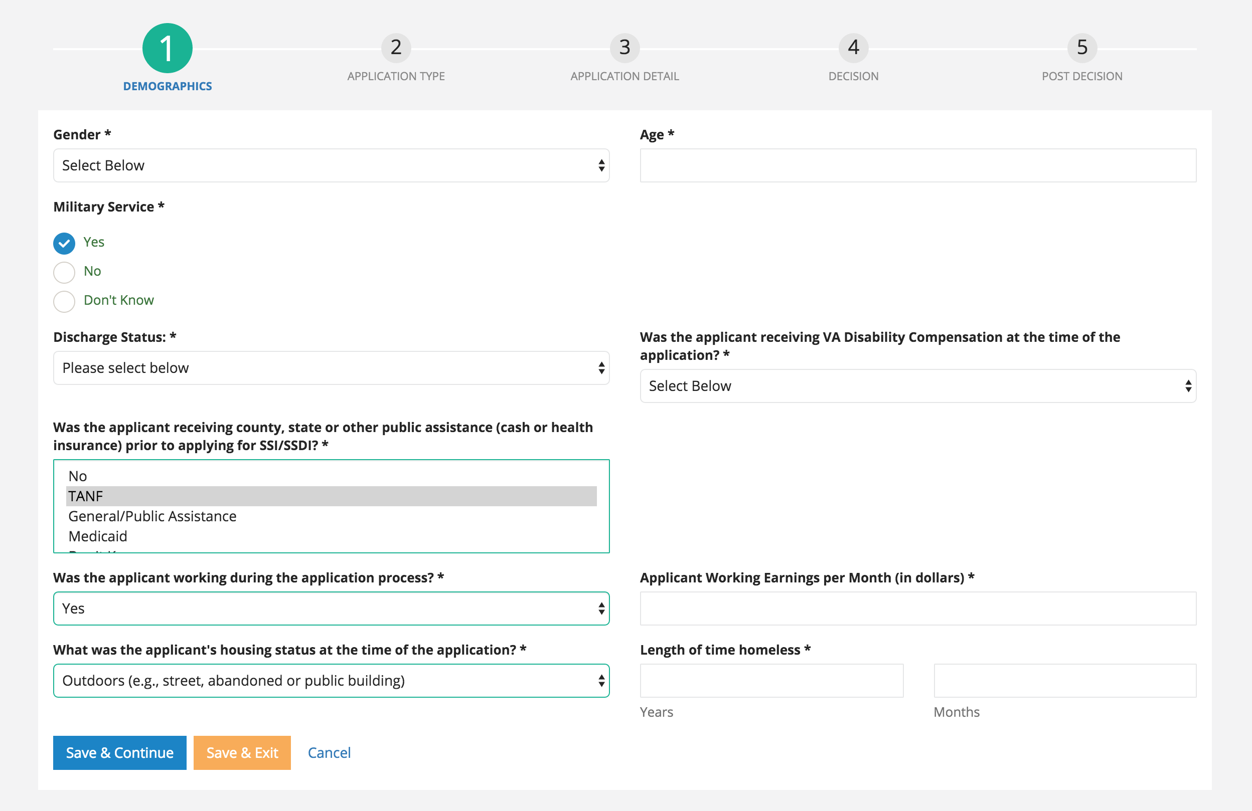

**Application Detail**

The second section asks a few questions about what SOAR critical components were used while assisting with the application. The system currently asks “Was a Consultative Exam (CE ordered?” In order to provide more accurate information, we have added a follow-up question if the answer is “Yes”: “How many CE’s were ordered?”

**New question:**

* How many CEs were ordered?

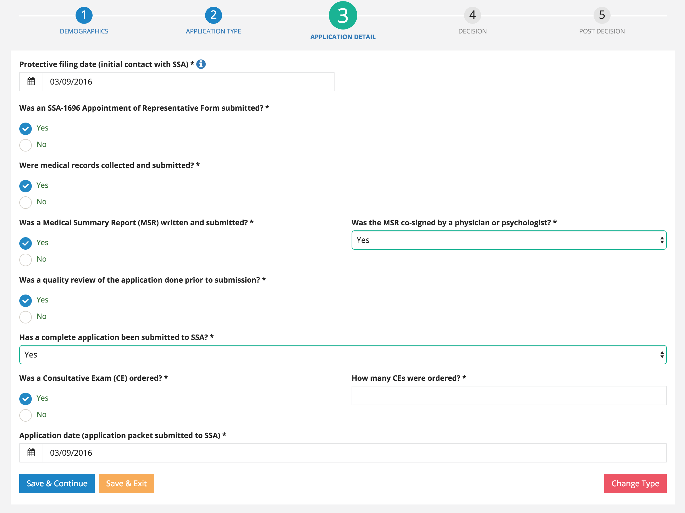

**Post Decision**

Most of the questions that are asked post-decision are optional for the user. They are asked to answer what programs the applicant was approved for and then can optionally track other reimbursement amounts and other more qualitative outcomes. In order to clarify the question that currently exists “Was applicant housed at time of decision?” we have added a follow-up question: “Did access to benefits facilitate housing?”

**New question:**

* Did access to benefits facilitate housing?

