Online Quarterly Pricing Data Entry Screen (CMS-367a)

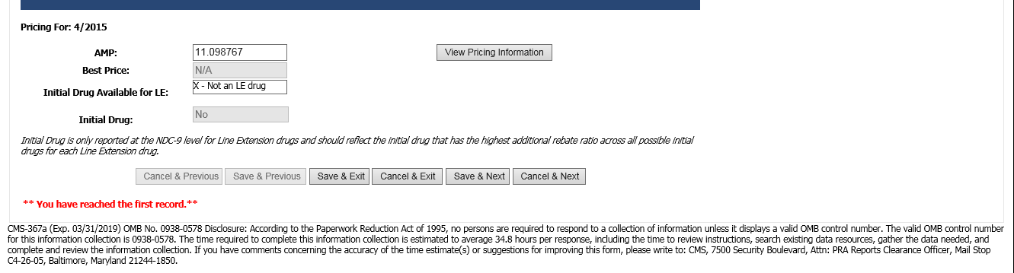

File Transfer Quarterly Pricing Layout (CMS-367a)

|  |  |  |  |
| --- | --- | --- | --- |
| **Field** | **Size** | **Position** | **Remarks** |
| Record ID | 1 | 1 - 1 | Constant of “Q” |
| Labeler Code | 5 | 2 - 6 | NDC #1 |
| Product Code | 4 | 7 - 10 | NDC #2 |
| Package Size | 2 | 11 – 12 | NDC #3 |
| Period Covered | 5 | 13 – 17 | QYYYY (Qtr/Yr) |
| Average Mfr Price | 12 | 18 – 29 | 99999.999999 |
| Best Price | 12 | 30 – 41 | 99999.999999 |
| Nominal Price | 9 | 42 – 50 | 999999999 |
| Customary Prompt Pay Disc. | 9 | 51 – 59 | 999999999 |
| Initial Drug Available for LE | 1 | 60-60 | Y, N, X or Z |
| Initial Drug | 9 | 61-69 | 9 digits alpha-numeric |

Online Monthly Pricing Data Entry Screen (CMS-367b)

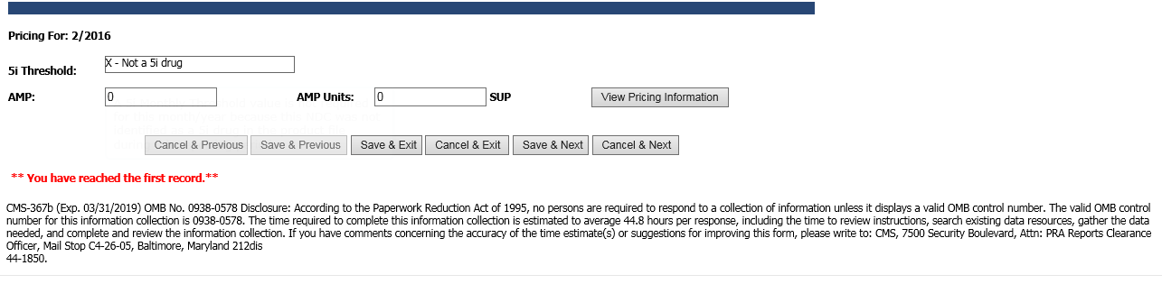

File Transfer Monthly Pricing Layout (CMS-367b)

|  |  |  |  |
| --- | --- | --- | --- |
| **Field** | **Size** | **Position** | **Remarks** |
| Record ID | 1 | 1 – 1 | Constant of “M” |
| Labeler Code | 5 | 2 – 6 | NDC #1 |
| Product Code | 4 | 7 – 10 | NDC #2 |
| Package Size | 2 | 11 – 12 | NDC #3 |
| Month | 2 | 13 – 14 | MM |
| Year | 4 | 15 – 18 | YYYY |
| Average Mfr Price | 12 | 19 – 30 | 99999.999999 |
| AMP Units | 14 | 31 – 44 | 99999999999.99 |
| 5i Threshold | 1 | 45 - 45 | Y, N, X, or Z |

Online Product Data Entry Screen – Screenshot #1 with Narrow Exception Indicator added (CMS-367c)

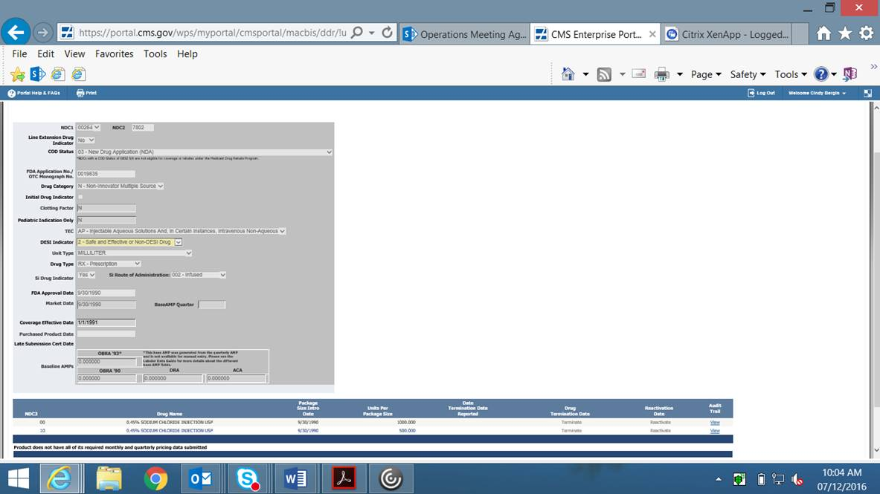

Note that the “Narrow Exception Indicator” will only appear in DDR if it has first been checked in MDR by CMS. This is not a field that manufacturers will have access to edit.

Online Product Data Entry Screen – Screenshot #2 with burden hours updated (CMS-367c)

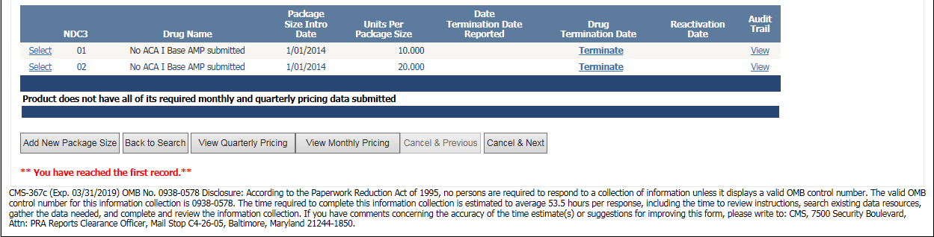

File Transfer Product Layout (CMS-367c)

|  |  |  |  |
| --- | --- | --- | --- |
| **Field** | **Size** | **Position** | **Remarks** |
| Record ID | 1 | 1 – 1 | Constant of “P” |
| Labeler Code | 5 | 2 – 6 | NDC #1 |
| Product Code | 4 | 7 – 10 | NDC #2 |
| Package Size Code | 2 | 11 - 12 | NDC #3 |
| Drug Category | 1 | 13 - 13 | See Data Element Definitions |
| Unit Type | 3 | 14 - 16 | See Data Element Definitions |
| FDA Approval Date | 8 | 17 - 24 | MMDDYYYY |
| FDA Thera. Eq. Code | 2 | 25 - 26 | See Data Element Definitions |
| Market Date | 8 | 27 - 34 | MMDDYYYY |
| Termination Date | 8 | 35 - 42 | MMDDYYYY |
| Drug Type Indicator | 1 | 43 – 43 | See Data Element Definitions |
| OBRA’90 Baseline AMP | 12 | 44 – 55 | 99999.999999 |
| Units Per Pkg Size | 11 | 56 – 66 | 9999999.999 |
| FDA Product Name | 63 | 67 – 129 | FDA Product Name |
| DRA Baseline AMP | 12 | 130 – 141 | 99999.999999 |
| Package Size Intro Date | 8 | 142 – 149 | MMDDYYYY |
| Purchased Product Date | 8 | 150 – 157 | MMDDYYYY |
| 5i Drug Indicator | 1 | 158 – 158 | See Data Element Definitions |
| 5i Route of Administration | 3 | 159 – 161 | See Data Element Definitions |
| ACA Baseline AMP | 12 | 162 - 173 | 99999.999999 |
| COD Status | 2 | 174 – 175 | See Data Element Definitions |
| FDA Appl. No./OTC Mono. No. | 7 | 176 – 182 | See Data Element Definitions |
| Line Extension Drug Indicator | 1 | 183 – 183 | See Data Element Definitions |