Screen Shots Document
Grouped by Scenario

Electronic Access Multi-Factor Authentication

April 21, 2016

Table of Contents
Scenario 1: Create LOA2 Account 1
S1-P1 - Sign In 1
S1-P2 - Terms of Service 2
S1-P3 - Verify Identity 3
S1-P4 - Secure Identity 4
S1-P5 - Create Account 5
S1-P6 – Provide Cell Phone Number_Create Account 6
S1-P7 - Enter Texted Security Code 7
S1-P8 – Confirmation 8
Scenario 2: Create LOA3 Account 9
S2-P1 - Sign In 9
S2-P2 - Terms of Service 10
S2-P3 - Verify Identity – User Chooses to Upgrade to LOA3 11
S2-P4 - Secure Identity 12
S2-P5 - Create Account 13
S2-P6 – Provide Cell Phone Number – Create Account 14
S2-P7 - Enter Texted Security Code_Create Account 14
S2-P8 - Confirmation_Set Up New Account_With Upgrade Selected 16
S2-P10 - Second Sign In, After Receiving Upgrade Code Letter 17
S2-P11 – Verify Cell Phone Number 18
S2-P12 - Enter Texted Security Code_No Steps 19
S2-P13 - Do You Have Your Upgrade Code Letter? 20
S2-P14 - Enter Upgrade Code 21
S2-P15 - Confirmation_Upgrade to LOA3 22
Scenario 3: Collect Cell Phone Number (2nd Factor) for Existing Account 23
S3-P1 - Sign In 23
S3-P3 - Provide Cell Phone Number_Grandfathered Account_No Steps 24
S3-P4 - Enter Texted Security Code_No Steps 24
S3-P5 – Confirmation – Set Up Account 26
Scenario 4: Update Cell Phone Number 27
S4-P1 - Sign In 27
S4-P2 – Verify Cell Phone Number 28
S4-P3 – Change Cell Phone Number Terms of Service 29
Change Cell Phone Number Terms of Service Error 30
S4-P4 - Update Phone Number - Provide Info 31
S4-P5 - Confirmation of Letter 32
S4-P7 - Sign In After Receiving Cell Phone Reset Code Letter 33
S4-P9 – Do you have your cell phone reset letter? 34
S4-P10 - Provide New Cell Phone Number 35
S4-P11 - Enter Texted Security Code_No Steps 36
S4-P11.1 – Enter Your Cell Phone Reset Code 37
S4-P12 - Confirmation_New Cell Phone Number 38
Scenario 5: Update Cell Phone Number on Account with Expired Password 39
S5-P1 - Sign In 39
S5-P3- Provide Cell Phone Number_Grandfathered Account_No Steps 40
S5-P4 - Enter Texted Security Code_Phone Added Immediately Prior 41
S5-P5 - Expired Password 42
S5-P6 - Confirmation of Password Change 43
Scenario 6: Update Cell Phone Number on Account, User Has Forgotten Password, Uses Reset Questions 44
S6-P1 - Sign In 44
S6-P3 - Forgot Password_Grandfathered User_ Verify Identity 45
S6-P4 - Forgot Password_Grandfathered User_Provide Answers 46
S6-P5 - Provide Cell Phone Number_ Grandfathered User_ Forgot Password 47
S6-P6 - Enter Texted Security Code_Grandfathered User_Forgot Password 48
S6-P7 - Update Password_Grandfathered User 49
S6-P8 - Confirmation of Password Change 50
Scenario 7: Update Cell Phone Number on Account, User Has Forgotten Password and Reset Question Answers 51
S7-P1 Sign In 51
S7-P3 - Forgot Password_Grandfathered User_ Verify Identity 52
S7-P4 - Forgot Password_Grandfathered User_Provide Answers 53
S7-P5 - Forgot Password - Send Temporary Password 53
S7-P6 - Email Confirmation 55
S7-P9 - Provide Cell Phone Number_ Grandfathered User_ Forgot Password 56
S7-P10 - Enter Texted Security Code_Grandfathered User_Forgot Password 57
S7-P11 - Update Password_Grandfathered User 58
S7-P12 - Confirmation of Password Change 59
Scenario 8: Login Happy Path (All Users) 60
S8-P1 Sign In 60
S8-P2 Verify Cell Phone Number 61
S8-P3 Enter Texted Security Code 62
S8-P4 my Social Security Terms of Service 63
Finish Setting Up Account Terms of Service 64
my Social Security - Security Settings 65
Standard Account 65
Standard Account (No Longer Using Extra Security) 66
Enhanced (Pending) Account 67
Enhanced Account 68
Deactivate Account 69
Disable Extra Security (DES) 69
Disable Extra Security Confirmation (DESCM) 70
Cancel Extra Security Confirmation (CESCC) 70
Upgrade Code Temporary Lockout (ERRUCT) 70
Help Pages 71
Security Feature FAQ 71
Privacy and Security Questions 72
Privacy and Security Questions (HPS) 73
How Does This Work? (HDTW) 76
Show Me How It Works (HSMHTW) 77

- Document Version Information
Version  Number | Date | Content Revisions | Page  # | Revised by
- (Draft) | 11/04/2015 | Initial Version |  | Beth Hanst
0.2 (Draft) | 11/05/2015 | Minor wording changes to Having Trouble containers on screens where user has added cell phone number immediately prior. |  | Beth Hanst
0.3 (Draft) | 11/20/2015 | - Globally changed formatting of “my Social Security”.  - Globally masked first 6 digits of user’s cell phone number.  - On pages collecting address, removed link for user to add a street address line and removed square brackets from State/Territory label.  - Added bullet about SMS-enabled cell phone to Sign In and Create Account ToS.  - Fixed capitization of “Do” in footer on Sign In screen.  - On Verify Info page, remove “add another line” from Address input areas where it is not applicable.  - On all Provide Your Cell Phone Number screens, updated message in yellow container to emphasize that a cell phone number is required to access, rather than secure, your account.  - On Provide Your Cell Phone Number screens for existing accounts, added link to block access.  - Modified heading and text on the Do You have Your Upgrade Code Letter? screen to remove references to the user’s cell phone.  - Removed Having Trouble container from Enter Upgrade Code screen.  - Added sign-in happy path screens |  | Beth Hanst
0.4 (Draft) | 12/02/2015 | - Added hyphen to “SMS-enabled” on Sign In (S1-P1, S2-P1, S2-P10, S3-P1, S4-P1, S4-P7, S5-P1, S6-P1, S7-P1) and Create Account (S1-P2, S2-P2, S2-P11, S3-P2, S4-P2, S4-P8, S5-P2, S6-P2, S7-P2, S7-P8) screens.  - Removed Previous buttons from Provide Cell Phone Number screens (S1-P6, S2-P6, S3-P3, S5-P3, S6-P5, S7-P3, S7-P9) and Update Password screens (S6-P7, S7-P11).  - Corrected steps on Entered Texted Security Code for grandfathered account when user has forgotten password (S6-P6, S7-P4, S7-P10).  - Updated language on Update Phone Number screen (S4-P4) to refer to cell phone update code letter consistently. |  | Beth Hanst
0.5 (Draft) | 12/17/2015 | - Globally modified capitalization of container (gray box) titles, except on Reset Password Questions screen (which mirror production screen). Generally, the first word is capitalized, the follow words are not.  - Globally changed “email” to “E-mail”.  - Changed “SMS-enabled cell phone” to “cell phone that can receive text messages” on Sign In and Create Account Terms of Service screens.  - Removed “SMS” from Enter Texted Code screens.  - Removed “We use their fraud prevention services…theft.” on Create Account Terms of Service screen.  - Changed container heading from “Upgrade your security” to “Add extra security” on Verify Identity screen.  - Removed “For your protection,” from second sentence in yellow container on Provide Your Cell Phone Number screens.  - In What If??? Container on Provide Your Cell Phone Number screens, made slight wording changes and changed order of questions.  - When first 6 digits of cell phone number is masked, added a space before and after the hyphen, e.g. “(***) *** - 1234. Affects Verify Cell Phone Number screen and Enter Security Code from Text Message screen.  - Globally revised references to “upgrading security level” to “adding extra security”, and “upgrade code letter” to “extra security letter”. Affects Add Extra Security screens.  - Removed steps on Add Extra Security screens.  - Globally revised “update cell phone number” to “change cell phone number”, and “update code” to “reset code”. Affects Change Cell Phone Number screen and related Confirmation of Letter screen.  - Modified capitalization of “your” in steps on Forgot Password screens to mirror production screens.  - Added FAQs screen.  - Removed screen S4-P9. |  | Beth Hanst
0.6 (Draft) | 12/23/2015 | - Updated text for S1-P6 confirmation notification  - Added “I don’t have a phone number” to primary phone number box on S4-P4  - Added page S4-P9 into scenario 4  - Updated text for new requirements on S4-P9 |  | Kirk Crawford
0.7 (Draft) | 1/8/2016 | - Updated text for S1-P6 and S2-P6 notification.  - Removed screen S4-P3.  - Removed “I don’t have a phone number” link from primary phone number field on S4-P4.  - Corrected font of progress steps in Scenarios 6 and 7 (S6-P4, S6-P5, S6-P7, S7-P4, S7-P9, S7-P11).  - Removed FAQs screen, pending feedback from OCOMM and OEST. |  | Beth Hanst
0.8 (Draft) | 1/11/2016 | - Added FAQs screen into package, reflecting language provided by OCOMM on 1/11/2016.  - Added my Social Security – Security Settings screens. |  | Beth Hanst
0.9 (Draft) | 1/12/2016 | - Added explanatory language to page containing screen S4-P4.  - Changed the title of the page containing screen S4-P7.  - Corrected S4-P9, replacing “update” with “reset”. Also, added the word “code” to the container heading. |  | Beth Hanst
0.10 (Draft) | 1/13/2016 | - Removed “Why?” link from Provide Cell Phone Number screens. |  | Beth Hanst
1.0 (Final) | 2/22/2016 | Per feedback received during AC review:  - Updated Security Feature FAQ screen  - Changed container title from “New Security Features” to “New Security Feature”.  - In first sentence, changed “my Social Security has…” to “The Social Security Administration has…”  - In second sentence, changed “This … my Social Security account…” to “This … personal my Social Security account…”  - Changed link on following screens from “… Security Features FAQ” to “… Security Feature FAQ”  - S1-P6  - S2-P6  - S3-P3  - S5-P3  - S6-P5  - S7-P9  - Updated “features” to “feature” on following screens  - S2-P14  - S2-P15 |  | Beth Hanst
1.1 | 3/21/2016 | Per DESCM language inquiry  - Created a new screen for Disable Extra Security – Confirmation  - Revised screen confirmation language  Removed steps in scenarios 6 and 7 |  | Kirk Crawford
1.2 (Final) | 4/21/2016 | - Change Cell Phone Number:  - Modified screen path  - Added Change cell phone number terms of service  - Added Change cell phone number terms of service error  - Removed Reset Code field from S4-P9 – Have you received your cell phone reset code letter?  - Added S4-P11.1 – Enter cell phone reset code  - Added the following screens:  - Extra Security  - Disable Extra Security – Confirmation Login (DESCM)  - Disable Extra Security (DES)  - Cancel Extra Security (CESCC)  - Deactivate Account  - Finish Setting Up Account Terms of Service  - Help Pages  - Privacy and Security (HPS)  - How does this work?  - What is Extra Security?  - Help pages (HSMHTW)  - Upgrade Code Temporary Lockout (ERRUCT)  - On help screens, added reference to Discover Card, where Visa and MasterCard were mentioned. |  | Kirk Crawford

Scenario 1: Create LOA2 Account

S1-P1 - Sign In

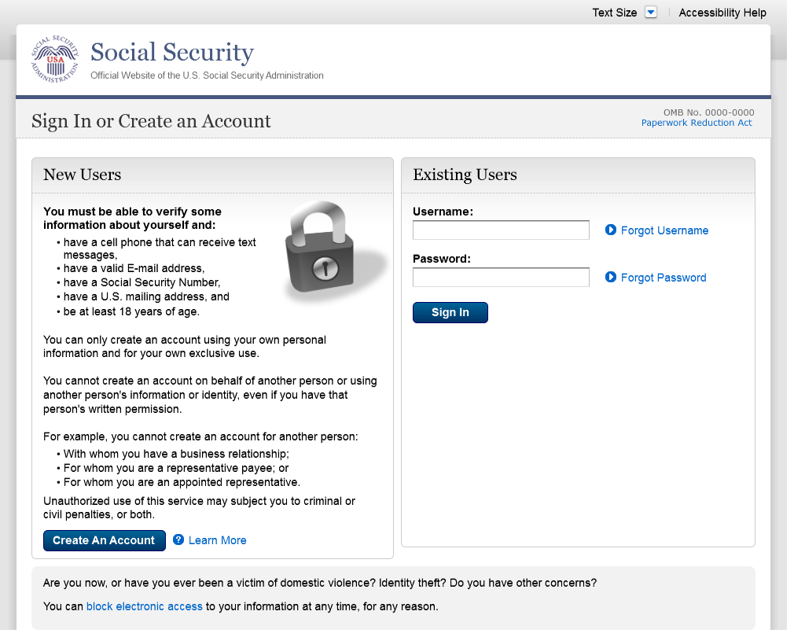
Changed “email” to “E-mail” on 12/17/2015.
Added 1st bullet on 11/19/2015. Added hyphen to “SMS-enabled” on 12/02/2015.
Modified wording on 12/17/2015.

S1-P2 - Terms of Service

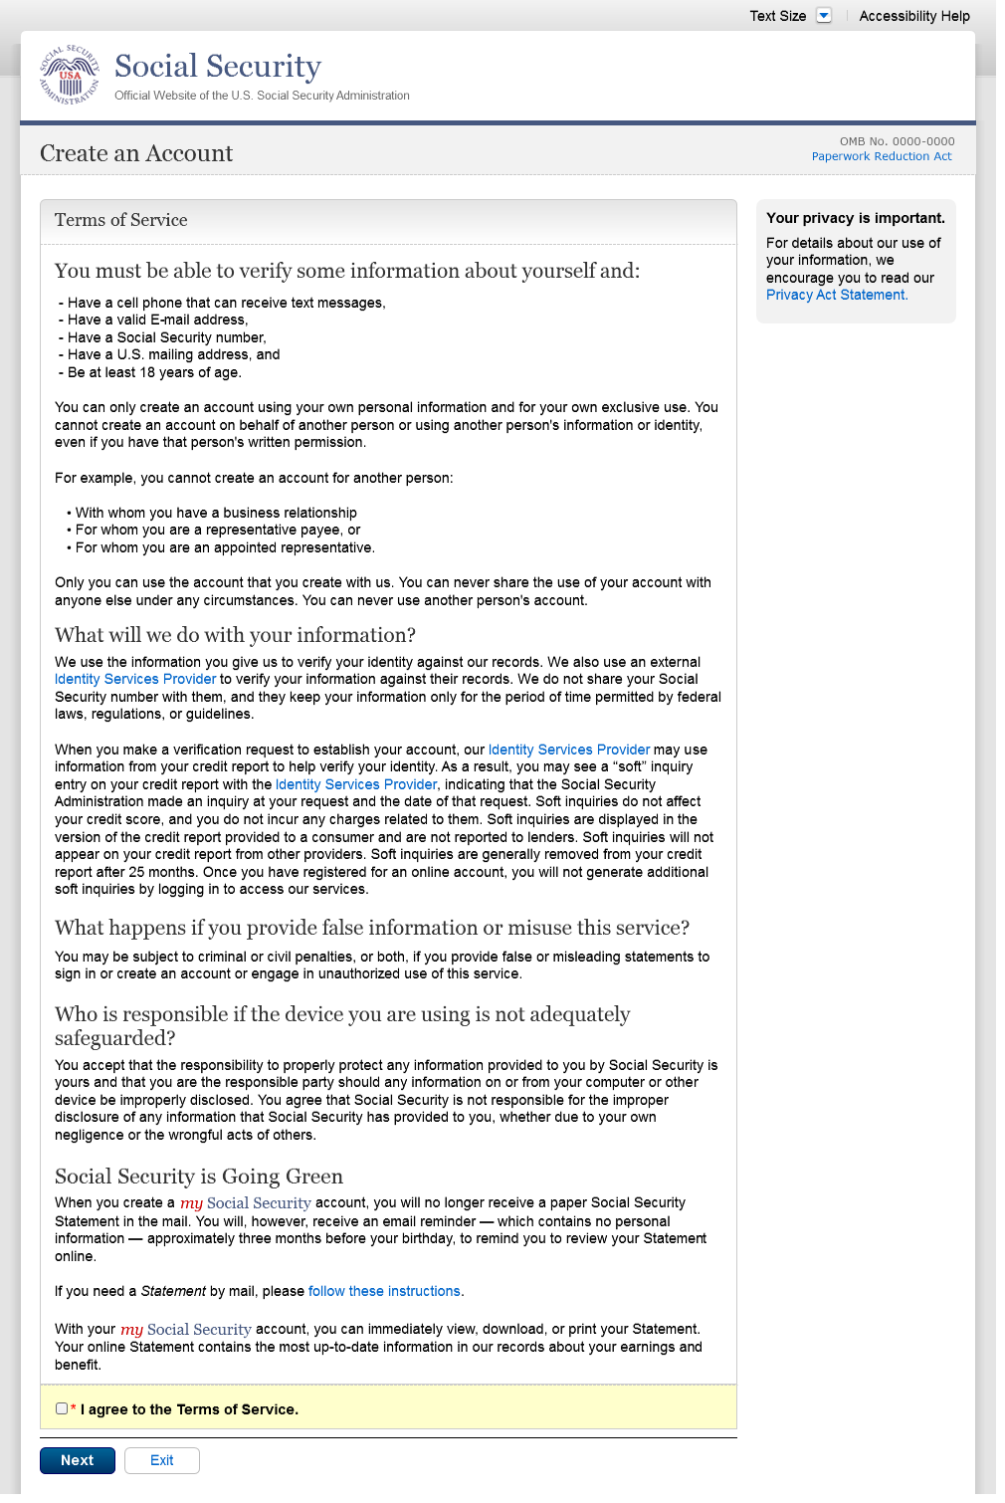
Added 1st bullet on 11/19/2015. Added hyphen to “SMS-enabled” on 12/02/2015. Modified wording on 12/17/2015.
Corrected spacing on 12/17/2015.
Removed “We used their fraud prevention services…theft.” on 12/17/2015.
Changed “email” to “E-mail” on 12/17/2015.

S1-P3 - Verify Identity

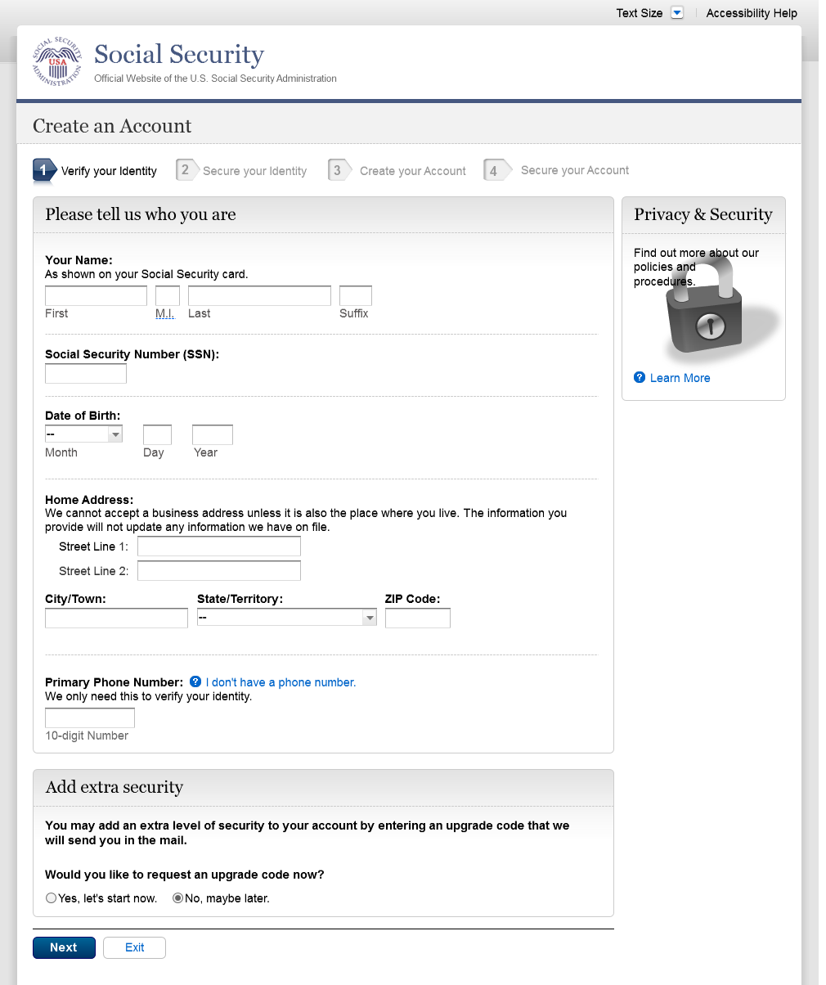
Changed from Action Link to Help link on 12/17/2015.
Text change
Restored container heading to “Add extra security” on 12/17/2015.
Added Step 4

S1-P4 - Secure Identity

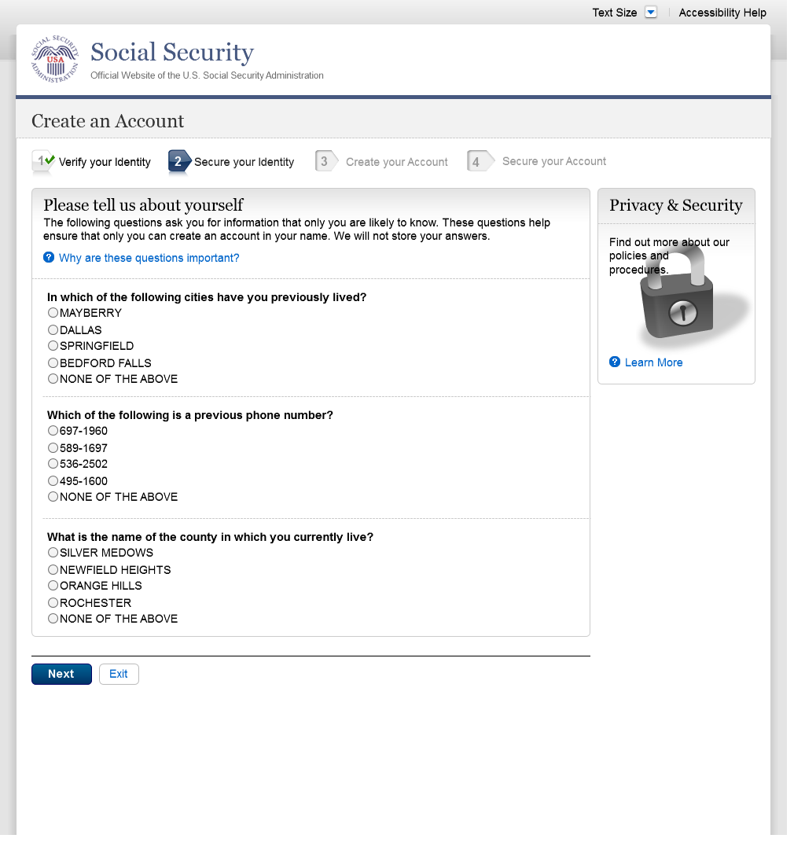
Added Step 4

S1-P5 - Create Account

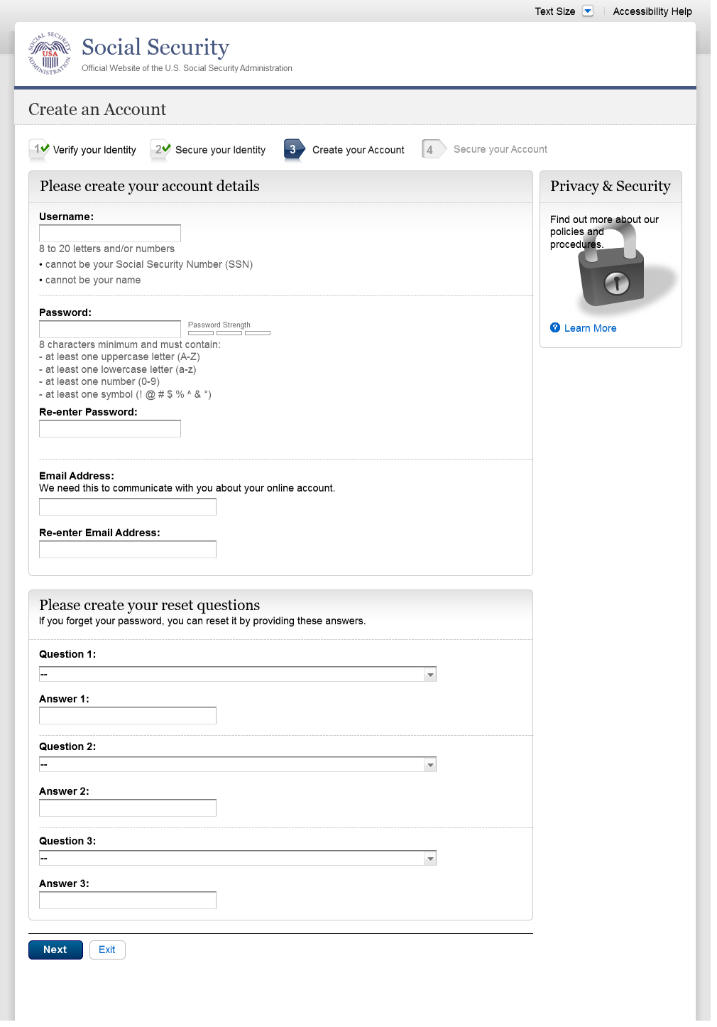
Added Step 4

S1-P6 – Provide Cell Phone Number_Create Account

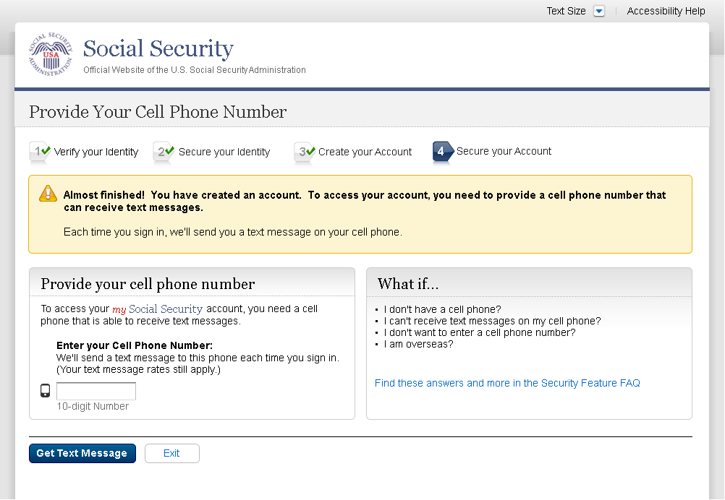
Added container
Changed “Security Features FAQ” to “Security Feature FAQ” on 2/22/2016.
Removed Previous button on 12/02/2015.
Removed “Why?” link on 1/13/2016.
Changed wording
Revised wording on 1/7/2016.
Added Step 4
Changed “own” to “have”, “cannot” to “can’t” and reordered questions on 12/17/15.
Changed wording
Added warning notice. Revised on 11/19/2015. Removed “For your protection,” on 12/17/2015.

S1-P7 - Enter Texted Security Code

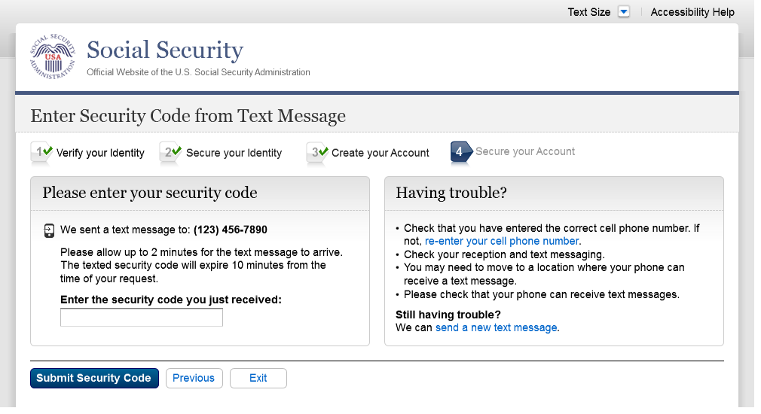
Removed “SMS” from 2nd bullet on 12/17/2015.
Added 1st bullet on 11/19/2015.
Added Step 4
Changed text

S1-P8 – Confirmation

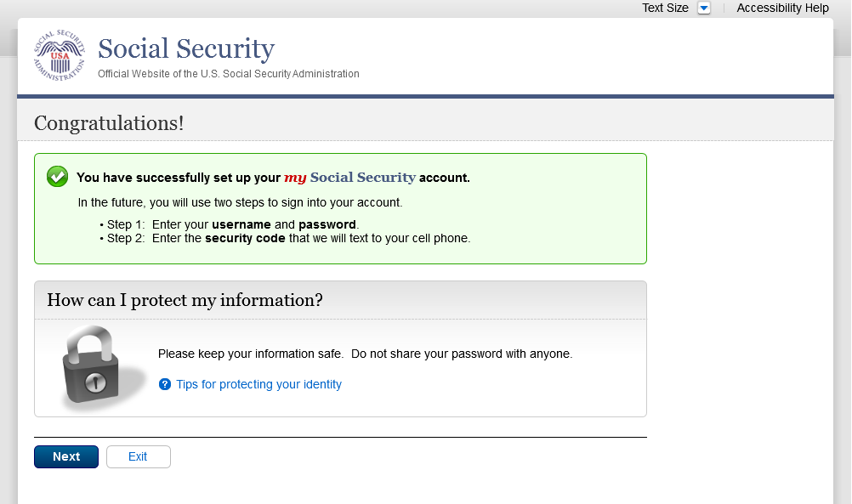
Modified text in container
Modified confirmation message

Scenario 2: Create LOA3 Account
Please see S1-P1 for description of changes.

S2-P1 - Sign In

S2-P2 - Terms of Service
Please see S1-P2 for description of changes.

S2-P3 - Verify Identity – User Chooses to Upgrade to LOA3

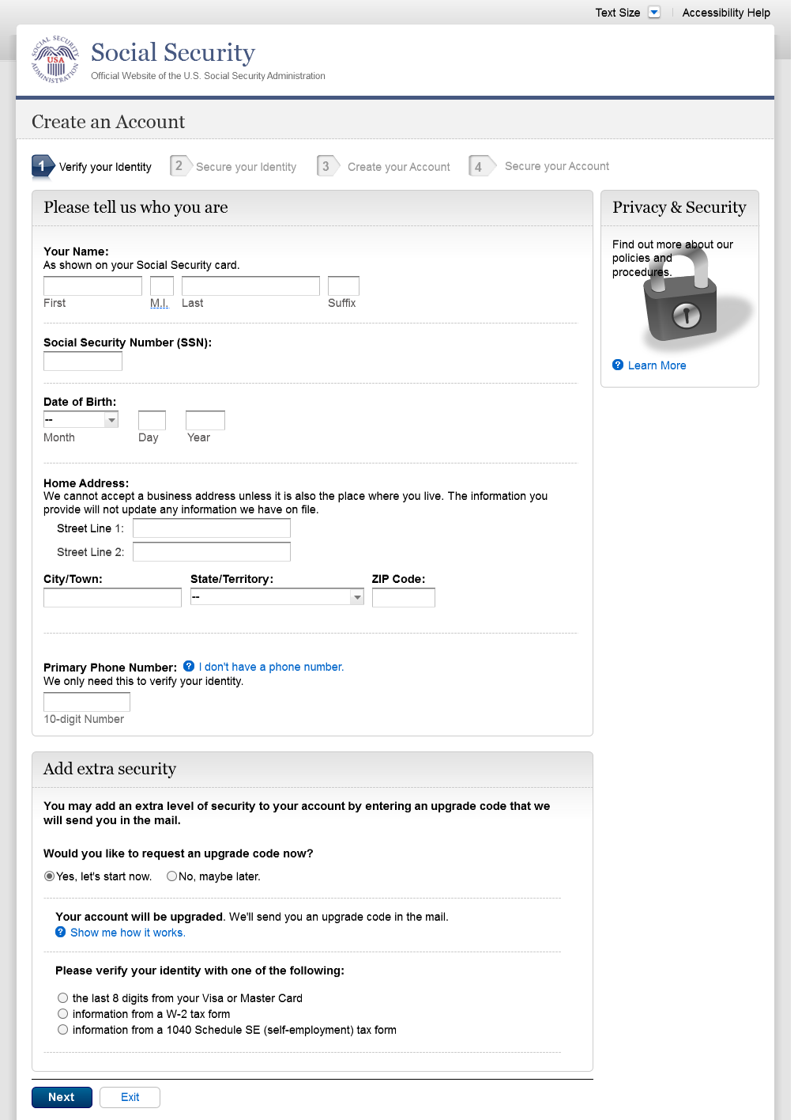
Text change
Restored container heading to “Add extra security” on 12/17/2015.
Changed “upgrade code” to lower case on 12/17/2015.
Added Step 4

S2-P4 - Secure Identity

Added Step 4

S2-P5 - Create Account

Added Step 4

S2-P6 – Provide Cell Phone Number – Create Account

Changed “Security Features FAQ” to “Security Feature FAQ” on 2/22/2016.
Changed wording
Revised wording on 1/7/2016.
Changed “own” to “have”, “cannot” to “can’t” and reordered questions on 12/17/15.
Changed wording
Added warning notice. Revised on 11/19/2015. Removed “For your protection,” on 12/17/2015.
Added Step 4

S2-P7 - Enter Texted Security Code_Create Account
Removed Previous button on 12/02/2015.
Removed “Why?” link on 1/13/2016.
Added container

Removed “SMS” from 2nd bullet on 12/17/2015.
Added 1st bullet on 11/19/2015.
Added Step 4
Changed text

S2-P8 - Confirmation_Set Up New Account_With Upgrade Selected

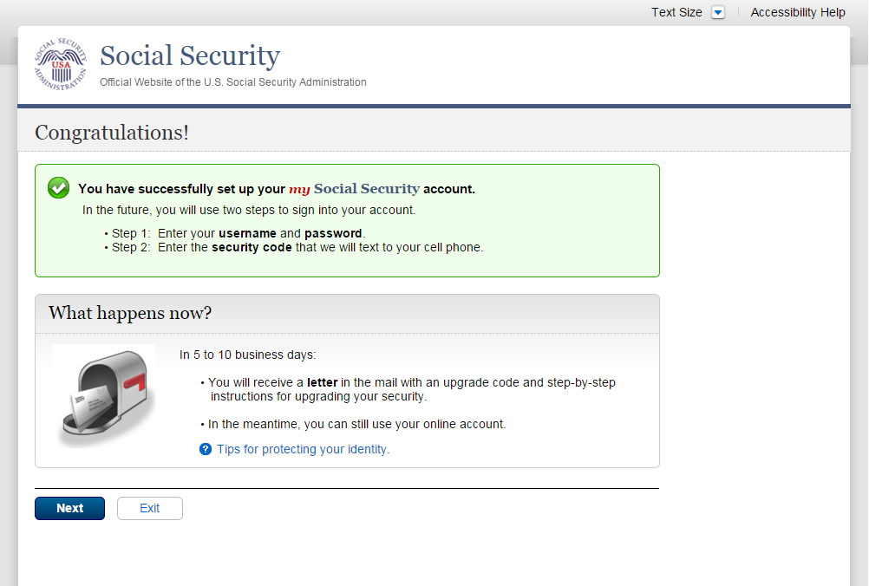
Modified confirmation message

S2-P10 - Second Sign In, After Receiving Upgrade Code Letter

Please see S1-P1 for description of changes.

S2-P11 – Verify Cell Phone Number

New screen

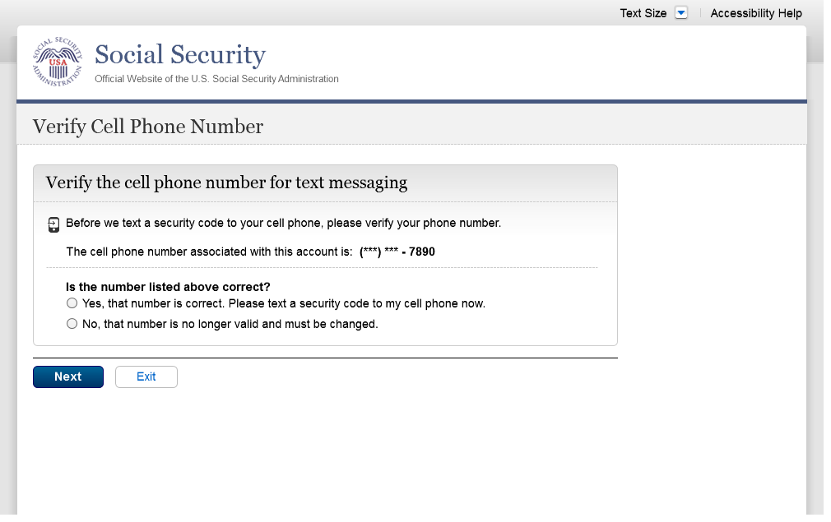
Added screen on 11/19/2015.
Modified wording on 12/17/2015.
Modified wording on 12/17/2015.
Added space before and after hyphen on 12/17/2015.

S2-P12 - Enter Texted Security Code_No Steps

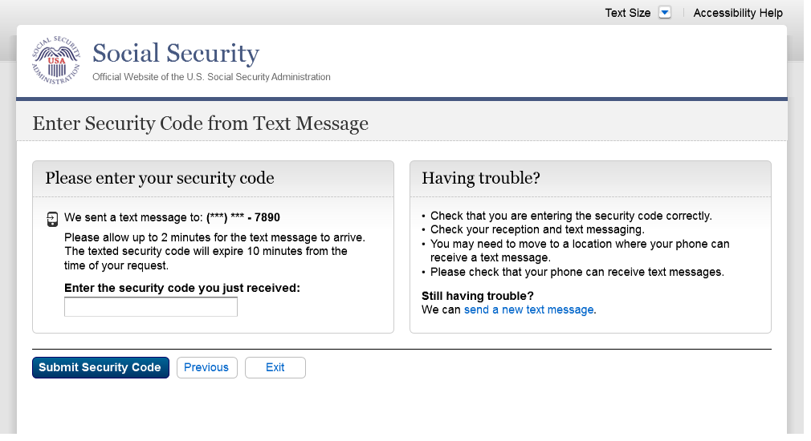
Removed “SMS” from 2nd bullet on 12/17/2015.
Masked 1st 6 digits of cell phone number on 11/19/2015. Added space before and after hyphen on 12/17/2015.
Changed text

S2-P13 - Do You Have Your Upgrade Code Letter?

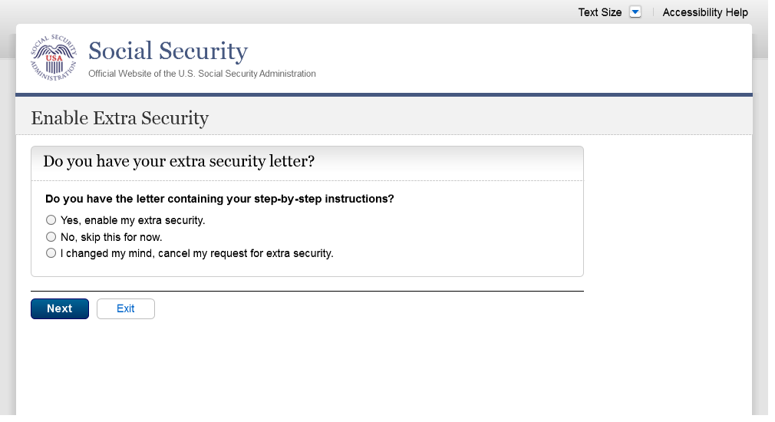
Modified wording in radio button labels to use “extra security” on 12/17/2015.
Changed “upgrade code letter” to “extra security letter” on 12/17/2015.
Modified page heading on 12/17/2015.
Removed steps on 12/17/2015.

S2-P14 - Enter Upgrade Code

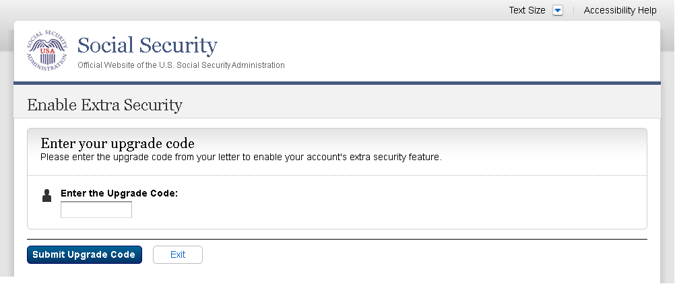
Removed 2nd container on 11/19/2015.
Changed “features” to “feature” on 2/22/2016.
Modified wording to use “extra security features” on 12/17/2015.
Modified page heading on 12/17/2015.
Removed steps on 12/17/2015.

S2-P15 - Confirmation_Upgrade to LOA3

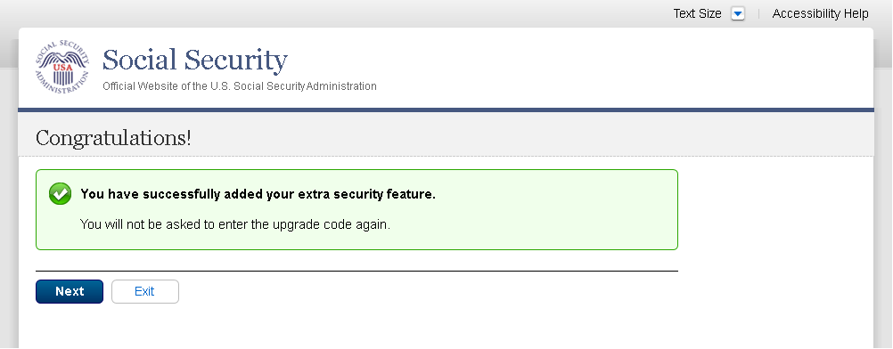
Changed “features” to “feature” on 2/22/2016.
Modified confirmation message
Modified confirmation message to “… added your extra security features” on 12/17/2015.

Scenario 3: Collect Cell Phone Number (2nd Factor) for Existing Account

S3-P1 - Sign In

Please see S1-P1 for description of changes.

S3-P3 - Provide Cell Phone Number_Grandfathered Account_No Steps

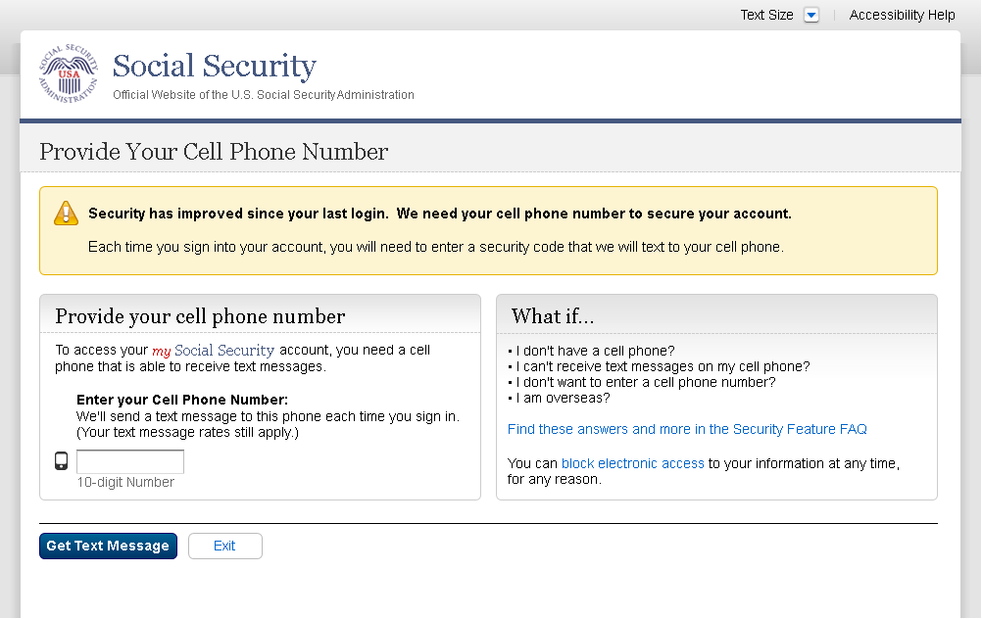
Changed “Security Features FAQ” to “Security Feature FAQ” on 2/22/2016.
Changed wording
Changed “own” to “have”, “cannot” to “can’t” and reordered questions on 12/17/15.
Changed wording
Added warning notice. Revised 11/19/2015. Removed “For your protection,” on 12/17/2015.

S3-P4 - Enter Texted Security Code_No Steps
Added text on 11/19/2015.
Added container
Removed Previous button on 12/02/2015.
Removed “Why?” link on 1/13/2016.

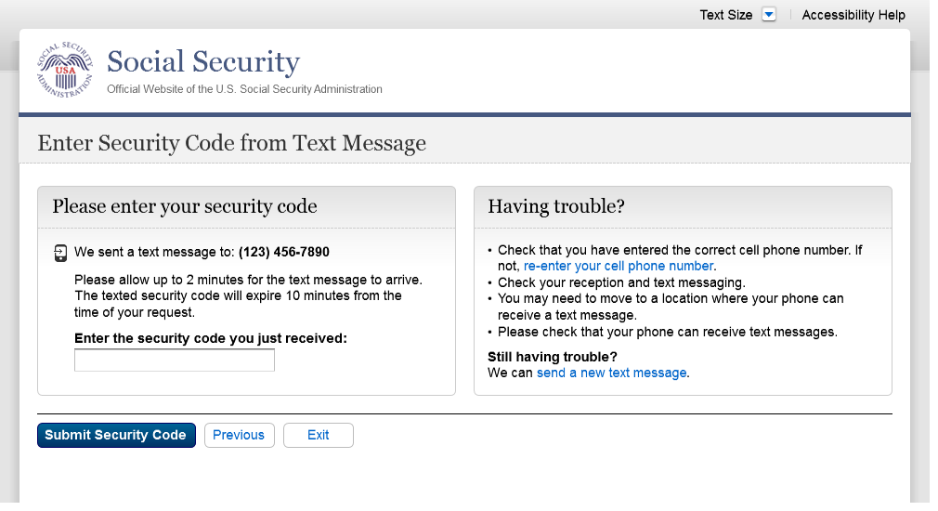
Removed “SMS” from 2nd bullet on 12/17/2015.
Changed text

S3-P5 – Confirmation – Set Up Account

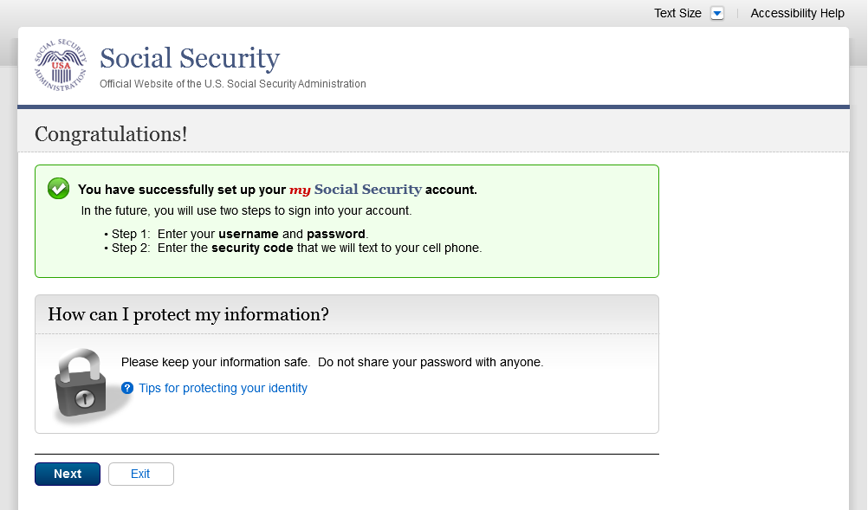
Modified text in container
Modified confirmation message

Scenario 4: Update Cell Phone Number

S4-P1 - Sign In

Please see S1-P1 for description of changes.

S4-P2 – Verify Cell Phone Number

Screen added on 11/19/2015.

Please see S2-P11 for changes.

S4-P3 – Change Cell Phone Number Terms of Service
Added on 4/20/2016.

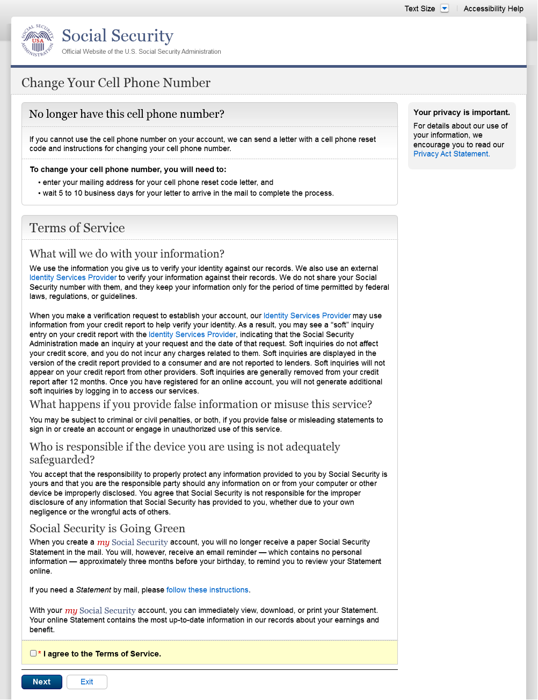
Revised text to “12 months” from “24 months” 4/20/16

Change Cell Phone Number Terms of Service Error
Added on 4/20/2016.

S4-P4 - Update Phone Number - Provide Info

This screen is displayed only if the user selects “No…” to the question “Is the number listed above correct?” on screen S4-P2, thereby indicating that they need to change their cell phone number in SSA’s records.

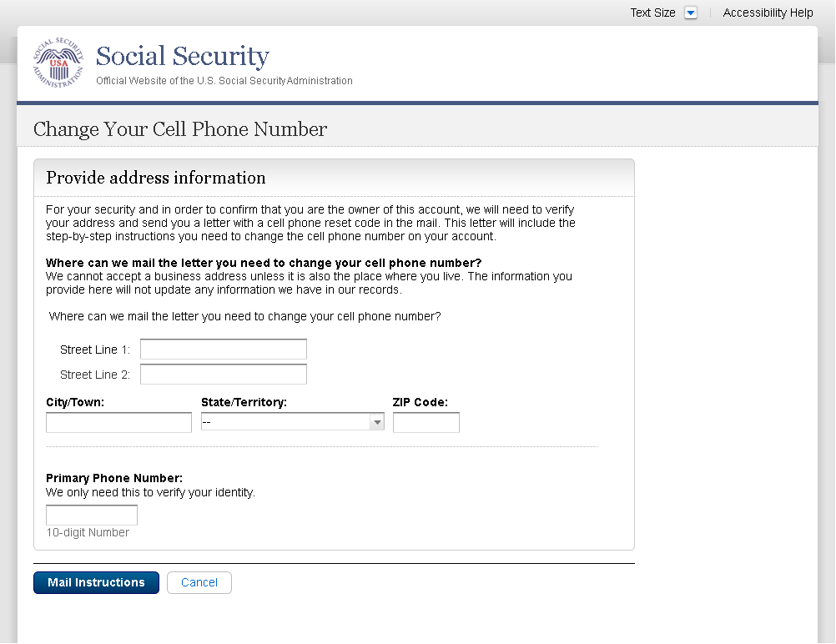
Removed “I don’t have a phone number” link on 1/7/2016.
Modified to use “change”, rather than “update”, and “reset code”, rather than “update code” on 12/17/2015.

Modified question to refer specifically to cell phone on 12/02/2015. Modified to reference cell phone number on 12/17/2015.
Added paragraph on 11/19/2015. Modified paragraph to refer to updating a cell phone consistently on 12/02/2015.
Modified page title on 12/17/2015.

S4-P5 - Confirmation of Letter

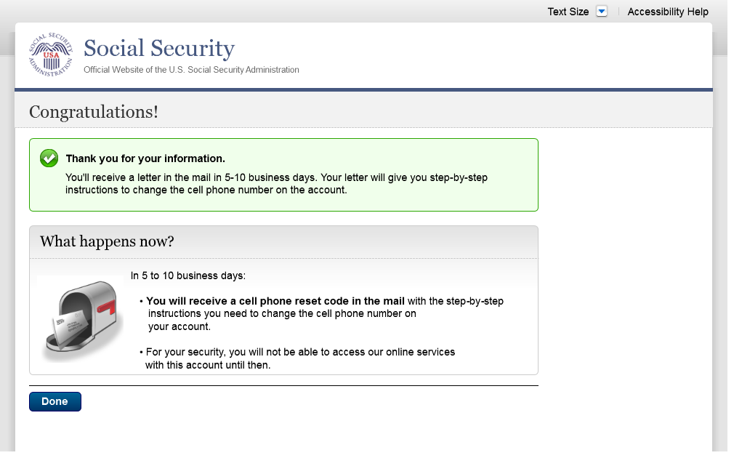
Changed “update code” to “reset code” on 12/17/2015.

S4-P7 - Sign In After Receiving Cell Phone Reset Code Letter

Please see S1-P1 for description of changes.

S4-P9 – Do you have your cell phone reset letter?

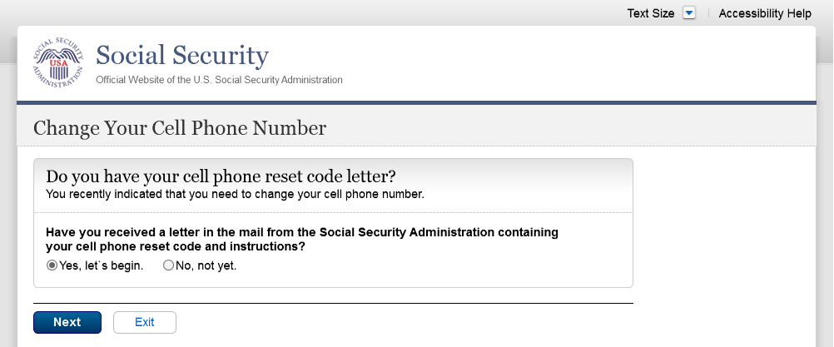
Updated language on 1/12/2016.
Updated language on 1/12/2016.
Removed “Enter your cell phone reset code” section under Yes/No. This content is now found on S4-P9.1. 4/20/16

S4-P10 - Provide New Cell Phone Number

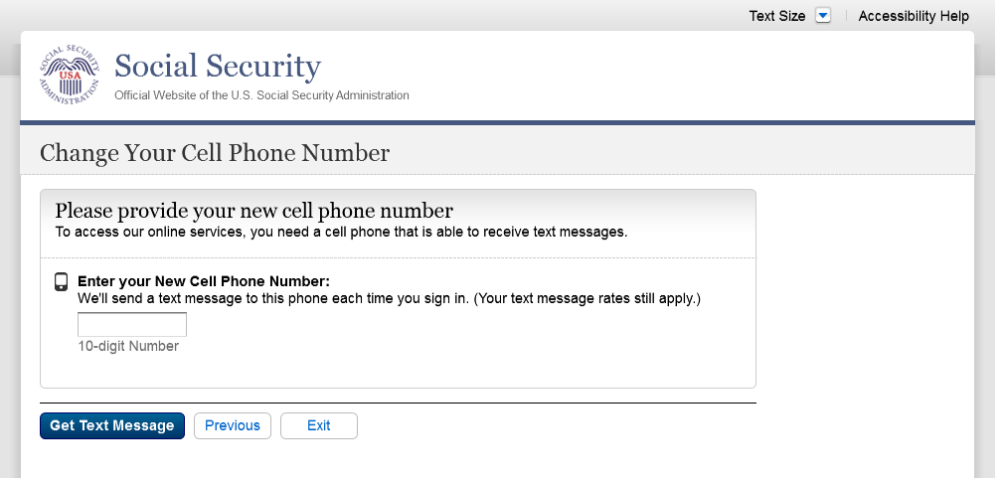
Modified text. Revised “Update” to “Change” on 12/17/2015.
Removed warning message.

S4-P11 - Enter Texted Security Code_No Steps

Removed “SMS” from 2nd bullet on 12/17/2015.
Changed text

S4-P11.1 – Enter Your Cell Phone Reset Code
Added on 4/20/2016.
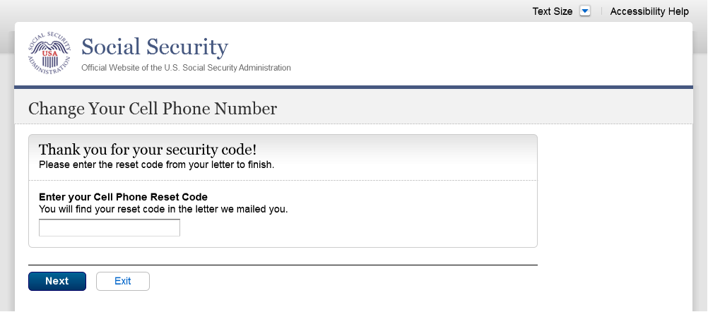
New screen added, asking users to enter their cell phone reset code. 4/20/16

S4-P12 - Confirmation_New Cell Phone Number

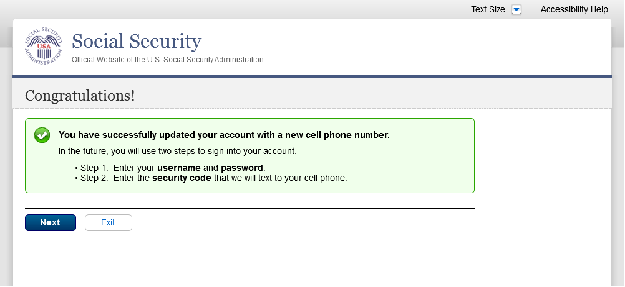
Changed wording in 1st sentence on 11/19/2015.

Scenario 5: Update Cell Phone Number on Account with Expired Password

S5-P1 - Sign In

Please see S1-P1 for description of changes.

S5-P3- Provide Cell Phone Number_Grandfathered Account_No Steps

Changed “Security Features FAQ” to Security Feature FAQ” on 2/22/2016.
Added container
Added text on 11/19/2015.
Removed “Why?” link on 1/13/2016.
Removed Previous button on 12/02/2015.
Changed wording
Changed “own” to “have”, “cannot” to “can’t” and reordered questions on 12/17/15.
Changed wording
Added warning notice. Revised 11/19/2015. Removed “For your protection,” on 12/17/2015.

S5-P4 - Enter Texted Security Code_Phone Added Immediately Prior

Removed “SMS” from 2nd bullet on 12/17/2015.
Changed text

S5-P5 - Expired Password
No changes in this release.

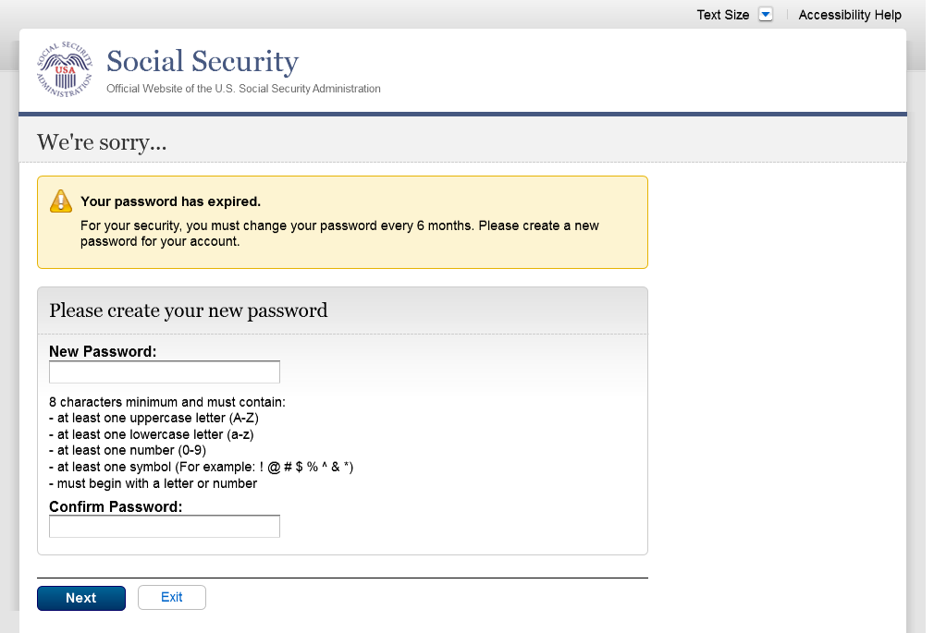

S5-P6 - Confirmation of Password Change

Modified confirmation message

Scenario 6: Update Cell Phone Number on Account, User Has Forgotten Password, Uses Reset Questions

S6-P1 - Sign In

Please see S1-P1 for description of changes.

S6-P3 - Forgot Password_Grandfathered User_ Verify Identity

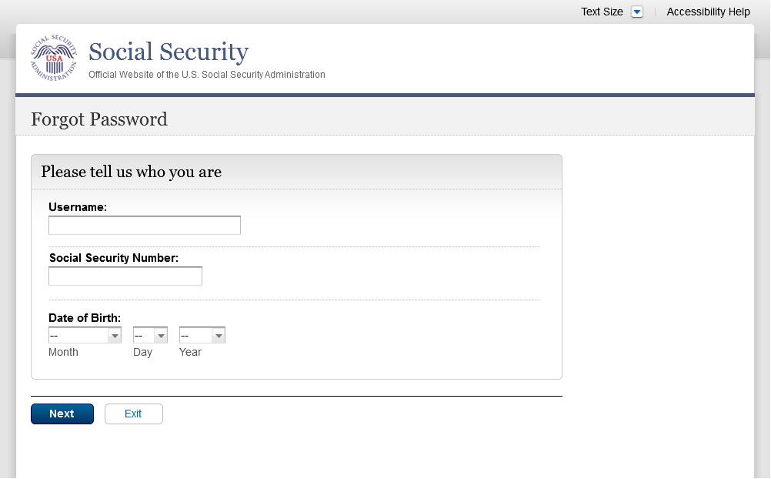
Removed Steps (3/21/16)

S6-P4 - Forgot Password_Grandfathered User_Provide Answers

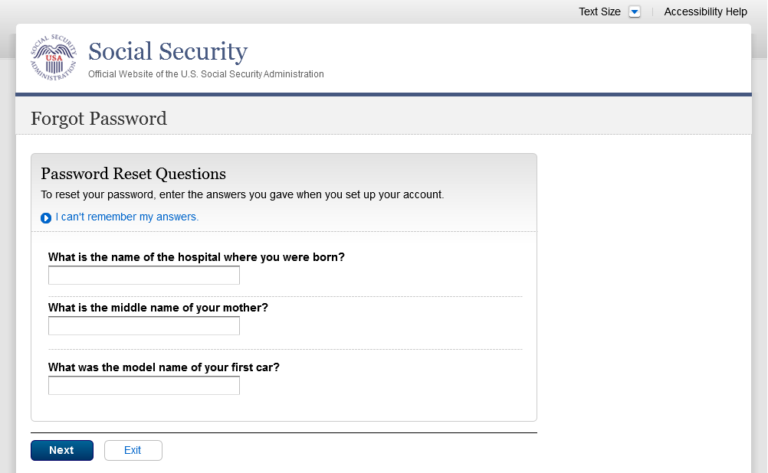
Removed steps (3/21/16)

S6-P5 - Provide Cell Phone Number_ Grandfathered User_ Forgot Password
Removed Steps (03/21/16)
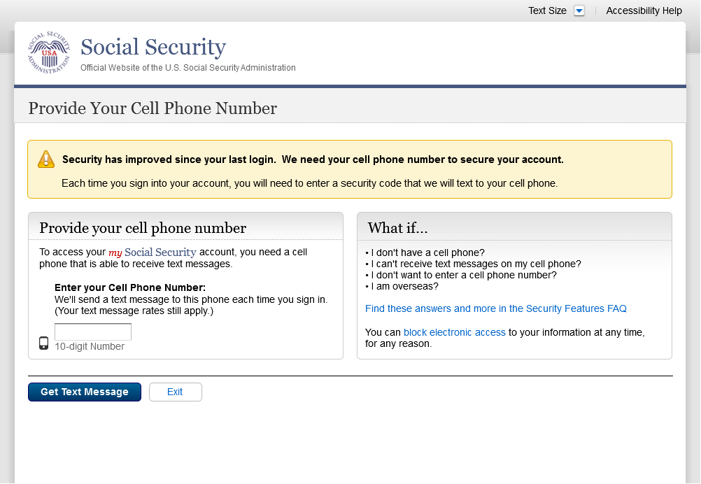
Removed Previous button on 12/02/2015.
Removed “Why?” link on 1/13/2016.
Added text on 11/19/2015.
Changed “Security Features FAQ” to “Security Feature FAQ” on 2/22/2016.
Changed “own” to “have”, “cannot” to “can’t” and reordered questions on 12/17/15.
Changed wording
Added warning notice. Revised on 11/19/2015. Removed “For your protection,” on 12/17/2015.
Changed wording

S6-P6 - Enter Texted Security Code_Grandfathered User_Forgot Password

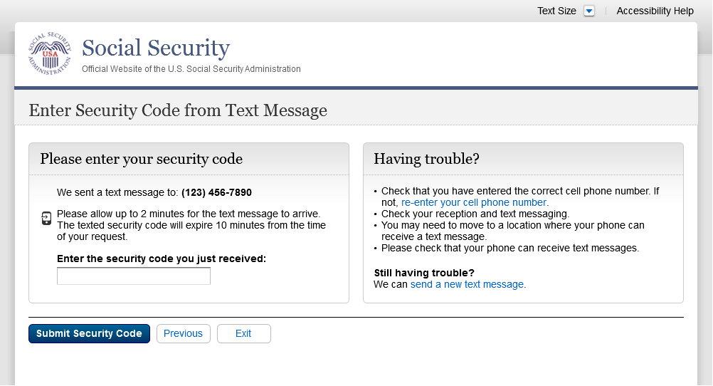
Removed steps (03/21/16)
Removed “SMS” from 2nd bullet on 12/17/2015.
Corrected steps on 12/02/2015. Changed capitalization of “your” on 12/17/2015.

S6-P7 - Update Password_Grandfathered User

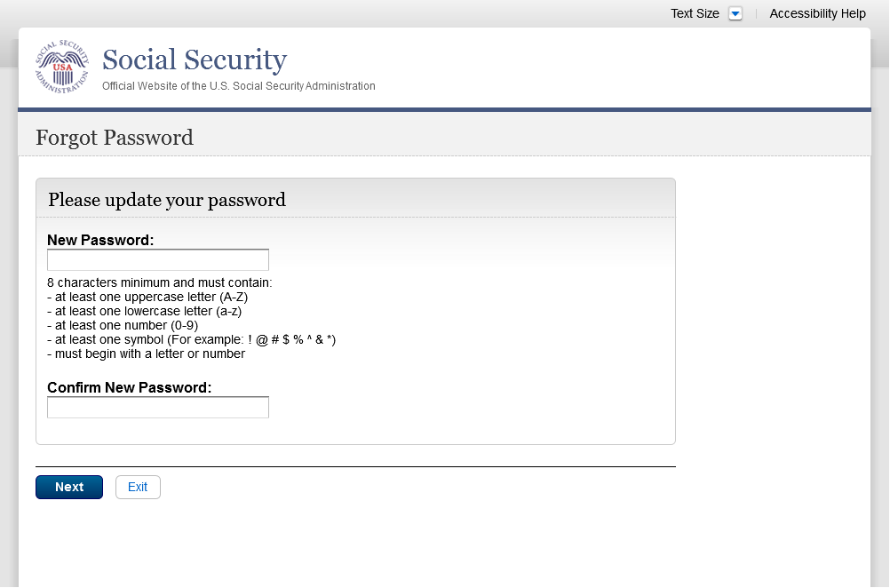
Removed Previous button on 12/02/2015.
Removed steps (03/21/16)
Changed capitalization of “your” on 12/17/2015.

S6-P8 - Confirmation of Password Change
Modified confirmation message

Scenario 7: Update Cell Phone Number on Account, User Has Forgotten Password and Reset Question Answers

S7-P1 Sign In

Please see S1-P1 for description of changes.

S7-P3 - Forgot Password_Grandfathered User_ Verify Identity

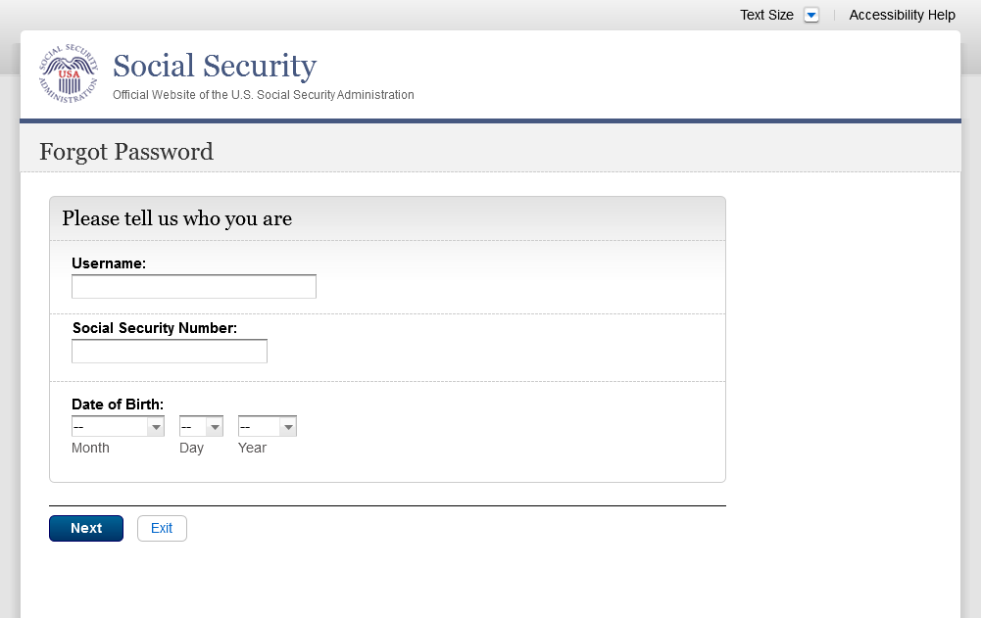
Removed steps (03/21/16)

S7-P4 - Forgot Password_Grandfathered User_Provide Answers

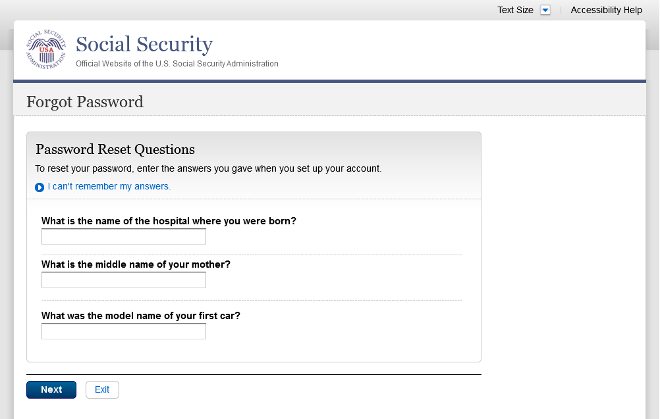
Removed Steps (03/21/16)

S7-P5 - Forgot Password - Send Temporary Password
Removed Previous button on 12/02/2015.
No changes in this release.

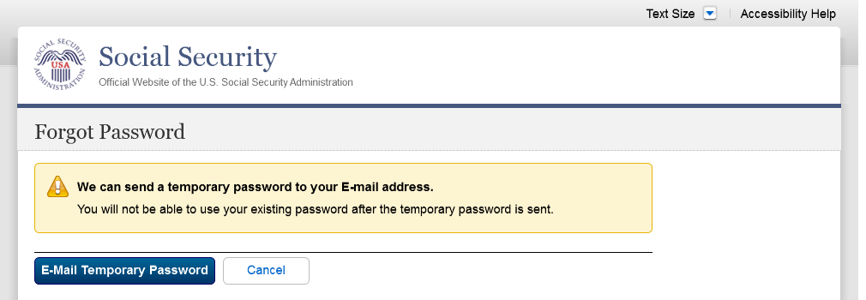

S7-P6 - Email Confirmation
No changes in this release.

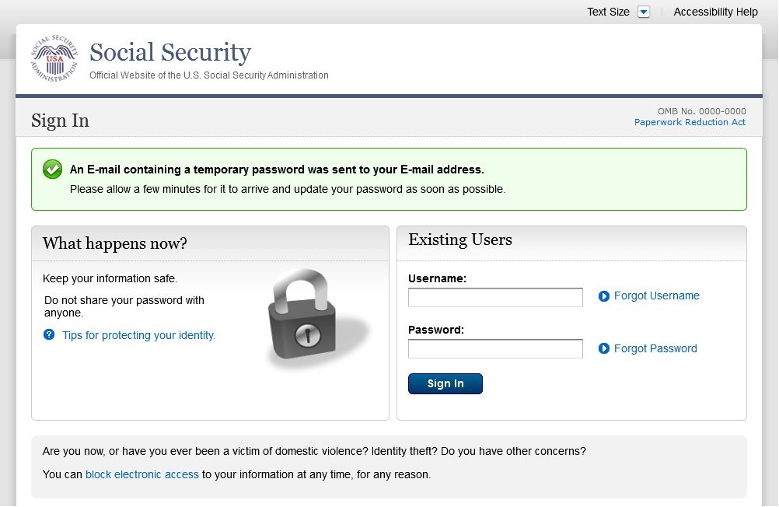

S7-P9 - Provide Cell Phone Number_ Grandfathered User_ Forgot Password
Removed steps (03/21/16)
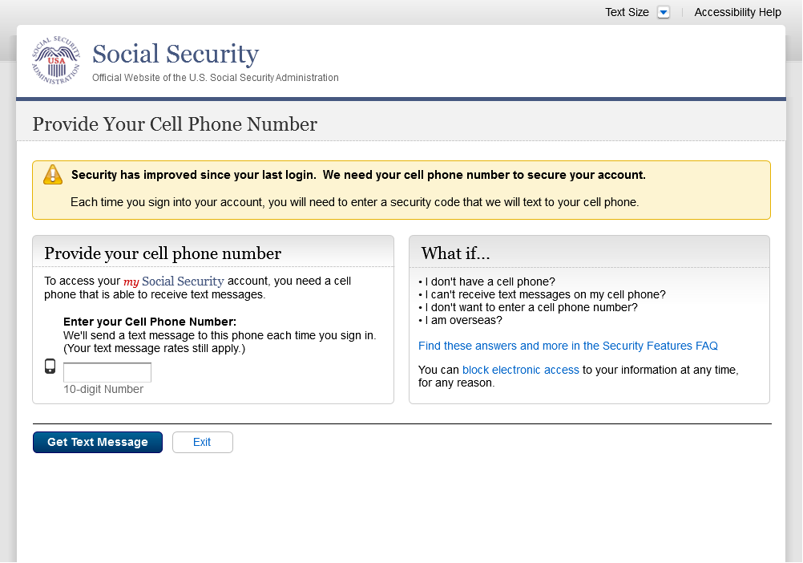
Changed wording
Changed “Security Features FAQ” to “Security Feature FAQ” on 2/22/2016.
Added container
Added warning notice. Revised on 11/19/2015. Removed “For your protection,” on 12/17/2015.
Changed wording
Changed “own” to “have”, “cannot” to “can’t” and reordered questions on 12/16/15.
Removed Previous button on 12/02/2015.
Added text on 11/19/2015.
Removed “Why?” link on 1/13/2016.

S7-P10 - Enter Texted Security Code_Grandfathered User_Forgot Password

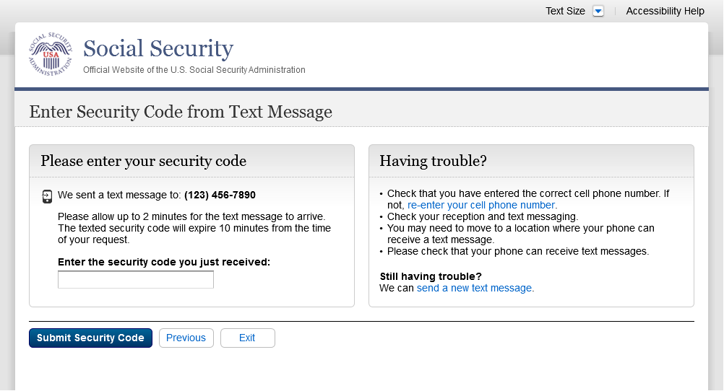
Removed steps (03/21/16)
Removed “SMS” from 2nd bullet on 12/17/2015.

S7-P11 - Update Password_Grandfathered User

Removed steps (03/21/16)
Removed Previous button on 12/02/2015.
Corrected capitalization on Step 2 on 12/17/2015.

S7-P12 - Confirmation of Password Change

Modified confirmation message

Scenario 8: Login Happy Path (All Users)

S8-P1 Sign In

Please see S1-P1 for description of changes.

S8-P2 Verify Cell Phone Number

Please see S2-P11 for changes.

S8-P3 Enter Texted Security Code

S8-P4 my Social Security Terms of Service

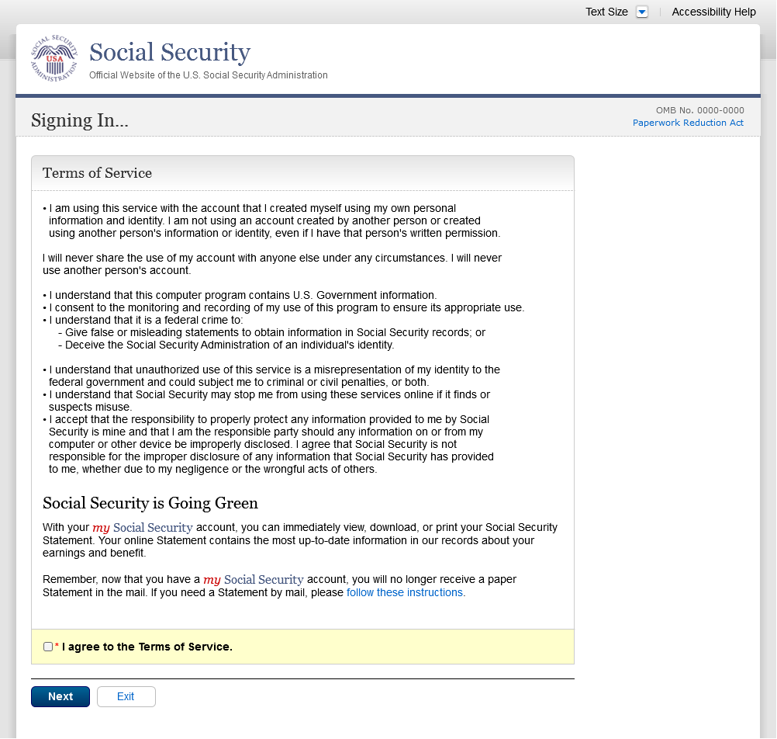

Finish Setting Up Account Terms of Service
Added revised language: cell phone. 4/20/16
Added on 4/20/2016

my Social Security - Security Settings

Standard Account

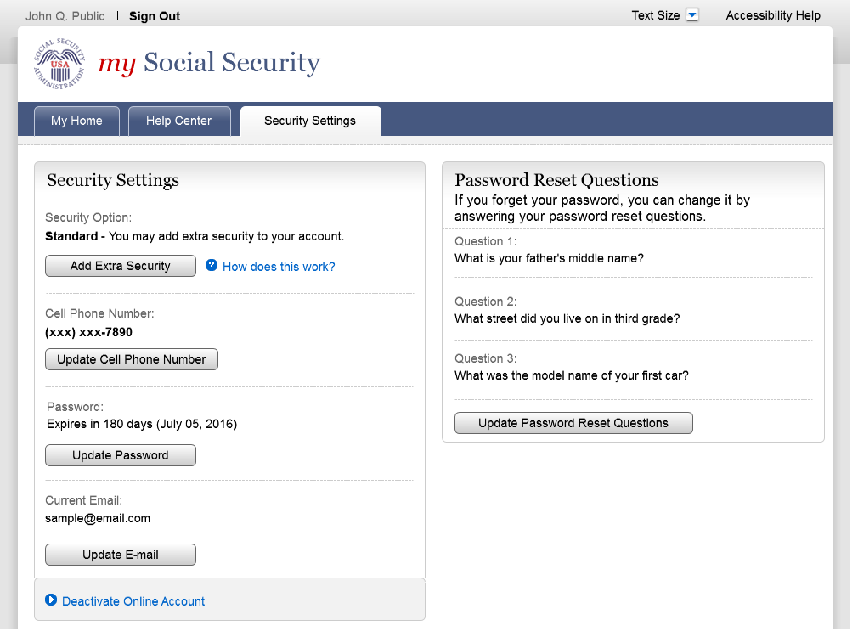

Standard Account (No Longer Using Extra Security)

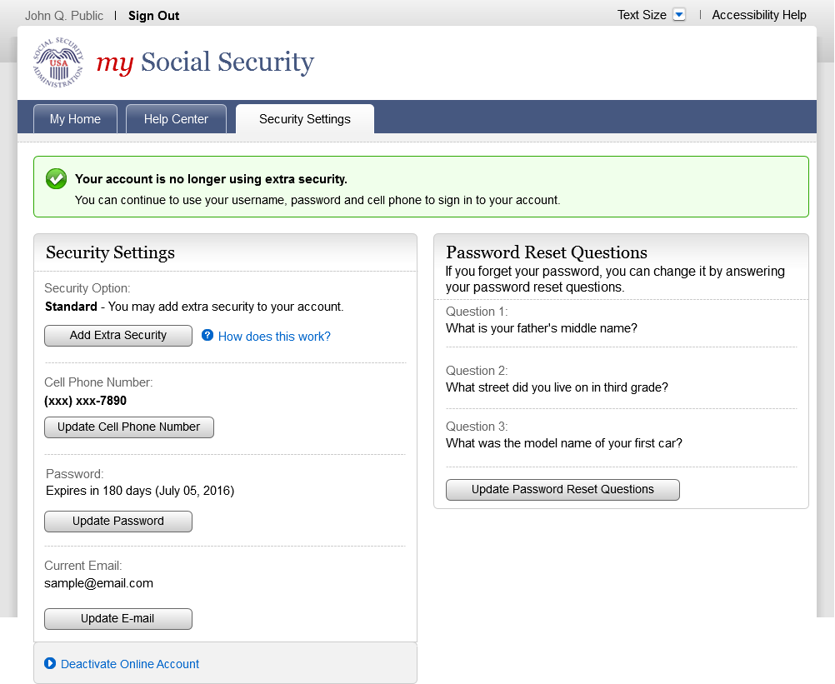
Added new confirmation message (03/21/16)

Enhanced (Pending) Account

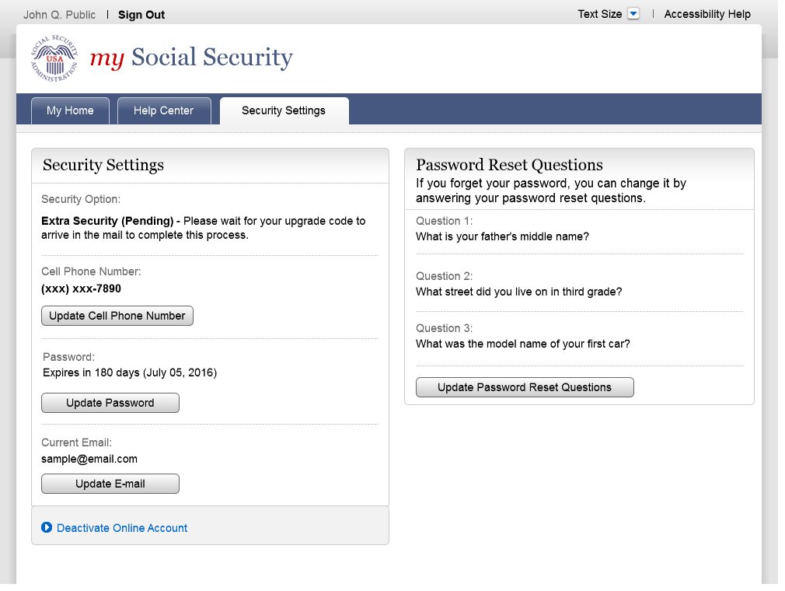

Enhanced Account

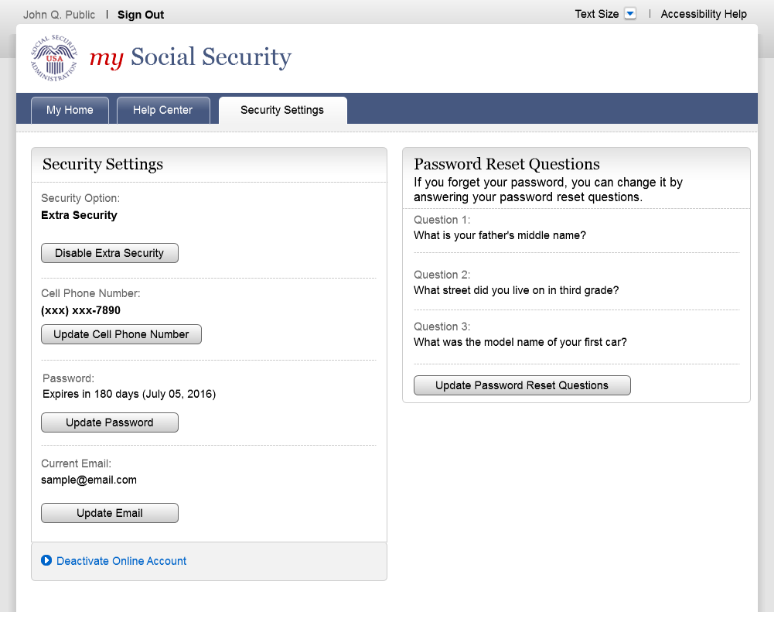

Deactivate Account
Added on 4/20/2016.

Disable Extra Security (DES)
Added on 4/20/2016

Modified language: Added “cell phone” to banner. 4/20/16

Disable Extra Security Confirmation (DESCM)
Modified language: Added “cell phone” to banner. 4/20/16
Added on 4/20/2016

Cancel Extra Security Confirmation (CESCC)
Added on 4/20/2016

Modified language: Added “cell phone” to banner. 4/20/16

Upgrade Code Temporary Lockout (ERRUCT)
Added on 4/20/2016

Help Pages

Security Feature FAQ

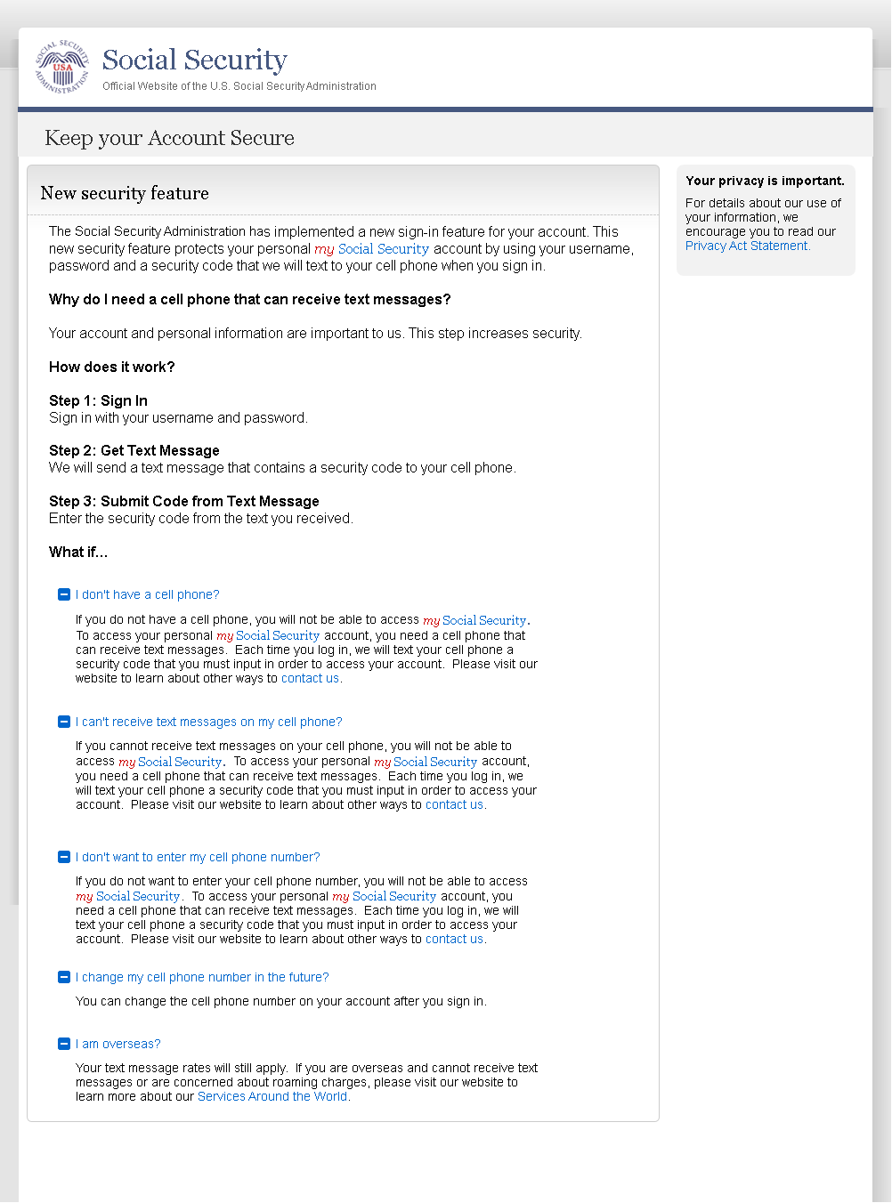
On 2/22/2016:
- Changed container title from “New Security Features” to “New Security Feature”.
- Changed first sentence from “my Social Security has…” to “The Social Security Administration has…”
- Changed second sentence from “This … my Social Security account…” to “This … personal my Social Security account…”

Privacy and Security Questions
Added on 4/20/2016.

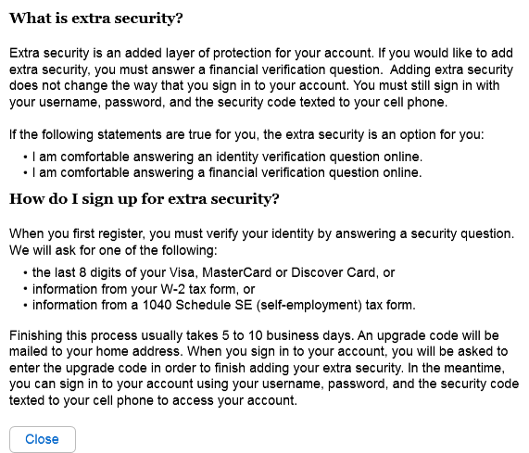
Revised language. 4/21/16

Privacy and Security Questions (HPS)
Added on 4/20/16

Revised language 4/20/16

Revised language 4/21/16

Revised language 4/20/16

How Does This Work? (HDTW)
Added on 4/20/2016.

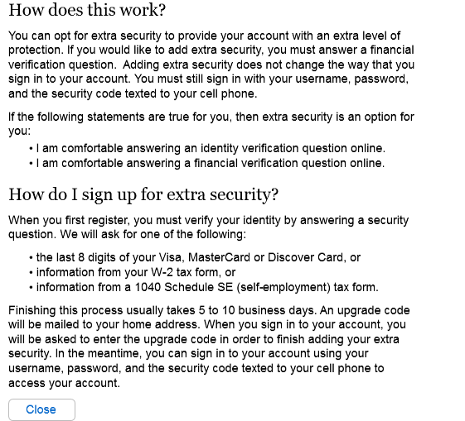
Revised language 4/21/16

Show Me How It Works (HSMHTW)
Added on 4/20/2016.

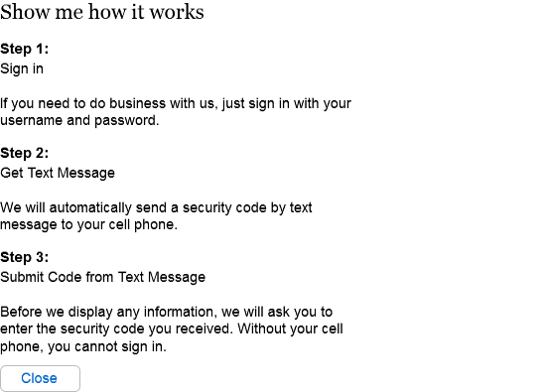
Removed outdated phone image. 4/20/16
Revised text. 4/20/16

