OMB No. 1205-0513 Expires: 9/30/2016

REO-YOUTH sample record layout
Enrollment:

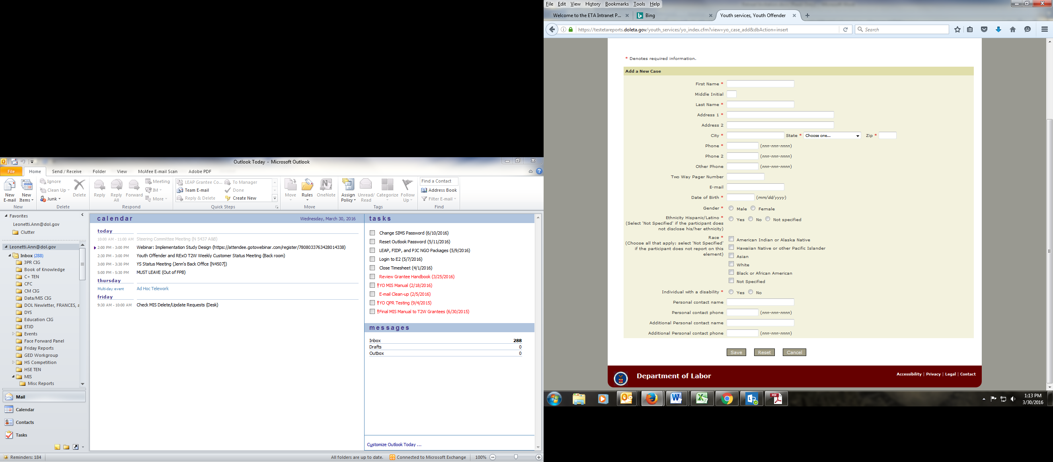

Assessment at Entry:

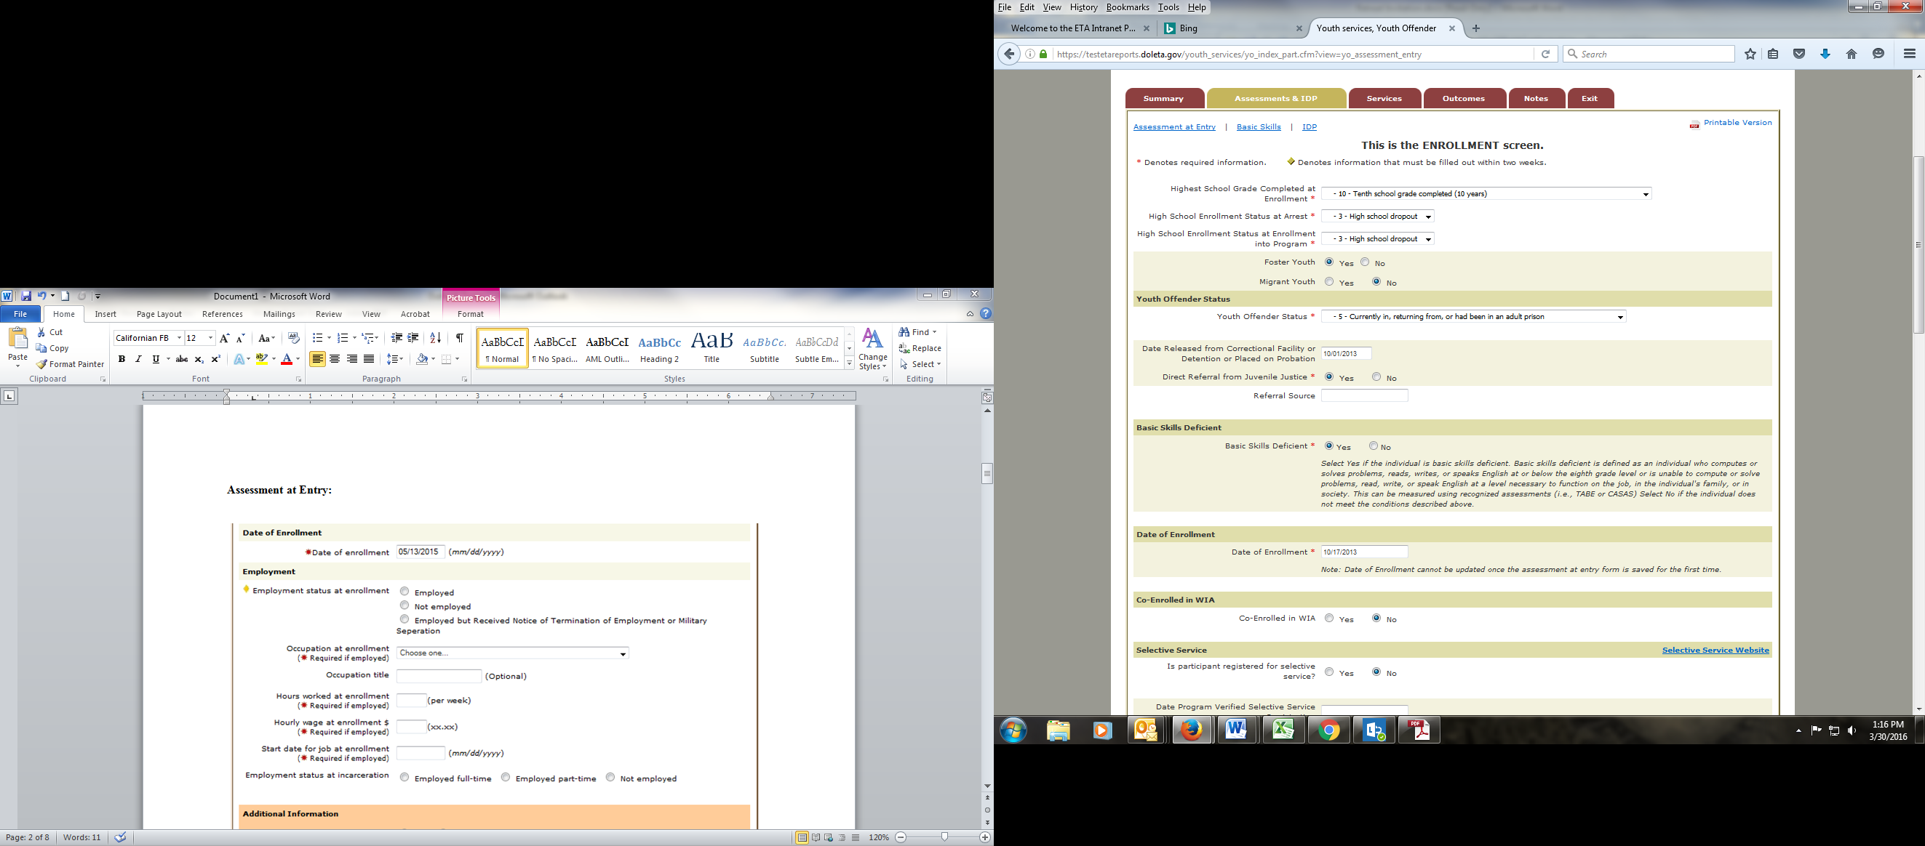

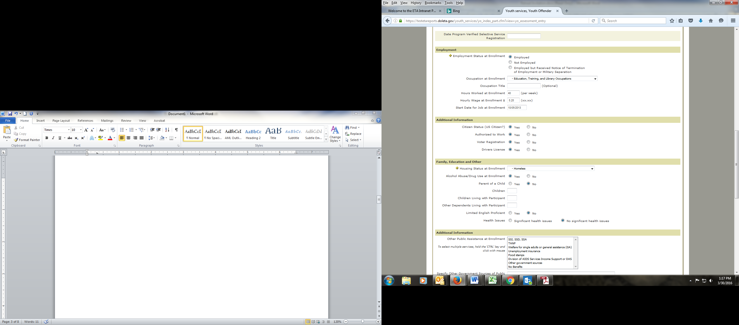

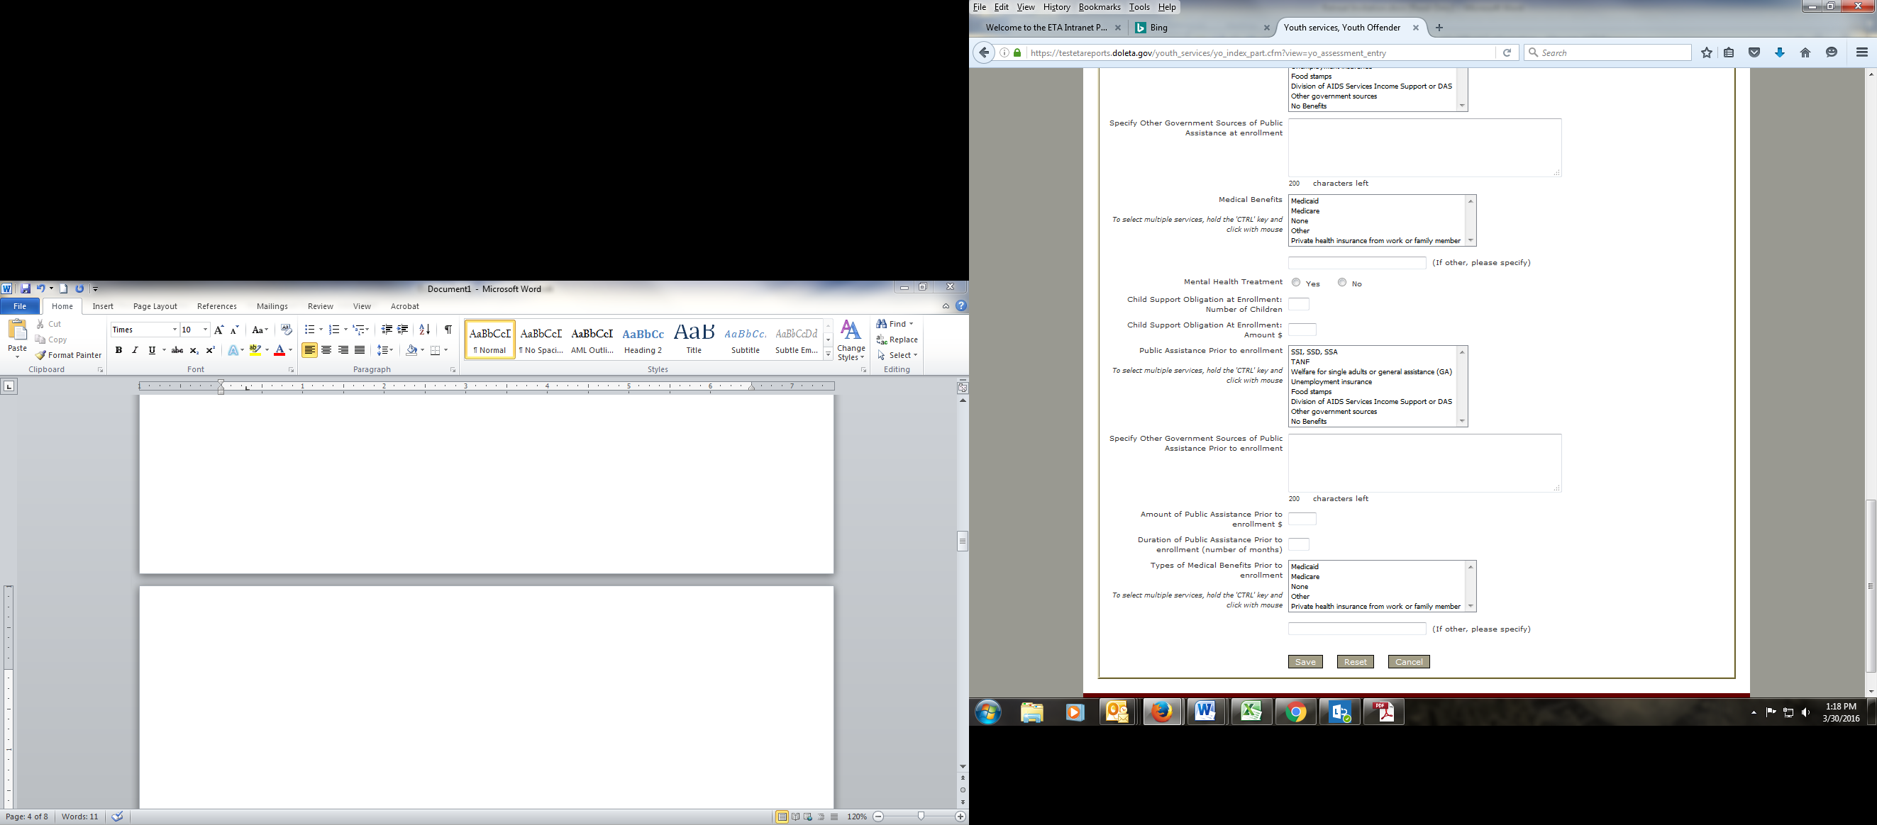

Basic Skills:

Pre-test
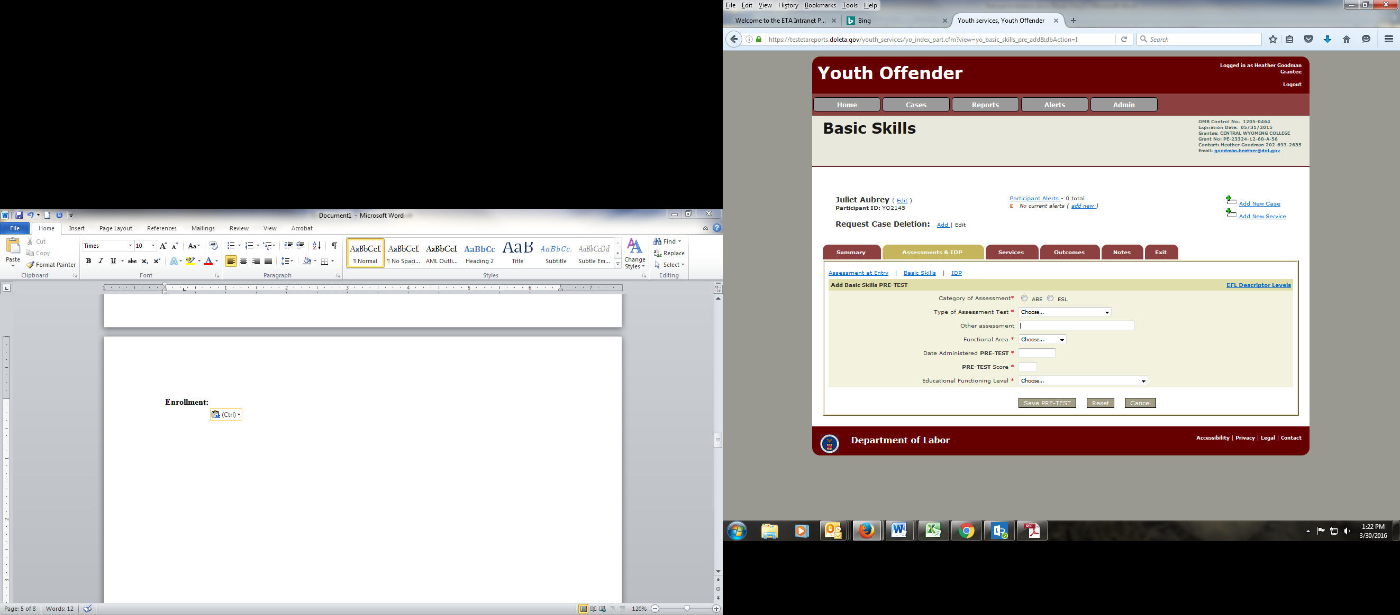

Post-Test
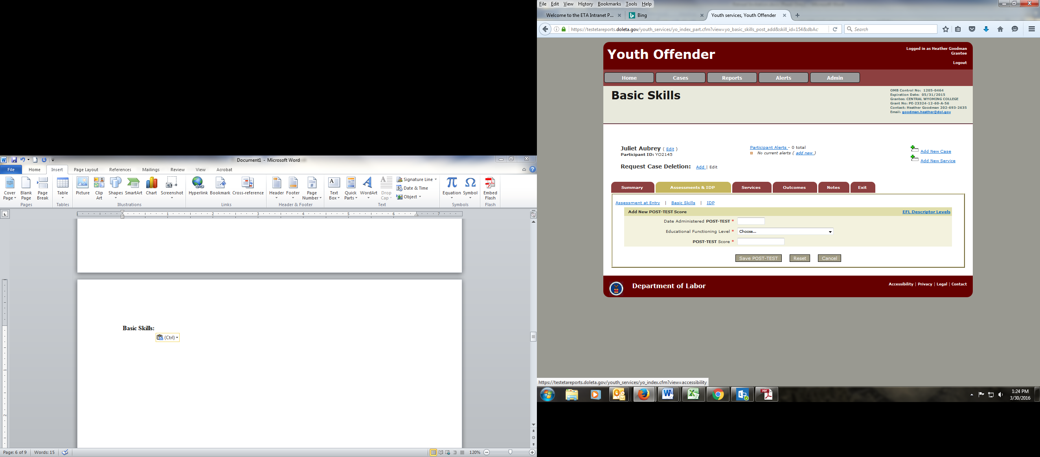
IDP:

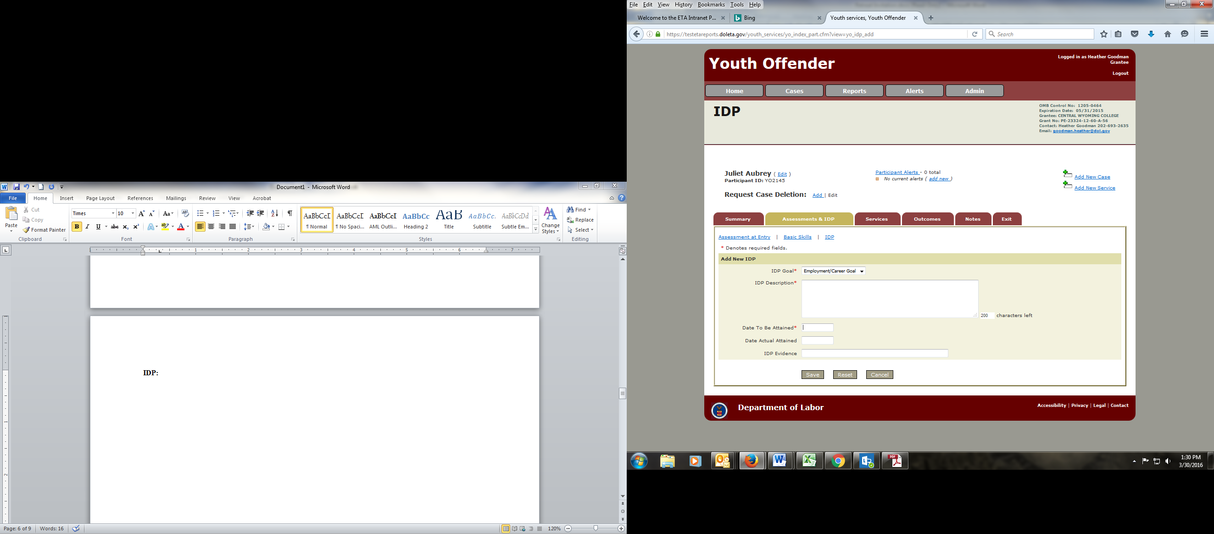
Services:

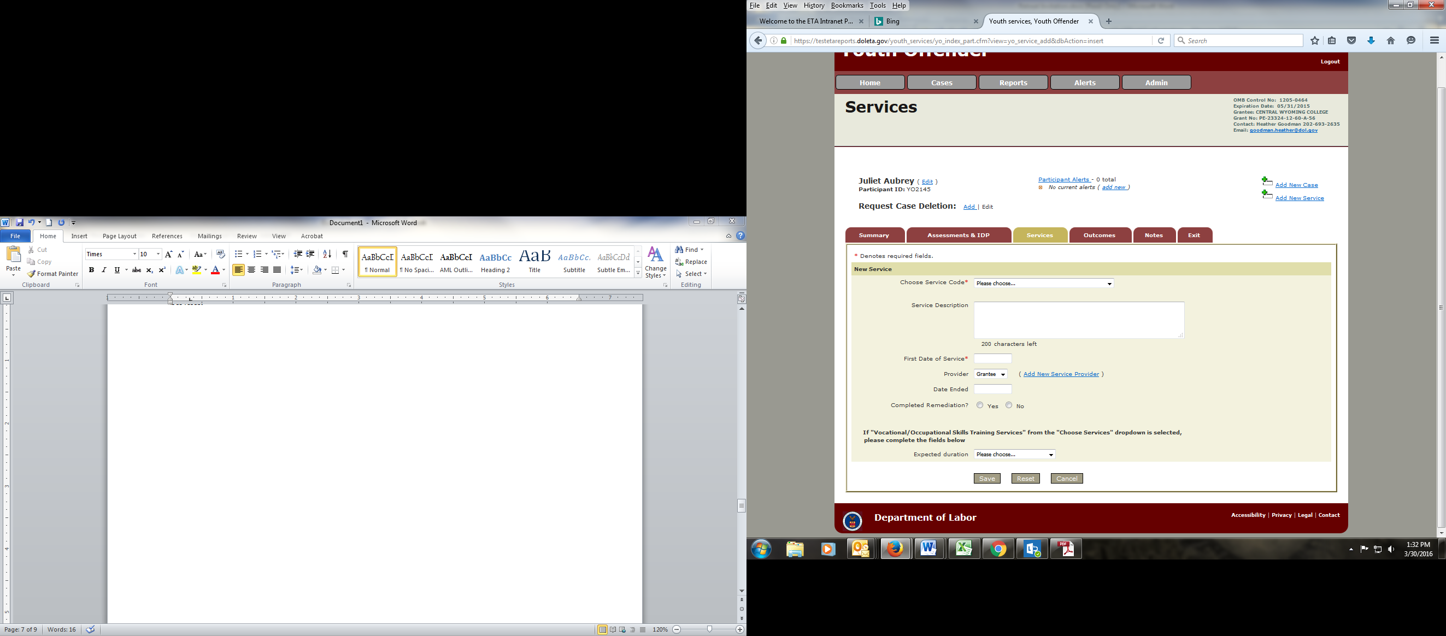
Outcomes:

Overview
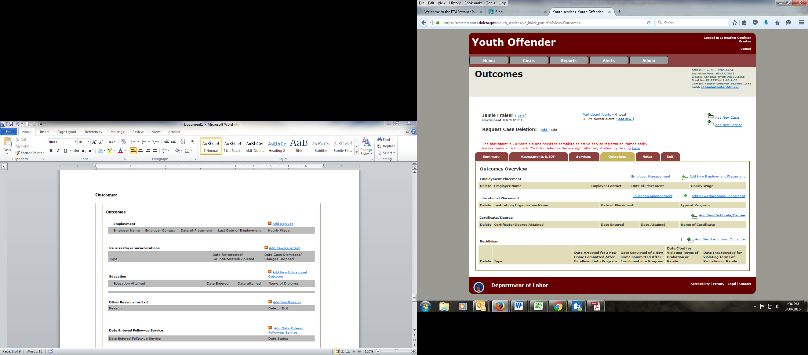

New Employment
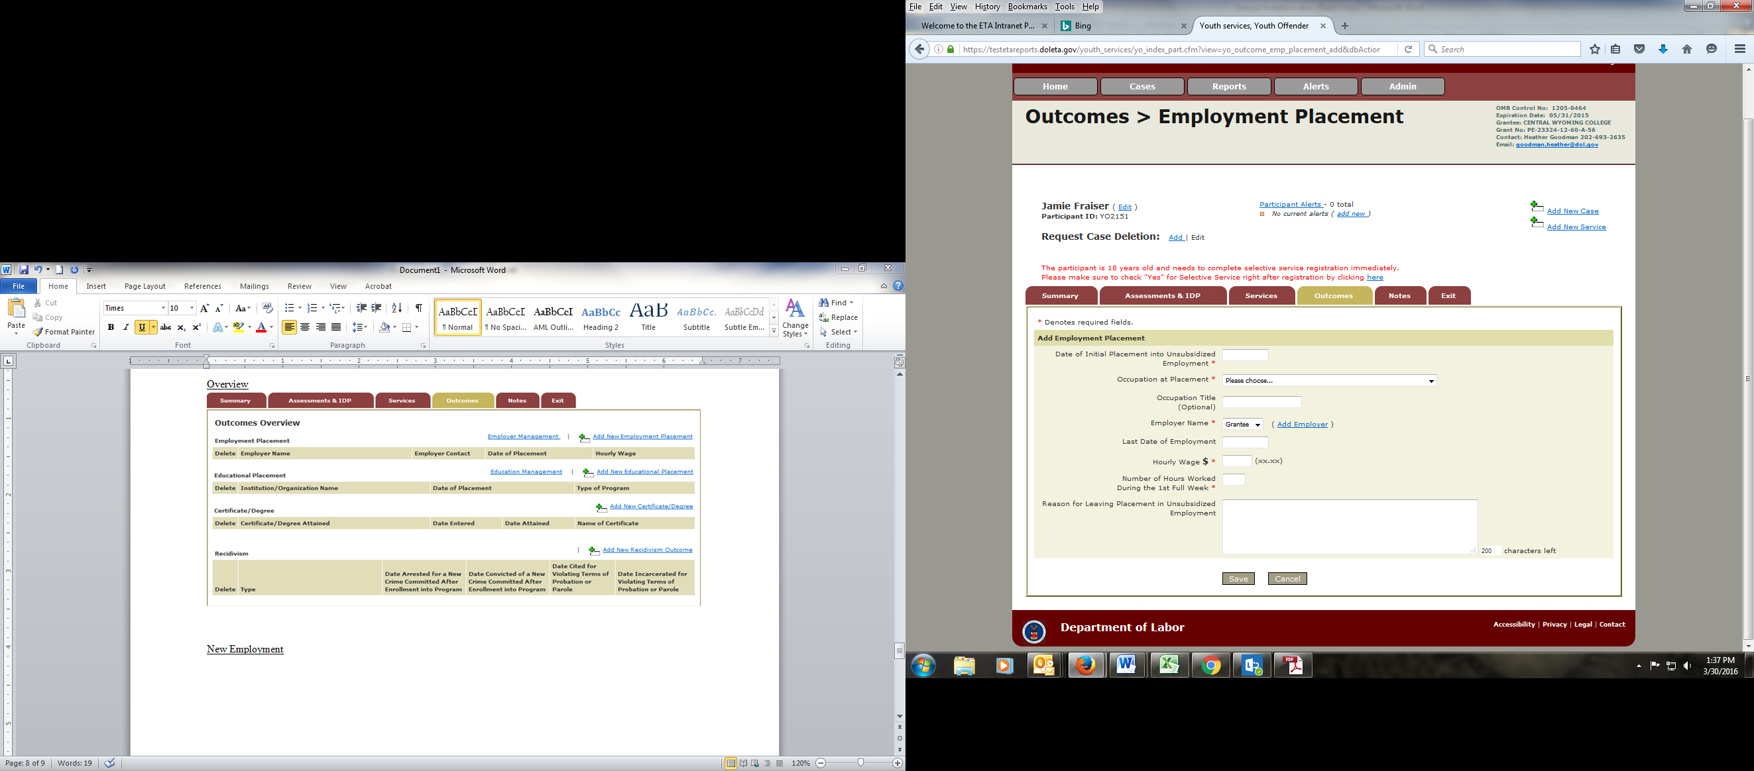

New Education
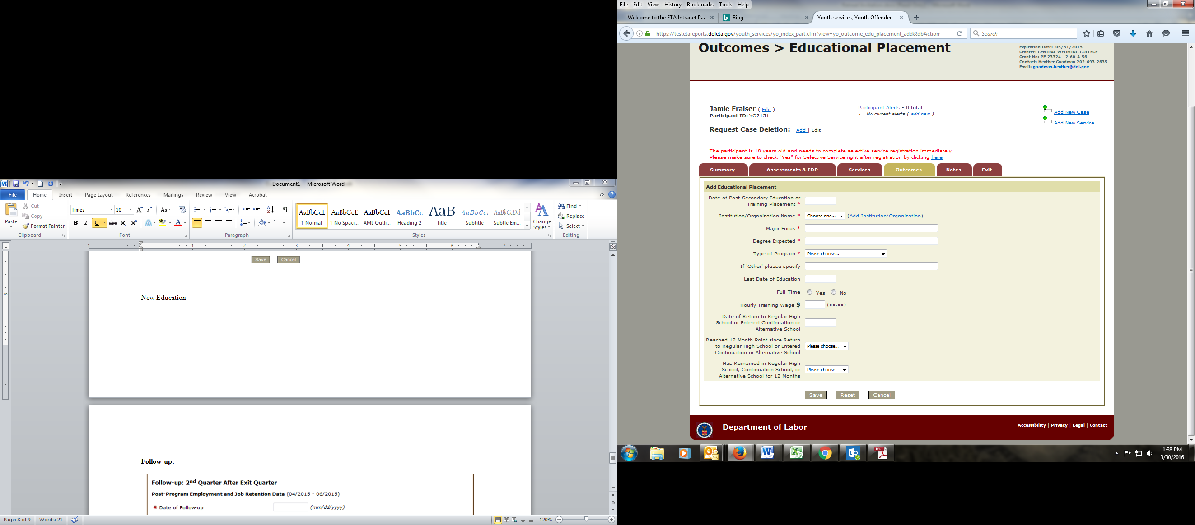

New Certificate/Degree
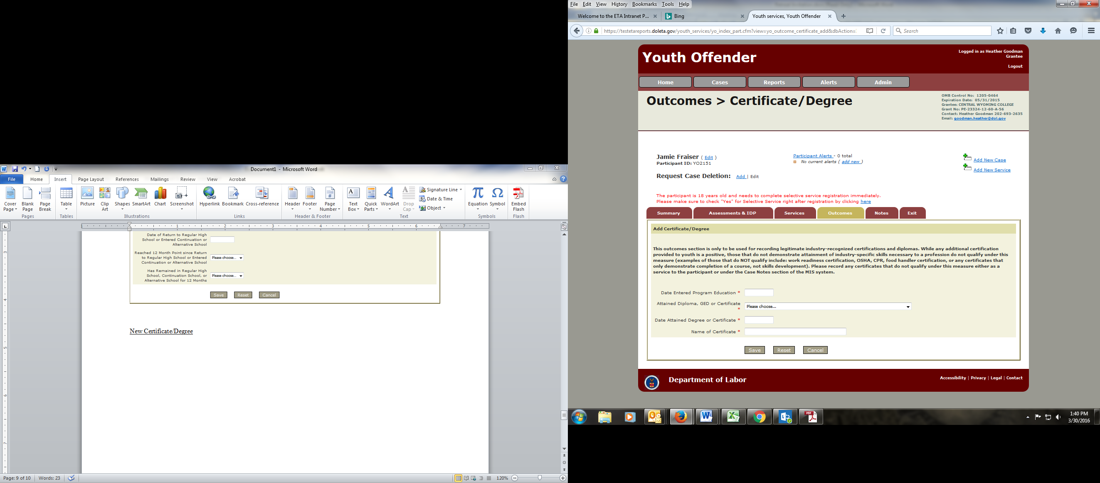

New Recidivism
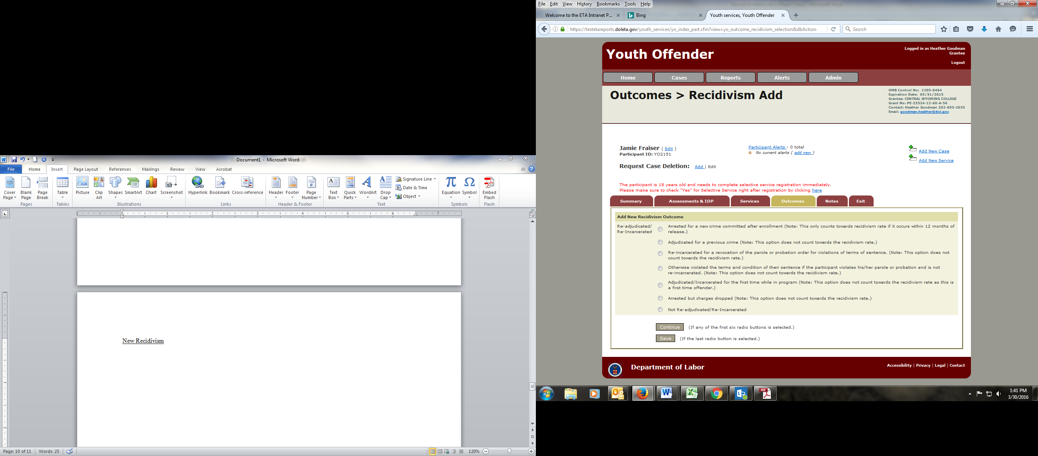

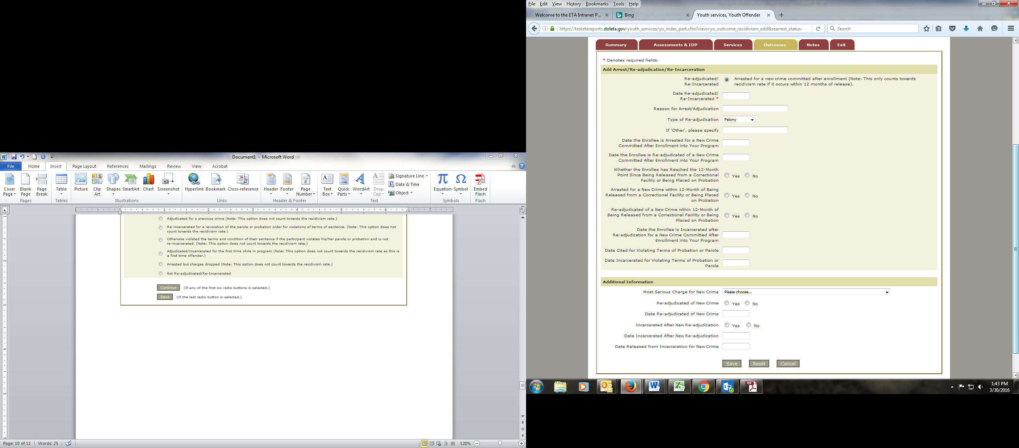
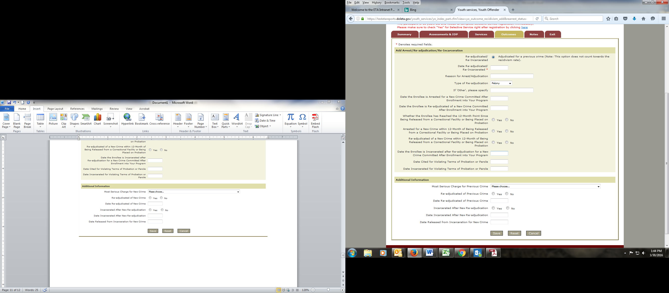
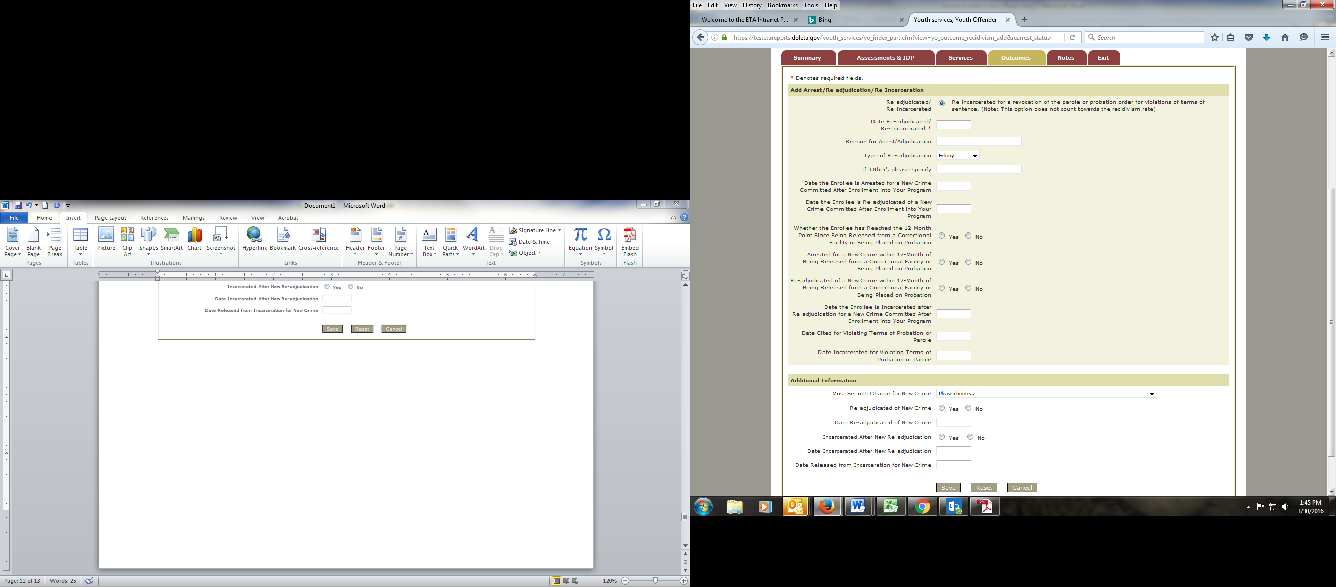

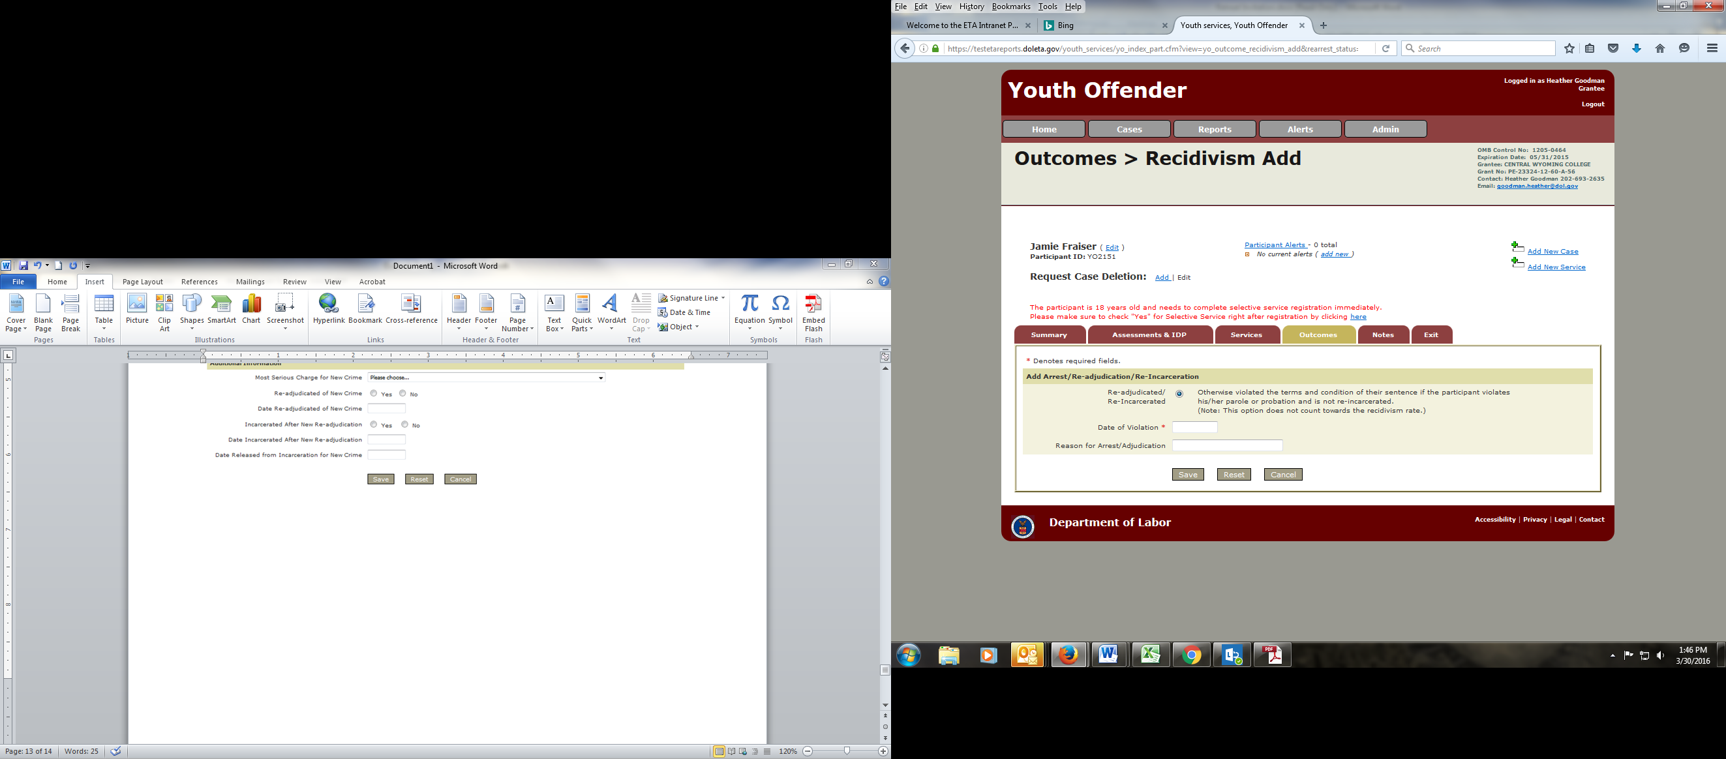
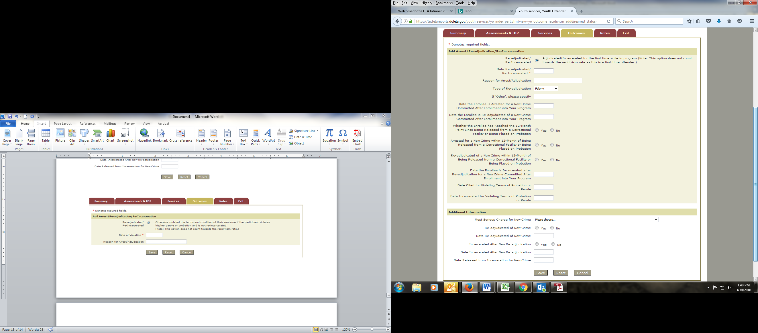
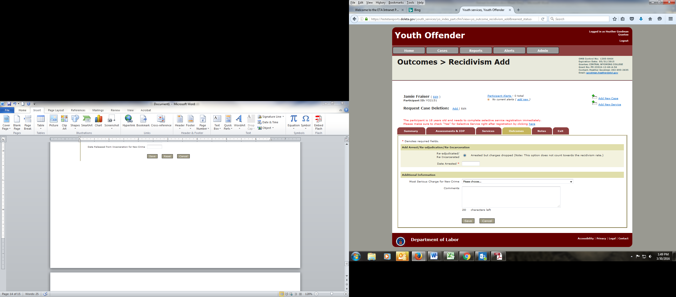
Exit:

Overview
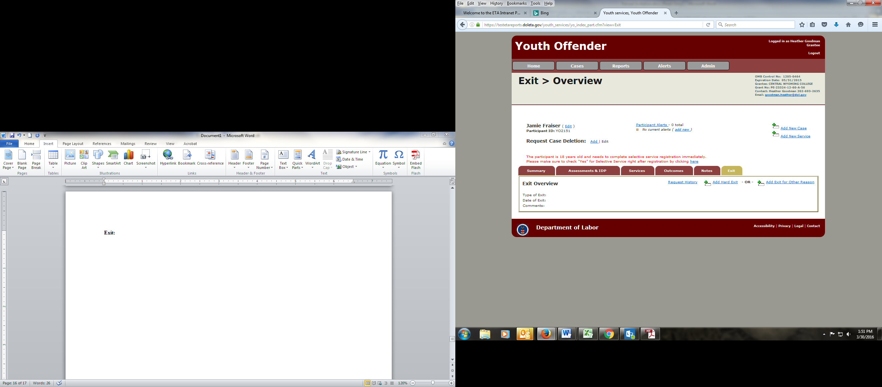

Hard Exit
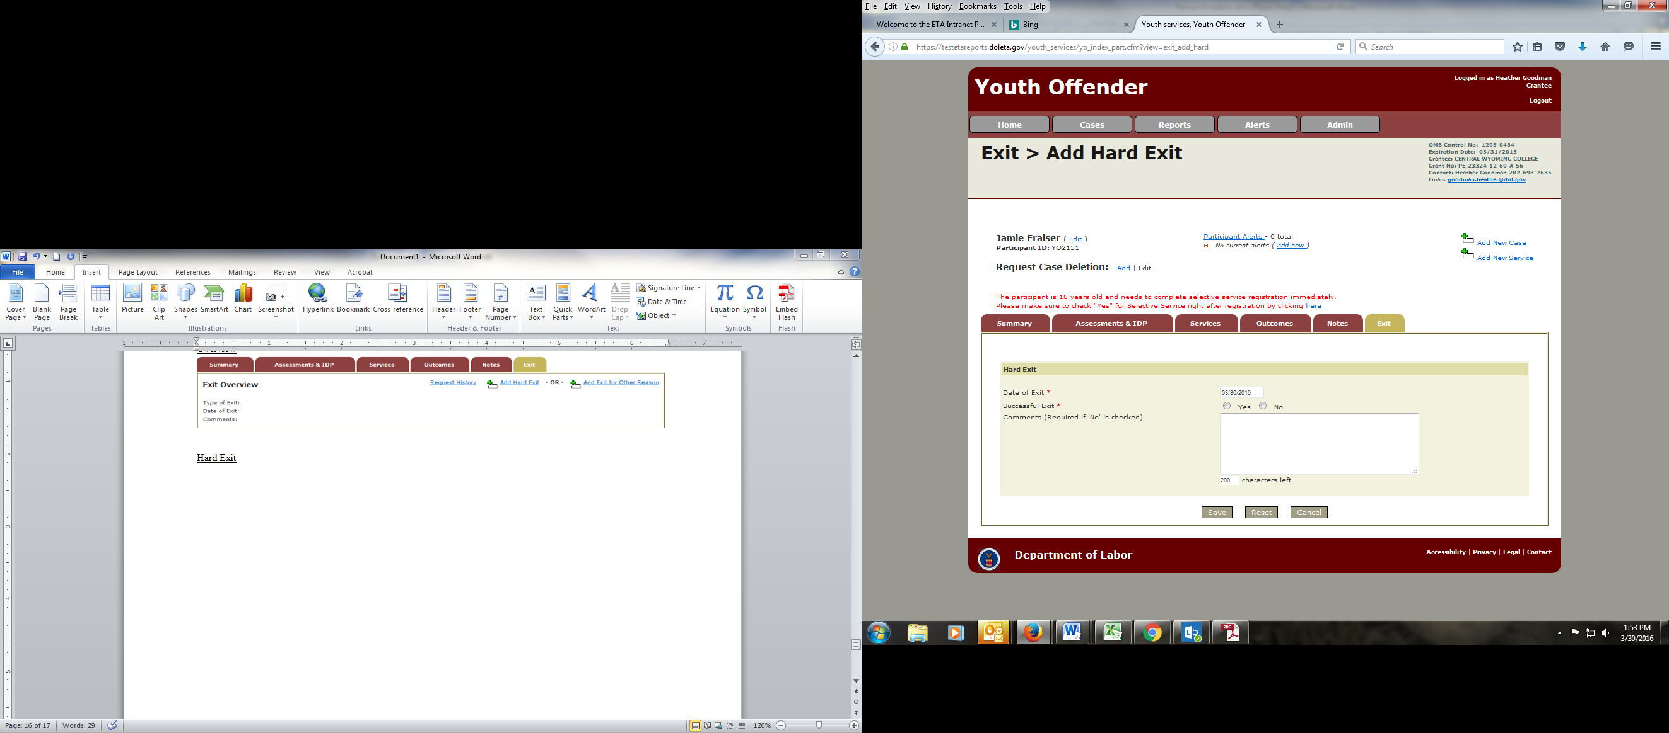

Other Exit
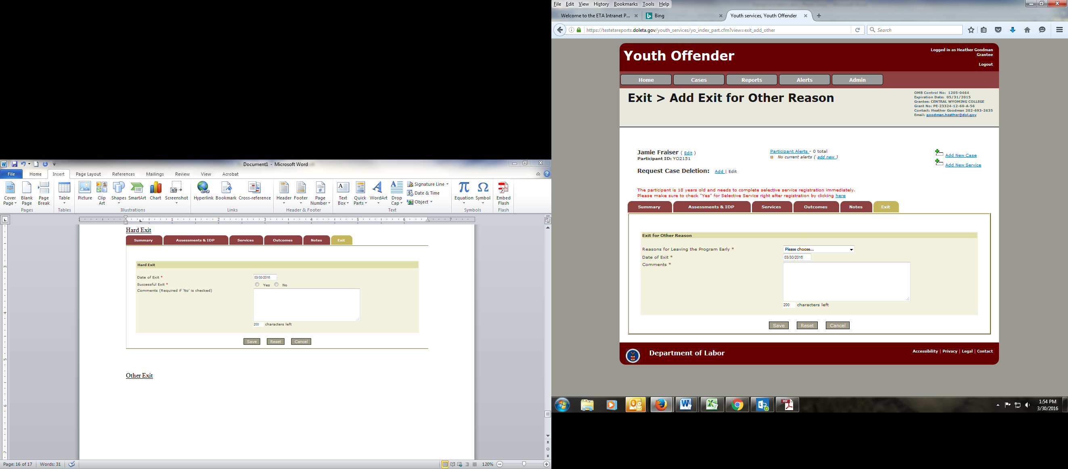
Follow-up:

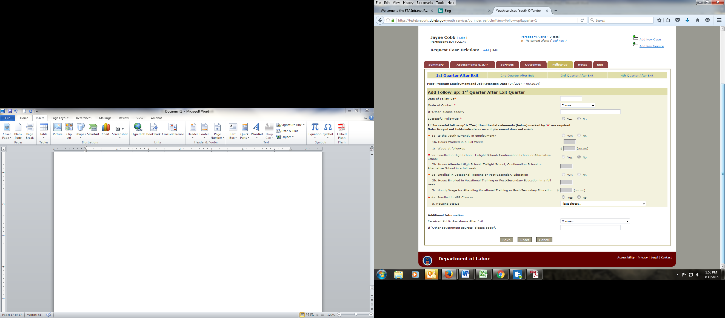

Public Burden Statement
This reporting requirement is approved under the Paperwork Reduction Act of 1995, OMB Control No. 1205-0513, expiring 09/30/2016. According to the Paperwork Reduction Act of 1995, no persons are required to respond to a collection of information unless such collection displays a valid OMB control number. The purpose of the information collection is collect data from youthful offender grantees including post-program data on outcomes to be made available to relevant congressional committees and during budget and allocation hearings. Public reporting burden for collecting information, which is required to obtain or retain benefits (PL 105-220 Sections 185 and 189), is estimated to average 45 minutes per record for the time of participants to provide the intake data and 2 hours for grantee staff to record the intake data and track the services and outcomes of participants, including the time for reviewing instructions, gathering and maintaining the data needed, and completing and reviewing the information. Send comments regarding this burden estimate or any other aspect of this collection of information, including suggestions for reducing this burden, to the U.S. Department of Labor, Employment and Training Administration, OWI Division of Youth Services, c/o Richard Morris, Washington, D.C. 20210 (Paperwork Reduction Project 1205-0513).

