**2017-18 NTPS Portal Usability Testing**

**Attachment 1**

**Recruitment, Consent Forms, and Receipt Acknowledgment Materials**

Table of Contents

Email text for personal and professional contacts 7

Text for advertisements on social media and/or Craig’s List 8

Recruiting Flyer 10

Informed Consent 11

Incentive Receipt Acknowledgement Form 12

Mailing Materials to be used during Interviews 13

# Email text for personal and professional contacts

Dear [contact]:

The U.S. Census Bureau is assisting with a study conducted by the National Center for Education Statistics (NCES) of the U.S. Department of Education. In an effort to improve a web survey, we are specifically looking for school administrators or administrative support staff for elementary, middle, or high schools to participate in a one-time voluntary web survey and provide feedback after taking it.

If you are eligible and participate in the study, you will receive $75 to thank you for your participation.

**What will I be doing in a usability study?**

You will be asked to complete the web survey and do several short tasks using the web. You will also be asked questions about your experience and perceptions of the web survey.

**What types of information will I be asked to provide?**

As part of this study, you will be asked to input into the web survey school address and basic information for each teacher at your school, such as teacher names, email addresses, subject matter taught, and full- or part-time status and school subjects. Please be assured that both the U.S. Department of Education and the U.S. Census Bureau follow strict procedures to protect the confidentiality of study participants. All of your responses may be used only for research purposes and may not be disclosed, or used, in identifiable form for any other purpose except as required by law (20 U.S.C., §9573).

**How long is a session?** 90 minutes

**When and where?**

The study will be held [DAYS, DATES]. Ideally, the session will take place at your school so you can access the necessary information. If that is not possible, we can hold sessions at our office in Suitland, MD or at a local library.

**Interested in participating?**

Please reply to this email with your contact information or call me at [ADD PHONE]. I’ll ask you some questions to help us determine if you are eligible for the study.

If someone you know is interested in participating, please contact [contact info].

Thank you for your time and help with this important study.

Sincerely,

[Recruitment Contact Info]

# Text for advertisements on social media and/or Craig’s List

**Education Research Study –Participants Needed**

The U.S. Census Bureau is looking for participants to help evaluate a new web survey conducted by the National Center for Education Statistics (NCES), part of the U.S. Department of Education. This survey is part of the National Teacher and Principal Survey (NTPS). Data from the NTPS are used by Congress, the U.S. Department of Education, state education agencies, public school districts, and education research organizations to:

* Evaluate the effects of school workplace conditions, salaries, and training opportunities on the educational workforce;
* Assess school staffing practices and personnel policies;
* Aid in the Department of Education’s program planning in the areas of teaching shortage incentives, teaching policies, and teacher education.

We are looking for individuals who:

* Work in the school as an administrator or administrative support staff;
* Have access to a list of teachers within the school; and
* Would be responsible for completing a survey or data collection at the school.

As part of this study, you will be asked to input school address and basic information, such as teacher names, emails, subjects, and full or part-time status into the web survey. You will also be asked questions about your experience and perceptions of the web survey. Please be assured that both the U.S. Department of Education and the U.S. Census Bureau follow strict procedures to protect the collected information.

This type of research is known as usability testing. We video-record your PC and audio-record your voice as you respond to the survey questions and take other notes as necessary; information collected during this study will be used for research purposes only. Usability testing sessions will last approximately 90 minutes. The research study will be conducted between [Date 1, 2017] and [Date 2, 2017]. So that you can access your records, it is best if the session takes place at your school. However, if that is not possible, we can conduct the session at the Census Bureau in Suitland, Maryland. The Census Bureau is next to the Green Line Metro Station. Free parking is available for those who drive.

**Eligibility to Participate:**

If interested, please call 301-763-4979 to complete a brief telephone screening in order to determine if you are eligible. The telephone screening will take approximately 5 minutes to complete. If eligible, the U.S. Census Bureau will schedule an interview at your convenience. Please contact Kevin Younes using the information below with questions. If you are eligible and participate in the study, you will receive $75 as a thank you for your participation.

**Shorter recruitment advertisement text for school staff and for BOC broadcast.**

K-12 School Staff Needed for Testing a National School Survey- Receive $75

The U.S. Census Bureau is looking for administrative staff in K-12 schools who can best provide information about the teachers at your school, including each teacher’s name, email address, subjects taught, and full- or part-time status. Public, charter, or private schools are welcome to participate! Interviews will be 90 minutes long and will be held at your school or at a convenient location. Participants will receive $75. Please call Kevin Younes at 301-763-4979 or email Kevin at Kevin.J.Younes@census.gov to learn more.

|  |
| --- |
| **BOC broadcast message**  Participants Needed for a Research Study |
| ***From the Desk of Paul Beatty, Chief, Center for Survey Measurement...***  The Center for Survey Measurement is seeking administrative staff in K-12 schools who can best provide information about the teachers at your school, including each teacher’s name, email address, subjects taught, and full- or part-time status. Public, charter, or private schools are welcome to participate. The interviews will be used to test the National Teacher, Principal Survey for the National Center for Education Statistics.  If you know anyone who meets these criteria, we'd appreciate it if you let them know of this research opportunity.  Interviews are around 90 minutes and take place at the school or at a location convenient to the participant during April and May*.*  Participants will receive $75.  **Please have interested participants contact us at (301) 763-4979 or email Kevin at Kevin.J.Younes@census.gov to learn more.** |

# Recruiting Flyer

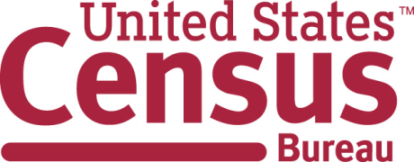

**You can participate if you are:**

**A school staff person in either an elementary, middle, or high school who can provide information about the teachers in your school, including names, email addresses, subjects taught and full or part-time status.**

The U.S. Census Bureau is looking for

Participants for a School Administrator Research Study

**$75 for a 90-minute session**

**Available dates: [Date 1] – [Date 2], 2017**

Aug 2016 - Sept 2016

**Call Kevin at: 301-763-4979**

**Kevin.J.Younes@census.gov**

**301-763-4979**

**————————-**

**Kevin.J.Younes@census.gov**

**301-763-4979**

**————————-**

**Kevin.J.Younes@census.gov**

**301-763-4979**

**————————-**

**Kevin.J.Younes@census.gov**

**301-763-4979**

**————————-**

**Kevin.J.Younes@census.gov**

**301-763-4979**

**————————-**

**Kevin.J.Younes@census.gov**

**301-763-4979**

**————————-**

**Kevin.J.Younes@census.gov**

**301-763-4979**

**­­————————-**

**Kevin.J. Younes@census.gov**

**301-763-4979**

**————————-**

**Kevin.J. Younes@census.gov**

**301-763-4979**

# Informed Consent



**Consent Form**

**For Individual Participants**

**Usability Testing of 2017 NTPS Portal**

Each year the Census Bureau conducts many different usability evaluations. For example, the Census Bureau routinely tests the wording, layout, and behavior of products, such as websites and online surveys in order to obtain the best information possible.

You have volunteered to take part in a study to improve the usability of the National Teacher and Principal Survey (NTPS) Portal. Census Bureau is administering the NTPS Portal usability testing on behalf of the National Center of Education Statistics (NCES). NCES is authorized to conduct this study by ESRA 2002 (20 U.S.C., § 9543).

In order to have a complete record of your comments, your usability session will be audio and video-recorded. Only your device will be video-recorded. We plan to use the recordings to improve the design of the product. Only staff directly involved in the research project will have access to the recordings. Your participation is voluntary and all of the information you provide may be used only for research purposes and may not be disclosed, or used, in identifiable form for any other purpose except as required by law (20 U.S. Code, § 9573). The OMB control number for this study is 1850-0803.

**I have volunteered to participate in this usability study, and I give permission for my recordings to be used for the purposes stated above.**

Participant’s Name: ______________________________________

Participant's Signature: ____________________________________ Date: ­­­­­__________

Researcher’s Name: _____________________________________

Researcher's Signature: ___________________________________ Date: __________

# Incentive Receipt Acknowledgement Form

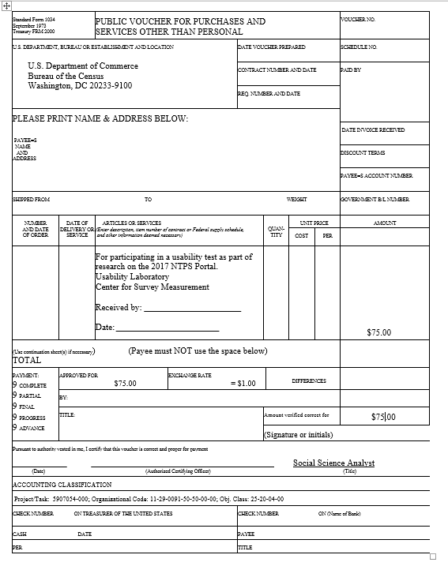

# Mailing Materials to be used during Interviews

Figure 1: Letter for main part of usability test

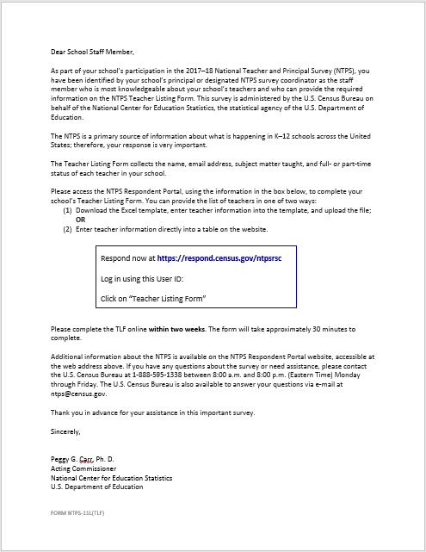

Figure 2: For the main part of the interview if the participant is a coordinator

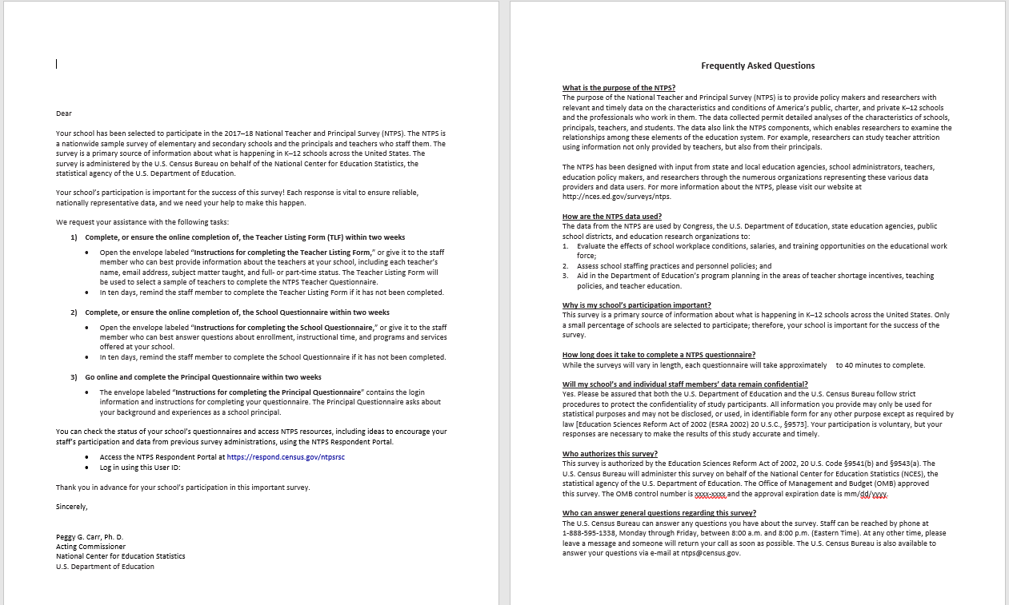

Figure 3: For the main part of the interview - if the participant is a principal

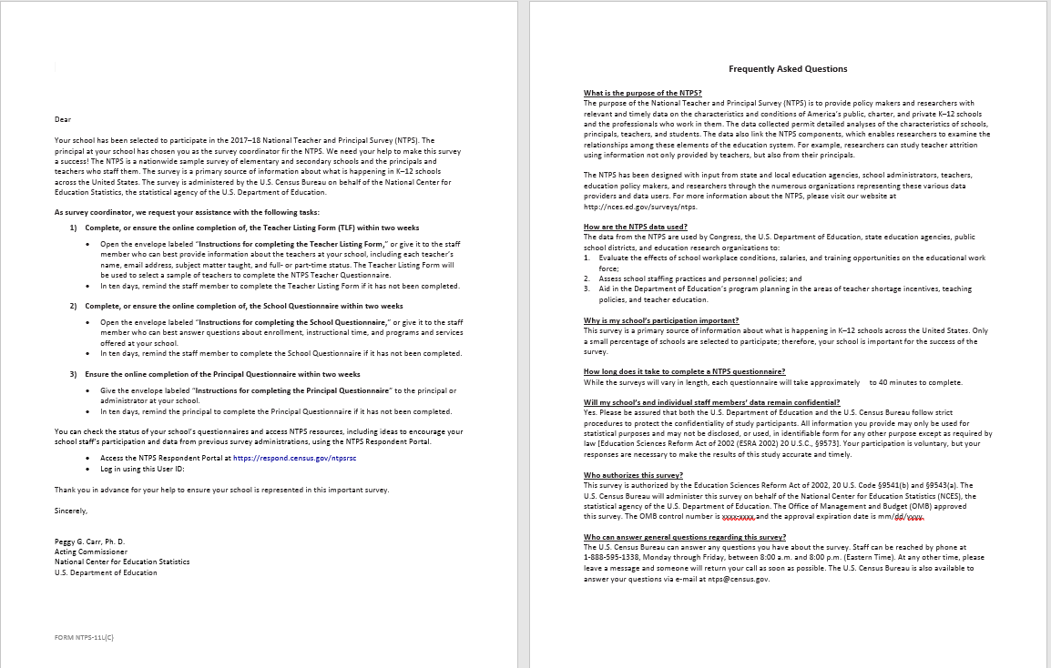

Figure 4: Letter and FAQs for Vignette 1

