UNITED STATES OF AMERICA
FEDERAL ENERGY REGULATORY COMMISSION

Data Collection for Analytics and Surveillance and Market-Based Rate Purposes |  | Docket No. RM16-17-000

NOTICE OF THE TECHNICAL WORKSHOP ON THE DRAFT DATA DICTIONARY ATTACHED TO THE DATA COLLECTION FOR ANALYTICS AND SURVEILLANCE AND MARKET-BASED RATE PURPOSES NOTICE OF PROPOSED RULEMAKING

(July 21, 2016)

The Notice of Proposed Rulemaking on Data Collection for Analytics and Surveillance and Market-Based Rate Purposes (NOPR) issued today in Docket No. RM16-17 proposes to revise the Commission’s regulations to collect certain data for analytics and surveillance purposes from market-based rate (MBR) sellers and entities trading virtual products or holding financial transmission rights and to change certain aspects of the substance and format of information submitted for MBR purposes. In the NOPR, the Commission also states that a data dictionary posted to the Commission’s website would define the framework to be followed by users in submitting information for inclusion in the relational database and that staff will hold technical workshops on the data dictionary and the submittal process. This notice announces a technical workshop to review the draft data dictionary attached to the NOPR.
All interested parties are invited to attend. The workshop will be held in Washington, D.C., on August 11, 2016 from 9:00 a.m. to 4:00 p.m. at FERC headquarters in the Commission Meeting Room, 888 First Street, NE, Washington, D.C. For those unable to attend in person, access to the workshop sessions will be available by webcast.
The workshop is intended to provide a forum for interactive, detailed discussion of the elements contained in the sample data dictionary. Commission staff will lead the workshop. The agenda for the workshop is attached. Notes from the workshop will be posted on FERC.gov.
Due to the detailed, substantive nature of the subject matter, parties interested in actively participating in the discussion are encouraged to attend in person. All interested parties (whether attending in person or via webcast) are asked to register online at https://www.ferc.gov/whats-new/registration/08-11-16-form.asp. There is no registration fee.
Those wishing to actively participate in the discussion by telephone during the workshop should send a request for a telephone line to RM16-17.NOPR@ferc.gov by close of business on Friday, August 5th, with the subject line: RM16-17 NOPR Workshop Teleconference Request.
Commission workshops are accessible under section 508 of the Rehabilitation Act of 1973. For accessibility accommodations please send an email to accessibility@ferc.gov or call toll free 1-866-208-3372 (voice) or 202-502 -8659 (TTY); or send a fax to 202-208-2106 with the required accommodations.

For additional information, please contact David Pierce of FERC's Office of Enforcement at (202) 502-6454 or send an e-mail to RM16-17.NOPR@ferc.gov.

Kimberly D. Bose,
Secretary.
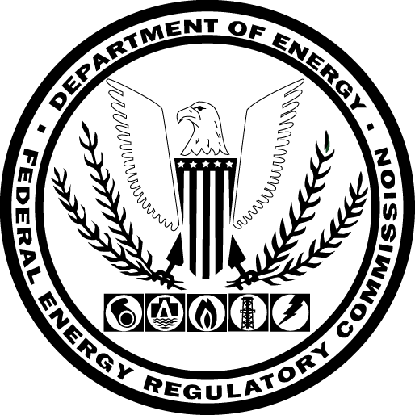

AGENDA
Technical Workshop on the Draft Data Dictionary Attached to the Data Collection For Analytics and Surveillance and Market-Based Rate Purposes Notice of Proposed Rulemaking

August 11, 2016
Commission Meeting Room
FERC, 888 1st St. NE
Washington, DC
Session I
Welcome, Introductions, Logistics
Fact and Dimensions Tables
Filing Information
Natural Person
Entities
Generation Assets
Dimensions Tables
Session II
Market-Based Rate Tables
Authorizations
Category Status & Mitigations
Other Authorizations & Limitations
Indicative Screens
Contracts
Long-Term Power Purchase Agreements
Contracts

AGENDA
(continued)
Technical Workshop on the Draft Data Dictionary Attached to the Data Collection For Analytics and Surveillance and Market-Based Rate Purposes Notice of Proposed Rulemaking

Session III
Linking Tables
Entities to Entities
Natural Person Affiliates to Entities
Entities to Generation Assets
Seller Entities to Vertical Assets
Entities to RTO/ISO Accounts
Traders to RTO/ISO Accounts
Entities to NAESB/OATI Purchaser Seller Entity ID
Traders to Entities
Entities to CID

Data Collection for Analytics and Surveillance and Market-Based Rate Purposes, 156 FERC ¶61, 045 (2016).
Id. at P 15.

