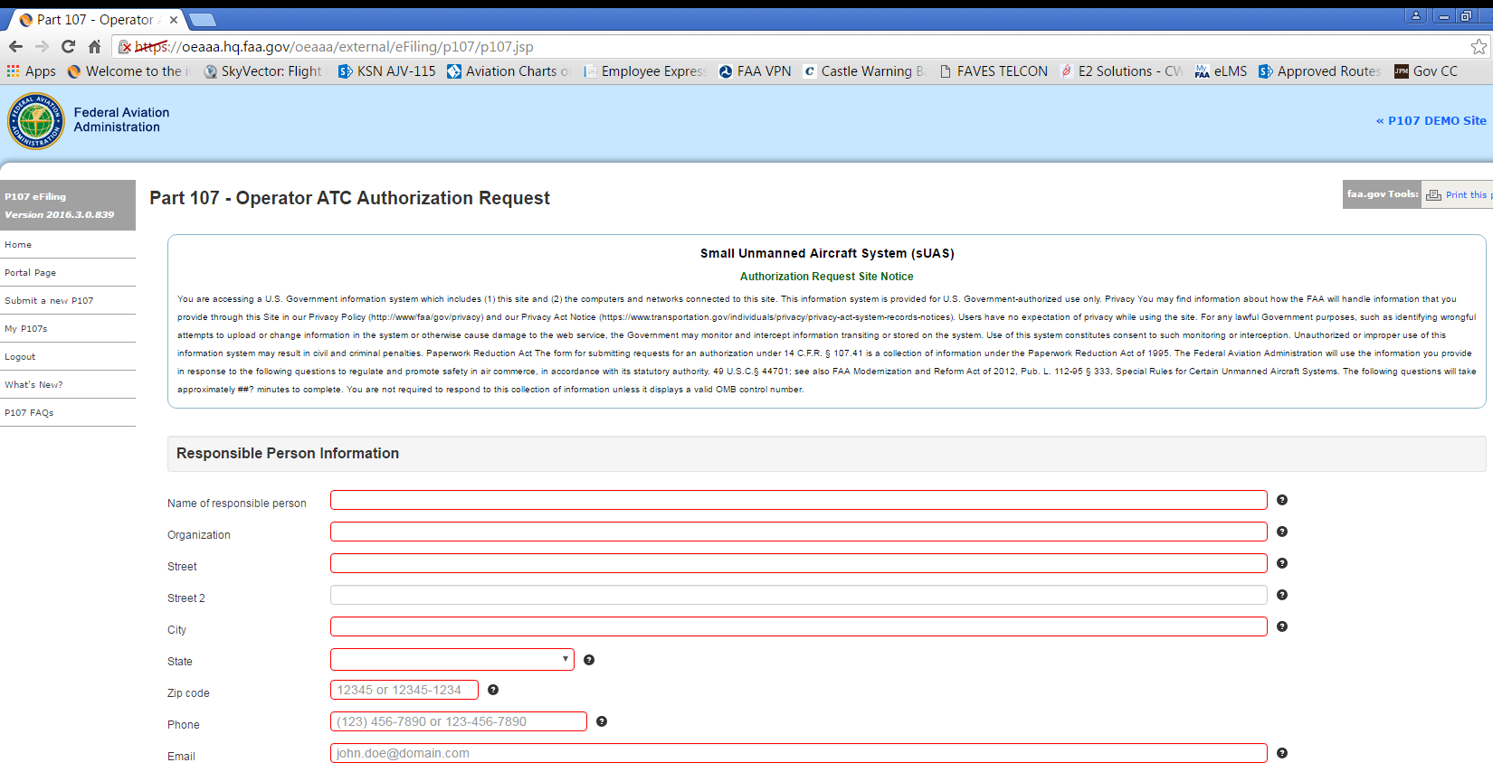
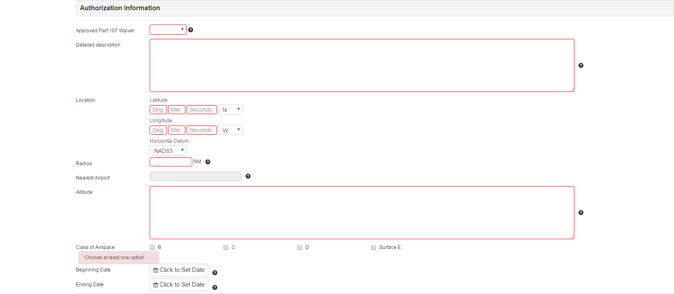
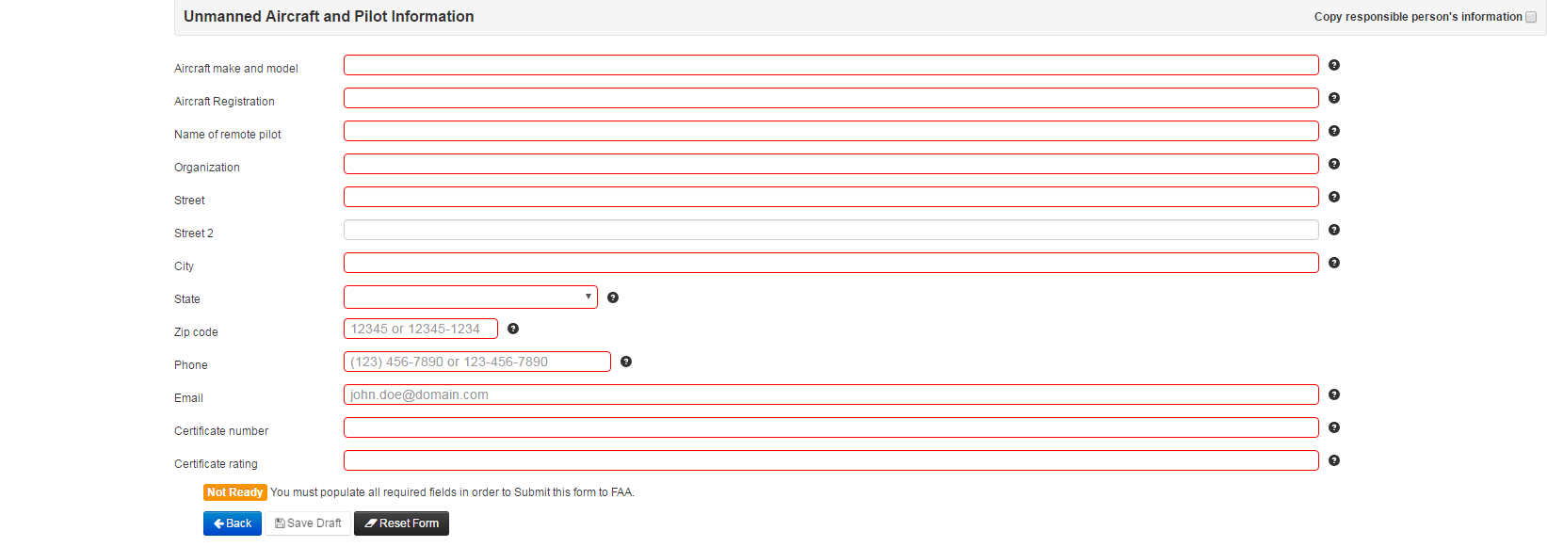
Question Mark Icons display the following when hovering over:
Icon number | Text Displayed Upon Hovering
Responsible Person Information
1 | Name of the proponent
2 | Organization of the proponent
3 | Address of the proponent
4 | Additional address of the proponent
5 | City of the proponent
6 | State of the proponent
7 | Zip code of the proponent
8 | Phone number of the proponent
9 | Email of the proponent
Authorization Information
1 | Whether there are any waiver(s) approved
 | Note: when the applicant selects “YES,” a box appears stating, “Please attach approved waiver(s):” adjacent to an “Attach File” button and a “Browse” button. Once attached successfully, a link to the document appears at the end of the form adjacent to a field heading titled “Support Documents.”
2 | Detailed description of the proposed operation. Attach supplement if needed (after the draft saved).
 | Latitude and Longitude entry blocks display brief instructions upon clicking in each block (e.g., “Please enter a valid number between -10 and 73”)
3 | Circle radius of the location in nautical miles (NM).
4 | The nearest airport if available. This information will be populated by the system automatically.
5 | Describe the altitude the UAS will operate (example: at or below 400ft AGL)
6 | Beginning date and time
7 | Ending date and time
Unmanned Aircraft and Pilot Information
1 | Enter the aircraft type. Please include the make and model.
2 | A valid registration number is required. TBD is not acceptable.
3 | Name of the pilot/operator
4 | Organization of the pilot/operator
5 | Address of the pilot/operator
6 | Additional address of the pilot/operator
7 | City of the pilot/operator
8 | State of the pilot/operator
9 | Zip code of the pilot/operator
10 | Phone number where air traffic control can reach the remote pilot/operator if necessary
11 | Email address of the pilot/operator
12 | Certificate number of the pilot/operator
13 | Certificate rating of the pilot/operator
At the bottom of the form, once all necessary fields are complete, a green box stating “Valid” appears, as well as a blue button stating “Submit to FAA →”
Applicants will also have the following options at the end of the form:
“← Back”
“Update Draft”

