|  |
| --- |
|  |
| Wireframes |
|  |
| OneCPD Needs Assessment  OneCPD Resource Exchange Project Portal  August 24, 2012 |
|  |

Table of Contents

Field Office - Assessment Input 3

Field Office Assessment - Print View 7

Grantee - Assessment Input 9

Grantee Self Assessment - Print View 13

TA Provider - Assessment Input 15

TA Provider Assessment - Print View 21

# Field Office - Assessment Input

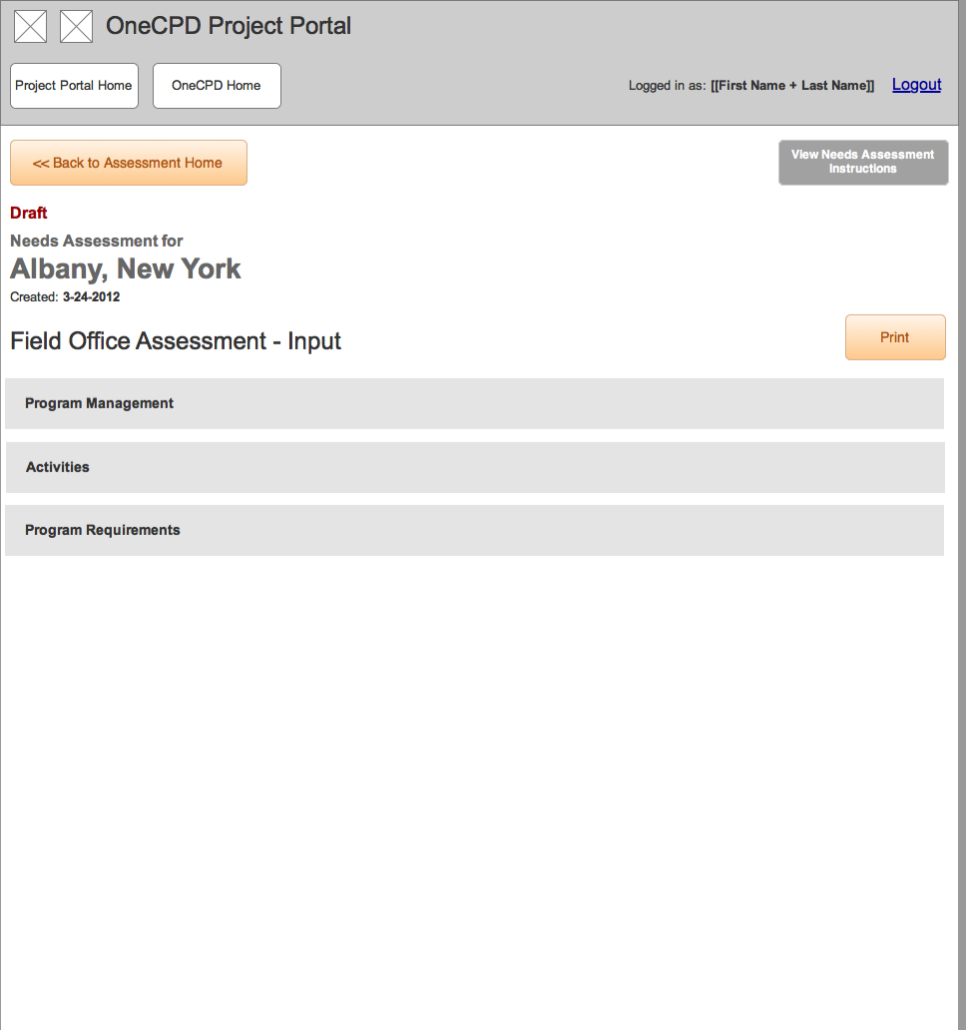

## Program Management Survey

### State1

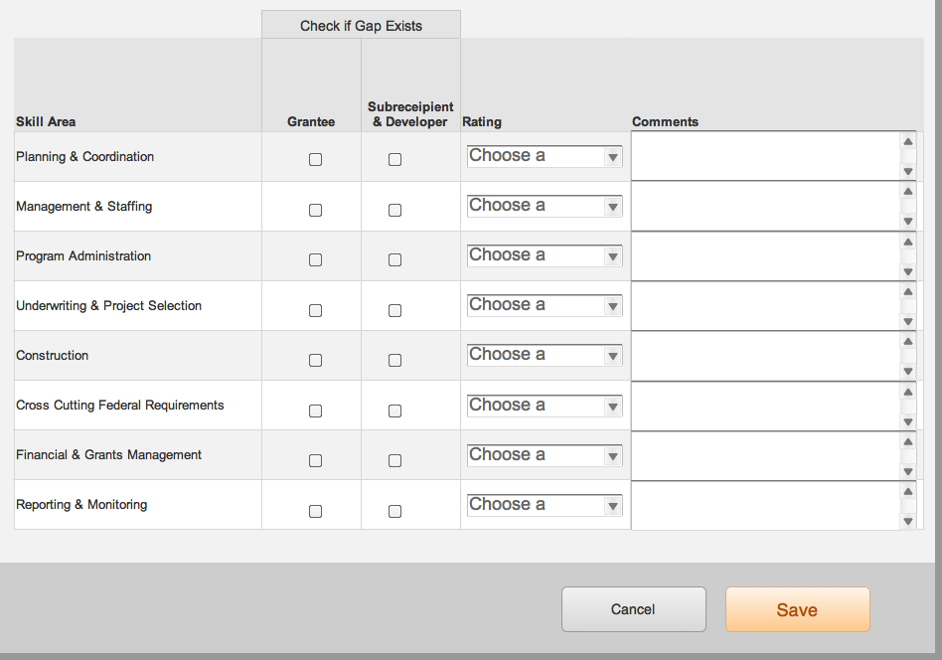

## Program Requirements Survey

### State1

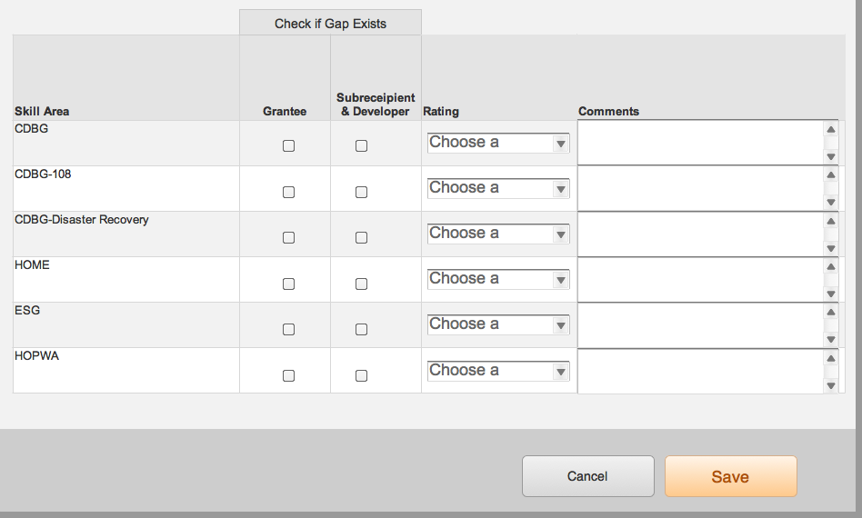

## Activities Survey panel

### State1

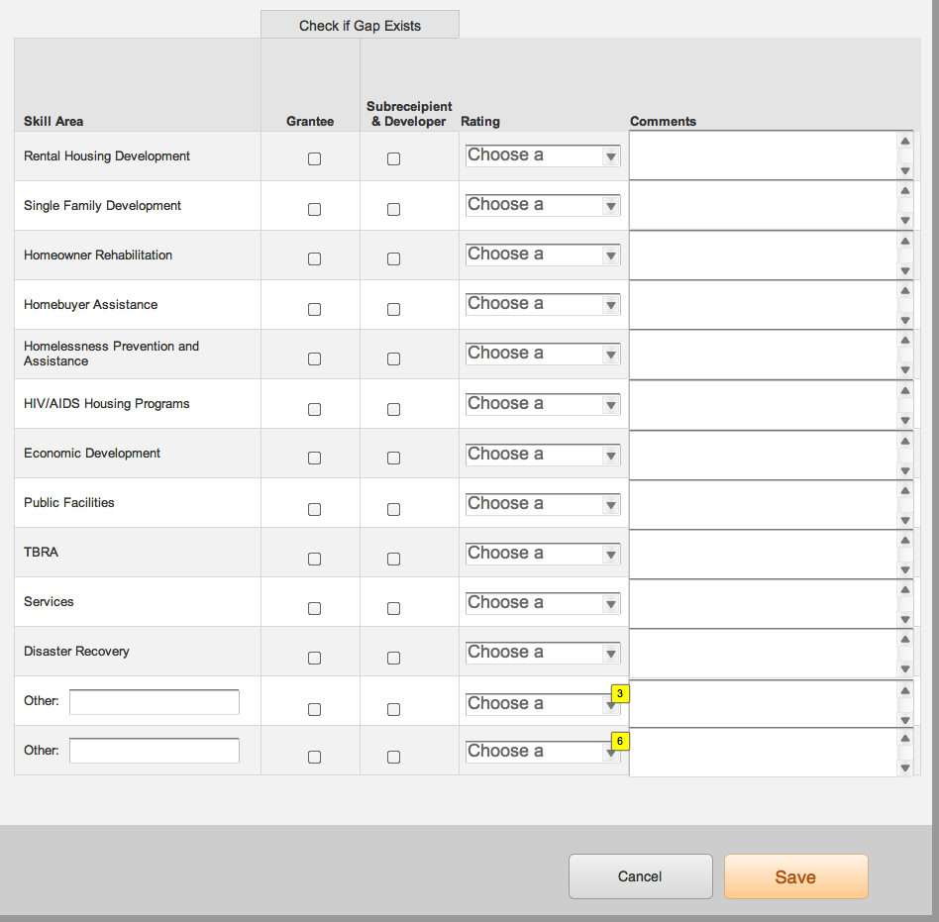

# Field Office Assessment - Print View

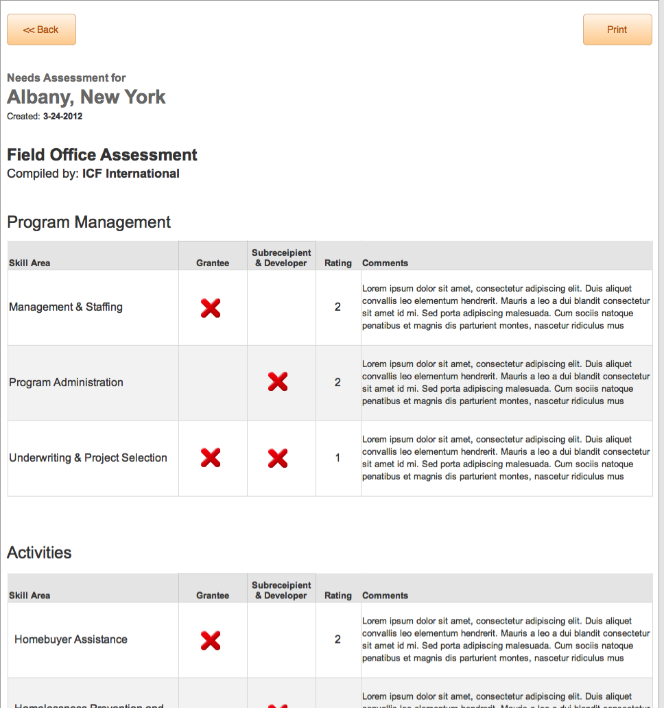

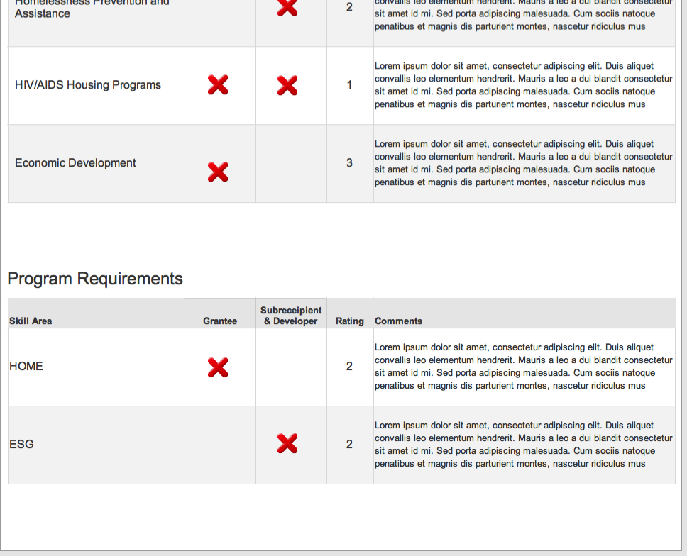

# Grantee - Assessment Input

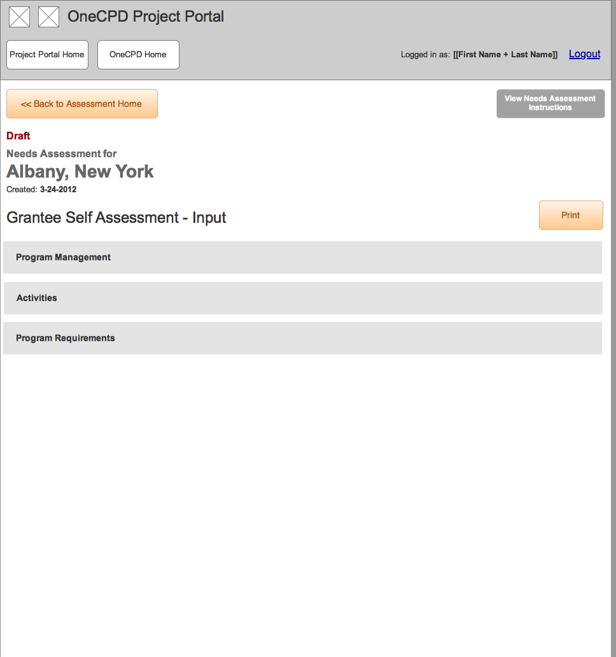

## Program Management Survey

### State1



## Program Requirements Survey

### State1



## Activities Survey panel

### State1

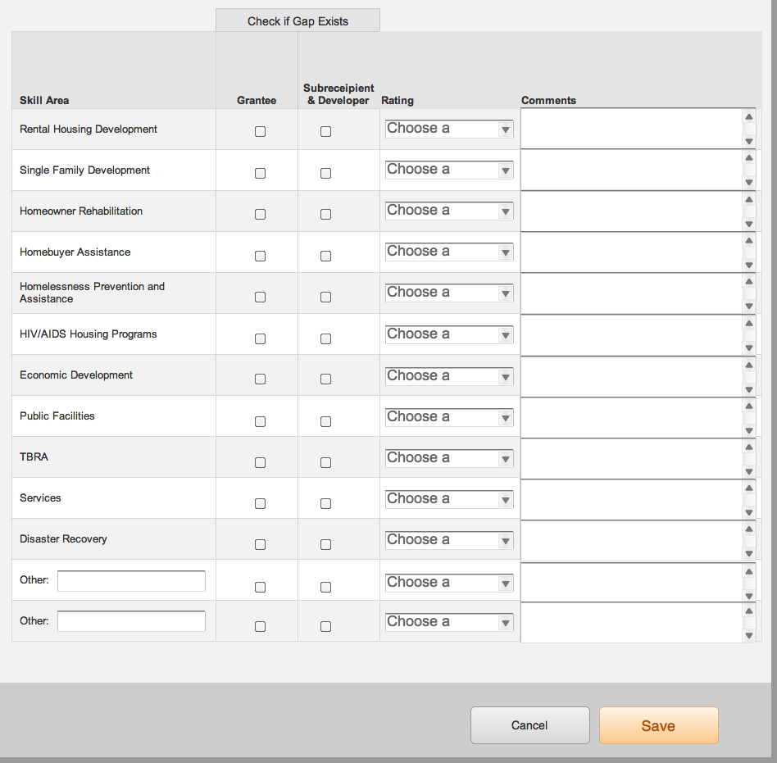

# Grantee Self Assessment - Print View

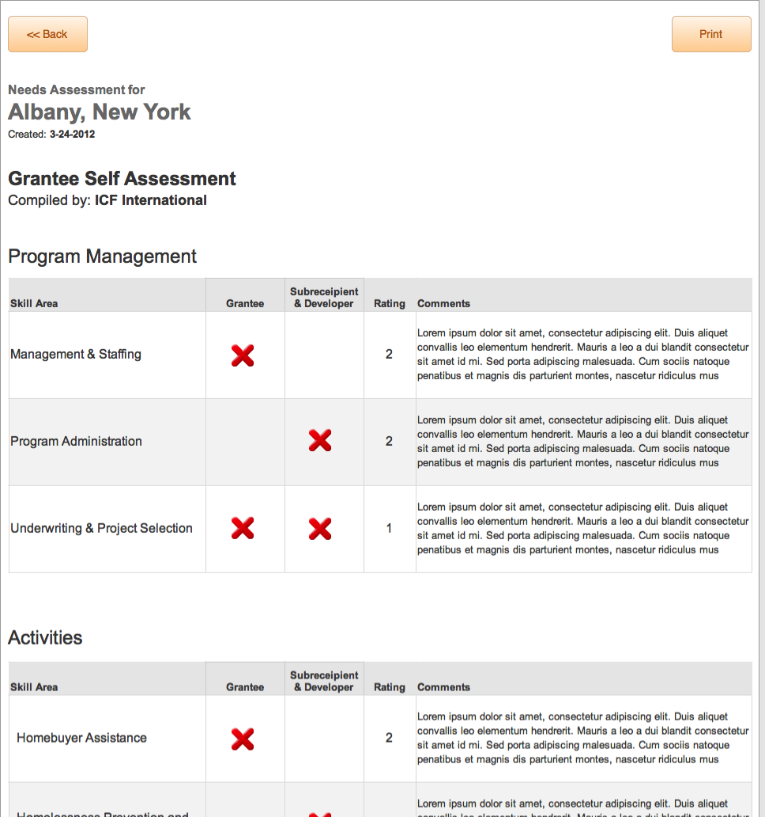

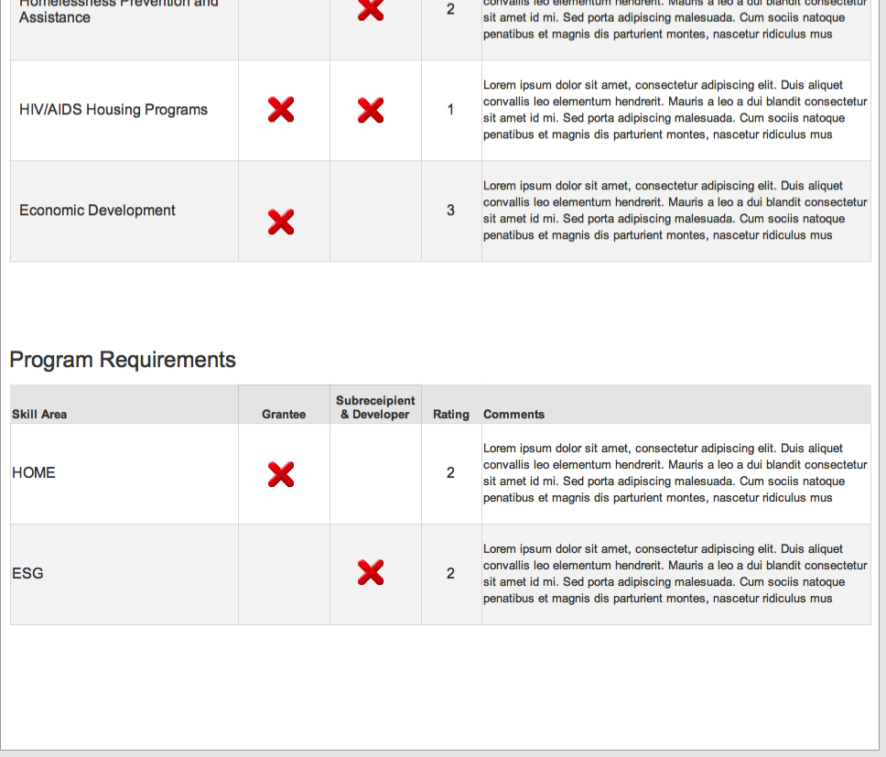

# TA Provider - Assessment Input

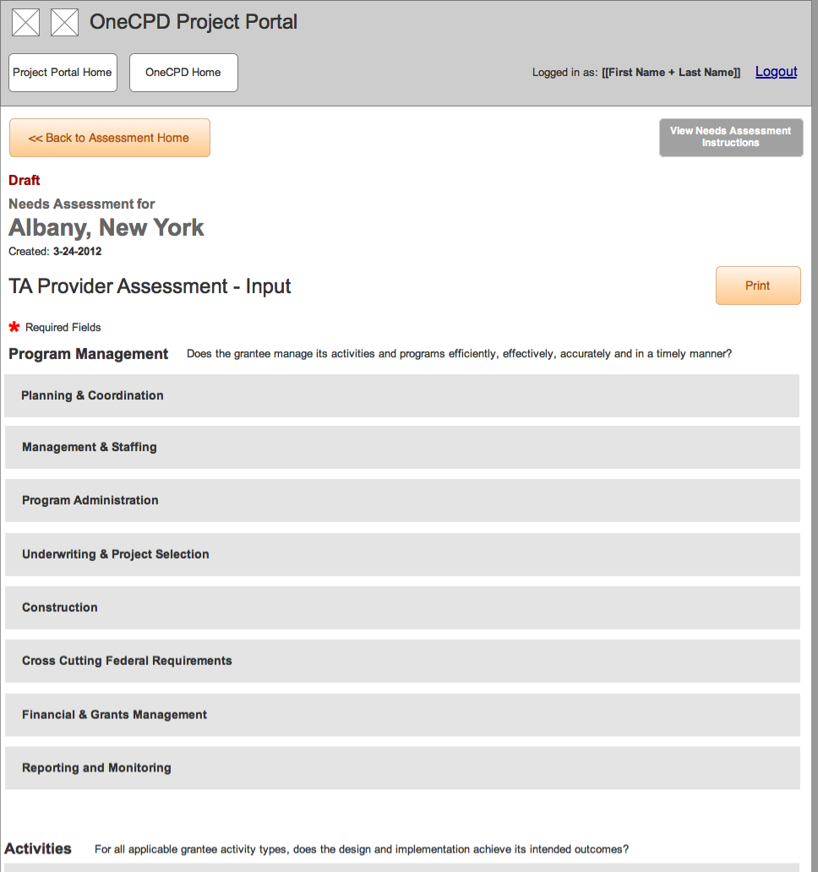

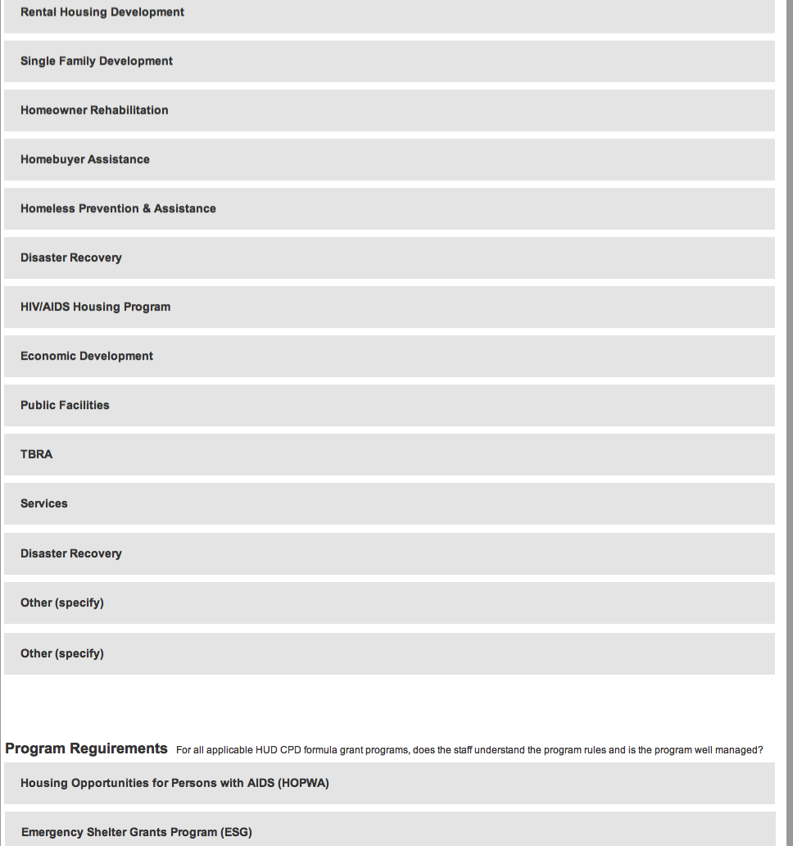

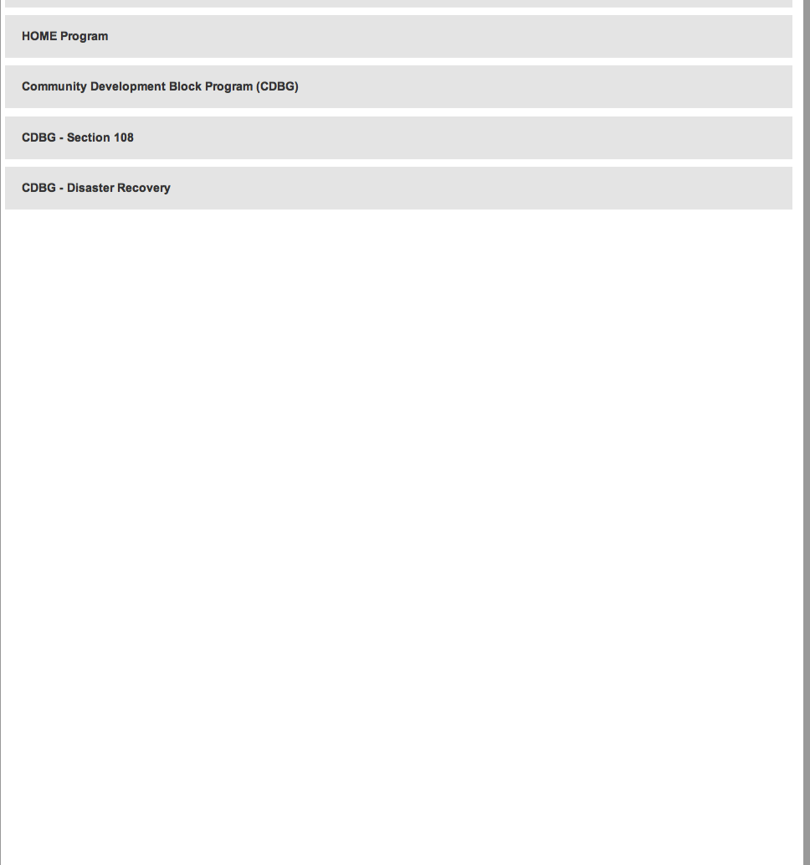

## Program Management Survey

### State1

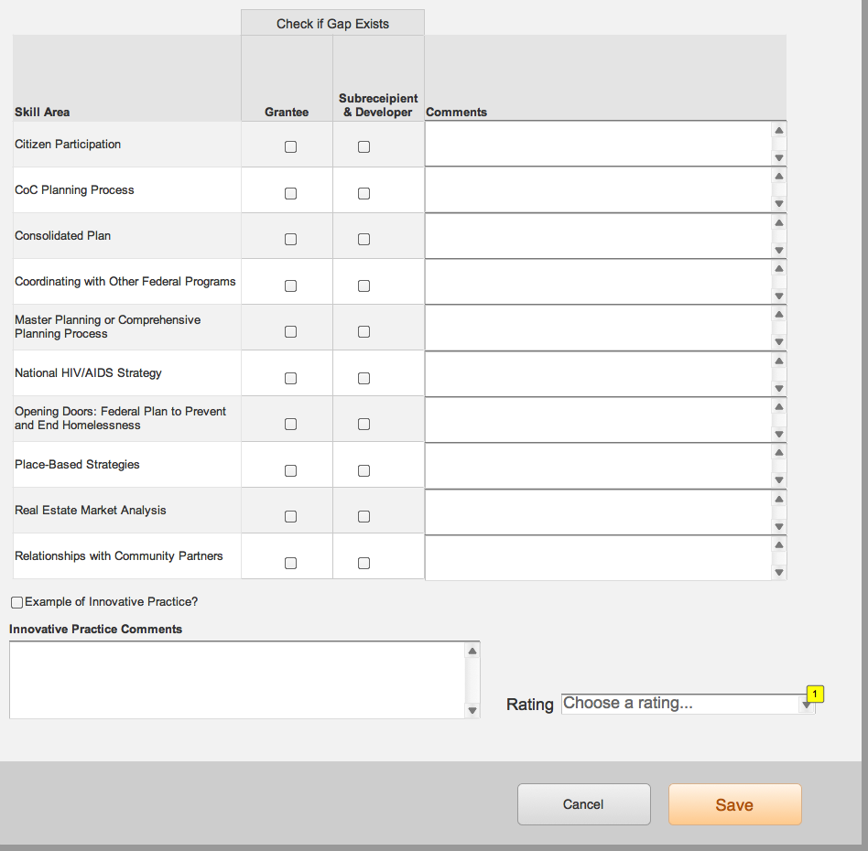

## Other Activities Survey panel

### State1

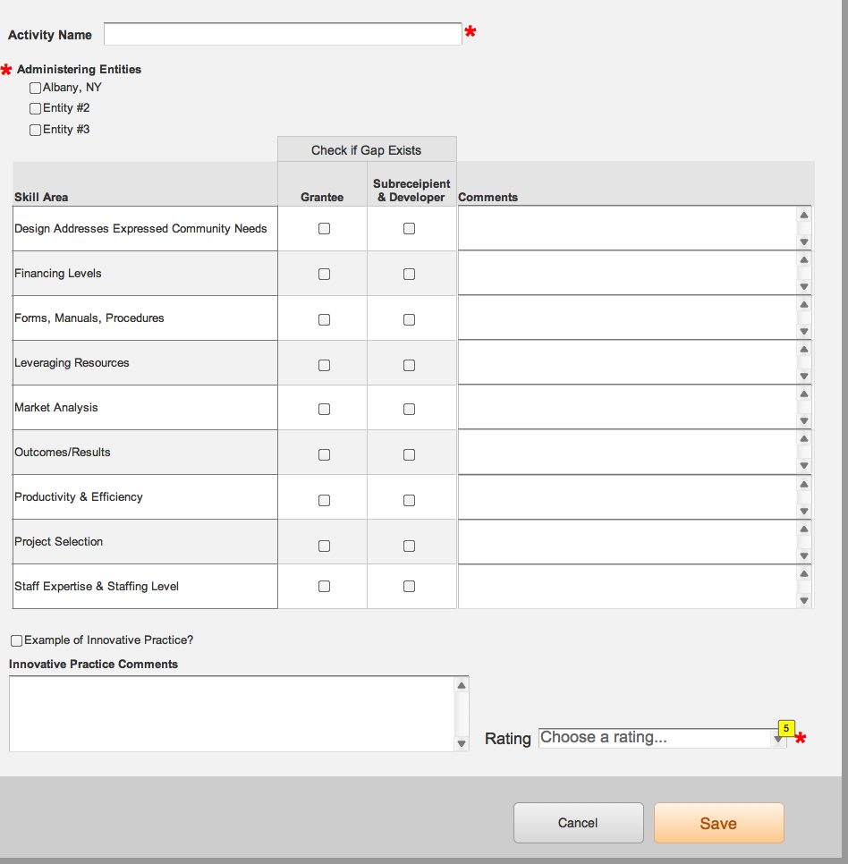

## HOPWA Survey panel

### State1

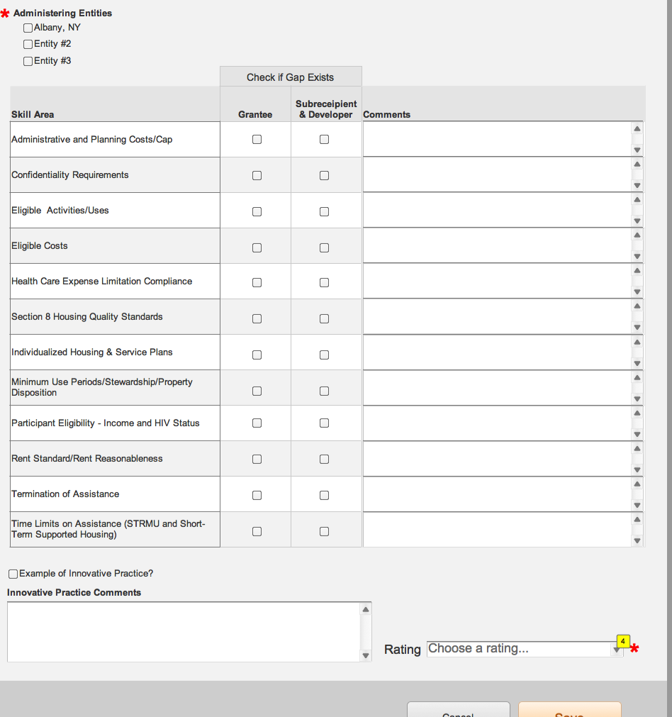



# TA Provider Assessment - Print View

