Farmers’ Market and Local Food Promotion Program (FMLFPP)
  - 2016 PROJECT NARRATIVE FORM AND INSTRUCTIONS
This form is mandatory. Thoroughly review the applicable Request for Applications (RFA) (FMPP RFA or LFPP RFA) before completing this form. This narrative form provides the basis for peer review evaluation using the scoring criteria in Section 5.0 of the respective grant program RFA.
- Applicant Organization Must match box 8 of the SF-424.
Name |  | Mailing Address
Email
Phone
Fax

- Authorized Organization Representative (AOR) This person will be the main contact for any FMLFPP correspondence and is responsible for signing any documentation should the grant be selected.
Name |  | Mailing Address | ☐ Check if same as above
Email
Phone
Fax

- Applicant Entity Type Select each applicable entity type as defined in Section 3.1 of the RFA. If your organization is a State Agency Regional Farmers Market Authority, you must provide the regulatory statute(s) that identify your agency as that entity type.
☐ Agricultural cooperative  ☐ Nonprofit corporation  ☐ Local government  ☐ Community Supported Agriculture (CSA) association  ☐ Tribal government  ☐ Producer network  ☐ Producer association | ☐ Public benefit corporation  ☐ CSA network  ☐ Economic development corporation  ☐ Regional farmers market authority  ☐ Agricultural business entity  ☐ State Agency Regional Farmers Market Authority (indicate regulation below): ___________________________________  ☐ Other (specify below): ___________________________________
- Project Activity Category Identify any/all of the activity categories that fit your project.
☐ Aggregation  ☐ Agritourism  ☐ Farm to Institution  ☐ Farmer Recruitment and Retention  ☐ Food Safety  ☐ Infrastructure  ☐ Marketing and Promotion  ☐ Production Diversification /Expansion | ☐ Organic  ☐ Processing  ☐ Season Extension  ☐ Training and Education  ☐ Transportation and Distribution  ☐ Other (specify below): ___________________________________

- Project Title
Must match box 15 of the SF-424.

- Grant Application Type (Described in Section 1.3 of the RFA):
FMPP:  ☐ Capacity Building  ☐ Community Development Training and Technical Assistance | LFPP:  ☐ Planning  ☐ Implementation

- Requested FMLFPP Funds  Insert the total amount ($) of Federal funds requested. This must match the total amount requested on Line 5 of the SF-424A. | $
- Matching Funds (if applicable)  This box applies ONLY for LFPP applications, which are required to provide a 25% match. See Section 3.5 of LFPP’s RFA for more information. | $
- Does the proposal address a Priority Area as described in Section 1.4 of the RFA?  See instructions on how to determine priority eligibility at Qualifying for Priority Consideration at the end of this form. | ☐ Yes ☐ No
- If you are working directly with a Promise Zone partner, identify the Promise Zone?
See Section 4.3.9 of the RFA. If the proposal involves a Promise Zone Implementation Partner, the HUD Promise Zone Certification Form must accompany the proposal at the time of application.

- Project Implementation Physical Address Enter up to three addresses where this project will be implemented. If you are requesting consideration as a priority area, enter the Food Access Research Atlas Low Income/Low Access (LI/LA) Census Tract number. See Qualifying for Priority Consideration at the end of this form for instructions on looking up your Census Tract number.

 | Address | Food Access Research Atlas  LI/LA Census Tract # (if applicable)
Address 1:
Address 2:
Address 3:

- Executive Summary—In 200 words or less, describe the project’s need, purpose, goals, and expected outcomes:
- Have you received a past FMPP or LFPP grant award? ☐ Yes ☐ No
  - If yes, provide the information below.

Year: | Type of Grant:  FMPP Grant  LFPP Planning Grant  LFPP Implementation Grant | Describe How this Project is/was Different From or Supplements the Proposed Activities

- Have you submitted this project to another Federal grant program for funding and/or is another Federal grant program currently funding the project? ☐ Yes ☐ No

If yes, fill out the below section.
Federal Grant Program Name(s) | Describe How this Project is/was Different From or Supplements the Proposed Activities

- Alignment and Intent
- Describe the specific issue, problem, or need that the project will address, in relation to the statutory language (found in the RFA in Section 1). Answering this question should justify the project’s objectives and approach and not just provide the associated statistics.

- List project objectives for the completion of this project. The objectives must be related to addressing the issue(s), problem(s), or need(s) mentioned in the above section and related to the project’s approach and work plan. Add objectives as necessary.
  - Objective 1:
  - Objective 2:
  - Objective 3:
  - Objective 4:
  - Objective 5:
- Who are the intended beneficiaries of this project and how many are there? Specifically, the project should benefit farm and ranch operations serving local markets.

- What are the expected short- and long-term impacts to the beneficiaries of this project? Specifically, the project should focus on the benefits to farm and ranch operations serving local markets.

- Technical Merit
- Work Plan: Describe the activities and timeline associated with each project objective. Include the following information for each objective mentioned in the Project Background:
A timeline for each activity and major output including the anticipated date of completion; Expected outcomes for each year of the project; Activities to be completed the project partners and collaborators; How and where the activities will take place; Required resources; Milestone(s) for assessing progress and success; Who is responsible for completing the activity, including collaborative arrangements or subcontractors; If conducting training and technical assistance, how will participants be recruited? How will you help guide program development and delivery?

- Outcome Indicators: Complete all Outcomes and Indicators that are relevant to the project with benchmark and/or target numbers. If you cannot provide the information, explain the reasoning (e.g. “Does not apply because…”). The exception is Outcome 4, which should only be completed for projects that have a food safety component). These outcomes and indicators are the same for both LFPP and FMPP because they are two components of FMLFPP. Applicants may provide additional Outcome(s) and Indicator(s) should they choose.
  - Outcome 1: To Increase Consumption of and Access to Locally and Regionally Produced Agricultural Products.
    - Of the [insert total number of] consumers, farm and ranch operations, or wholesale buyers reached:
      - The number that gained knowledge on how to buy or sell local/regional food OR aggregate, store, produce, and/or distribute local/regional food:____
      - The number that reported an intention to buy or sell local/regional food OR aggregate, store, produce, and/or distribute local/regional food:____
      - The number that reported buying, selling, consuming more or supporting the consumption of local/regional food that they aggregate, store, produce, and/or distribute:____
  - Of the [insert total number of] individuals (culinary professionals, institutional kitchens, entrepreneurs such as kitchen incubators/shared-use kitchens, etc.) reached:
    - The number that gained knowledge on how to access, produce, prepare, and/or preserve locally and regionally produced agricultural products:____
    - The number that reported an intention to access, produce, prepare, and/or preserve locally and regionally produced agricultural products:____
    - The number that reported supplementing their diets with locally and regionally produced agricultural products that they produced, prepared, preserved, and/or obtained:____
  - Outcome 2: Increase Customers and sales of local and regional agricultural products.
    - Sales increased from $________ to $_________ and by ______ percent (^{n} final – ^{n} initial/^{n} initial (100) =% change), as result of marketing and/or promotion activities during the project performance period.
    - Customer counts increased from [total number of] to [total number of] customers and by _____percent (^{n} final – ^{n} initial/^{n} initial (100) =% change) during the project performance period.
  - Outcome 3: Develop new market opportunities for farm and ranch operations serving local markets.
    - Number of new and/or existing delivery systems/access points of those reached that expanded and/or improved offerings of:
      - Farmers markets:____
      - Roadside stands:____
      - Community supported agriculture programs:____
      - Agritourism activities:____
      - Other direct producer-to-consumer market opportunities:____
      - Local and regional Food Business Enterprises that process, aggregate, distribute, or store locally and regionally produced agricultural products:____
    - Number of local and regional farmers and ranchers, processors, aggregators, and/or distributors that reported:
      - An increase in revenue expressed in dollars: _____
      - A gained knowledge about new market opportunities through technical assistance and education programs: ______
    - Number of:
      - New rural/urban careers created (Difference between "jobs" and "careers": jobs are net gain of paid employment; new businesses created or adopted can indicate new careers): _______
      - Jobs maintained/created:_______
      - New beginning farmers who went into local/regional food production: _____
      - Socially disadvantaged famers who went into local/regional food production: _____
      - Business plans developed:____
  - Outcome 4: Improve the food safety of locally and regionally produced agricultural products. (Only applicable to projects focused on food safety!)
    - Number of individuals who learned about prevention, detection, control, and intervention food safety practices:_____
    - Number of those individuals who reported increasing their food safety skills and knowledge:______
    - Number of growers or producers who obtained on-farm food safety certifications (such as Good Agricultural Practices or Good Handling Practices):_______
  - Additional Outcome(s) and Indicator(s) (REQUIRED: Identify based on relevant project activities not covered above):
Indicator(s):
- Describe how you will disseminate project’s results (positive and negative) to similar organizations, stakeholders, and others that may be interested in the project’s results or implementing a similar project.

- Achievability
  - Describe your evaluation plan for measuring and achieving each relevant outcome and indicator, including the project-specific outcome and indicator.

  - Discuss if and how this project can be adapted to other regions, communities, and/or agricultural systems.

  - What are the potential challenges that may be encountered that would limit your ability to fulfill the objectives of this project and your strategy to address these challenges?

  - If the project and/or entity was previously funded, provides a depiction of the previous project’s results that includes what was learned from the past project(s), what can be improved upon, and how those lessons and improvements are being incorporated into this application to make the ongoing project more effective and successful at meeting program goals.

- Expertise and Partners
  - List project contributors, including applicant staff and external project partners and collaborators, and describe their relevant experience and past successes in developing and operating projects similar to those to be conducted under this project.
Project Contributor | Relevant Experience

  - Describe the key role of all project contributors and your plans for coordination, communication, data sharing and reporting among members of the project team and stakeholder groups, both internal applicant personnel and external partners and collaborators.

  - Describe how the project, and its partnerships and collaborations, will be sustained beyond the project’s period of performance (grant funds).
- Fiscal Plan and Resources

Please complete the budget justification below and ensure that you have included Critical Resources and Infrastructure letters to support the information.

Budget Justification The expenses outlined in the Budget Justification must align with the activities provided in the Project’s Timeline and need to fulfill the Project’s Objectives and Expected Outcomes. The subtotal amounts for each cost category mentioned below must also match the amounts provided in each cost category in the SF-424A. Refer to Section 4.7.3 Allowable and Unallowable Costs and Activities of the RFA for more information on allowable and unallowable expenses. Applications submitted for consideration under LFPP must include the matching contribution in this section
  - Personnel List each person who has a substantive role in the project and the amount of the request and/ or the value of their match.
Personnel # | Name/Title and How the Individual’s Role Relates to the Objectives as Described under 15b Above | Level of Effort (# of hours OR % FTE) | Funds Requested
Personnel 1
Personnel 2
Personnel 3
Personnel Subtotals |  |  | $

  - Fringe Benefits Provide the fringe benefit rates for each of the project’s salaried employees above.
Personnel # | Name/Title | Fringe Benefit Rate | Funds Requested
Personnel 1
Personnel 2
Personnel 3
Fringe Benefits Subtotals |  |  | $

  - Travel Explain the purpose for each Trip Request. Please note that travel costs are limited to those allowed by formal organizational policy; in the case of air travel, project participants must use the lowest reasonable commercial airfares. For recipient organizations that have no formal travel policy and for-profit recipients, allowable travel costs may not exceed those established by the Federal Travel Regulation, issued by GSA, including the maximum per diem and subsistence rates prescribed in those regulations. This information is available at http://www.gsa.gov.
Trip # | Trip Destination and Travel Date(s) | Trip Purpose and How Travel Relates to Objectives Described Under 15b Above | Type of Expense  (airfare, car rental, hotel, meals, mileage, etc.) | Unit of Measure  (days, nights, miles) | # of Units | Cost per Unit | # of Travelers Claiming the Expense | Funds Requested
Travel Subtotals |  |  |  |  |  |  |  | $

☐ By checking this box, I affirm that my organization’s established travel policies will be adhered to when completing the above-mentioned trips in accordance with 2 CFR 200.474 or 48 CFR subpart 31.2 as applicable.
  - Equipment Describe any special purpose equipment to be purchased or rented under the grant. ‘‘Special purpose equipment’’ is tangible, nonexpendable, personal property having a useful life of more than one year and an acquisition cost that equals or exceeds $5,000 per unit and is used only for research, medical, scientific, or other technical activities. Rental of "general purpose equipment’’ must also be described in this section. Purchase of general purpose equipment is not allowable under this grant.

Item # | Item Description, How Equipment will be Used to Meet Objectives Described Under 15b Above | Rental or Purchase | Acquire When? | Funds Requested
Equipment Subtotals |  |  |  | $

  - Supplies List the materials, supplies, and fabricated parts costing less than $5,000 per unit and describe how they will support the purpose and goal of the proposal.
Item Description | Per-Unit Cost | # of Units/Pieces Purchased | Acquire When? | Funds Requested
Supplies Subtotal |  |  |  | $

  - Contractual Contractual/consultant costs are expenses associated with purchasing goods and/or procuring services performed by an individual or organization other than the applicant in the form of a procurement relationship. If there is more than one contractor or consultant, each must be described separately. (List each contract/consultant separately.)
Contract # | Name/Organization, Justification for Contract, and How Work Relates to Objectives Described Under 15b Above | Hourly Rate / Flat Rate | Funds Requested
Contractual Subtotal |  |  | $

☐ By checking this box, I affirm that my organization followed the same policies and procedures used for procurements from non-federal sources, which reflect applicable State and local laws and regulations and conform to the Federal laws and standards identified in 2 CFR Part 200.317 through.326, as applicable. If the contractor(s)/consultant(s) are not already selected, I affirm that my organization will follow the same requirements.
  - Other Include any expenses not covered in any of the previous budget categories. Be sure to break down costs into cost/unit. Expenses in this section include, but are not limited to, meetings and conferences, communications, rental expenses, advertisements, publication costs, and data collection.
Item Description and How Expense Relates to Objectives Described Under 15b Above | Per-Unit Cost | # of Units/Pieces Purchased | Acquire When? | Funds Requested
Other Subtotal |  |  |  | $

  - Indirect Indirect costs (also known as “facilities and administrative costs”—defined at 2 CFR §200.56) represent the expenses of doing business that are not readily identified with a particular grant, contract, project function or activity, but are necessary for the general operation of the organization and the conduct of activities it performs. For the indirect cost formula and additional information, refer to Section 4.7.1 of the RFA.
Indirect Cost Rate Requested (%) | Funds Requested | Matching Funds  LFPP only
 | $ | $

  - Program Income Program income is gross income—earned by a recipient or subrecipient under a grant—directly generated by the grant-supported activity, or earned only because of the grant agreement during the grant period of performance. Program income includes, but is not limited to, income from fees for services performed; the sale of commodities or items fabricated under an award (this includes items sold at cost if the cost of producing the item was funded in whole or partially with grant funds); registration fees for conferences, etc.
Source/Nature of Program Income | Description of how you will reinvest the program income | Funds Expected
Program Income Total

Qualifying for Priority Consideration

ERS Food Access Research Atlas (Atlas)
http://www.ers.usda.gov/data-products/food-access-research-atlas.aspx
Once you enter the Atlas, check one of the four the map layer(s) that applies to the proposal’s targeted community.
Zoom in on the map to identify your community. Clicking on your targeted area will produce the census tract and additional information about the locale.
In the example below, the dark green area qualifies as low income and low access, and the census tract would be 35047957600.
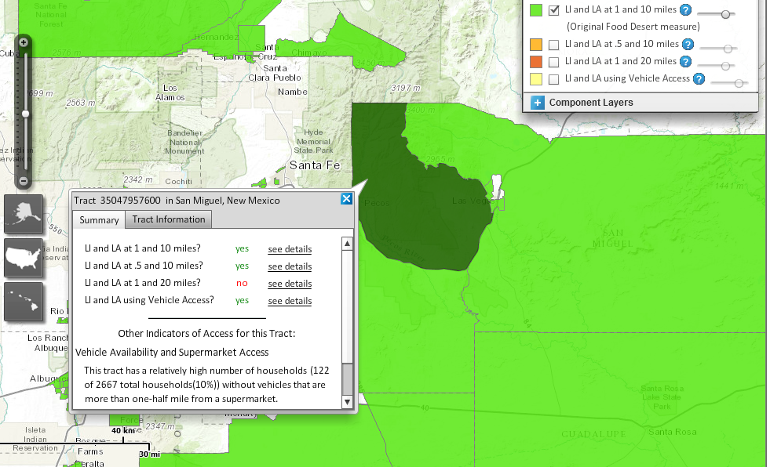

According to the Paperwork Reduction Act of 1995, an agency may not conduct or sponsor, and a person is not required to respond to a collection of information unless it displays a valid OMB control number. The valid OMB control number for this information collection is 0581-0240. The time required to complete this information collection is estimated to average 10 hours per response, including the time for reviewing instructions, searching existing data sources, gathering and maintaining the data needed, and completing and reviewing the collection of information.

USDA’s Nondiscrimination Statement (effective 2015)

In accordance with Federal civil rights law and U.S. Department of Agriculture (USDA) civil rights regulations and policies, the USDA, its Agencies, offices, and employees, and institutions participating in or administering USDA programs are prohibited from discriminating based on race, color, national origin, religion, sex, gender identity (including gender expression), sexual orientation, disability, age, marital status, family/parental status, income derived from a public assistance program, political beliefs, or reprisal or retaliation for prior civil rights activity, in any program or activity conducted or funded by USDA (not all bases apply to all programs). Remedies and complaint filing deadlines vary by program or incident.
Persons with disabilities who require alternative means of communication for program information (e.g., Braille, large print, audiotape, American Sign Language, etc.) should contact the responsible Agency or USDA’s TARGET Center at (202) 720-2600 (voice and TTY) or contact USDA through the Federal Relay Service at (800) 877-8339. Additionally, program information may be made available in languages other than English.
To file a program discrimination complaint, complete the USDA Program Discrimination Complaint Form, AD-3027, found online at http://www.ascr.usda.gov/complaint_filing_cust.html and at any USDA office or write a letter addressed to USDA and provide in the letter all of the information requested in the form. To request a copy of the complaint form, call (866) 632-9992. Submit your completed form or letter to USDA by:
- mail: U.S. Department of Agriculture Office of the Assistant Secretary for Civil Rights 1400 Independence Avenue, SW Washington, D.C. 20250-9410;

- fax: (202) 690-7442; or

- email: program.intake@usda.gov.
USDA is an equal opportunity provider, employer, and lender.

