OMB No.: 0915-0285. Expiration Date: X/XX/20XX
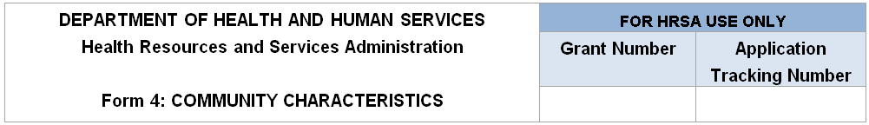
Note: All information provided regarding race and/or ethnicity will be used only to ensure compliance with statutory and regulatory governing board requirements. Data on race and/or ethnicity collected on this form will not be used as an awarding factor.
The Service Area Population Percent and Target Population Percent will auto-calculate in EHB and can only be viewed on the read-only version of the form under Review Program Specific Forms in the left side menu.
Race and Ethnicity | Service Area Population | Service Area Population Percent | Target Population | Target Population Percent
Asian |  | will auto-calculate in EHB |  | will auto-calculate in EHB
Native Hawaiian |  | will auto-calculate in EHB |  | will auto-calculate in EHB
Other Pacific Islanders |  | will auto-calculate in EHB |  | will auto-calculate in EHB
Black/African American |  | will auto-calculate in EHB |  | will auto-calculate in EHB
American Indian/Alaska Native |  | will auto-calculate in EHB |  | will auto-calculate in EHB
White |  | will auto-calculate in EHB |  | will auto-calculate in EHB
More than One Race |  | will auto-calculate in EHB |  | will auto-calculate in EHB
Unreported/Declined to Report  (if applicable) |  | will auto-calculate in EHB |  | will auto-calculate in EHB
Total: | will auto-calculate in EHB | 100% | will auto-calculate in EHB | 100%

Hispanic or Latino Ethnicity | Service Area Population | Service Area Population Percent | Target Population | Target Population Percent
Hispanic or Latino |  | will auto-calculate in EHB |  | will auto-calculate in EHB
Non-Hispanic or Latino |  | will auto-calculate in EHB |  | will auto-calculate in EHB
Unreported/Declined to Report  (if applicable) |  | will auto-calculate in EHB |  | will auto-calculate in EHB
Total: | will auto-calculate in EHB | 100% | will auto-calculate in EHB | 100%

Income as a Percent of Poverty Level | Service Area Population | Service Area Population Percent | Target Population | Target Population Percent
Below 100% |  | will auto-calculate in EHB |  | will auto-calculate in EHB
100-199% |  | will auto-calculate in EHB |  | will auto-calculate in EHB
200% and Above |  | will auto-calculate in EHB |  | will auto-calculate in EHB
Total: | will auto-calculate in EHB | 100% | will auto-calculate in EHB | 100%

Principal Third Party Payment Source | Service Area Population | Service Area Population Percent | Target Population | Target Population Percent
Medicaid |  | will auto-calculate in EHB |  | will auto-calculate in EHB
Medicare |  | will auto-calculate in EHB |  | will auto-calculate in EHB
Other Public Insurance |  | will auto-calculate in EHB |  | will auto-calculate in EHB
Private Insurance |  | will auto-calculate in EHB |  | will auto-calculate in EHB
None/Uninsured |  | will auto-calculate in EHB |  | will auto-calculate in EHB
Total: | will auto-calculate in EHB | 100% | will auto-calculate in EHB | 100%

Special Populations and  Select Population Characteristics | Service Area Population | Service Area Population Percent | Target Population | Target Population Percent
Migratory/Seasonal Agricultural Workers and Families |  | will auto-calculate in EHB |  | will auto-calculate in EHB
People Experiencing Homelessness |  | will auto-calculate in EHB |  | will auto-calculate in EHB
Residents of Public Housing |  | will auto-calculate in EHB |  | will auto-calculate in EHB
School Age Children |  | will auto-calculate in EHB |  | will auto-calculate in EHB
Veterans |  | will auto-calculate in EHB |  | will auto-calculate in EHB
Lesbian, Gay, Bisexual, and Transgender |  | will auto-calculate in EHB |  | will auto-calculate in EHB
HIV/AIDS-Infected Persons |  | will auto-calculate in EHB |  | will auto-calculate in EHB
Individuals Best Served in a Language Other Than English |  | will auto-calculate in EHB |  | will auto-calculate in EHB
Other  Please Specify (maximum 200 Characters): ______________ |  | will auto-calculate in EHB |  | will auto-calculate in EHB

Public Burden Statement: An agency may not conduct or sponsor, and a person is not required to respond to, a collection of information unless it displays a currently valid OMB control number. The OMB control number for this project is 0915-0285. Public reporting burden for this collection of information is estimated to average 1 hour per response, including the time for reviewing instructions, searching existing data sources, and completing and reviewing the collection of information. Send comments regarding this burden estimate or any other aspect of this collection of information, including suggestions for reducing this burden, to HRSA Reports Clearance Officer, 5600 Fishers Lane, Room 14N-39, Rockville, Maryland, 20857.

