## ATTACHMENT 2 – Fallout Map of New Mexico

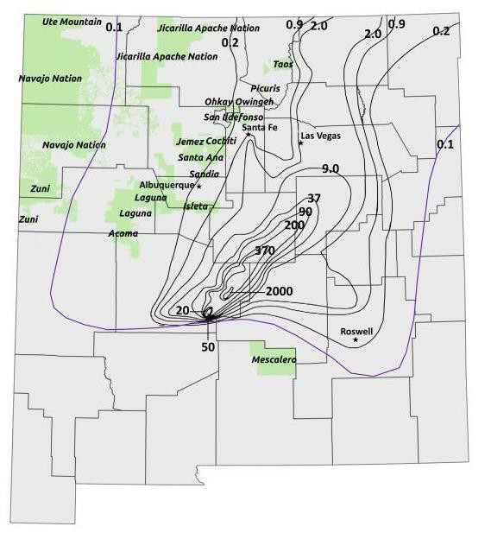

FMap of New Mexico showing county outlines and overlaid with composite of exposure- rate iso-contours based on Quinn (*85*) and Cederwall and Peterson (*86*). Green colored areas are Native American pueblos. Trinity ground zero (detonation site) is located at the lower central location were contours converge (northwest of Mescalero Apache pueblo). Note: iso-contours are not indicative of radiation dose but are lines of equal exposure rate (mR/h) from fallout deposited on the ground normalized to 12 hours post-detonation. Data derived from iso-contours are used as input data to radiation dose calculations.