Supplemental Document: Justification for a no material/non-substantive change
ATF Form 3312.1, National Tracing Center Request has a typo on Page 3 in the instructions.
“Question 5C – Type of Firearm” should be changed to the following:
“Question 5D – Type of Firearm”
This section of instructions on Page 3 of F 3312.1 (see article 1) corresponds with:
Part V – Firearms Information, 5d. Type* (see article 2)

Article 1
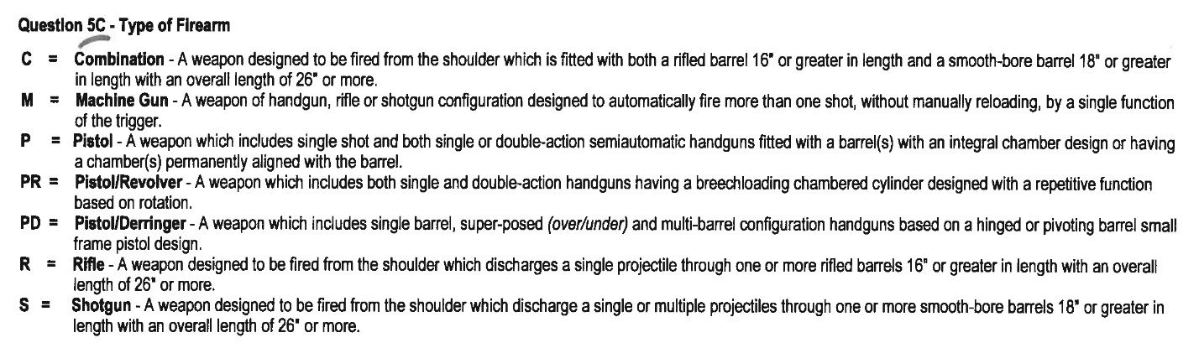

Article 2
