TSA seeks to improve customer service while protecting the homeland.
To help us improve your checkpoint experience, please complete an anonymous, voluntary, on-line survey about your experience today. To complete the survey, please visit the URL below. We estimate that the survey will take you about 5 minutes. Thank you for your participation!

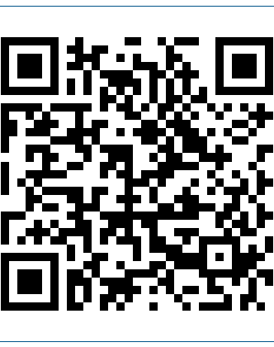
To complete the survey either:
1. Type the URL below into your internet browser:
https://apps.tsa.dhs.gov/survey/ se.ashx?s=SSFEAOEB283AB963
2. Scan the
QR code using your
mobile device:
Questions or concerns? Please email TSAHumanFactors@tsa.dhs.gov

TSA seeks to improve customer service while protecting the homeland.
To help us improve your checkpoint experience, please complete an anonymous, voluntary, on-line survey about your experience today. To complete the survey, please visit the URL below. We estimate that the survey will take you about 5 minutes. Thank you for your participation!

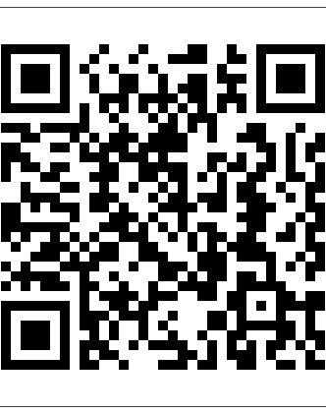
To complete the survey either:
1. Type the URL below into your internet browser:
https://apps.tsa.dhs.gov/survey/ se.ashx?s=SSFEAOEB30CEB080
2. Scan the
QR code using your
mobile device:
Questions or concerns? Please email TSAHumanFactors@tsa.dhs.gov

TSA seeks to improve customer service while protecting the homeland.
To help us improve your checkpoint experience, please complete an anonymous, voluntary, on-line survey about your experience today. To complete the survey, please visit the URL below. We estimate that the survey will take you about 5 minutes. Thank you for your participation!

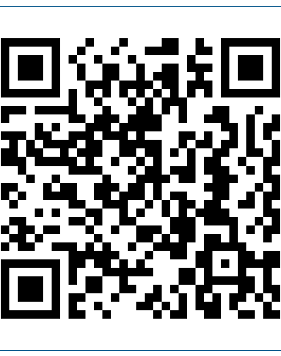
To complete the survey either:
1. Type the URL below into your internet browser:
https://apps.tsa.dhs.gov/survey/ se.ashx?s=SSFEAOEB4089C30B
2. Scan the
QR code using your
mobile device:
Questions or concerns? Please email TSAHumanFactors@tsa.dhs.gov

TSA seeks to improve customer service while protecting the homeland.
To help us improve your checkpoint experience, please complete an anonymous, voluntary, on-line survey about your experience today. To complete the survey, please visit the URL below. We estimate that the survey will take you about 5 minutes. Thank you for your participation!

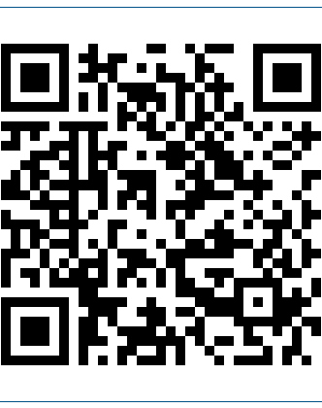
To complete the survey either:
1. Type the URL below into your internet browser:
https://apps.tsa.dhs.gov/survey/ se.ashx?s=SSFEAOEB4089C359
2. Scan the
QR code using your
mobile device:
Questions or concerns? Please email TSAHumanFactors@tsa.dhs.gov

