 |  |  | 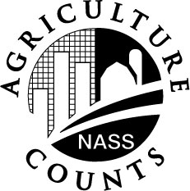 | NATIONAL  AGRICULTURAL  STATISTICS  SERVICE
U.S. Department of Agriculture
Rm. 5030, South Building
1400 Independence Avenue, S.W.
Washington, D.C. 20250-2000
1-800-727-9540
E-mail: nass-dc@nass.usda.gov

COTTON GINNER’S

RECORD BOOK

U. S. DEPARTMENT OF AGRICULTURE

NATIONAL AGRICULTURAL STATISTICS SERVICE

COTTON GINNER’S RECORD
CROP YEAR 20 ________
Name of Gin
SUMMARY OF REPORTS OF COTTON GINNED
made to the U.S. Department of Agriculture
National Agricultural Statistics Service
 | Ginned prior to: | Total Bales | Total Bales
 | Ginned prior to: | Upland | American - Pima
 | August 1
 | September 1
 | September 15
 | October 1
 | October 15
 | November 1
 | November 15
 | December 1
 | December 15
 | January 1
 | January 15
 | February 1
 | March Report

