July 15, 2016

Dear Cotton Ginner:

Beginning in August 2016, USDA’s National Agricultural Statistics Service (NASS) will collect cotton gin data throughout the ginning season (generally every two weeks). We know your time is valuable and therefore offer two simple options to respond:

➢ Online at www.agcounts.usda.gov. Responding online is the easiest, fastest and most secure way to complete your survey. All you need is the identification number on the front page of the questionnaire.
➢ By mail. Complete the survey questionnaire and mail it back in the return envelope provided.

Once you and your fellow ginners nationwide respond, NASS will publish the combined results in Cotton Ginnings reports every two weeks during the survey season. All NASS reports are available online free of charge at www.nass.usda.gov.

Please be assured that your responses are kept confidential, as required by Federal law. NASS safeguards the privacy of all respondents, ensuring that no individual operation or producer can be identified.

We are once again offering you free copies of the Cotton Ginnings Record Book. If you would like one or several copies, please use the enclosed “Ginnings Record Book Order” form and envelope to place your order. You can also use the form to request a copy of Cotton Ginnings 2015 Summary.

Thank you once again for participating and for your support of our programs and U.S. agriculture.

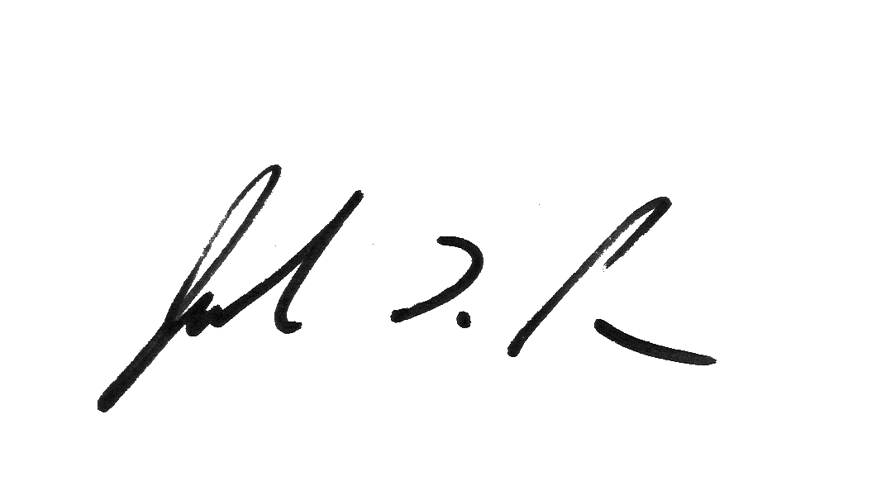
Sincerely,

Joseph L. Parsons
Chairman, Agricultural Statistics Board

Enclosures

GINNINGS RECORD BOOK ORDER

​YES - Please provide me with ____________copies of the Cotton Ginnings Record Book.

​YES - Please provide me with a copy of the Cotton Ginnings 2015 Summary.

Please enter the address where you would like the books sent:
Operation /Name:__________________________________________
Street Address:___________________________
City______________State_______Zip_________
Phone: [______] ________ - __________

