DATE: September 22, 2016
TO: Patrick Wells, OMB Desk Officer
Stephanie Mok, OMB Desk Officer
FROM: Lisa Wright-Solomon, HRSA Information Collection Clearance Officer
SUBJECT: Non-substantive change request for the OMB clearance packages for the Health Resources and Services Administration’s, Bureau of Health Workforce (BHW) Management Information Systems Solution (BMISS) Information Collections (OMB #0915-0127, expires 01/31/2017; OMB #0915-0146, expires 6/30/2017; OMB #0915-0140, 4/30/2017)
PURPOSE: The proposed change consists of collecting the National Provider Identifier (NPI) number on the BMISS application for the National Health Service Corps (NHSC) Loan Repayment Program (LRP), the NURSE Corps (NC) LRP Program, and the Students to Service (S2S) LRP Programs.
TIME SENSITIVITY: NHSC LRP and NC LRP data collection begins in January, 2017. If approved, the BHW will need to make this update in the scheduled November 5th, 2016 software release.

This is a request for a non-substantive change to the Health Resources and Services Administration’s, BHW Management Information Systems Solution (BMISS) Information Collections (OMB #0915-0127, expires 01/31/2017; OMB #0915-0146, expires 6/30/2017; OMB #0915-0140, 4/30/2017). The proposed change consists of collecting the National Provider Identifier (NPI) number on the BMISS application for the National Health Service Corps (NHSC) Loan Repayment Program (LRP), the NURSE Corps (NC) LRP Program, and the Students to Service (S2S) LRP programs.
BMISS is the online system used by applicants interested in applying for Bureau of Health Workforce (BHW) loan repayment and scholarship programs. The proposed additions to the applications include the following:
- A new mandatory field that asks the applicant whether or not they have an NPI number
- If the user selects yes, they can enter in their 10 digit NPI number or look up their number externally on the Centers for Medicare & Medicaid Services (CMS) website via a direct link.
NPI numbers are publically available through the CMS website and will only be used to help BHW analysts track applicants and participants throughout their medical careers in underserved areas, per the vision of the BHW strategic plan. Entering the NPI number is not mandatory and will not affect the applicant’s ability to continue through the application process or impact program eligibility.
This non-substantive change will not increase the number of respondents and will impose a very minimal increase to burden as the NPI is publically available and each provider will know his/her NPI number.

PROPOSED NPI Updates FOR CY2017 NHSC LRP, NC LRP, and S2S LRP applications:
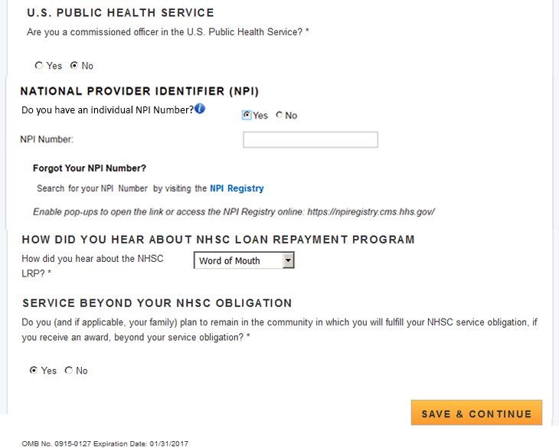

An NPI number is a unique 10-digit number managed by The Centers for Medicare & Medicaid Services (CMS). It is acquired by healthcare providers to identify themselves in a standard way throughout their industry. NPI numbers are publicly available data

