This participant had a previous approved request, so the new request is auto-populated from previous data.
- Initiating a PGT Request via the service request tab:
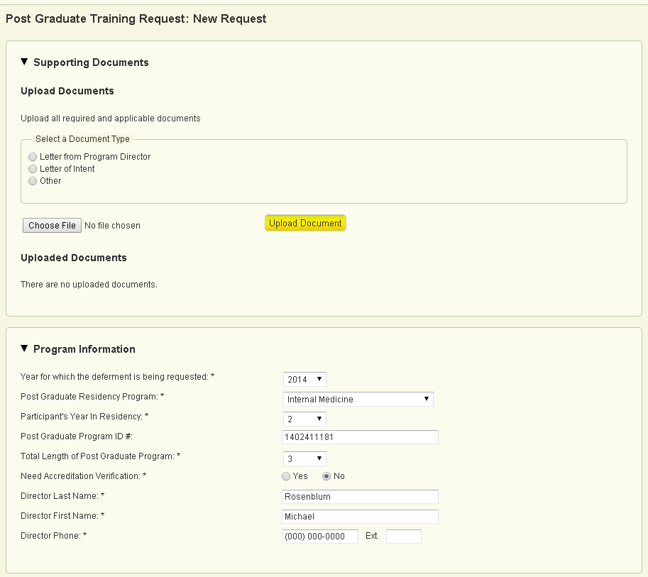
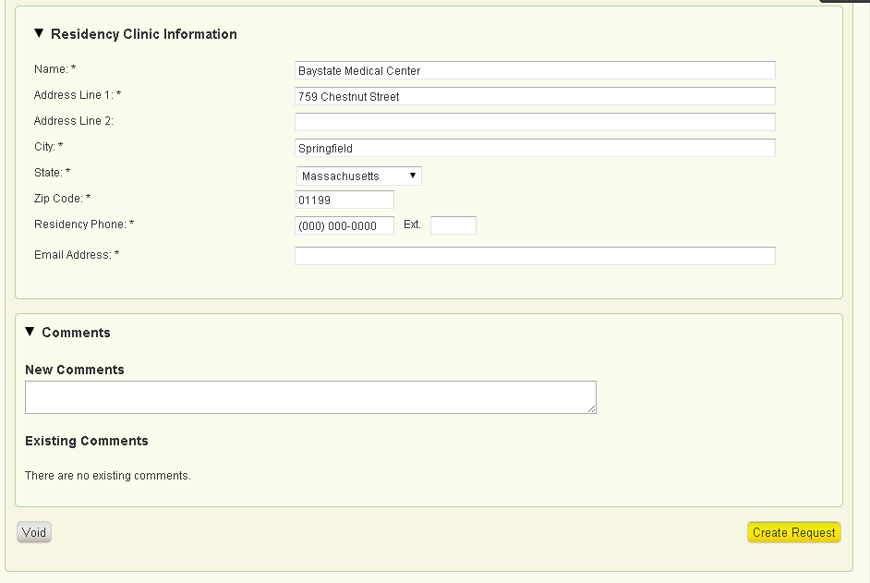

Once the user selects “Create Request,” a task will be generated for review on the task dashboard.

- First Review Step (Recommendation):
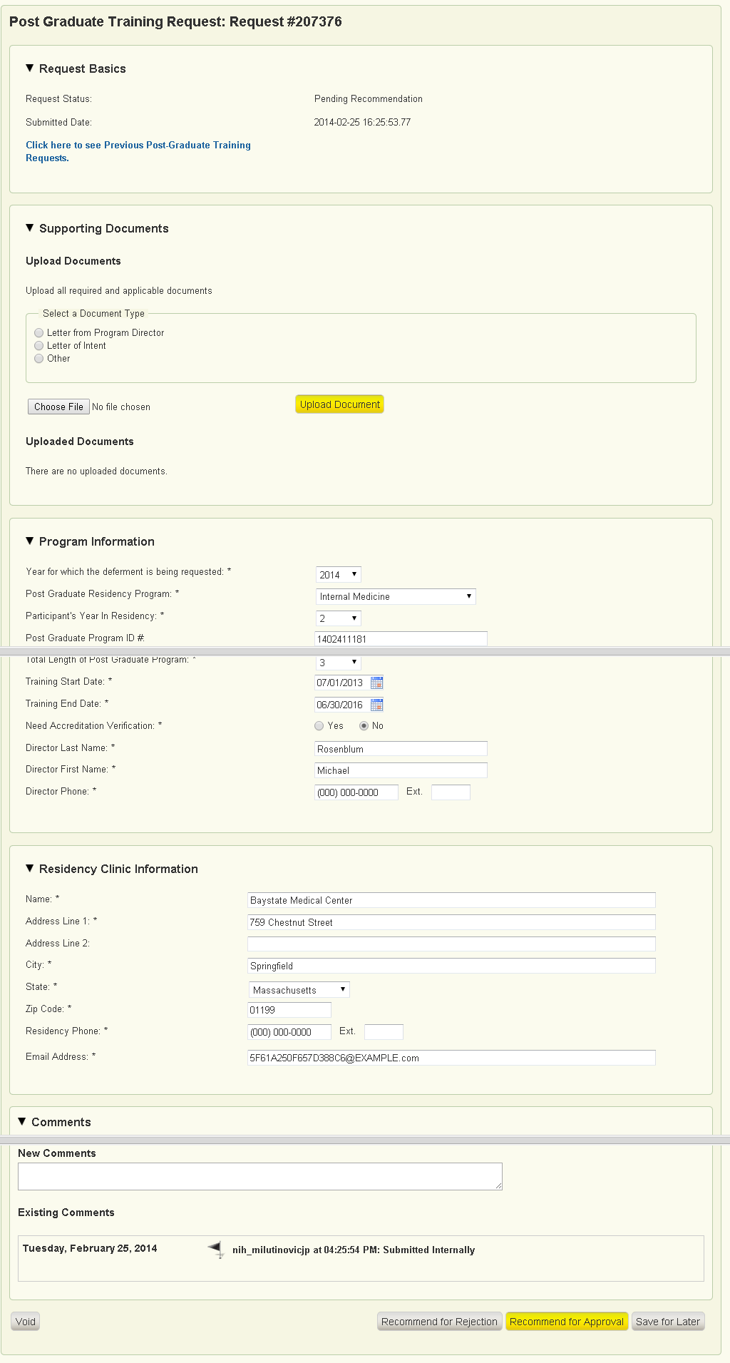
- Second Review Step (Final Decision):
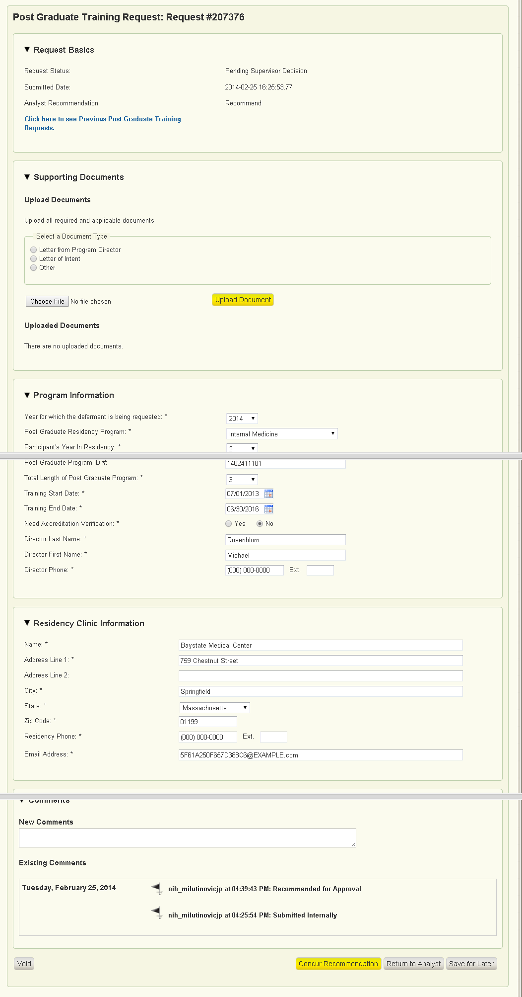
- Read-Only Format of request after a decision has been made. The approval letter has been uploaded by the system in a pdf format. An example of the letter is below.
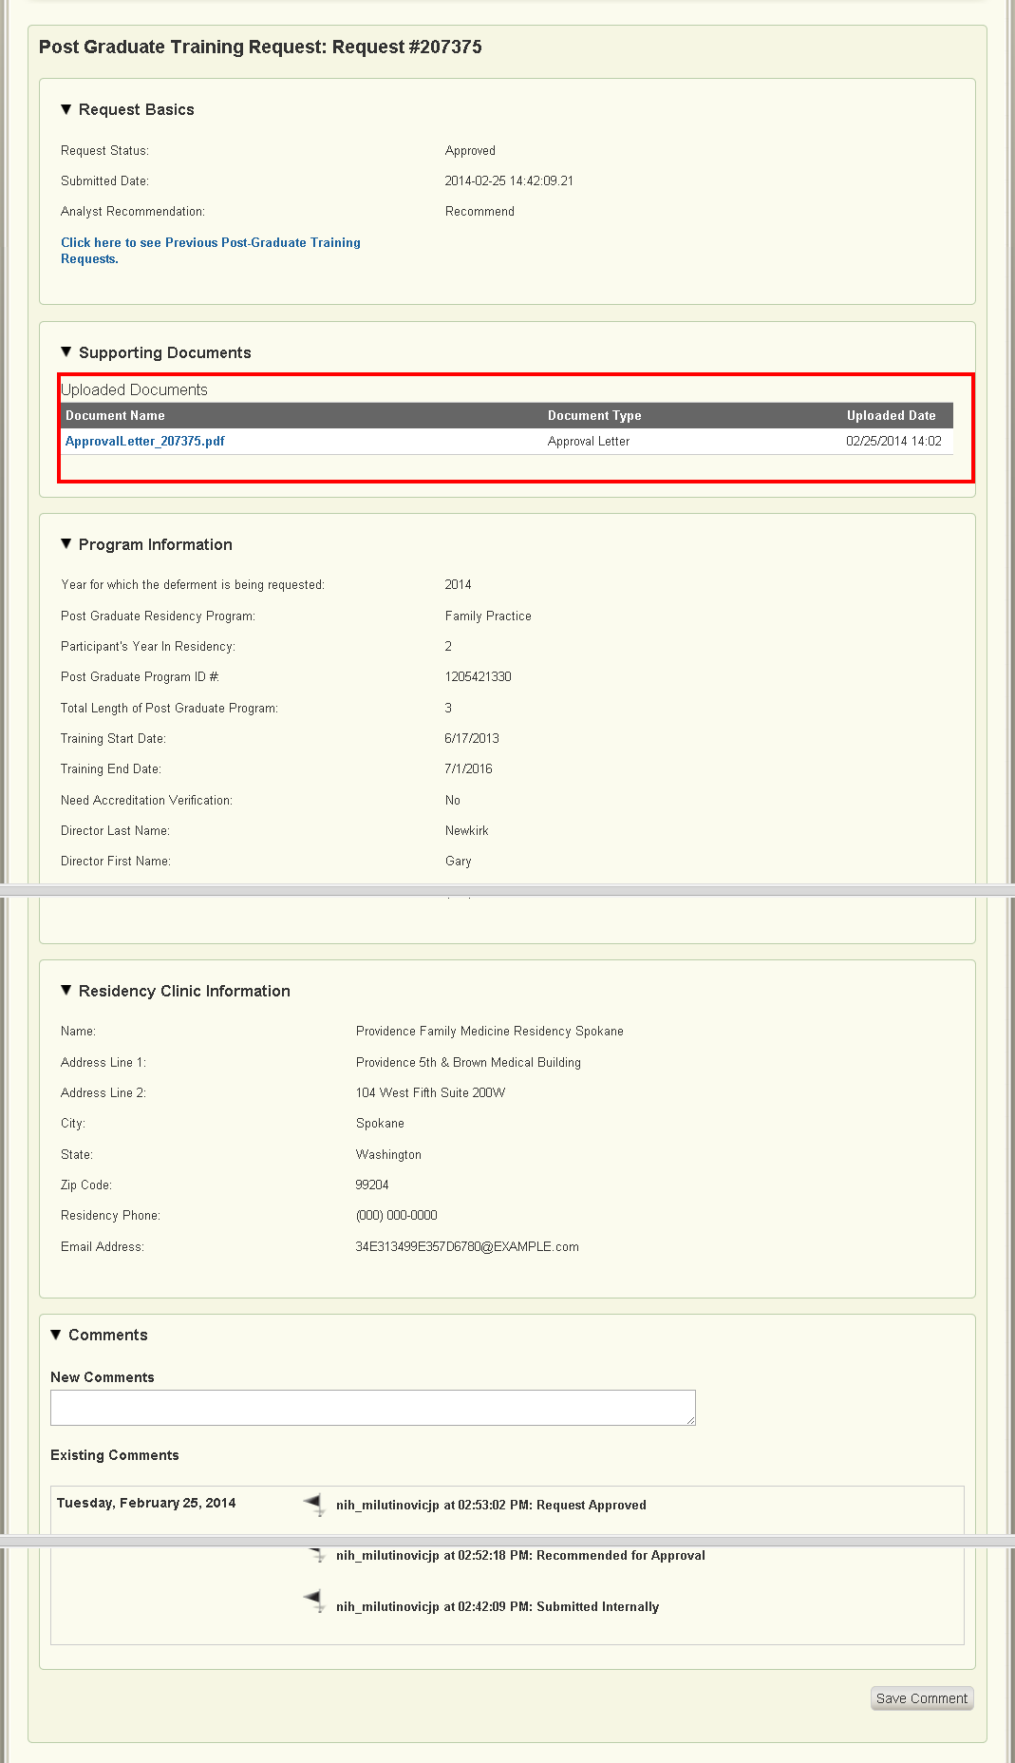
- Participant Read only View of the request (post final decision):
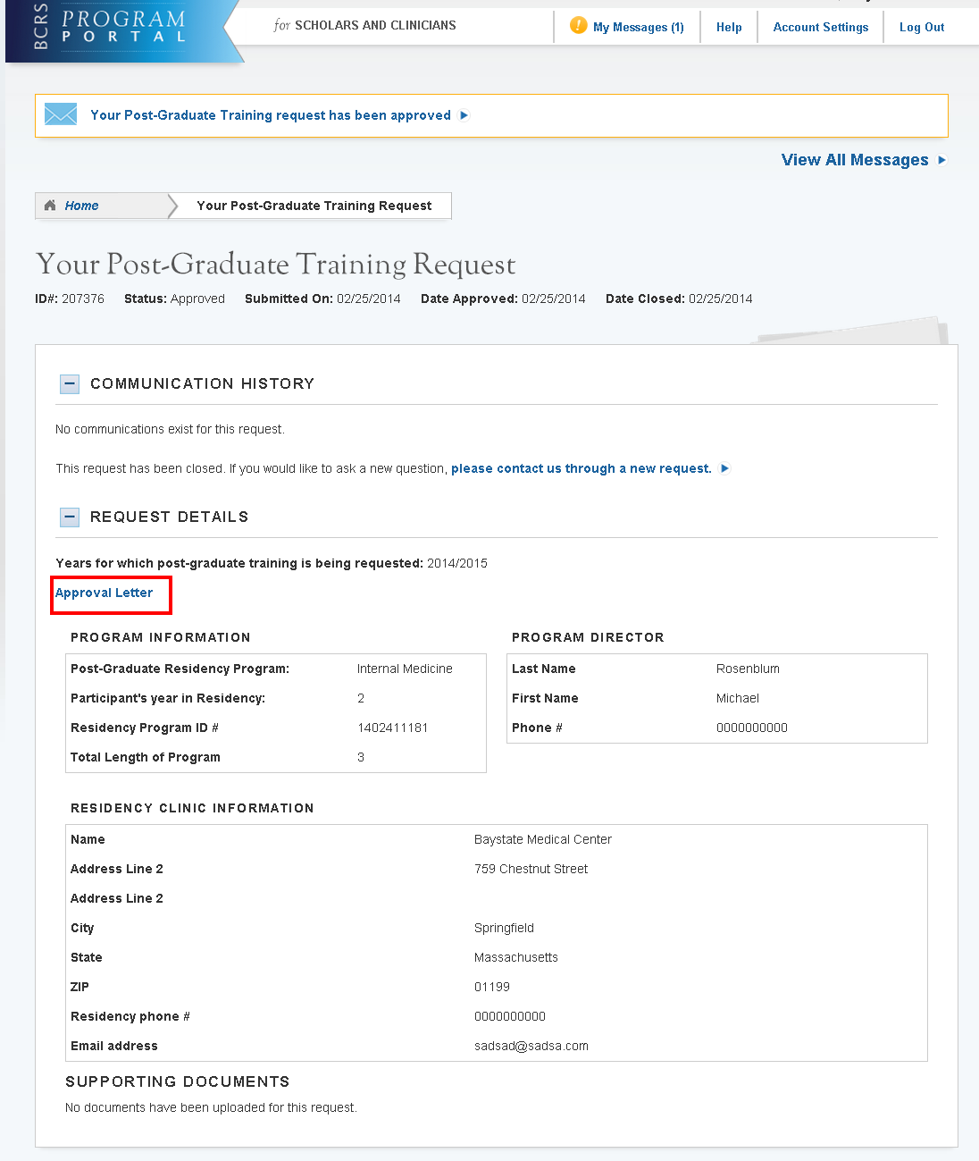
If selected, the approval letter will open in a PDF format:
