July 1, 2016

Dear ACOG Fellow or Junior Fellow,
ACOG’s Research Department sent you an email requesting your participation in the Practice Patterns related to Opioid Use during Pregnancy and Lactation study.* As of XXX, we do not have a record of your completing or opting out of the survey.
The survey is voluntary, but we would greatly appreciate your participation; it should take approximately 10-15 minutes to complete. If you complete the survey, we will assume that you have consented to participate. You may skip any question, and may end your participation at any time without consequence. This survey is being conducted in collaboration with the Centers for Disease Control (CDC) to address an issue of common interest. We will remove all identifiers from your responses before sharing them with the CDC.
You can complete the survey by clicking here or by copying and pasting the following link into your web browser:
http://www.magnetmail.net/forms/display_form.cfm?uid=ACOG&fid=45428&rtype=nonmm
If you wish to complete this survey by mail, please contact Lauren Stark at 202-863-4998.
We will be sending you another email with a link to either complete or opt-out of the above referenced study on XXX.
Thank you for your time and participation.
Sincerely,
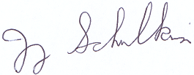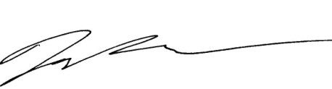

Jay Schulkin, Ph.D. Mike Power, Ph.D. Lauren Stark, M.P.P.
Director of Research Senior Research Associate Research Coordinator

*Please check your Spam or Promotions inboxes for the email if you do not see it in your general Inbox. Unfortunately, some of ACOG’s emails are sorted there.

July 1, 2016

Dear ACOG Fellow or Junior Fellow,
ACOG’s Research Department has sent you four emails requesting your participation in the Practice Patterns related to Opioid Use during Pregnancy and Lactation study.* As of XXX, we do not have a record of you completing or opting out of the survey. If you completed the survey between XXX and the date you receive this letter, we apologize for the inconvenience and appreciate your participation.
The survey is voluntary, but we would greatly appreciate your participation; it should take approximately 10-15 minutes to complete. If you complete the survey, we will assume that you have consented to participate. You may skip any question, and may end your participation at any time without consequence. This survey is being conducted in collaboration with the Centers for Disease Control (CDC) to address an issue of common interest. We will remove all identifiers from your responses before sharing them with the CDC.
You can complete the survey by clicking here or by coping and pasting the following link into your web browser:
http://www.magnetmail.net/forms/display_form.cfm?uid=ACOG&fid=45428&rtype=nonmm
Thank you for your time and participation.
Sincerely,

Jay Schulkin, Ph.D. Mike Power, Ph.D. Lauren Stark, M.P.P.
Director of Research Senior Research Associate Research Coordinator

*Please check your Spam or Promotions inboxes for the email if you do not see it in your general Inbox. Unfortunately, some of ACOG’s emails are sorted there.

