NYTS DISTRICT LETTER OF INVITATION

{Date}

{Contact Name}

{School Name}

{Address}

{City}, {State} {Zip Code}

Dear {Contact Name}:

I am writing to inform you that {#} schools in your district are among the approximately {#} schools randomly selected across the United States to participate in the {Year} National Youth Tobacco Survey (NYTS) sponsored by the U.S. Centers for Disease Control and Prevention (CDC). As witnessed over the past few decades, youth tobacco use can increase or decrease rapidly. More recently, from 2003 to 2012, the CDC reported that while youth smoking has declined, it has occurred at a slower pace. Conduct of the NYTS has increased our ability to detect rapid changes in tobacco use behaviors and their influences, thereby enabling states, school districts, schools, and community organizations to modify their tobacco prevention and control interventions, if circumstances require.

First conducted in 1999, the NYTS is an ongoing survey of students in grades 6 through 12 that gathers information on: (1) prevalence of use (cigarettes, smokeless tobacco, cigars, and other tobacco products), (2) knowledge and attitudes, (3) media and advertising, (4) minors' access and enforcement, (5) school curriculum, (6) secondhand smoke exposure, and (7) cessation. The NYTS was designed in cooperation with Federal agencies and numerous state and local departments of education and health. Each cycle has produced valuable data regarding students’ knowledge of and attitudes toward tobacco; their exposure to secondhand smoke; and their exposure to influences that promote or discourage tobacco use.

The selected schools in your district are:

|  |  |
| --- | --- |
| **School** | **Grade (Number of Classes)** |
|

The CDC respects the educational mission of schools. For that reason, only a small number of classes in each school, one or two at each selected grade level, are chosen randomly to participate. Data collection will occur during {Month} through {Month} {Year}. Questionnaires will be administered during one normal class period by specially trained field staff. Survey administration procedures are designed to protect student privacy and allow for anonymous participation. States, counties, cities, school districts, schools, and students will not be identified in any published reports.

As a symbol of appreciation for contributing their time and support, the CDC will provide each participating school with a monetary award. One option is to use these funds for prevention curriculum and educational materials. However, no restrictions will be placed on how schools can use these funds.

Your support for this survey will help ensure the voluntary participation of the schools selected in your district. The NYTS is the most comprehensive, nationally representative source of data regarding tobacco-related behaviors and the *only* source of such data for middle school students (grades 6-8). In parallel to this national survey, the NYTS questionnaire is used independently by many state and local departments of education and health to conduct their own surveys. Results from the national survey serve as an index against which state- and local-level data can be compared and are used by states to support the design, implementation, and evaluation of effective tobacco use prevention and control programs.

Enclosed are copies of the NYTS questionnaire, sample parental permission forms, a survey fact sheet, and letters of support. Within one week, a representative from ICF International, a nationally recognized survey research firm contracted by CDC to conduct the NYTS, will contact you. If you have any immediate questions, please call {Name} of ICF International at (800) 675-9727. Your support for this survey, which will help assess and improve efforts to reduce tobacco use among adolescents throughout our Nation, is appreciated.

Sincerely yours,

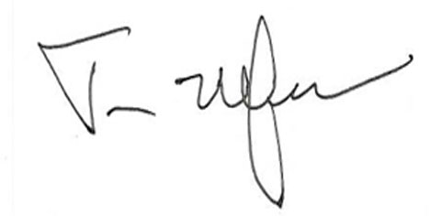

|  |
| --- |
|  |

Timothy McAfee, MD, MPH

Director

Office on Smoking and Health

Enclosures

|  |  |
| --- | --- |
| cc: |  |