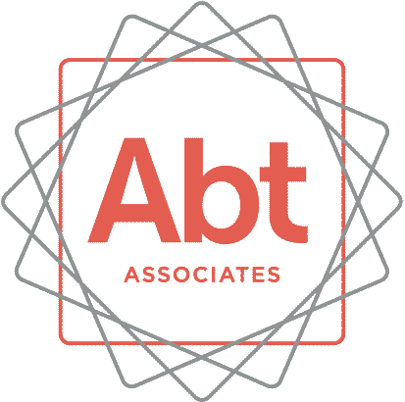

[INSERT DATE]

[INSERT NAME]
[INSERT ADDRESS]

Dear <<applicant/participant>>

As you may recall, last year when you applied to the Cascades Job Corps College and Career Academy Pilot program, you learned that there was a study being conducted to understand how applicants are doing since the time they applied for the program. This study is funded by the Chief Evaluation Office at the U.S. Department of Labor. We are writing today about a very important part of the study and we hope that you will participate! So that we can reach you when it comes time for the follow-up survey, we need to make sure we have the most current contact information for you.

We have included a contact update form for you here. Please complete this form and return it to us in the postage paid envelope. In consideration of your time, we will mail you $2 for completing this form. You may also wish to go online to complete this form.

[Enter URL]
Please enter your PIN. We provided a PIN for you in your welcome letter. The PIN is a number unique to you that will help our research team locate your information and survey.

Any information you provide to us for the study is kept private. Your answers will never be shared with the Cascades Job Corps program, and your personal information will never be published in a report. Your participation is completely voluntary. You can choose not to answer any question for any reason.

We hope to hear from you soon! Thank you in advance for your help with our study.

Sincerely yours,

Julie Williams
Project Director

Form Approved
OMB Control No. 1290-XXXX
Expiration Date X/XX/2020
Cascades Job Corps College and Career Academy Pilot Evaluation, Participant Tracking Form

(PLEASE PRINT)
1. Is this the correct spelling of your name?
[First_Name] [Last_Name]
Please check appropriate box. Yes No, the correct spelling is:
First Name | Last Name

2. Is this your correct address?
[Address1] [Address2] [City], [State] [Zip]
Please check appropriate box. Yes No, my correct address is:
Street |  | Apartment #
City | State | Zip Code

- Is this your correct phone number? «phone»
Please check appropriate box. Yes No, my correct phone number is:
Home Phone |  |  |  | Cell Phone
 | Area Code |  | Telephone Number |  | Area Code |  | Telephone Number

4. Please list the name, address, and relationship to you of three people who will always know how to reach you.
(PLEASE PRINT)
1. Name: |  | Relation to you :
Address | Apartment # | City
State | Zip Code | Phone  ( ) —
2. Name: |  | Relation to you:
Address | Apartment # | City
State | Zip Code | Phone  ( ) —
3. Name: |  | Relation to you:
Address | Apartment # | City
State | Zip Code | Phone  ( ) —

Abt Associates IRB Approval No. XXXX
Public Burden Statement. Persons are not required to respond to this collection of information unless it displays a currently valid OMB Control Number. Public reporting burden for this collection of information is estimated to average 6 minutes per response, including the time for reading instructions, and completing and reviewing the requested information. Send comments regarding the burden estimate or any other aspect of this collection of information, including suggestions for reducing this burden, to the [Contact Name; Contact Address] (Paperwork Reduction Project Control No. 1290-xxxx).

