- Apply Online for Immigrant Petition by Alien Entrepreneur
This is the second screen the applicant will see after the applicant logs into USCIS ELIS. On the first screen, the applicant selected “Alien Petition by Immigrant Investor.”
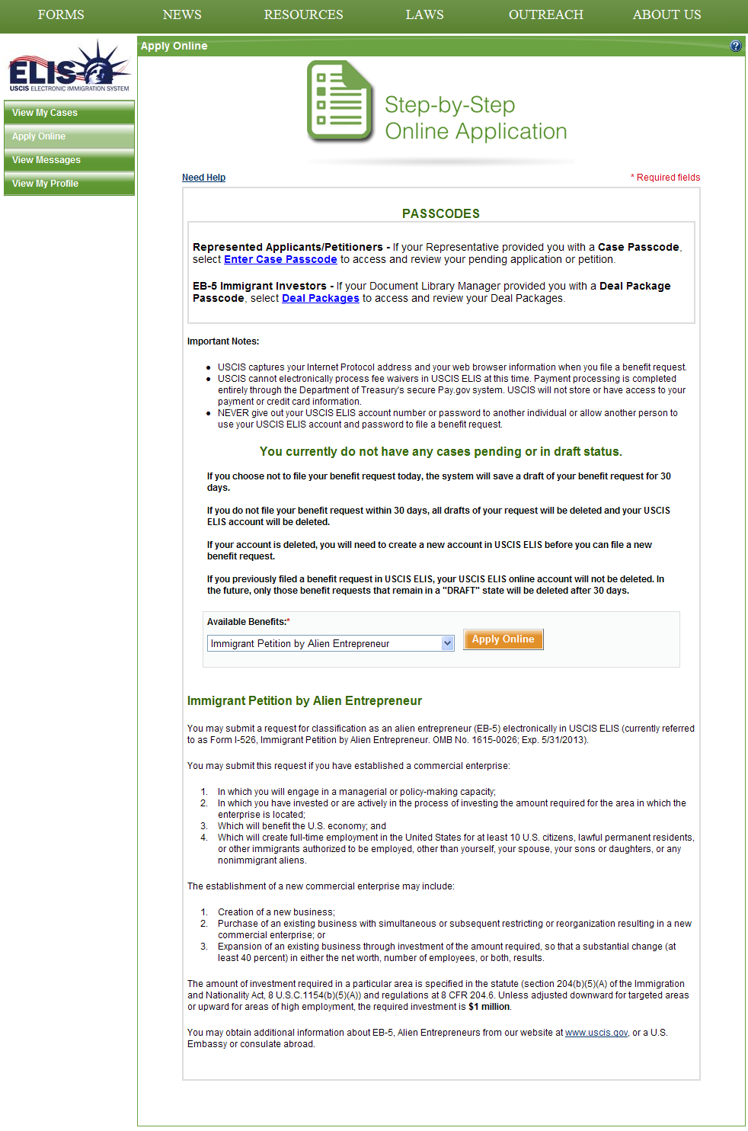

2a. **New Screen** Paperwork Reduction & Privacy Act Statements (before select checkbox)
After the applicant selects “Apply Online”, the applicant will be taken to this screen. The applicant will not be permitted to move forward until the “I Agree” box has been checked.
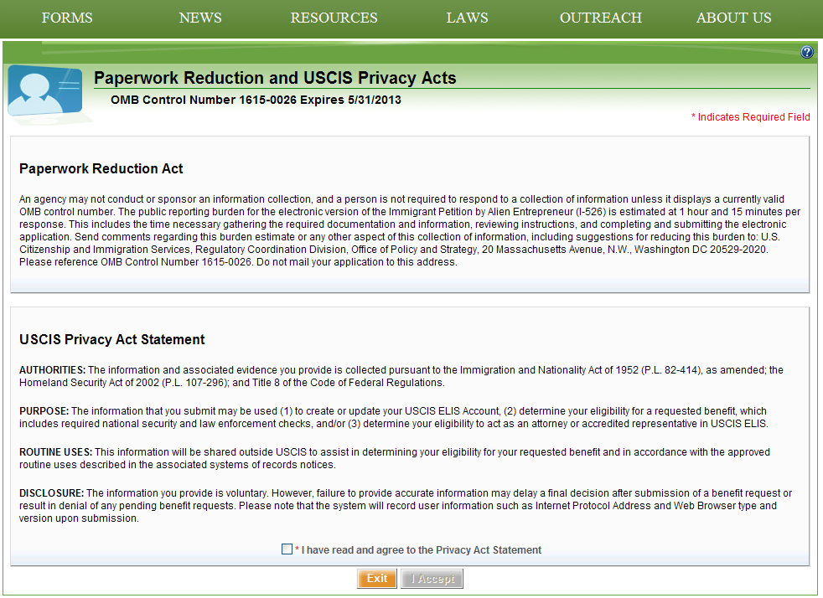

2b. **New Screen** Paperwork Reduction & Privacy Act Statements (after select checkbox)
The applicant checks the “I Agree” box.
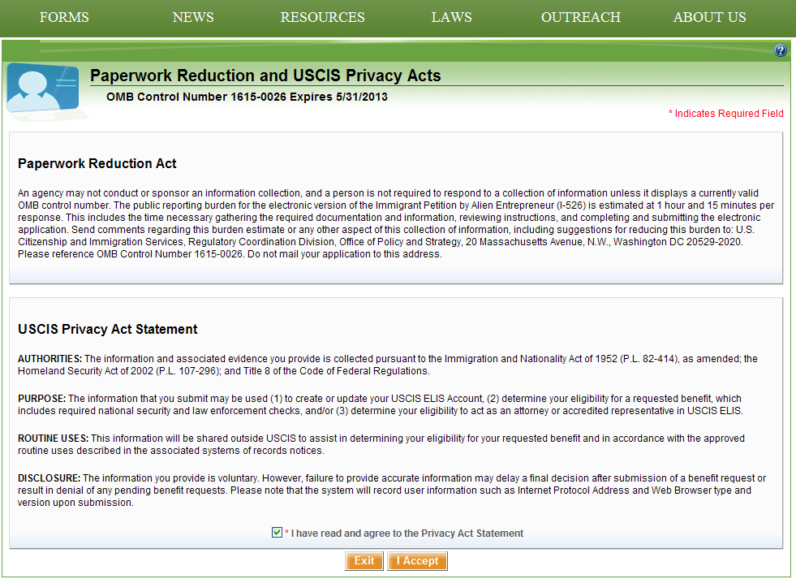

- I-526 About You – Name & Contact (beginning of I-526 petition)
The applicant has checked the “I Agree” box and is brought to this page. The applicant now completes the application for the I-526.
