Appendix D
Respondent Communication Materials –
Institutions and Students

Brochure Text 2
Student Lead Letter 4
Parent Letter 5
Incentive Letter 6
DATA COLLECTION E-MAIL 7
E-MAIL REMINDER 1 - EXAMPLE 8
E-MAIL REMINDER 2 - EXAMPLE 9
E-MAIL REMINDER 3 - EXAMPLE 10
E-MAIL REMINDER 4 - EXAMPLE 11
E-MAIL REMINDER 5 - EXAMPLE 12
E-MAIL REMINDER 6 - EXAMPLE 13
POSTCARD 1 14
POSTCARD 2 16
POSTCARD 3 18
FINAL FLYER 20
EXAMPLE OF STUDENT RECORD INSTRUCTIONS THAT WILL BE PROVIDED TO INSTITUTIONS 22
STUDENT RECORDS REQUEST LETTER TO INSTITUTION COORDINATOR 25
DISCLOSURE NOTICE FOR NPSAS 27
STUDENT RECORDS SAMPLE REMINDER EMAIL 1 TO INSTITUTION COORDINATOR 28
STUDENT RECORDS SAMPLE REMINDER EMAIL 2 TO INSTITUTION COORDINATOR 29
Postsecondary Data Portal Flyer Text 30
Website Text 31
NCES E-MAIL REMINDER – ABBREVIATED INTERVIEW 41

Revised February 2016
Last Revised September 2016

Brochure Text
What is NPSAS?
The National Postsecondary Student Aid Study (NPSAS) is a national survey of approximately 125,000 undergraduate and graduate students who were enrolled during the 2015-2016 academic year. In order to have a complete picture of the costs and benefits of postsecondary education, it is important that we include students from a wide variety of schools and backgrounds.
NPSAS will collect information about students’ enrollment and employment history, income and educational expenses, and future plans. We also collect financial aid, student record, and related information from your institution and other sources, such as student loan databases and admissions testing agencies.
Why am I being asked to participate?
You are being asked to participate in NPSAS because you were enrolled in postsecondary education during the 2015-2016 academic year. Postsecondary education is any education beyond high school, including career and technical school, college, and graduate school.
Why is my participation important?
Your survey responses help educators, researchers, and policymakers at the local, state, and national levels understand national trends in enrollment patterns, education goals, employment, and backgrounds of students who pursue education after high school. Your experiences are unique, and if you choose not to participate in NPSAS, no one else can be substituted for you.
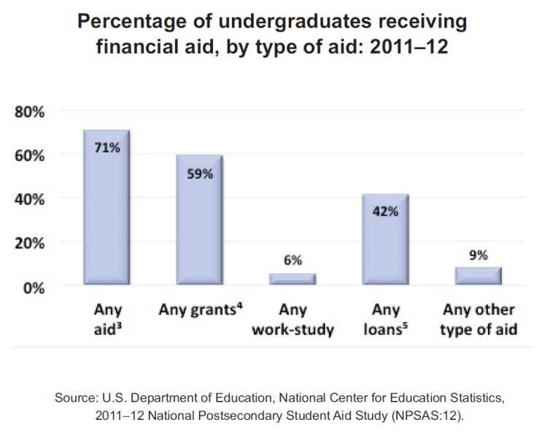
Did you know? About 71 percent of all undergraduates received some form of financial aid in the 2011-2012 school year. Nearly 60 percent of undergraduates received grant aid, and 42 percent took out loans to pay for their education.

What happens to the results?
As with results from previous rounds of NPSAS, results from the current study are scheduled to be released in [fall 2017] and will be posted on the NCES website (http://nces.ed.gov/surveys/npsas/) as soon as they are available. Your responses will be combined with those of other students and will be presented in summary form only. No individually-identifying information will be published.

Researchers will use NPSAS data to explore a wide variety of topics, including student loan debt and persistence in postsecondary education.
Who is conducting NPSAS?
The 2015-16 National Postsecondary Student Aid Study is conducted by the National Center for Education Statistics (NCES) under the authority of the Higher Education Opportunity Act (HEOA) of 2008 (20 U.S.C. § 1015) and the Education Sciences Reform Act (ESRA) of 2002 (20 U.S.C. § 9543), which authorize NCES to collect and disseminate information about education in the United States.
NPSAS data are being collected under contract by RTI International, a nonprofit research organization based in North Carolina.
How will my information be protected?
NCES is required to follow strict procedures to protect personal information in the collection, reporting, and publication of data. All individually identifiable information supplied by individuals or institutions may be used only for statistical purposes and may not be disclosed or used in identifiable form for any other purpose, except as required by law (20 U.S.C. § 9573).
Data security procedures for NPSAS:16 are reviewed and approved by NCES data security staff. Your answers are secured behind firewalls and are encrypted during internet transmission using Secure Sockets Layer (SSL) protocol. All data entry modules are password protected and require the user to log in before accessing confidential data. Project staff is subject to large fines or imprisonment if individual responses are disclosed.
How do I participate?
You can complete the NPSAS interview online or over the phone.
ONLINE
Log onto the study website at https://surveys.nces.ed.gov/npsas/ using the Study ID and password provided in your welcome letter. The survey is mobile-optimized, so it can be easily completed on a mobile device.
OVER THE PHONE
Call our Help Desk at 1-877-677-2766 to speak to one of our professional interviewers.
Contact Us
NPSAS HELP DESK
1-877-677-2766

npsas@rti.org
https://surveys.nces.ed.gov/npsas/

Jennifer Wine, Ph.D.
NPSAS Project Director (RTI)
jennifer@rti.org
1-877-225-8470

Tracy Hunt-White, Ph.D.
NPSAS Project Officer (NCES)
tracy.hunt-white@ed.gov
1-202-502-7438

Student Lead Letter

NPSAS  Endorsed by  American Association of  Collegiate Registrars and  Admissions Officers  American Association of Community Colleges  American Association of State Colleges and Universities  American Council on Education  Association for Institutional Research  Association of American Colleges and Universities  Association of Catholic Colleges and Universities  Association of Private Sector Colleges and Universities  Association of Public and  Land-Grant Universities  Association of Schools of Allied Health Professions  The Carnegie Foundation for the Advancement of Teaching  The College Board  Council of Graduate Schools  The Council of Independent Colleges  Hispanic Association of Colleges and Universities  Midwestern Higher Education Compact  National Accrediting Commission of Cosmetology Arts and Sciences  National Association of College and University Business Officers  National Association for Equal Opportunity in Higher Education  National Association of Independent Colleges and Universities  National Association of Student Financial Aid Administrators  New England Board of Higher Education  Southern Regional Education Board  State Higher Education Executive Officers  The United Negro College Fund  Western Interstate Commission for Higher Education | February 1, 2016  «casenamenosuffixALLCAPS»  Study ID: «caseID»  Password: «password»m  «addr1»  «city», «state» «zip»  Dear «casenamenosuffix»:  I am writing to inform you that you have been selected to participate in the 2016 National Postsecondary Student Aid Study (NPSAS), an important study that will help determine how students and their families meet the cost of education beyond high school.  Students from all types of institutions and all financial situations have been randomly selected for NPSAS. Many types of students are selected for NPSAS, ranging from first-time students to doctoral students, even if they are no longer enrolled in postsecondary education. Your survey responses will represent other students enrolled at «NPSASschool» who were not selected to participate in NPSAS. Therefore, your participation is critical to the success of the study.  After you complete the survey, you will receive $«inc_amount» as a token of our appreciation, payable by PayPal or check.  To complete the survey on your computer, smartphone, or tablet:  - Go to: https://surveys.nces.ed.gov/npsas/.  - Type the Study ID and password (provided below) on the Home/Login page.  - Click “Login” to begin the survey.  Please complete the survey by February 22, 2016.  On average, the survey takes about «interviewtime» minutes to complete, depending on your answers. Your participation in this study is voluntary and will not affect any aid or other benefits you receive.  The enclosed brochure answers many common questions about the study and contains additional information on laws and procedures that protect the confidentiality of your responses. If you have questions about the study, or prefer to complete the survey over the phone, call the NPSAS help desk at 1-877-NPSAS-NOW (1-877-677-2766), or send an e-mail to npsas@rti.org. You can also learn more by visiting the study website at https://surveys.nces.ed.gov/npsas/.  I thank you in advance for your participation in this important study. Your cooperation is greatly appreciated.  Sincerely,  To complete the NPSAS survey:  https://surveys.nces.ed.gov/npsas/  Your Study ID: «caseID»  Your password: «password»m  Peggy G. Carr, Ph.D.  Acting Commissioner  National Center for Education Statistics  Enclosures  «panelinfo» / «controlID»

Parent Letter

February 1, 2016

Parent or Guardian of «casenamenosuffix»
«addr1»
«addr2»
«city», «state» «zip»

Dear Parent or Guardian,

We are pleased to inform you that your student, «casenamenosuffix», has been selected to participate in the 2015-16 National Postsecondary Student Aid Study (NPSAS), an important study that will help determine how students and their families meet the cost of education beyond high school.

Approximately 125,000 students from about 2,000 schools across the nation have been selected to participate in NPSAS. Students are being asked to complete a survey about their enrollment during the 2015-2016 academic year, including questions about [fname]’s degree, field of study, financial aid, employment while enrolled, educational experiences, and background. The survey only takes about <time> minutes, and «fname» will receive $<incamt> as a token of our appreciation for participating.

NPSAS is sponsored by the National Center for Education Statistics, part of the U.S. Department of Education. RTI International, an independent nonprofit research organization based in North Carolina, is administering NPSAS data collection for NCES. Participation in NPSAS is voluntary and will not affect any aid or benefits [fname] may receive.

[Fname]’s responses are important to ensure that the results of NPSAS accurately reflect the circumstances of all types of students. Please help us today by encouraging «fname» to participate, and by calling the NPSAS Help Desk at 1-877-677-2766 to provide us with a phone number or email address that we can contact «fname». The survey is mobile-optimized and can be completed online or over the phone.

The enclosed brochure provides more information about the study, including information about confidentiality procedures. If you have any questions about NPSAS, please visit the NPSAS website at https://surveys.nces.ed.gov/npsas/, call the NPSAS Help Desk toll-free at 1-877-677-2766, or email npsas@rti.org.

I thank you in advance for your cooperation in this important research.

Sincerely,

Peggy G. Carr
Associate Commissioner
National Center for Education Statistics
Enclosures

Incentive Letter

February 10, 2016

«casename»
Study ID: «caseID»
«addr1»
«addr2»
«city», «state» «zip»

Dear «casename»:

On behalf of the National Center for Education Statistics in the U.S. Department of Education’s Institute of Education Sciences and the staff of the 2016 National Postsecondary Student Aid Study (NPSAS), we would like to thank you for completing your NPSAS survey. Your participation in this study is very important to its success. Enclosed you will find a check for $<incamt>.

Please do not hesitate to contact us directly at 1-877-225-8470 if we can provide any additional information or assistance.

Again, thank you for your time and willingness to participate.

Sincerely,

Jennifer Wine, Ph.D.
Project Director, NPSAS
RTI International

Tracy Hunt-White, Ph.D.
Project Officer, NPSAS
National Center for Education Statistics

DATA COLLECTION E-MAIL

SUBJECT: The National Postsecondary Student Aid Study (NPSAS)
Congratulations [FNAME], you have been selected to participate in the 2015-16 National Postsecondary Student Aid Study (NPSAS), an important study that will help determine how students and their families meet the cost of education beyond high school.
For your participation in NPSAS, we are asking you to complete a mobile-optimized survey. The survey will take about [time] minutes to complete, depending on your answers.
Click here to start your survey on our secure website.
If you complete the survey, you will receive $30 as a token of our appreciation - payable by PayPal or check. Please complete the survey by [February 22, 2016].
If you’d like more information about NPSAS, visit the study website at https://surveys.nces.ed.gov/npsas/, or call the NPSAS Help Desk at 1-877-NPSAS-NOW (1-877-677-2766). You can also complete the survey over the phone if you prefer.
Thank you for helping to make NPSAS a success.
Jennifer Wine, Ph.D. Tracy Hunt-White, Ph.D.
Project Director, NPSAS Project Officer, NPSAS
RTI International National Center for Education Statistics
jennifer@rti.org tracy.hunt-white@ed.gov
877-225-8470 202-502-7438

You can log in at https://surveys.nces.ed.gov/npsas/ using the Study ID and password provided below.
Study ID = [case id]
Password = [password]e

E-MAIL REMINDER 1 - EXAMPLE

SUBJECT LINE; The NPSAS Survey Needs Your Participation

[Fname], we still need you for NPSAS to be a success!

I noticed that you haven’t yet participated in the 2015-16 National Postsecondary Student Aid Study (NPSAS). As a [student type], your participation is critical to the success of the study, so I hope you will participate soon. As a reminder, the survey is mobile-optimized and can be done completely online, and you’ll receive $30 for participating, payable by PayPal or check.

I understand that you may have questions or concerns about NPSAS – and we’re here to help! I’ve listed the answers to some of the most frequently asked questions about NPSAS below.

How can I participate in NPSAS?
It’s easy! Just [click here] to start to online survey, or go to https://surveys.nces.ed.gov/npsas/ and log in:
Study ID: [caseid]
Password: [password]
Or, complete the survey over the phone at 1-877-677-2766.

I’m enrolled in [graduate school]. Can I participate in NPSAS?
Yes! NPSAS includes students enrolled in all levels of postsecondary education, including [graduate and professional schools.] Your participation is important to making sure that the NPSAS results represent all types of students.

What if I don’t have time to complete the entire survey right now?
No problem! You can start the survey now and finish it later – you’ll pick up right where you left off.
If you have other questions, please contact the NPSAS Help Desk at 1-877-677-2766 or email us at npsas@rti.org. Thank you in advance for making NPSAS a success.

Jennifer Wine, Ph.D.
Project Director, NPSAS
RTI International

E-MAIL REMINDER 2 - EXAMPLE

SUBJECT: NPSAS Data Collection Continues…

…and it won’t be a success without you, [FNAME]!

Data collection for the 2015-16 National Postsecondary Student Aid Study (NPSAS) continues! The survey – which can easily be completed on your mobile device - takes approximately [time] minutes to complete, and when you complete your survey, you will receive $30 as a token of our appreciation, payable by PayPal or check.

To access the online survey on our secure website, click here.

Need help accessing the online survey? Prefer to complete the survey by telephone? Please call our Help Desk at 1-877-677-2766.

Thank you in advance for your participation in this very important study.

Sincerely,

Jennifer Wine, Ph.D.
Project Director, NPSAS
RTI International

Your secure login credentials:
https://surveys.nces.ed.gov/npsas/
Study ID: [caseid]
Password: [password]

E-MAIL REMINDER 3 - EXAMPLE

SUBJECT: Don’t Forget to Complete Your NPSAS Survey!

[FName], start it on your mobile device today!

We still need you to participate in the 2015-16 National Postsecondary Student Aid Study (NPSAS) for the U.S. Department of Education.

It only takes about <time> minutes and, once you’ve completed the survey, you’ll receive $30, payable by PayPal or check! Click here to get started right away!
You can complete the survey by phone by calling 1-877-677-2766, and find more information on the study website at https://surveys.nces.ed.gov/npsas/.
Thanks!

Jennifer Wine, Ph.D.
Project Director, NPSAS
RTI International
jennifer@rti.org
877-225-8470

YOUR SECURE LOGIN CREDENTIALS:
https://surveys.nces.ed.gov/npsas/
Study ID: [caseid]
Password: [password]

E-MAIL REMINDER 4 - EXAMPLE

SUBJECT: Don’t Delay! Participate in NPSAS Today!

We’ve been contacting you and other students at [NPSAS school] about participating in NPSAS, [Fname]!
NPSAS is an important study that will help policymakers understand the experiences of students enrolled in education after high school.
We know that you have a lot of demands on your time, but we need your help to make sure that the study is representative of all types of students. The survey takes only [time] minutes to complete, and we will send you $30 for doing it -- just click here to get started!
You can also log in at our secure website:
https://surveys.nces.ed.gov/npsas/
Study ID: <caseID>
Password: <password>
Call 1-877-677-2766 to get more information about NPSAS or complete the survey by phone.
Thank you for considering participating in this important study. We hope you will – NPSAS won’t be the same without you.
Thanks!
Jennifer Wine, Ph.D.
Project Director, NPSAS
RTI International
jennifer@rti.org

E-MAIL REMINDER 5 - EXAMPLE

SUBJECT: NPSAS Needs You

[FName], NPSAS needs your help!

NPSAS only takes about <time> minutes and is easy to complete on your mobile device. And, when you complete the survey, you’ll receive $30, payable by PayPal or check!

To get started, just click here!
You can complete the survey by phone by calling 1-877-677-2766, and find more information on the study website at https://surveys.nces.ed.gov/npsas/.
Thanks!

Jennifer Wine, Ph.D.
Project Director, NPSAS
RTI International
jennifer@rti.org
877-225-8470

YOUR SECURE LOGIN CREDENTIALS:
https://surveys.nces.ed.gov/npsas/
Study ID: [caseid]
Password: [password]

E-MAIL REMINDER 6 - EXAMPLE

SUBJECT: Only You Can Make NPSAS A Success

NPSAS is easy to complete, <Fname>!

NPSAS can be completed on your mobile device! The survey only takes about <time> minutes. And, when you complete the survey, you’ll receive $30, payable by PayPal or check!

Click here to get started right away!
You can complete the survey by phone by calling 1-877-677-2766, and find more information on the study website at https://surveys.nces.ed.gov/npsas/.
Thanks!

Jennifer Wine, Ph.D.
Project Director, NPSAS
RTI International
jennifer@rti.org
877-225-8470

YOUR SECURE LOGIN CREDENTIALS:
https://surveys.nces.ed.gov/npsas/
Study ID: [caseid]
Password: [password]

POSTCARD 1

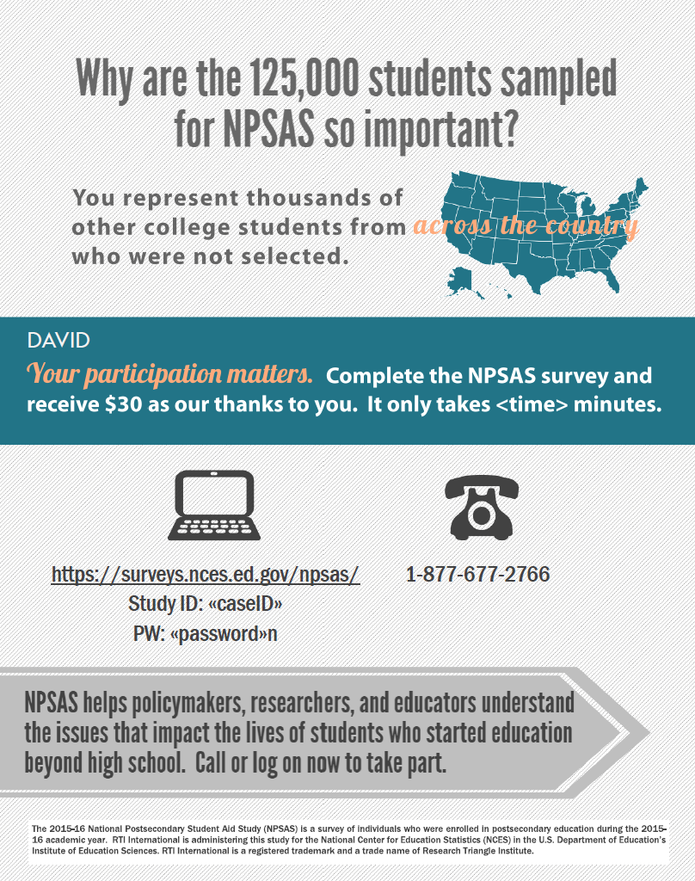
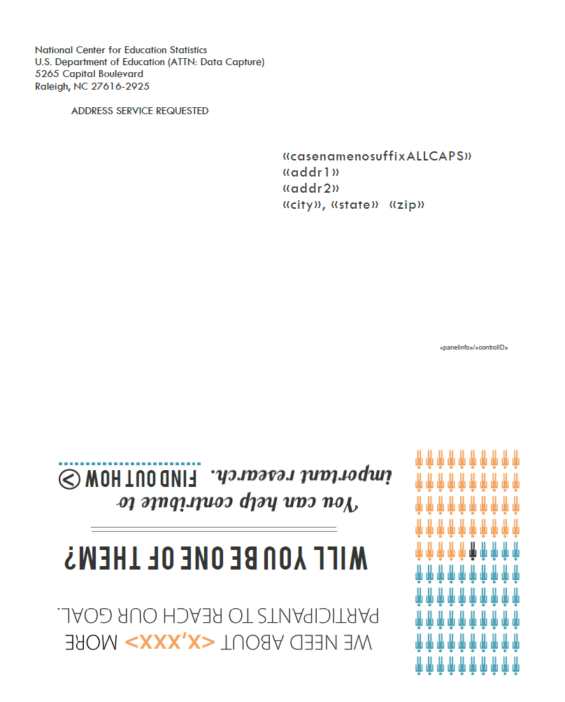

POSTCARD 2
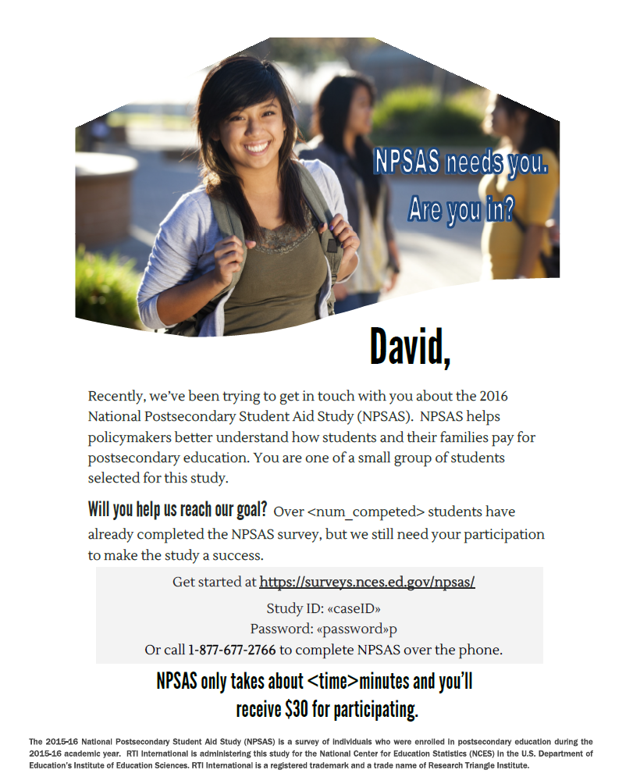

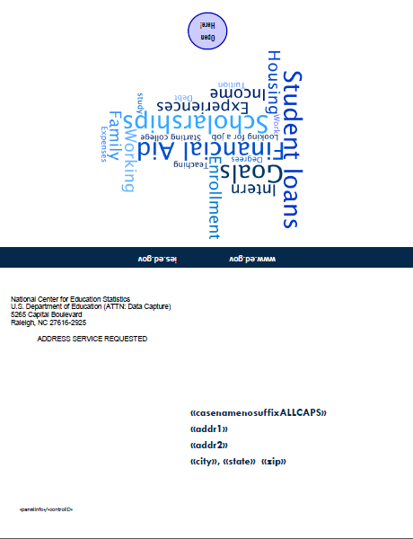
POSTCARD 3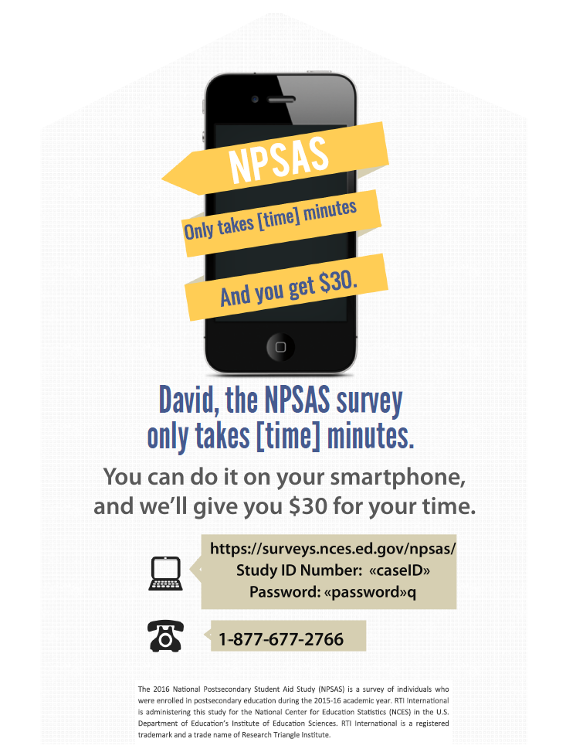
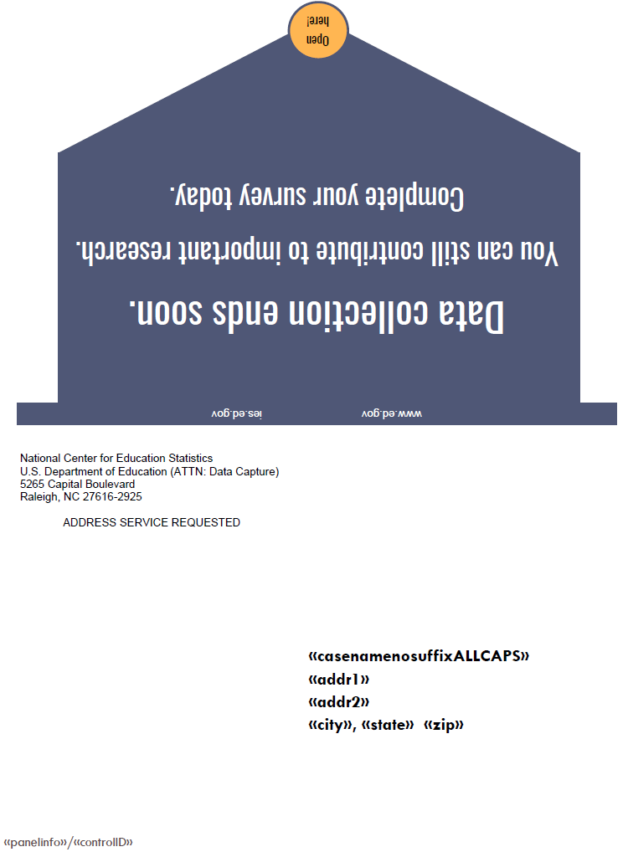
FINAL FLYER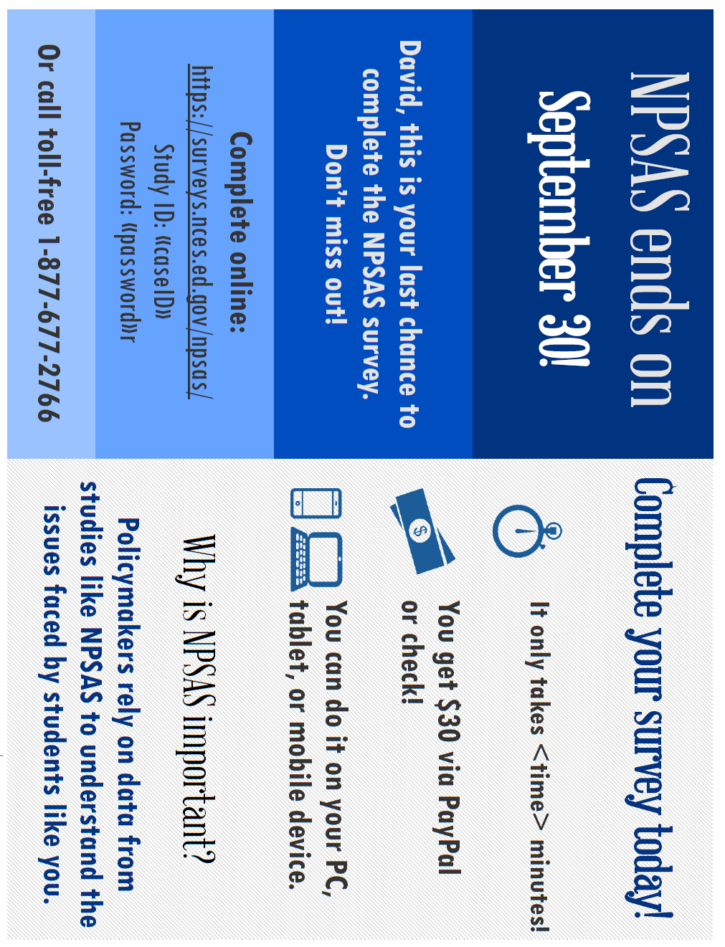
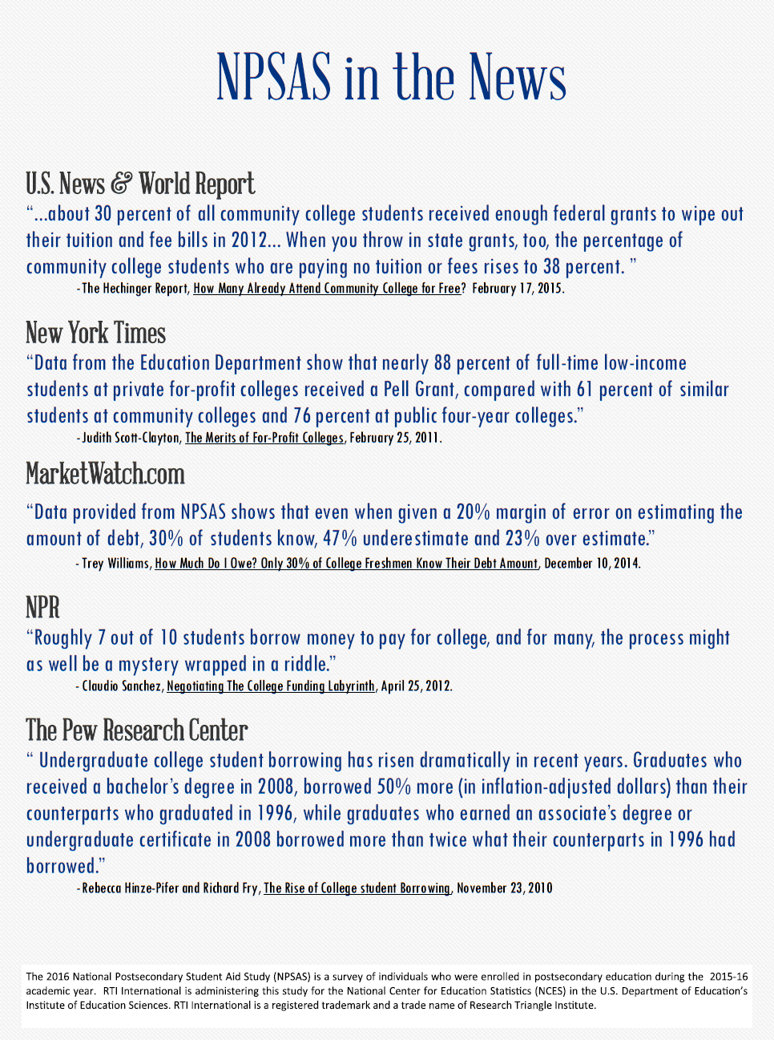

EXAMPLE OF STUDENT RECORD INSTRUCTIONS THAT WILL BE PROVIDED TO INSTITUTIONS
From NPSAS:16 Field Test Student Record Instructions
Quick Guide to Providing Student Records Data
There are 2 steps for providing student records for the 2015-16 National Postsecondary Student Aid Study (NPSAS:16) field test. To complete them, log in to the secure National Center for Education Statistics’ Postsecondary Data Portal (PDP) website at https://surveys.nces.ed.gov/portal.
Log in at the prompt using the username and password printed on the letter or email you received from RTI.
NOTE: To ensure the security of your student data, you must log off when you are going to be away from your computer and when you are finished with a data entry session.
1. Provide Institution Information for Student Records
Before you begin entering student data, you will need to enter information about your institution.
- From the Task Menu, click Provide Institution Information for Student Records.
- Enter the requested school term information (institutions with continuous enrollment and no terms/periods with defined start and end dates should leave the Terms section blank).
- Select the number of credits awarded for a standard course.
- Click the Submit & Return to Task Menu or the Submit & Go to Next Section button at the bottom of the page.
After you submit, the information can be viewed, but not changed. The link on the Task Menu changes to View Institution Information for Student Records and the two Submit buttons on the Institution Information page disappear.
2. Provide Student Record Information
The student-level data we are requesting include contacting information as well as budget, enrollment, and financial aid awarded during the study year (July 1, 2014-June 30, 2015).
- From the Task Menu, click Provide Student Record Information.
- On the Mode Selection page, click View list to view sampled students. Then select which mode you will use to provide data.
There are 3 options available for providing the information: entering data online, entering data offline and then uploading, or uploading data files. Each is described below.
Option 1: Entering Data Online (Web Mode)
- Click Web Mode.
- Select a student and section from the Web Mode Grid and begin keying.
- Save or finalize the section you completed using the buttons at the bottom of the section. Save allows you to leave and return to complete the section. Finalize saves and performs error checks and will highlight missing data and data values that are out of the expected range.
- After you have entered data for a section, you can either continue on to another section for that student or select another student. To select another student, click the link Back to Web Mode Grid and click on a new student and section.
- Once you have completed entering all data for a student, click Finalize (Student Name) at the bottom of his or her web page.
- When you are done entering data for all students, or if you want to check on your progress, return to the Web Mode Grid page. The grid contains icons indicating the status of each section: not started, in progress, errors present, or complete.
- After you have entered all available data for all students, click Finalize All Student Record Information at the bottom of the Web Mode Grid page. You will no longer be able to edit or enter data.
Option 2: Entering Data Offline and then Uploading (Excel Mode)
You may download an Excel template to key or cut and paste in the requested data and then upload the file.
- Click Excel Mode.
- Check the “I agree” box in Step 1 and click Download Excel Template.
- For Step 2, complete the worksheets in the template corresponding to the student information, budget, enrollment, and financial aid data for your students.
- When keying is complete, click Select File in Step 3 and select your saved file to upload. The grid in Step 3 displays a list of each file you have uploaded. When a file is uploaded, it is checked for errors (such as values outside of expected ranges). If errors are detected, a Show Errors button will appear. Please view and correct any errors before attempting to upload the file again.
- Click Review Your Data in Step 4 to review your uploaded data in a grid.
- After you have successfully uploaded your file and are ready to submit final data, click Finalize All Student Record Information in Step 5. You will no longer be able to edit data.
Option 3: Uploading Data Files (CSV Mode)
You or other staff at your institution can create and upload each of the four required comma separated values (CSV) data files following our specifications.
- Click CSV Mode.
- Click Download CSV Specs to view the specifications in Step 1.
- Click Download List to view a list of sampled students in Step 2.
- When a file is ready for upload, click on the tab for the type of file, such as Enrollment, in Step 3. Click Browse, select your saved file to upload, and click Upload File. The grid in Step 3 displays a list of each file you have uploaded. When a file is uploaded, it is checked for errors (such as values outside of expected ranges). If errors are detected, a Show Errors button will appear. Please view and correct any errors before attempting to upload the file again.
- Click Review Your Data in Step 4 to review your uploaded data in a grid.
- After you have successfully uploaded your 4 files and are ready to submit final data, click Finalize All Student Record Information in Step 5. You will no longer be able to edit data.
Regardless of the mode you select, clicking the Finalize All Student Record Information button alerts us that we may begin processing your data and will generate an e-mail to you confirming submission of the data.
NOTE: If you discover that a student does not meet the eligibility criteria for NPSAS, please contact the Help Desk to alert us.
Additional information, including answers to frequently asked questions, is available on the PDP website, https://surveys.nces.ed.gov/portal. If you need assistance, please contact the Help Desk toll-free at 1-855-500-1441 or via e-mail at PortalHelp@rti.org.

STUDENT RECORDS REQUEST LETTER TO INSTITUTION COORDINATOR
The text of the letter is also sent in an e-mail.

<date>
«salutation» «fname» «lname»
«Title»
«entity_name»
«phys_addr1»
«phys_addr2»
«phys_city», «phys_state» «phys_zip»

Your IPEDS UNITID: «entity_id»
Your password: «password»
Student Records Data Due: «expected_Date_curr»
Dear «salutation» «lname»,
Thank you for your continued participation in the 2015-16 National Postsecondary Student Aid Study (NPSAS). We have finished processing the student enrollment file you provided, and have selected a random sample of [# sampled] students from your institution for participation in NPSAS. We now ask that you provide student record data for your sampled students using our secure Web application. Please complete the record abstraction and provide the requested data for these students on or before [DUE DATE]. We will send separate correspondence to the sampled students asking that they complete the NPSAS survey either online or by telephone interview.
We have developed an Internet-based Student Records System through which you (or someone on your staff) will be able to provide data for your selected students. The Student Records System is located on the same secure NCES Postsecondary Data Portal website that you have used for prior components of the study: https://surveys.nces.ed.gov/portal.
To assist you with the process of providing student record data, we have enclosed a Quick Guide to Providing Student Records Data describing how to access and use the Student Records software. You can find details on what data are needed for each sampled student from the Reference Materials page on the portal website. A list of your sampled students can also be found on the website, and you can easily print a hardcopy if you would like one.
There are three different methods available for providing the student data through the Student Records System:
- Webmode – enter data online for one student at a time.
- Upload a data file created from our template – download an Excel template, fill in the requested data for all students, and upload the completed file.
- Upload data files created by an institution programmer – create and upload data files following the specifications on the portal website.

Please be assured that the security of your students’ data is of the utmost importance, and the Student Records software has been developed with this in mind. The system encrypts all data, with the latest technologies, before transmitting them over the Internet to NCES. In addition, access to the list of students (and to the forms used to enter their data) will require authentication using your IPEDS UNITID and unique password. They are printed near the top of this letter for your convenience. Please ensure that access is given only to those at your institution who will provide student records data.
Soon, we will call you to confirm your receipt of this material and the completion date for providing student records data. Help Desk staff will be available from 9:00 a.m. to 6:30 p.m. ET, Monday through Friday, to answer any questions you may have about the study or about using the Student Records System. You may contact the Help Desk at 1-855-500-1441, toll-free, or via e-mail at PortalHelp@rti.org.
Again, thank you for your continued participation in this important study.
Sincerely,

Jennifer Wine, Ph.D. Tracy Hunt-White, Ph.D.
Project Director, NPSAS Project Officer, NPSAS
RTI International National Center for Education Statistics
jennifer@rti.org tracy.hunt-white@ed.gov
1-855-500-1441 1-202-502-7438

Your institution’s response to the National Postsecondary Student Aid Study may be completed online at:

https://surveys.nces.ed.gov/portal

To access the Student Records System, log in using the IPEDS
UNITID below as your Username and enter the password below.

Your IPEDS UNITID: «entity_id»
Your password: «password»

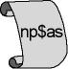
2015-16 National Postsecondary Student Aid Study
(NPSAS:16)

DISCLOSURE NOTICE FOR NPSAS

Information from student records for this individual has been provided to RTI International, a data collection agent for the U.S. Department of Education for NPSAS. This disclosure statement fulfills the requirement of 34 CFR 99.32(a) pursuant to the Family Educational Rights and Privacy Act of 1974 (20 U.S.C. 1232g).
This individual is included in the sample for the 2015-16 National Postsecondary Student Aid Study (NPSAS). Strict protection of all information obtained from individuals selected for participation in NPSAS is assured by current federal laws and regulations. All responses that relate to or describe identifiable characteristics of individuals may be used only for statistical purposes and may not be disclosed or used in identifiable form for any other purpose, except as required by law (20 U.S.C. § 9573).
March 2016
OMB # 1850-(insert number)
Expiration Date: (insert date)

STUDENT RECORDS SAMPLE REMINDER EMAIL 1 TO INSTITUTION COORDINATOR

Dear «salutation» «lname»:

I am writing as a follow-up to the package you should have received recently that included a letter from me about NPSAS Student Records data collection, which is the final institutional component of the 2015-16 National Postsecondary Student Aid Study (NPSAS). The letter requests that you log on to the secure website and provide student records data for sampled students through the Student Records System.

NPSAS is being conducted by the National Center for Education Statistics (NCES), U.S. Department of Education, with the data collection carried out by RTI International, a not-for-profit research organization. The data your institution provides are very important to the success of the study.

Please find below a link to the NCES Postsecondary Data Portal website as well as the username and password needed to access the site and provide data.

Website: https://surveys.nces.ed.gov/portal
Your IPEDS UNITID: «entity_id»
Your PASSWORD: «password»

If you have any questions about the study or procedures involved, please contact the Help Desk at 1-855-500-1441 or via e-mail at PortalHelp@rti.org.

Thank you again for your cooperation.

Sincerely,

Jennifer Wine, Ph.D.
Project Director, NPSAS
RTI International

STUDENT RECORDS SAMPLE REMINDER EMAIL 2 TO INSTITUTION COORDINATOR

Dear «salutation» «lname»:

I am writing to remind you about the 2015-16 National Postsecondary Student Aid Study (NPSAS) that your institution is participating in this [spring/summer]. Data collection is carried out by RTI International for the National Center for Education Statistics in the U.S. Department of Education’s Institute of Education Sciences. By providing student records data for the sampled students, you make an important contribution to research that will help determine how students and their families meet the cost of education beyond high school.

If you are currently preparing the data, thank you. If you have not begun, please do so. We need representation of all the types of institutions and students to compile the most valuable, accurate data.

Please find below a link to the NCES Postsecondary Data Portal website as well as the username and password needed to access the site and provide data.

Website: https://surveys.nces.ed.gov/portal
Your IPEDS UNITID: «entity_id»
Your PASSWORD: «password»

If you have any questions about the study or procedures involved, please contact the Help Desk at 1-855-500-1441 or via e-mail at PortalHelp@rti.org.

Thank you for your participation in this important study.

Sincerely,

Jennifer Wine, Ph.D.
Project Director, NPSAS
RTI International

Postsecondary Data Portal Flyer Text

National Center for Education Statistics (NCES)
Postsecondary Data Portal (PDP)
Institutions can now provide data for NCES sample studies easily—at one central location!

What is the Postsecondary Data Portal?
The Postsecondary Data Portal (PDP) is a website that was created with input from institutions like yours!

By taking advantage of the PDP, you can help NCES collect data on students in our sample studies. These data provide much-needed information on vital concerns to students, families, policymakers, and the academic community.
Visit http://nces.ed.gov/surveys/ for more information on these studies.
Key Benefits
- Eliminates the need to visit a separate website for each NCES sample study in which you are asked to participate
- Creates consistency across studies, as all data are collected using the same interface
- Presents frequently asked questions, timelines, confidentiality information, and contact information for each study currently in progress
- Gives valuable information on current studies’ objectives and research questions, as well as access to data and publications from previous studies
- Provides easy access to the NCES DataLab, where you can create tables and graphs with data from NCES sample studies

How do I use the PDP?
We will contact you when your institution is in an active data collection and supply you with your PDP username and password.
The PDP Task Menu will list the steps to follow to provide data.
Depending on your institution’s capabilities and specific request, you can choose the most convenient way to provide your data.

Visit the PDP website at https://surveys.nces.ed.gov/portal.
For additional questions, you can contact our help desk at 1-855-500-1441 or PortalHelp@rti.org. Help Desk staff are available from 9:00 a.m. to 6:30 p.m. Eastern time, Monday – Friday.

Website Text

Postsecondary Data Portal Website Content (before log in)
Home page
IES logo
Login <IPEDS UnitID> <Password>

Welcome to the Postsecondary Data Portal
An online data collection portal used by institutions to provide data for various educational studies that are sponsored by the National Center for Education Statistics (NCES), part of the U.S. Department of Education.
Log in above to get started.

Click below to visit the NCES website and learn more about the studies that use this portal.
<link to NCES website for NPSAS>
<link to NCES website for BPS>
<link to NCES website for B&B>
<link to NCES website for HSLS:09>

See Prior NCES Studies' data in action: <link to http://nces.ed.gov/datalab/>
(Text below is on footer of every page)
Other NCES Links
NCES DataLab
National Center for Education Statistics

Contact Info
Help Desk: PortalHelp@rti.org or 1-855-500-1441
RTI Institution Contact Tiffany Mattox or 1-855-500-1441
NPSAS
RTI Project Director Jennifer Wine, Ph.D. or 1-855-500-1441
NCES Project Officer Tracy Hunt-White, Ph.D. or (202) 502-7438

Latest Tweets
<link to NCES Tweeter feed>
OMB Clearance No:1850-xxxx Expires xx/xx/xxxx

About
About this website
This website serves as a portal for institutions to provide data for studies sponsored by the National Center for Education Statistics (NCES), United States Department of Education. Each of the studies collects data that are used by NCES for reporting and analysis. Any data released to the public will be in aggregate form (e.g., statistical tables, graphs). Review the FAQs or log in to learn more. Background information on each study can be accessed from the Home page.
The Education Sciences Reform Act of 2002 (ESRA 2002, 20 U.S.C. § 9543) authorizes NCES to collect and disseminate information about education in the United States. NCES is the primary federal entity for collecting and analyzing data related to education in the U.S. and other nations. NCES is located within the Institute of Education Sciences of the U.S. Department of Education. NCES fulfills a Congressional mandate to collect, collate, analyze, and report complete statistics on the condition of American education; conduct and publish reports; and review and report on education activities internationally.
NCES has contracted with RTI International* to administer these studies. RTI is an independent, nonprofit contract research organization located in Research Triangle Park, NC, that was established by a joint action of three major universities in North Carolina: University of North Carolina at Chapel Hill, North Carolina State University, and Duke University. RTI began operations in 1958 and has provided contract support to NCES on postsecondary research that dates back to 1971.
Annually, NCES also conducts a system of interrelated surveys entitled the Integrated Postsecondary Education Data System (IPEDS) through a different website. IPEDS gathers information from every college, university, and technical and vocational institution that participates in the federal student financial aid programs. These data are made available to students and parents through the College Navigator college search Web site and to researchers and others through the IPEDS Data Center.
*RTI International is a registered trademark and trade name of Research Triangle Institute.

Contact Us
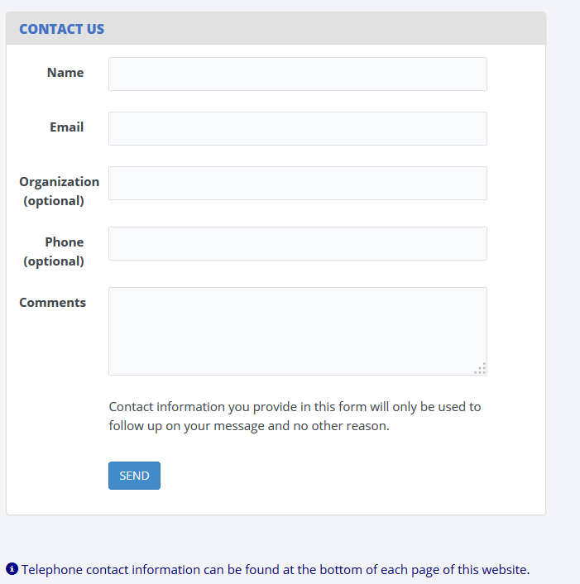
FAQs
FAQs - General (these apply across projects and are available before the user logs in.)
Who is collecting these data?
The National Center for Education Statistics (NCES), in the United States Department of Education's Institute of Education Sciences, has contracted with RTI International to collect data for the studies that use this website. The studies are listed on the Home page. RTI International is an independent, nonprofit research organization located in Research Triangle Park, NC that was established as a joint action of the three major universities in North Carolina: University of North Carolina at Chapel Hill, North Carolina State University, and Duke University. RTI International began operations in 1958 and has provided contract support to NCES on postsecondary education research since 1971.

By what authority does NCES collect this information?
Congress has authorized (20 U.S.C. § 9543) the National Center for Education Statistics within the U.S. Department of Education to conduct these studies in compliance with the Education Sciences Reform Act of 2002 (20 U.S.C. § 9573), the Federal Statistical Confidentiality Order of 1997, the Privacy Act of 1974 (5 U.S.C. § 552a), and the E-Government Act of 2002. Each study has been approved by the U.S. Office of Management and Budget (OMB).
How was my institution selected?
The National Postsecondary Student Aid Study (NPSAS) scientifically samples institutions from all Title IV institutions included in the Integrated Postsecondary Education Data System (IPEDS). For the longitudinal studies, sample members have identified which institutions they attended when completing the student interview; this information may also come from other administrative data sources. Transcripts and financial aid records are collected from the postsecondary institutions attended by sample members.
Why is participation important?
The quality and affordability of postsecondary education are vital concerns for students and their families. The National Postsecondary Student Aid Study (NPSAS) is designed to describe how students meet the cost of education beyond high school and it provides comprehensive data on the enrollment status, education goals, employment, and demographic characteristics of postsecondary students.
The longitudinal studies collect data from transcripts, financial aid records, and/or student interviews to provide much-needed information on the course of study of today’s college students as they begin, leave, and re-enter postsecondary study, transfer between institutions, and complete programs at all levels of institutions. The combination of transcripts and other study data collected through interviews, file matching, and record abstraction, affords researchers the opportunity to summarize the undergraduate and graduate paths taken by sample members and provides them with an important link between academic performance and outcomes.
Do we need to have the student's permission before providing this information?
No. Student or parental consent is not required for release of student record information for the purposes of these studies. The data request conforms fully to the requirements of the Family Educational Rights and Privacy Act of 1974 (FERPA) (34 CFR Part 99). Under FERPA’s general consent rule, NCES is authorized to obtain student level data from institutions for any study-eligible student, without prior consent, if the disclosure is to authorized representatives of the Secretary of Education [34 CFR § 99.31(a)(3)]. Student data are subject to strict protections that are adhered to by NCES and its contractor organizations. You can review this regulation on the U.S. Department of Education's website at http://www2.ed.gov/policy/gen/reg/ferpa.
FERPA regulations also stipulate that all disclosures be reported in the student record, with an indication of who received the information and their legitimate interests in the information. For schools without electronic student record systems, a Disclosure Notice may be printed after log in from the Reference Materials page. These notices fulfill the requirements of 34 CFR 99.32(a) pursuant to the Family Educational Rights and Privacy Act (20 U.S.C. 1232g). Electronic student record systems will require the insertion of a similar statement.

What about confidentiality of the data collected?
Both NCES and RTI International follow strict procedures to protect the privacy and confidentiality of study participants. All project staff members have signed confidentiality agreements and affidavits of nondisclosure. Any data released to the public will be in aggregate form (e.g., statistical tables, graphs). Information obtained may be used only for statistical purposes and may not be disclosed, or used, in identifiable form for any other purpose, except as required by law (ESRA 2002, 20 U.S.C. § 9573).
Are the data secure when sending via the portal website?
Yes. Secure Sockets Layer (SSL) protocol is used to encrypt the data transmitted over the Internet. All data entry modules are password-protected and require users to log in before they are allowed access to confidential data. The system automatically logs the user out after 20 minutes of inactivity. These safeguards prevent unauthorized access to the password-protected site.
The forms that gather data on this website require session cookies to run. RTI upholds the U.S. Department of Education's privacy policy with respect to the use of cookies. Web servers will send a cookie containing a unique session ID to the Web user in order to remember the user as he or she moves from page to page during a session. The cookie does not get written to the user's hard disk, nor does it contain personal data about the user. At the end of the session, the cookie is deleted when the user closes his/her browser. The most recent versions of Microsoft Internet Explorer, Google Chrome, and Mozilla Firefox allow for rejecting all cookies other than those required for session tracking.
How do we provide the data?
The data are submitted by upload or keying as well as other methods. After logging in, you will see a list of what is needed on the Postsecondary Data Portal Task Menu. You can click on any active menu option.
What assistance is available from RTI staff?
The Help Desk at RTI International is available to answer your questions about the studies and using this website. Please call 1-855-500-1441 or e-mail PortalHelp@rti.org with your concerns. Help Desk staff are available from 9:00 a.m. to 6:30 p.m. Eastern time, Monday - Friday.

Postsecondary Data Portal Website Content (after log in)
Paperwork Reduction Act of 1995
According to the Paperwork Reduction Act of 1995, no persons are required to respond to a collection of information unless it displays a valid OMB control number. The valid OMB control numbers for the voluntary information collections using this website are listed below. The time required to complete the information collections is estimated to average the number of minutes or hours listed below per response, including the time to review instructions, search existing data resources, gather the data needed, and complete and review the information collection.
If you have any comments concerning the accuracy of the time estimate, suggestions for improving the collections, or any comments or concerns regarding the status of your individual submission of these data, please write to: Postsecondary Data Portal studies, National Center for Education Statistics, PCP, 550 12th St., SW, 4th floor, Washington, DC 20024.
OMB Clearance No: 1850-xxxx Expiration Date: xx/xx/xxxx
NPSAS:16 Full Scale Student Records Collection: 22 hours
POSTSECONDARY DATA PORTAL TASK MENU
Welcome, it's time to complete the tasks below.
Your participation in studies developed by the National Center for Education Statistics is very important.
The data collected from your institution will provide much-needed information on the academic experience of today's postsecondary students as they begin, leave, and re-enter postsecondary study, transfer between institutions, and complete programs at all types of institutions.
Please complete the tasks indicated by a green arrow.
Designate a Coordinator
Provide Institution Information
Provide Student Record Information
Provide Transcript Data
(screen shot below)

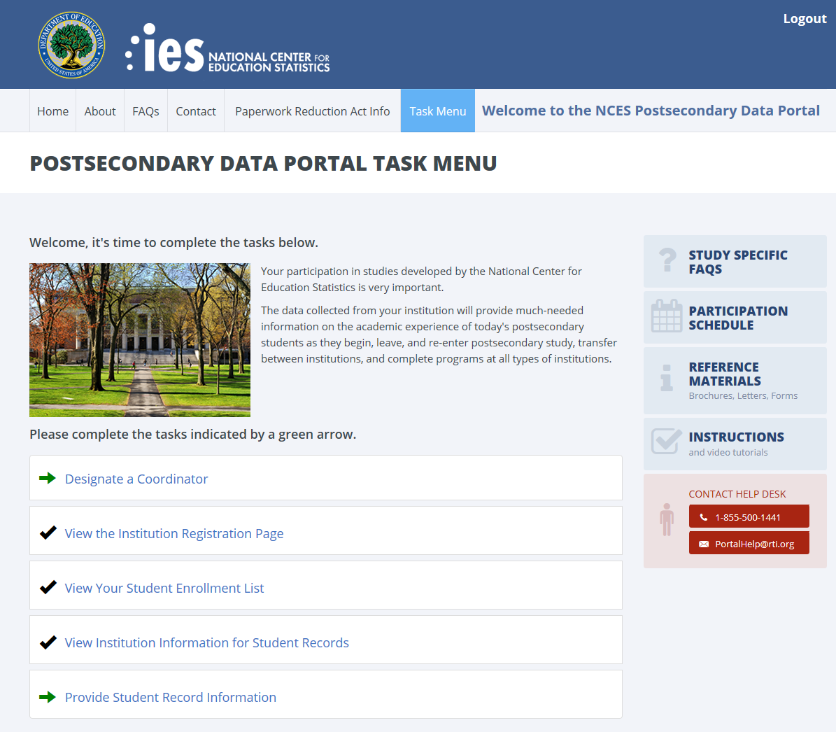

Study Specific FAQS

(These FAQS are specific to NPSAS Student Records and are available only after the user has logged in to the website.)
Who is collecting these data?

The National Center for Education Statistics (NCES), in the United States Department of Education's Institute of Education Sciences, has contracted with RTI International to collect data for the studies that use this website. The studies are listed on the Home page. RTI International is an independent, nonprofit research organization located in Research Triangle Park, NC that was established as a joint action of the three major universities in North Carolina: University of North Carolina at Chapel Hill, North Carolina State University, and Duke University. RTI International began operations in 1958 and has provided contract support to NCES on postsecondary education research since 1971.

By what authority does NCES collect this information?

Congress has authorized (20 U.S.C. § 9543) the National Center for Education Statistics within the U.S. Department of Education to conduct these studies in compliance with the Education Sciences Reform Act of 2002 (20 U.S.C. § 9573), the Federal Statistical Confidentiality Order of 1997, the Privacy Act of 1974 (5 U.S.C. 552a), and the E-Government Act of 2002. Each study has been approved by the U.S. Office of Management and Budget (OMB).

How was my institution selected?

The National Postsecondary Student Aid Study (NPSAS) scientifically samples institutions from all Title IV institutions included in the Integrated Postsecondary Education Data System (IPEDS). For the longitudinal studies, sample members have identified which institutions they attended when completing the student interview; this information may also come from other administrative data sources. Transcripts and financial aid records are collected from the postsecondary institutions attended by sample members.

Why is participation important?

The quality and affordability of postsecondary education are vital concerns for students and their families. The National Postsecondary Student Aid Study (NPSAS) is designed to describe how students meet the cost of education beyond high school and it provides comprehensive data on the enrollment status, education goals, employment, and demographic characteristics of postsecondary students.

The longitudinal studies collect data from transcripts, financial aid records, and/or student interviews to provide much-needed information on the course of study of today’s college students as they begin, leave, and re-enter postsecondary study, transfer between institutions, and complete programs at all levels of institutions. The combination of transcripts and other study data collected through interviews, file matching, and record abstraction affords researchers the opportunity to summarize the undergraduate and graduate paths taken by sample members and provides them with an important link between academic performance and outcomes.

Do we need to have the student’s permission before providing this information?

No. Student or parental consent is not required for release of student record information for the purposes of these studies. The data request conforms fully to the requirements of the Family Educational Rights and Privacy Act of 1974 (FERPA) (34 CFR Part 99). Under FERPA’s general consent rule, NCES is authorized to obtain student level data from institutions for any study-eligible student, without prior consent, if the disclosure is to authorized representatives of the Secretary of Education [34 CFR § 99.31(a)(3)]. Student data are subject to strict protections that are adhered to by NCES and its contractor organizations. You can review this regulation on the U.S. Department of Education's website at http://www2.ed.gov/policy/gen/reg/ferpa.

FERPA regulations also stipulate that all disclosures be reported in the student record, with an indication of who received the information and their legitimate interests in the information. For schools without electronic student record systems, a Disclosure Notice may also be printed after log in from the Reference Materials page. These notices fulfill the requirements of 34 CFR 99.32(a) pursuant to the Family Educational Rights and Privacy Act (20 U.S.C. 1232g). Electronic student record systems will require the insertion of a similar statement.

Are the data secure when sending via the portal website?

Yes. Secure Sockets Layer (SSL) protocol is used to encrypt the data transmitted over the Internet. All data entry modules are password-protected and require users to log in before they are allowed access to confidential data. The system automatically logs the user out after 20 minutes of inactivity. These safeguards prevent unauthorized access to the password-protected site.

The forms that gather data on the website require session cookies to run. RTI upholds the U.S. Department of Education's privacy policy with respect to the use of cookies. Web servers will send a cookie containing a unique session ID to the Web user in order to remember the user as he or she moves from page to page during a session. The cookie does not get written to the user's hard disk, nor does it contain personal data about the user. At the end of the session, the cookie is deleted when the user closes his/her browser. The most recent versions of Microsoft Internet Explorer, Google Chrome, and Mozilla Firefox allow for rejecting all cookies other than those required for session tracking.

What about confidentiality of the data collected?

Both NCES and RTI International follow strict procedures to protect the privacy and confidentiality of study participants. All project staff members have signed confidentiality agreements and affidavits of nondisclosure. Any data released to the public will be in aggregate form (e.g., statistical tables, graphs). Information obtained may be used only for statistical purposes and may not be disclosed or used in identifiable form for any other purpose, except as required by law (Education Sciences Reform Act of 2002, 20 U.S.C. § 9573).

Where do I go for the information requested?

The information needed for each of the sampled students is typically collected from three distinct sources at your institution: the Admissions or Registrar’s Office, the Bursar’s or Business Office, and the Financial Aid Office. If you require assistance after reviewing the Quick Guide to Providing Student Records Data, please contact the Help Desk with your questions at 1-855-500-1441, toll-free, or via e-mail at PortalHelp@rti.org.

How long does it take to collect student records data for NPSAS?

Our estimates indicate that providing the requested student records data will take about 22 hours on average. If you have any concerns with the amount of time it is taking you to provide the requested data, please call the Help Desk at 1-855-500-1441, toll-free. RTI will work with you to successfully complete this data collection effort.

How do we provide the data?

There are three methods available for providing the student records data through the online Student Records System: keying data into the system, filling in and then uploading an Excel template, or uploading data files created by you or an institution programmer.

Can I provide a data file instead of using the online data entry option?

Yes. You can download an Excel template to create the data file we need, or you or a programmer can create data files according to the specifications available on the Student Records Data page of the website. If you have questions, please contact the Help Desk at 1-855-500-1441 or e-mail PortalHelp@rti.org.

Do I need to supply the student’s Social Security Number (SSN) in NPSAS Student Records if we already provided it on the student enrollment list?

No. If your institution provided each student’s SSN on the student enrollment list, it will be displayed in the Student Records System so that you can be sure you are entering data for the correct student. Please correct the SSN if needed. The student’s SSN is needed to perform file matches to other data sources, including the Central Processing System (CPS).

What assistance is available from RTI staff?

The Help Desk at RTI International is available to answer your questions about the studies and using this website. Please call 1-855-500-1441 or e-mail PortalHelp@rti.org with your concerns. Help Desk staff are available from 9:00 a.m. to 6:30 p.m. Eastern time, Monday - Friday.

Reference Materials
NPSAS Student Records
- Request letter (text included on previous pages of this appendix)
- Data Elements
- Disclosure Notice (text included on previous pages of this appendix)
- Quick Guide (text included on previous pages of this appendix)

Instructions
NPSAS Student Records

- Quick Guide (text included on previous pages of this appendix)

NCES E-MAIL REMINDER – ABBREVIATED INTERVIEW

<< Email for all pending cases >>

Subject line = “Message from the U.S. Department of Education”

Dear <<fname>>,

I am contacting you today to ask for your participation in the National Postsecondary Student Aid Study (NPSAS) currently being conducted by the National Center for Education Statistics, part of the U.S. Department of Education.

NPSAS is an important study of how students and their families pay for education beyond high school. Congress and the White House often use data from NPSAS to inform policy decisions regarding student loans and to address other critical issues that affect students like you. Your participation is particularly important to our being able to collect data representing all students who attended a college, university, or trade school during the 2015-16 academic year.

You can complete your NPSAS survey now, online, by going to our secure website:
https://surveys.nces.ed.gov/npsas/
Study ID number = <<caseID>>
Password = <<password>>P

It will only take you about <<duration>> minutes to do and you will receive $<<inc_amount>> as a token of our appreciation.

If you prefer to complete your NPSAS survey over the phone or have questions about the study, please call us at:
1-877-677-2766.

Specially-trained staff from our data collection contractor, RTI International, are available to assist you.

Also, you will find further information and findings from previous NPSAS studies by visiting: http://nces.ed.gov/surveys/npsas/.

You have my sincere thanks for helping make NPSAS a success.

Tracy Hunt-White
National Center for Education Statistics
U.S. Department of Education
Tracy.Hunt-White@ed.gov

OMB Control Number: 1850-0666
Learn more about our confidentiality procedures at https://surveys.nces.ed.gov/npsas/confidentiality.aspx

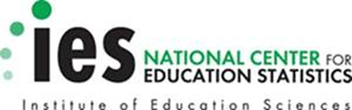

Further detail on the data requested may be found by logging in to the portal website, clicking Reference Materials, and then viewing the Student Records Collection Data Elements.
Does not include Integrated Postsecondary Education Data System (IPEDS).
The Postsecondary Data Portal website is designed to be used by more than one study to collect data. The majority of the website text is designed to apply to multiple NCES studies. Study-specific text is labeled and only available after log in.

