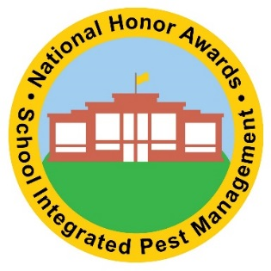
Awards Application Checklist

Suggested Preparation Activities
□ Visit the School IPM Recognition and Certifications webpage to determine the award for which your district qualifies.
□ Familiarize yourself with all pest management related state or tribal laws to ensure your school district is in compliance.
□ Review the model school IPM policy to create or update your school district’s policy plan.
□ Review guidance on preparing a written IPM plan.
□ Consider using a sample pest management contract if your district uses outside pest management service providers.
□ View the School IPM webinar series to familiarize yourself with additional School IPM components.
□ Create or update your school’s pest sighting log to prepare for the application process.
□ Do you have an IPM Checklist?
Steps to Complete Your Application
□ Identify your school district’s IPM coordinator and their contact information.
□ Visit our School IPM website to access the appropriate application.
□ Follow the detailed instructions for the award for which you are applying.
□ Gather all related pest management materials (these may include pest sighting logs, IPM policy, inspection reports, etc.).
□ Review the narrative sections before submittal. Consider soliciting feedback from IPM team members as well as non-team members, to ensure a complete and cohesive application.
□ Submit your application by the deadline
Tier 1 & 2 (rolling admission) | Tier 3, 4 & Connector (November 1st)

