Appendix A-8. Parent User Guide for Child Attendance Reporting System (CARS)

OMB Number: 0584-XXXX  Expiration Date: XX/XX/XXXX  According to the Paperwork Reduction Act of 1995, an agency may not conduct or sponsor, and a person is not required to respond to, a collection of information unless it displays a valid OMB control number. The valid OMB control number for this information collection is 0584-XXXX. The time required to complete this information collection is estimated to average 15 minutes per response, including the time for reviewing instructions, searching existing data sources, gathering and maintaining the data needed, and completing and reviewing the collection of information.
  
  Child Attendance Reporting System
  User Guide
  
  
  
  
  November 2017 v. 3.1
  
  
Contents  Welcome to CARS 1  What Is CARS? 1  What Is CARS Asking Me To Report? 1  How Will My Information Be Protected? 2  Getting Started: Using CARS on My Cell Phone 2  Setting Up My Phone To Use CARS 2  How to Unsubscribe 3  Using the Correct Format To Text CARS 3  Reporting a Drop-Off 4  Reporting a Pick-Up 4  Reporting an Absence 5  Reporting a Closure 5  Texting CARS for Multiple Children 6  Special Reporting 9  How Do I Correct My Response? 10  What If I Receive an Error Message? 10  Getting Help with CARS Text 10  Using CARS on the Web 11  Accessing and Logging In to CARS Web 11  Retrieving My Password……………………………………………………………12  Reporting Child Attendance on the CARS Website………………………….12  Selecting a Date…………………………………………………………………………13  Reportng a Drop-Off……………………………………………………………….....14  Reporting a Pick-Up…………………………………………………………………..15  Reporting Additional Drop-off and Pick-Up Times………………………15  Reporting an Absence…………………………………………………………….….16  Reporting a Closure….………………………………………………………………..16  Website Access for Additional Parents……………………………………….16  Getting Help with CARS Web..……………………………………….………………17  Additional Examples of How to Text CARS…………...………....…................18 |  |  | Notes
Notes |  |  |  | Welcome to CARS  This user guide describes how to use the Child Attendance Reporting System (CARS) on your phone or online to report your child’s attendance at his or her day care home. CARS is being used to help the Food and Nutrition Service (FNS) determine if your day care provider is receiving the correct amount of reimbursement for the meals they serve. Your participation in the study will have no effect on your child’s or your provider’s eligibility in the Child and Adult Care Food Program (CACFP), which you may know simply as the Food Program.  What Is CARS?  CARS is a text-based attendance reporting system. It functions like the sign-in, sign-out log you already complete at your child’s day care home. You can access CARS from your cell phone. CARS also has a website you can access from any computer.  What Is CARS Asking Me to Report?  CARS asks you to text the drop-off and pick-up times for your child on a daily basis. You will be texting only the times and the first name of your child. CARS does not collect any other personally identifying information.  CARS asks you to report the drop-off and pick-up times for your child every day no later than 12 midnight. The system also sends two text reminders daily to help you remember to report in.
20 |  |  |  | 1
How Will My Information Be Protected?  Information you share by using CARS is anonymous and cannot be linked. It cannot be used to make any contact with you or your child. The CARS system cannot share your phone number with others. All data are securely stored in an encrypted format to prevent the data from being compromised in any way.  Getting Started: Using CARS on My Cell Phone  Setting Up My Phone to Use CARS  - “Please enroll in the Child Attendance Reporting System (CARS) to report the time you drop-off and pick-up your child(ren). The valid OMB control number for this information collection is 0584-XXXX. The time required for a respondent to complete this information collection is estimated at 3.75 hours. Text 1 for ENROLL ME NOW.  Step 1: The number for CARS is 510-858-2277. Once you agree to participate in the study, CARS will send a text message to your cell phone. It will read:  - “Welcome to CARS. You have successfully enrolled. Please save this number as CARS.”  Step 2: If you respond with “1,” CARS will send you another message that reads:
  YOU ARE A PARENT WITH MULTIPLE CHILDREN ENROLLED AT DAY CARE:
  Parent Actions | Texts You Send  to CARS
  You just dropped off ALL of your children at the day care. | D 7:30am
  You just picked up ALL of your children from the day care. | P 5:15pm
  ALL of your children will be absent today. | A
  Your child’s day care is closed today. | C
  One of your children, Billy, is absent. The others, Lisa and Jayda, are dropped off at day care and picked up together in the evening. | Text 1: A Billy  Text 2: D 7:30am Lisa  Text 3: D 7:30am Jayda  Text 4: P 5:45pm
  You dropped off all of your children at the same time. You pick up one of your children, Billy, from day care at noon for a dentist appointment, but the others, Lisa and Jayda, are picked up later. | Text 1: D 6:30am  Text 2: P 12:00pm Billy  Text 3: P 5:45pm Lisa  Text 4: P 5:45pm Jayda
  You texted an incorrect pick-up time for one of the children, Jayda, and want to correct your response. | Text “1,” then text the correct pick-up time with the child’s name, for example, P 5:30pm Jayda.
2 |  |  |  | 19
More Examples of How to Text CARS  Use this two-page guide for additional help texting CARS. |  |  |  | Step 3: Please save the number, 510-858-2277, as a contact in your phone and name it “CARS.”  How to Unsubscribe  If you decide you no longer wish to participate in the study, please call the hotline at 1-800-912-9384. Then text “STOP” to CARS.  Using the Correct Format to  Text CARS  CARS asks you to report:  - The drop-off and pick-up times for your child every day if he or she is in care.  - An absence if your child is not in care.  - Whether your child is not in attendance because the day care is closed.  You must text CARS no later than 12 midnight daily.  Report an absence only if your child is absent from the day care home all day. If your child was absent for only part of the day, make sure to enter the times your child was dropped off and picked up. You will also text CARS when the day care is closed and your child is not in care.  CARS requires that you use a specific format to send your responses to the system. The format you use is as follows:
  YOU ARE A PARENT WITH ONE CHILD ENROLLED AT DAY CARE:
  Parent Actions | Texts You Send to CARS
  You just dropped off your child at the day care. | D 7:30am
  You just picked up your child from the day care. | P 5:15pm
  Your child is sick and is absent today. | A
  Your child’s day care is closed today. | C
  Your child attended day care in the morning, but was picked up early because the child became ill. | Text 1: D 8:45am  Text 2: P 1:15pm
  Your child was dropped off at the day care in the morning, but you picked up your child for a doctor’s appointment in the afternoon. After the appointment, you dropped off the child at the day care again and picked up the child at the end of day. | Text 1: D 7:15am  Text 2: P 11:15pm  Text 3: D 1:30pm  Text 4: P 5:00pm
  You texted the incorrect pick-up time to CARS and want to correct your response. | Text “1” then text the correct pick-up time, for example,  P 5:30pm
18 |  |  |  | 3
Reporting a Drop-Off  To report a drop-off, text “D” and then enter the time in the HH:MMam/pm format. For example: for a drop-off at 7:35 am, simply text “D 7:35am”  - CARS 11/26/15:  - Thank you for reporting the drop-off time. If you’d like to make a correction, please text “1”.  - 7:36 am  No space is needed between the time and am or pm.  CARS will send you a confirmation message after you report a drop-off time:  Reporting a Pick-Up  To report a pick-up, text “P” and then enter the time in the HH:MMam/pm format. For example: for a pick-up at 6:30 pm, simply text “P 6:30pm”  - CARS 11/26/15:  - Thank you for reporting the pick-up time. If you’d like to make a correction, please text “1”.  - 6:32 pm  No space is needed between the minute and am or pm.  CARS will send you a confirmation message after you report a pick-up time: |  |  |  | Getting Help with CARS Web    To get help with CARS Web, click the HELP icon located in the top right corner:  This will take you to the help screen, where you can view the toll-free hotline number, email the study team for assistance, or download the user guide.  Email us for help at cars@manhattanstrategy.com, or call us at 1-800-912-9384. Email and telephone assistance are available from 9 am to 5 pm EDT. If you call or email after  5 pm, we will contact you the next business day.
4 |  |  |  | 17
Reporting an Absence  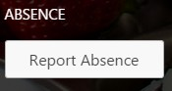  Click the “Report Absence” button:  The absence is recorded immediately. The absent child is recorded as “Absent Today,” as shown below:    Reporting a Closure  To report when your child is not in attendance because the day care is closed, click the red REPORT CLOSURE button.  Website Access for Additional Parents  You may choose to share your login information with additional parents/guardians so they can access the CARS website. |  |  |  | Reporting an Absence  To report an absence, text “A.”  - CARS 11/26/15:  - Thank you for reporting an absence. If you’d like to make a correction, please text “1”. 6:32 pm  CARS will send you a confirmation message after you report an absence:  If you have only one child enrolled in day care, you do not need to put your child’s name in your text.  Reporting a Closure  To report when your child is not in attendance because the day care is closed, text “C.”  - CARS 11/26/15:  - Thank you for reporting the pick-up time. If you’d like to make a correction, please text “1”.  - 6:32 pm  CARS will send you a confirmation message after you report a closure:
16 |  |  |  | 5
Texting CARS for Multiple Children  If you have multiple children attending the day care who are dropped off and picked up at the same time, you can send one text for each drop-off or pick-up that will count for all of your children.  In some cases, CARS will require you to send one text per child and add the name of your child after the drop-off or pick-up time so that it can tell which child you are reporting for:  - If your children have different drop-off and pick-up times, send a separate text for each child to report his or her unique drop-off or pick-up time, followed by that child’s name.  - If one of your children attends day care, but the other is absent, send separate texts for each child to report drop-off/pick-up times and the absence.  Below are examples of each of these situations and how you should  text CARS.  Example 1: You have two children in the day care, Garry and Mary. If they are both dropped off at 7:15 am and picked up at 6:30 pm, your texts to CARS would look like this:  - D 7:15am  - P 6:30pm |  |  |  |   Reporting a Pick-Up  Follow the same steps described above to report a pick-up time, using the blue Log Pick-Up Time button.    When you select a pick-up time, this is shown in green, circled in red below:  Reporting Additional Drop-Off and  Pick-Up Times  If your child leaves and then returns to the day care on the same day, report the additional drop-off and pick-up times  by clicking the +More feature, displayed under your  child’s name.  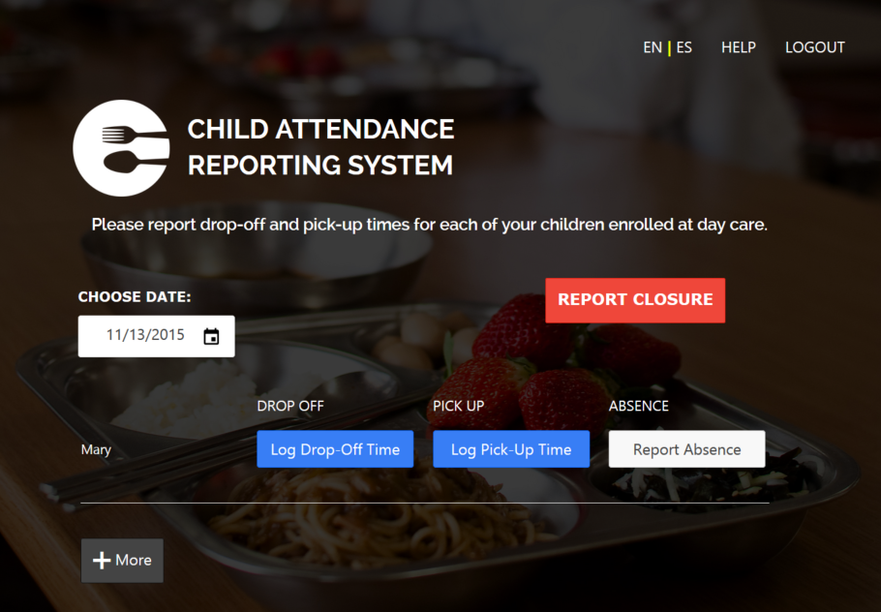
6 |  |  |  | 15
Reporting a Drop-Off  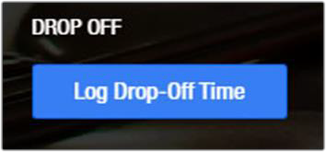  Step 1: Click the blue Log Drop-Off Time button to report a drop-off time.  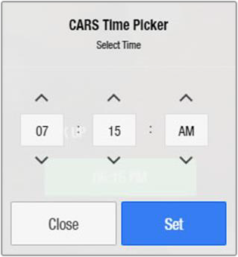  Step 2: On the CARS Time Picker window, use the up/down arrows to adjust the hours, minutes, and AM or PM.  - Click the blue Set button to save the drop-off time.  - Click the Close button if you want to exit the CARS Time Picker without saving the changes.  Step 3: The drop-off time is now shown in the green rectangle. |  |  |  | Example 2: Garry and Mary were dropped off at the same time on Tuesday, but Garry was picked up early for a doctor’s appointment and did not return to the day care,  while Mary stayed all day. Your texts to CARS would be:  Your cell phone would look like this:  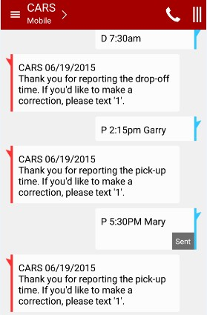
  D 7:30am | Which means both children were dropped off at the same time.
  P 2:15pm Garry | Which means Garry was picked up early at 2:15 pm.
  P 5:30pm Mary | Which means Mary was picked up later at 5:30 pm.
14 |  |  |  | 7
Example 3: On Wednesday, Garry was sick and stayed home, but Mary went to day care. You should report Gary as absent in one text, and the drop-off and pick-up times for Mary in two other texts. Your texts to CARS would be:  Your cell phone would look like this:  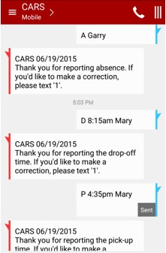 |  |  |  | You must complete CARS Web by 12 midnight of each day. You can make changes for the current day, until midnight of the day you are reporting for.  To report your child’s drop-off, pick-up, or absence in CARS Web, use the following steps:  Selecting the Date  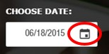  Step 1: Select the date by clicking on the CHOOSE DATE calendar button.  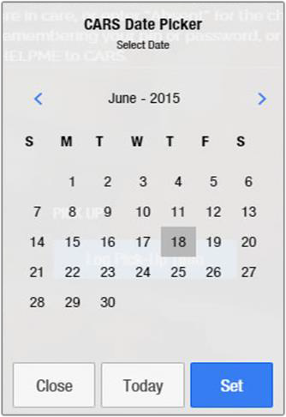  Step 2. On the calendar, select a date. Click the Today button to reset the date to today’s date, circled in red.  - To exit the Date Picker without changing the date, click the Close button, circled in green.  - To confirm a selected date, click the blue Set button. This saves the date.
  A Garry | Which means Garry is absent: no other times are reported for him.
  D 8:15am Mary | Which means that Mary was dropped off at 8:15 am.
  P 4:35pm Mary | Which means that Mary was picked up at 4:35 pm.
8 |  |  |  | 13
Retrieving My Password  Click the HELP link in the top right corner of the website. This will direct you to the toll-free hotline number,  1-800-912-9384, to get help resetting your password any time between 9 am and 5 pm EDT.  Reporting Child Attendance on the CARS Website  Report the drop-off and pick-up times, or absence (including those due to closure of the day care) for your child on the Main Reporting Page, below. Your child’s name will be displayed on the screen.  Report an absence only if your child is absent all day from the day care home. If your child was absent only part of  the day, make sure to enter the times when your child was dropped off and picked up. |  |  |  | How Do I Report If My Child Leaves and Returns to Day Care During the Day  Your child may be picked up for a doctor’s appointment and returned back to day care. If this happens, you should send a text for each drop-off and pick-up for your child. This means you would send four text messages:  - A drop-off time in the morning  - The time when your child is picked up for the appointment  - The time when your child is dropped off again after the appointment  - The time when you pick up the child in the evening  For example:  You must text the times sequentially in the order they occurred.  Every drop-off time must have a corresponding pick-up time recorded.
  D 6:15am | The first drop-off time
  P 11:45am | The first pick-up time: child leaves for appointment
  D 2:35pm | The second drop-off time: child returns to the day care home
  P 7:15pm | The final pick-up time for the child for  the day
12 |  |  |  | 9
How Do I Correct My Response?  If you need to make corrections to your response, text “1” to CARS, and CARS will let you correct your answer in a new text. You can report and make corrections until midnight local time. You can make changes only on the current day. You cannot change any data reported after 12 midnight.  What If I Receive an Error Message?  CARS will send you an error message if your information is in a format that CARS can’t recognize or process. If this happens, CARS will provide instructions to help you correct your response so you can resend it.  Getting Help with CARS Text  At the end of this user guide, you will find quick reference tables with more examples for how to text CARS.  To get help using CARS Text, text “HELPME” or “helpme” at any time. For simple issues, CARS will send a text that gives basic instructions. For more complex issues, call the help desk. You can reach the help desk by calling the toll-free hotline at 1-800-912-9384.  REMINDER: You must text CARS no later than 12 midnight daily. |  |  |  | Using CARS on the Web  Accessing and Logging In to CARS Web  You can access CARS on the web by going to http://cars.manhattanstrategy.com. To log in, follow these steps:  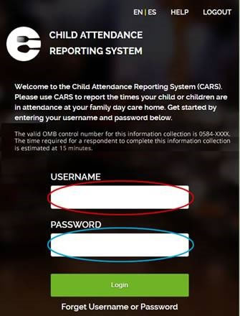  Step 1: Enter your cell phone number as the username (for example, 4122646975) in the field labeled “USERNAME” (circled in red in the illustration).  Step 2: Enter your password in the field labeled PASSWORD, circled in blue. The password is “srac.”  Step 3: Click or press the green “Login” button to access the system.  TIP: If you have trouble locating your password, call the toll-free hotline at 1-800-912-9384 any time from 9 am to 5 pm EDT or email cars@manhattanstrategy.com.
10 |  |  |  | 11

