Appendix B-3-1. Glossy Fact Sheet for CACFP Sponsor and FDCH Provider

  Privacy  The study uses strict security protocols to ensure the privacy and security of your information.  The study team will keep all information you provide private, to the full extent allowed by law, and will use the information only for the purposes of this study.  The study team will not identify participating providers or sponsors in any reports, data files,  or correspondence provided to the USDA.  Frequently Asked Questions  - How do providers access the technology for the study?  Providers can download the smartphone application (app) to their cell phone, or access it on a laptop computer/tablet.  No costs are associated with downloading  the app.  - Is there a Spanish version of the technology providers are being asked to use?  Yes. Providers can choose their language preference from the app’s main screen, for cell phone and computer.  - How long will it take a provider to complete this reporting?  The reporting time may vary depending on the number of meals a provider serves and the number of children enrolled in the day care. However, we estimate that the daily reporting time is approximately 15 minutes or less. |  |  |  |  |  |   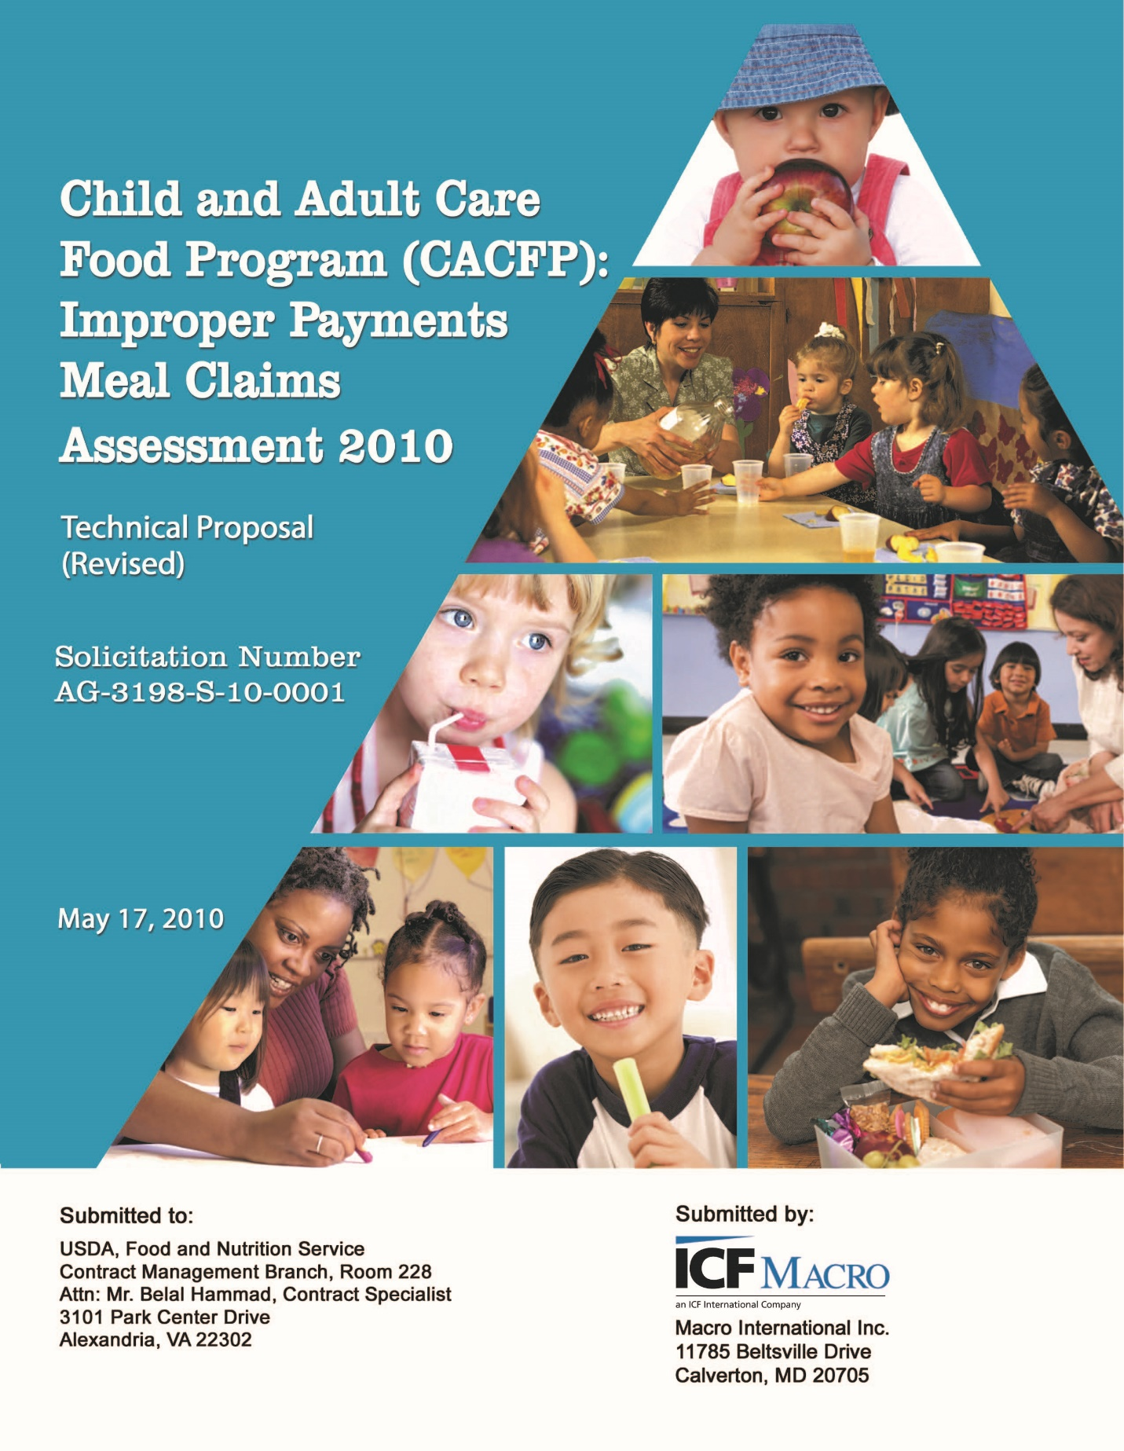      OMB Number: 0584-XXXX  Expiration Date: XX/XX/XXXX  CACFP Meal Claims Feasibility  Study  Study conducted for  the Food and  Nutrition Service
  Contact Us
  Have a Question or Need Help?
  Please contact us toll-free at 1-800-912-9384 or email us at CACFP@manhattanstrategy.com.
  We are happy to assist you.
  According to the Paperwork Reduction Act of 1995, an agency may not conduct or sponsor, and a person is not required to respond to, a collection of information unless it displays a valid OMB control number. The valid OMB control number for this information collection is 0584-xxxx. The time required to complete this information collection is estimated to average 15 minutes per response, including the time for reviewing instructions, searching existing data sources, gathering and maintaining the data needed, and completing and reviewing the collection of information.
  
What is the CACFP Meals Claims Feasibility Study?    The U.S. Food and Nutrition Service (FNS) funds the Child and Adult Care Food Program (CACFP). The agency is conducting a study to test the feasibility of a new method to find out whether day care providers are claiming and receiving the correct amount of reimbursement for meals they serve. The agency is required to determine this in order to meet the Federal Government’s reporting requirement for measuring the integrity of the CACFP.  FNS has contracted with Manhattan Strategy Group (MSG), an experienced program evaluation and research firm, to conduct the feasibility study. MSG designed two technologies for the study that provide simple means for providers to report meal serving times and for parents to report child attendance.  The study collects data from selected sponsors, providers, and parents. During the study:  - Sponsors will be asked to provide administrative data and meal claim  records for a three-month period.  - Providers will be asked to provide child enrollment information and to record their meal serving times and child attendance during the study month, March 2017.  - Parents will be asked to report child attendance during March 2017. |  |  | Your Role in the Study  You have been randomly selected to participate in the study. The MSG study team would like to partner with you for the study. Your participation is crucial to ensure the success of this study. Your participation is strongly encouraged under Section 305 of the Child Nutrition Reauthorization Act (CNR). We greatly appreciate your cooperation and support.  The Role of a Sponsor Organization in the Study  Your participation in the study will not impact any benefits that your sponsor organization  or its subsidiary FDCHs are entitled to under CACFP.  If you are a sponsoring organization, we ask you to support the study by doing the following:  - Provide administrative data needed to complete the selection of approximately  15 providers you oversee for the study.  - Support the invitation of selected providers  to participate in the study as a liaison.  - Provide additional administrative data (such as provider meal service agreements and meal claims forms) for the study months for sampled providers.  The MSG study team will partner with you to  make the transmission of requested data as  easy as possible. |  |  |   The Role of a Provider in the Study  Your participation in the study will not impact your current agreement with your sponsor organization, or the meals you currently claim  for reimbursement.  We would like you, as a study participant, to take a few minutes each day to use a simple smartphone application or website to report meal claims for the month of March 2017. For your participation in the study, we will provide you with a Visa gift card of $60.  During the study, the smartphone application, called the Meal Service Reporting System (MSRS), will allow you to report daily child attendance and meal services you provided to children. It will not take the place of the current reporting approach you use to file meal claims with your sponsor. We also ask you to support the invitation of parents in your day care to the study.  You will receive an easy-to-follow user guide on how to use the technology before the study starts. Technical assistance will be available  to help you use the system when you need it during the study.

