OMB Control No. 0648-0342
Expiration Date: 5/31/2018

Rip Current Public Survey

Thank you for logging into this survey. The survey is voluntary and any information you provide will be anonymous.

The purpose of this research is to understand which, among a series of graphics, best helps you understand the likelihood of hazardous rip currents. By doing this research, we hope to learn what will best motivate people to protect themselves from rip currents.

We are asking those who are willing to complete the survey that addresses knowledge of rip currents as well as perceptions of various ways to illustrate rip current potential. The amount of time it will take you to complete this survey is approximately 30 minutes.

If you agree to take part in this survey, you will be asked questions that relate to how often you visit the beach, what you know about rip currents and what aspects of several graphical warning products you like and do not like. In addition, we will be collecting some demographic information.

This research is being conducted by an independent contractor on behalf of the National Weather Service. You are not required to take part in this research, and you can stop at any time.

Thank you for taking the time to participate.

Q1 What is your age?
under 20
20-29
30-39
40-49
50-59
60-69
70+

Q2 Do you live in North Carolina?
Yes
No
Q2: If yes, go to Q3; if no, answer Q2a-c

Q2a In what state do you live? ______________

Q2b Have you vacationed in North Carolina?
Yes
No
Q2b: If yes, go to Q2c; if no, go to Q3

Q2c In what year did you last vacation in North Carolina?

Q3 On average, how many days do you visit the beach each year?

Q4 When you visit the beach, do you or your family typically go in the water?
Yes
No

Q5 Where do you get information about the weather? (Please check all that apply)
NOAA (National Weather Service) websites
Other weather websites
TV
Radio
Smartphone app(s)
Twitter
Facebook
Other (please specify) ____________________

Q6 How often do you check the weather forecast?
Several times a day
Once a day
Several times a week
Once a week
I rarely check the forecast

Q7 Have you ever checked an ocean wave forecast or tide prediction before going to the beach?
Yes
No

Q8 Have you ever heard of a rip current?
Yes
No

Q8: If No Is Selected, Then Skip To End of Survey and a page with “Thank you for your time and taking our survey.”

Q9 What statement describes what a rip current is?
It is an undertow that pulls you under the water
It is a tidal movement that can carry you alongshore
It is a strong current that carries you through the surf just past the breaking waves
Don't know

Q10 Have you ever been caught in a rip current?
Yes
No

Q11 Do you know someone who has been caught in a rip current?
Yes
No

Q12 What common advice have you heard or seen about what to do when caught in a rip current? (Please check all that apply)
Swim parallel to the beach
Stay afloat
Stay calm/don't panic
Don't swim against the rip current
Have not heard or seen advice about what to do
Other (please specify) ____________________

Below we provide several visualizations with questions relating to each. For each, please respond to the questions that follow the graphic.

Graphic A
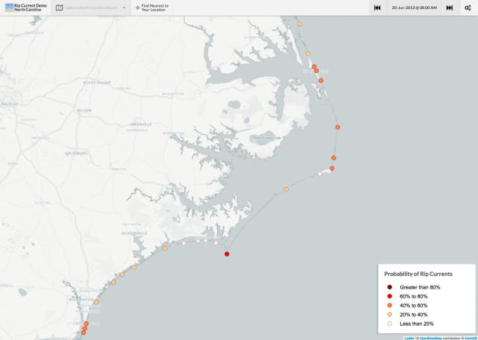
Q13 What does this product tell you?
How strong the rip current is
How strong the rip current is likely to be
The likelihood of a hazardous rip current
Not sure

Q14 What element or elements of this product are most useful in understanding the rip current risk forecast? (Please check all that apply)
Locational information
Use of color
Text explanations
The area shown
Categories used
Other (please specify) ____________________

Q15 What is your perception of this product with respect to the following qualities or characteristics?
 | Very negative | Somewhat negative | Neutral | Somewhat positive | Very positive | Don't know
Information included
Format
Understandability
Graphics/symbols
Text
Use of color

Q16 What does "less than 20%" on this graphic mean to you?
Rip currents are present all of the time
Rip currents can be present some of the time
Rip currents are not present
Other (please specify) ____________________

Q17 How would each of the following categories affect what you would do?
 | Avoid that location | Still go but stay out of the water | Still go but check with a lifeguard before going in the water | Still go but check what other people are doing before going in the water | Nothing different than originally planned
Greater than 80%
40-60%
Less than 20%

Q18 Considering all of the information shown above, how likely...
 | Very likely | Somewhat likely | Undecided | Somewhat unlikely | Very unlikely | Don't know
would this product affect your decision to go to the beach?
would this product affect your decision on which beach to go to?
would this product affect your decision to go in the water if you were already at the beach?
would this product affect your decision to swim in an area with lifeguards?
is it that you would use this product in the future to understand rip current risk?
would this product lead you to learn more about rip currents and what to do if caught in one?

Q19 If you were to use this product, when would you look at it?
Prior to going to the beach
While at the beach
Both
I wouldn't use it

Graphic B
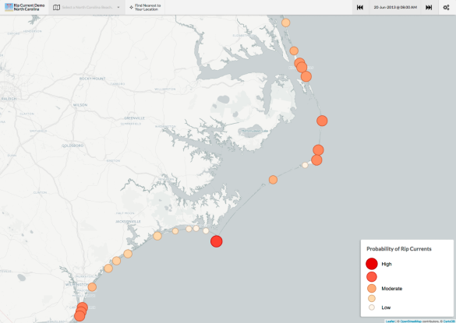

Q20 What does this product tell you?
How strong the rip current is
How strong the rip current is likely to be
The likelihood of a hazardous rip current
Not sure

Q21 What element or elements of this product are most useful in understanding the rip current risk forecast? (Please check all that apply)
Locational information
Use of color
Text explanations
The area shown
Categories used
Other (please specify) ____________________

Q22 What is your perception of this product with respect to the following qualities or characteristics?
 | Very negative | Somewhat negative | Neutral (3) | Somewhat positive | Very positive | Don't know
Information included
Format
Understandability
Graphics/Symbols
Text
Use of color

Q23 What does "low" on this graphic suggest to you?
Rip currents are present all of the time
Rip currents can be present some of the time
Rip currents are not present
Other (please specify) ____________________

Q24 How would each of the categories shown below affect what you would do?
 | Avoid that location | Still go but stay out of the water | Still go but check with a lifeguard before going in the water | Still go but check what other people are doing before going in the water | Nothing different than originally planned
High
Moderate
Low

Q25 Considering all of the information shown above, how likely
 | Very likely | Somewhat likely | Undecided | Somewhat unlikely | Very unlikely | Don't know
would this product affect your decision to go to the beach?
would this product affect your decision on which beach to go to?
would this product affect your decision to go in the water if you were already at the beach?
would this product affect your decision to swim in an area with lifeguards?
is it that you would use this product in the future to understand rip current risk?
would this product lead you to learn more about rip currents and what to do if caught in one?

Q26 If you were to use this product, when would you look at it?
Prior to going to the beach
While at the beach
Both
I wouldn't use it

Graphic C
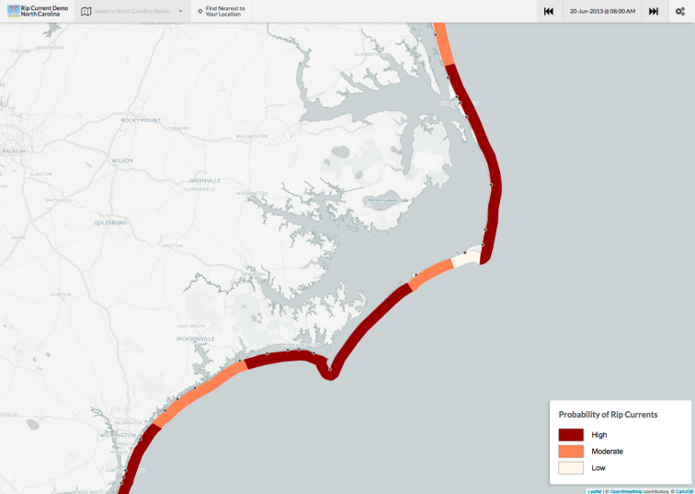

Q27 What does this product tell you?
How strong the rip current is
How strong the rip current is likely to be
The likelihood of a hazardous rip current
Not sure

Q28 What element or elements of this product are most useful in understanding the rip current risk forecast? (Please check all that apply)
Locational information
Use of color
Text explanations
The area shown
Categories used
Other (please specify) ____________________

Q29 What is your perception of this product with respect to the following qualities or characteristics?
 | Very negative | Somewhat negative | Neutral | Somewhat positive | Very positive | Don't know
Information included
Format
Understandability
Graphics/Symbols
Text
Use of color

Q30 How would each of the categories shown below affect what you would do?
 | Avoid that location | Still go but stay out of the water | Still go but check with a lifeguard before going in the water | Still go but check what other people are doing before going in the water | Nothing different than originally planned
High
Moderate
Low

Q31 Considering all of the information shown above, how likely...
 | Very likely | Somewhat likely | Undecided | Somewhat unlikely | Very unlikely | Don't know
would this product affect your decision to go to the beach?
would this product affect your decision on which beach to go to?
would this product affect your decision to go in the water if you were already at the beach?
would this product affect your decision to swim in an area with lifeguards?
is it that you would use this product in the future to understand rip current risk?
would this product lead you to learn more about rip currents and what to do if caught in one?

Q32 If you were to use this product, when would you look at it?
Prior to going to the beach
While at the beach
Both
I wouldn't use it

Graphic D
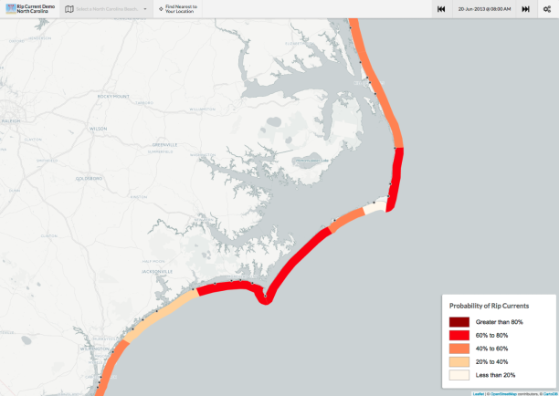

Q33 What does this product tell you?
How strong the rip current is
How strong the rip current is likely to be
The likelihood of a hazardous rip current
Not sure

Q34 What element or elements of this product are most useful in understanding the rip current risk forecast? (Please check all that apply)
Locational information
Use of color
Text explanations (3)
The area shown
Categories used
Other (please specify) ____________________

Q35 What is your perception of this product with respect to the following qualities or characteristics?
 | Very negative | Somewhat negative | Neutral | Somewhat positive | Very positive | Don't know
Information included
Format
Understandability
Graphics/Symbols
Text
Use of color

Q36 How would each of the categories below affect what you would do?
 | Avoid that location | Still go but stay out of the water | Still go but check with a lifeguard before going in the water | Still go but check what other people are doing before going in the water | Nothing different than originally planned
Greater than 80%
40-60%
Less than 20%

Q37 Considering all of the information above, how likely...
 | Very likely) | Somewhat likely | Undecided | Somewhat unlikely | Very unlikely | Don't know
would this product affect your decision to go to the beach?
would this product affect your decision on which beach to go to?
would this product affect your decision to go in the water if you were already at the beach?
would this product affect your decision to swim in an area with lifeguards?
is it that you would use this product in the future to understand rip current risk?
would this product lead you to learn more about rip currents and what to do if caught in one?

Q38 If you were to use this product, when would you look at it?
Prior to going to the beach
While at the beach
Both
I wouldn't use it

Graphic E
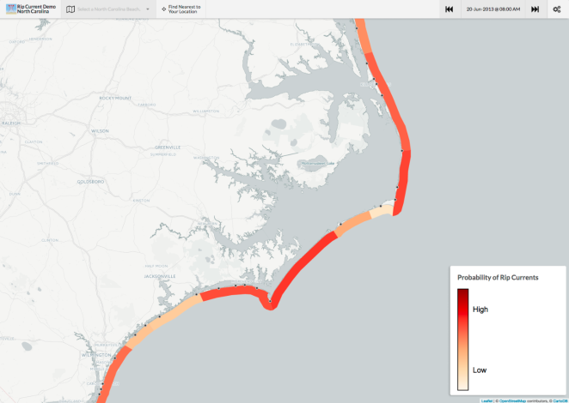

Q39 What does this product tell you?
How strong the rip current is
How strong the rip current is likely to be
The likelihood of a hazardous rip current
Not sure

Q40 What element or elements of this product are most useful in understanding the rip current risk forecast? (Please check all that apply)
Locational information
Use of color
Text explanations
The area shown
Categories used
Other (please specify) ____________________

Q41 What is your perception of this product with respect to the following qualities or characteristics?
 | Very negative | Somewhat negative | Neutral | Somewhat positive | Very positive | Don't know
Information included
Format
Understandability
Graphics/symbols
Text
Use of color

Q42 How would each of the categories shown below affect what you would do?
 | Avoid that location | Still go but stay out of the water | Still go but check with a lifeguard before going in the water | Still go but check what other people are doing before going in the water | Nothing different than originally planned
High
Low

Q43 Considering all of the information shown above, how likely...
 | Very likely | Somewhat likely | Undecided | Somewhat unlikely | Very unlikely | Don't know
would this product affect your decision to go to the beach?
would this product affect your decision on which beach to go to?
would this product affect your decision to go in the water if you were already at the beach?
would this product affect your decision to swim in an area with lifeguards?
is it that you would use this product in the future to understand rip current risk?
would this product lead you to learn more about rip currents and what to do if caught in one?

Q44 If you were to use this product, when would you look at it?
Prior to going to the beach
While at the beach
Both
I wouldn't use it

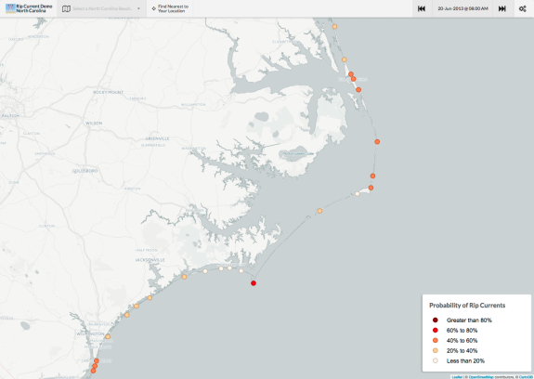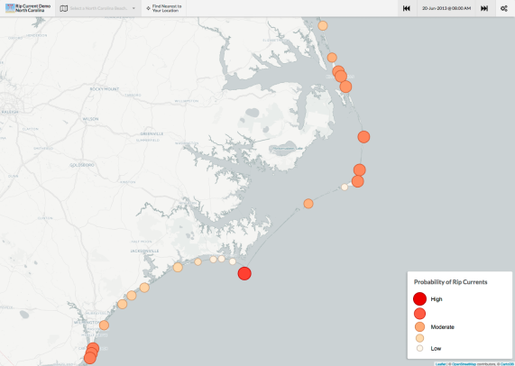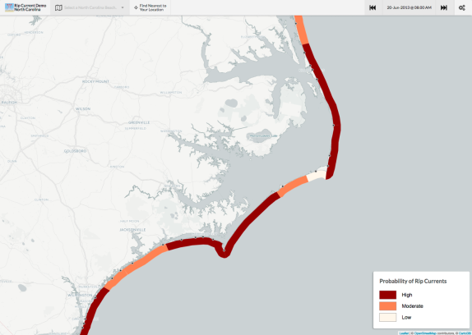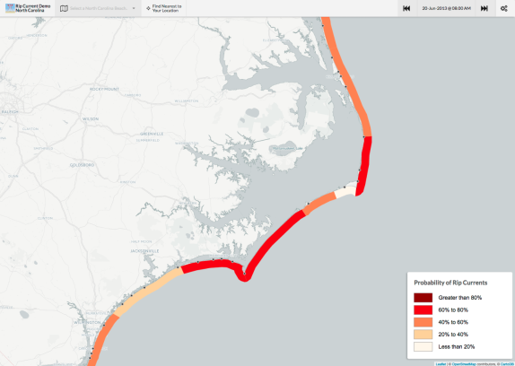
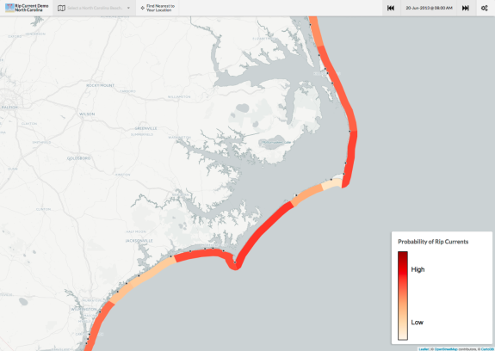

Q45 Which of the five graphics do you think is MOST effective?
A
B
C
D
E
None

Q46 Why? (Please check all that apply)
The categories make sense to me
The colors make sense to me
The symbols make sense to me
It is easy to find the situation at a particular beach
I can see what the risk is at a number of places
It is easy to interpret
Other (please specify) ____________________

Q47 Which of the graphics do you think is LEAST effective?
A
B
C
D
E
None

Q48 Why? (Please check all that apply)
The categories do not help me understand the risk
The colors are not helpful
The symbols do not make sense to me
It is difficult to find the situation at a particular beach
It is difficult to distinguish risk at one location from another
It is difficult to interpret
Other (please specify) ____________________

Q49 Please provide any additional comments about any of the products or other information you would like concerning rip currents.

