OMB Control No. 0648-0342
Expiration Date: 5/31/2018

Thank you for logging into this survey. The survey is voluntary and any information you provide will be anonymous.

The purpose of this research is to understand which, among a series of graphics, best helps you understand the likelihood of hazardous rip currents. By doing this research, we hope to learn what will best motivate people to protect themselves from rip currents.

We are asking those who are willing to complete the survey that addresses knowledge of rip currents as well as perceptions of various ways to illustrate rip current potential. The amount of time it will take you to complete this survey is approximately 30 minutes.

If you agree to take part in this survey, you will be asked questions that relate to how often you visit the beach, what you know about rip currents and what aspects of several graphical warning products you like and do not like. In addition, we will be collecting some demographic information.

This research is being conducted by an independent contractor on behalf of the National Weather Service. You are not required to take part in this research, and you can stop at any time.

Thank you for taking the time to participate.

Notwithstanding any other provisions of the law, no person is required to respond to, nor shall any person be subjected to a penalty for failure to comply with, a collection of information subject to the requirements of the Paperwork Reduction Act, unless that collection of information displays a currently valid OMB Control Number. If you have any questions, please contact Michael Churma, National
Weather Service, michael.churma@noaa.gov.

We are asking you to take a short survey using the clickers provided. Following the survey we will all look at the results and discuss the findings with an emphasis on understanding your needs.

Demographic Information
What is your age? ___under 20 ___20-29 ___30-39 ___40-49 ___50-59 ___60-69 ___70+

What is your gender? ___Male ___Female

What is your current position?
___Emergency Manager
___Public official
___Emergency services
___Broadcast Meteorologist
___Other (please specify) __________________________________________

How long have you been in your current position?
___Less than 5 years
___5-10 years
___10-15 years
___More than 15 years

How long have you lived in coastal North Carolina?
___Less than 5 years
___5-10 years
___10-15 years
___More than 15 years

To what extent do you think the public pays attention to current rip current warnings?
___Not at all
___Somewhat
___To a great extent

How would you characterize the public’s understanding of rip currents?
___No Understanding
___Very little understanding
___Some understanding
___Great understanding

Rank the following based on your sense of what aspects of rip currents the public least understands, with 1 being the factor they understand least and 4 what they understand the most.
___ What a rip current is
___ How dangerous a rip current can be
___ Their ability to get out of a rip current’s pull
___ How to spot a rip current

Below, we provide several visualizations
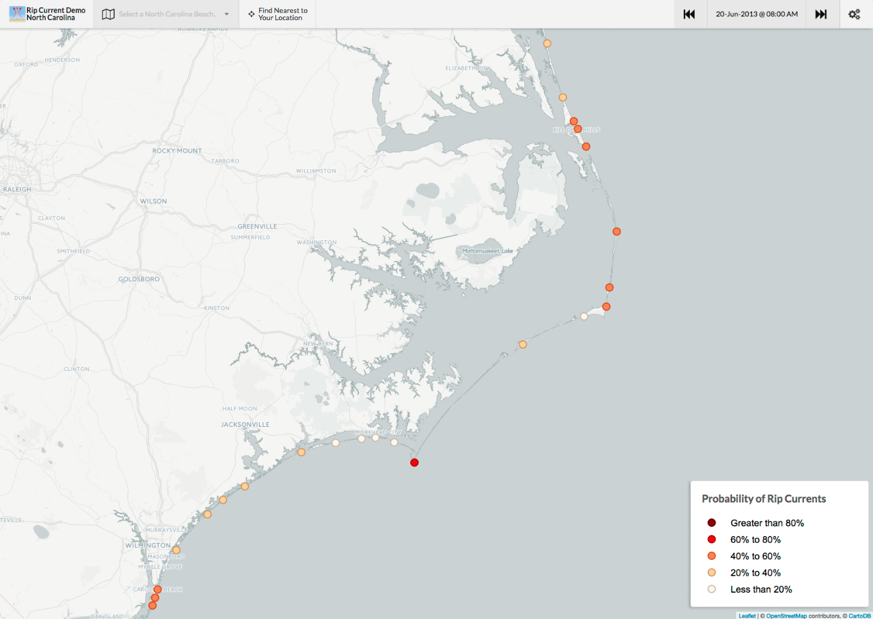

What is your perception of this product with respect to the following qualities or characteristics?
 | Very negative | Somewhat negative | Neutral | Somewhat positive | Very positive | Don’t know
Information included
Format
Understandability
Accuracy
Timeliness
Graphics/Symbols
Text
Use of color

How helpful is this product for your day-to-day operations?
___Entirely unhelpful
___Somewhat unhelpful
___Neither helpful nor unhelpful
___A little helpful
___Very helpful

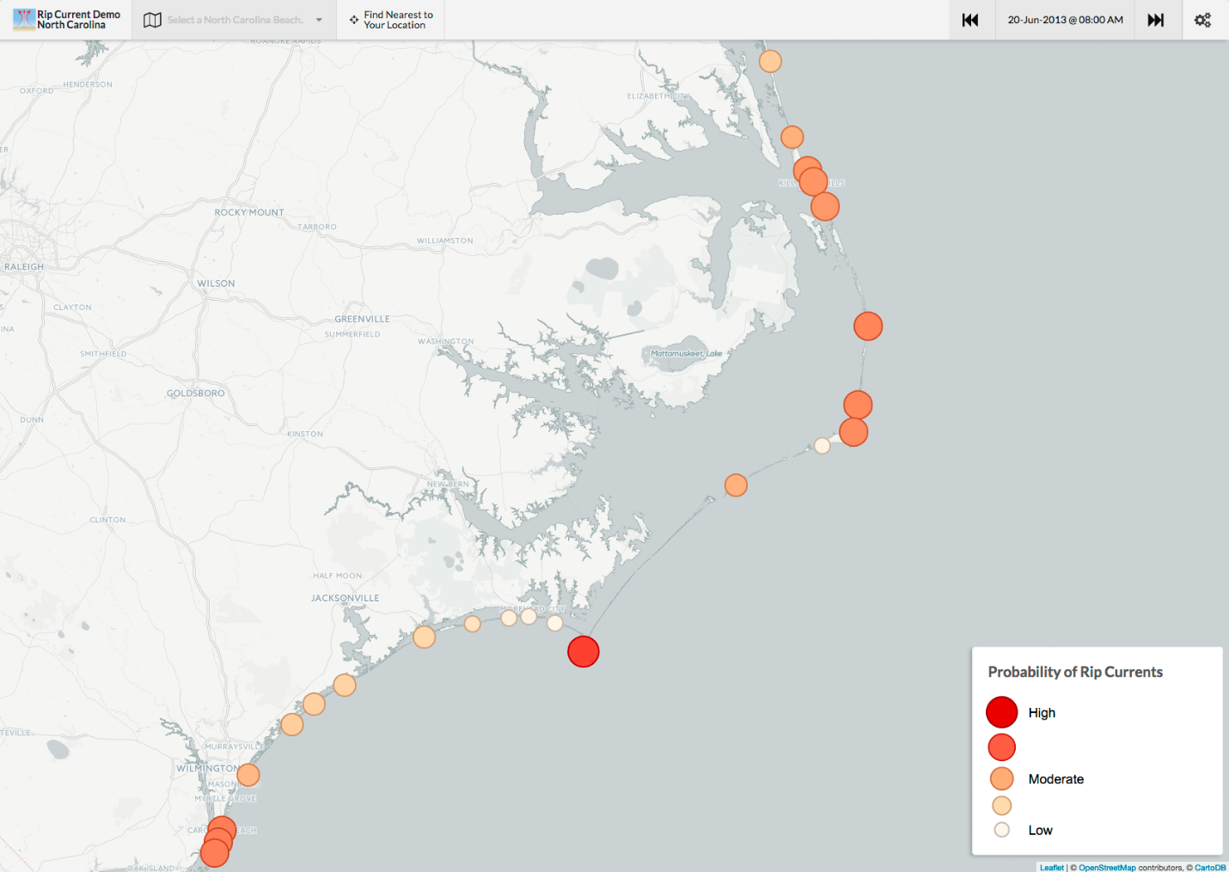

What is your perception of this product with respect to the following qualities or characteristics?
 | Very negative | Somewhat negative | Neutral | Somewhat positive | Very positive | Don’t know
Information included
Format
Understandability
Accuracy
Timeliness
Graphics/Symbols
Text
Use of color

How helpful is this product for your day-to-day operations?
___Entirely unhelpful
___Somewhat unhelpful
___Neither helpful nor unhelpful
___A little helpful
___Very helpful

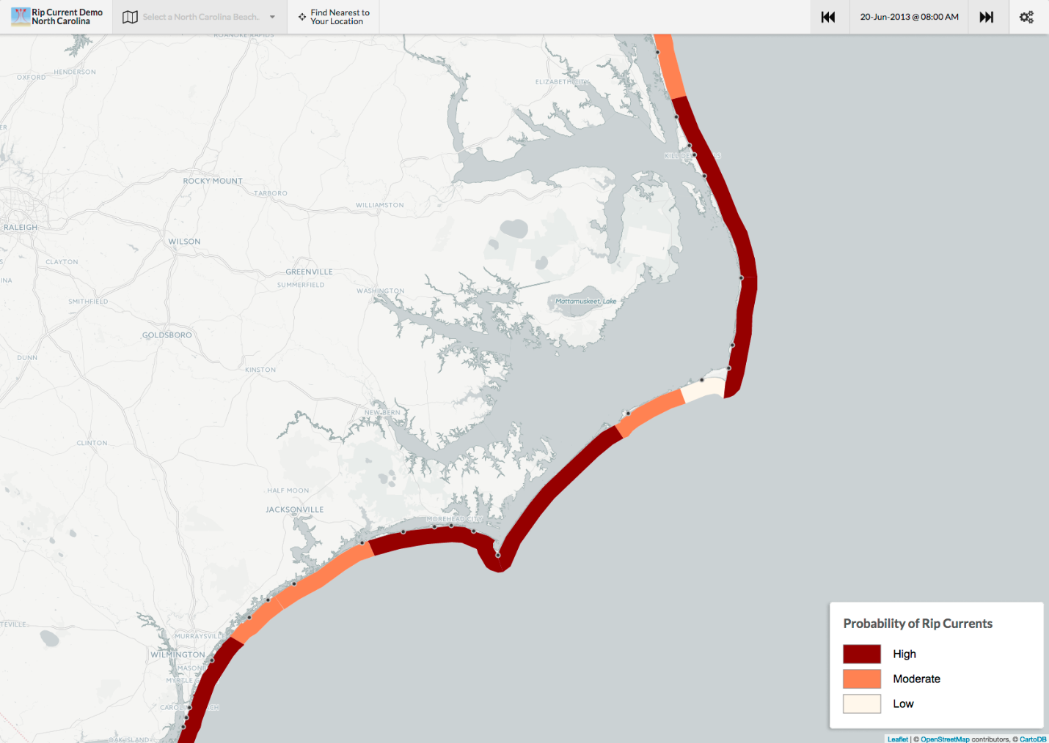

What is your perception of this product with respect to the following qualities or characteristics?
 | Very negative | Somewhat negative | Neutral | Somewhat positive | Very positive | Don’t know
Information included
Format
Understandability
Accuracy
Timeliness
Graphics/Symbols
Text
Use of color

How helpful is this product for your day-to-day operations?
___Entirely unhelpful
___Somewhat unhelpful
___Neither helpful nor unhelpful
___A little helpful
___Very helpful

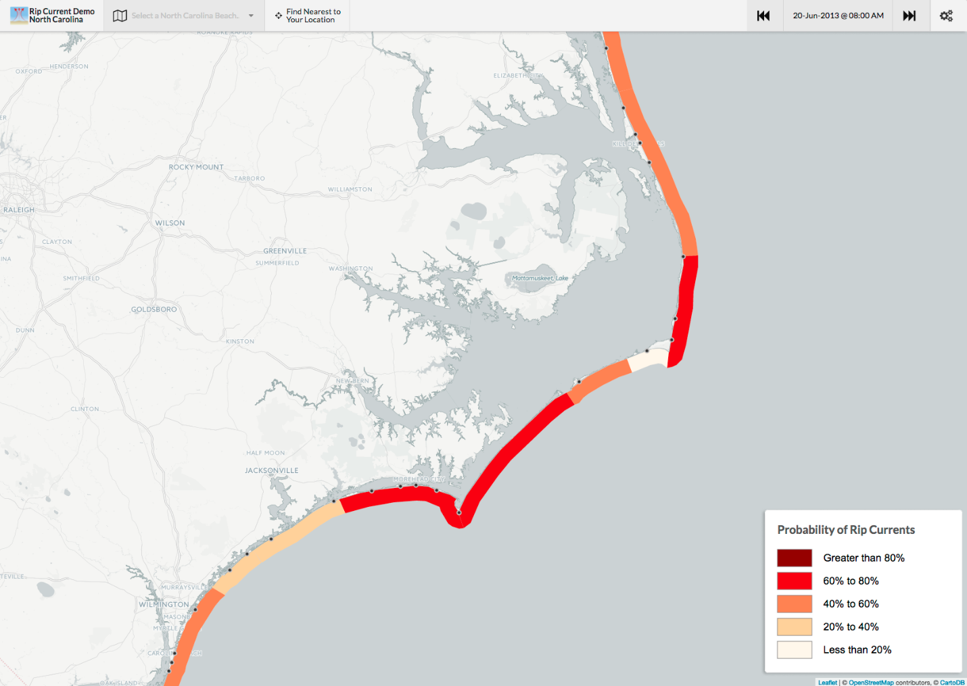

What is your perception of this product with respect to the following qualities or characteristics?
 | Very negative | Somewhat negative | Neutral | Somewhat positive | Very positive | Don’t know
Information included
Format
Understandability
Accuracy
Timeliness
Graphics/Symbols
Text
Use of color

How helpful is this product for your day-to-day operations?
___Entirely unhelpful
___Somewhat unhelpful
___Neither helpful nor unhelpful
___A little helpful
___Very helpful

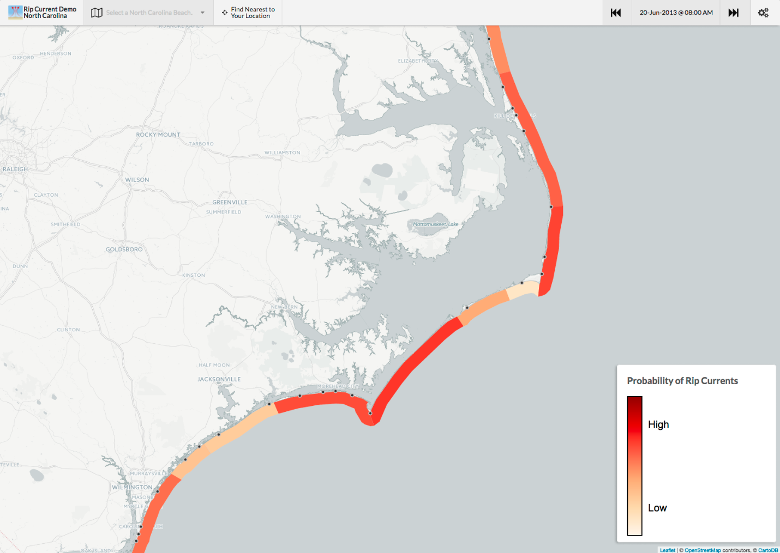

What is your perception of this product with respect to the following qualities or characteristics?
 | Very negative | Somewhat negative | Neutral | Somewhat positive | Very positive | Don’t know
Information included
Format
Understandability
Accuracy
Timeliness
Graphics/symbols
Text
Use of color

How helpful is this product for your day-to-day operations?
___Entirely unhelpful
___Somewhat unhelpful
___Neither helpful nor unhelpful
___A little helpful
___Very helpful

Rank the graphics based on your order of preference, with 1 being most preferred and 4 (or whatever number of graphics we end up with) being the least preferred

Then based on responses… discuss each graphic, going through the results for each question.

For those who said “very negative” or “somewhat negative” why? Same for “very positive” and “somewhat positive.”

Same for preferred graphics

Other comments on graphics?

