Sample Messaging/Graphical Images Activity

The Explaining Drinking Limits section of the Phase 2 In-Depth Interview and Triad Guide serves to explore with participants the ways that information presented on amounts of alcohol consumption, related risks, and patterns of drinking can influence people’s understanding of alcohol consumption and its potential impacts on their health and wellbeing. In this portion of the interview/triad, participants will be presented with messages/graphics that provides information on one of the following dimensions of alcohol consumption:
- Health Effects of Drinking: Information provided on the health effects of alcohol consumption

- Risky Drinking Guidelines: Recommendations on levels of drinking considered to be “too much”
- Levels of Drinking: Information that illustrates the continuum or proportion of different levels of consumption

For each category, we will select one to two example graphics to show to participants. In each interview/triad, a total of three messages/graphics, one per category, will be presented. For each message/graphic, participants will be asked a series of questions to explore their comprehension and opinions of each message/graphic. They will also be asked to compare the three types to understand differences and preferences.
The following are examples of graphics for each of the above categories.

Example- Health Effects of Drinking
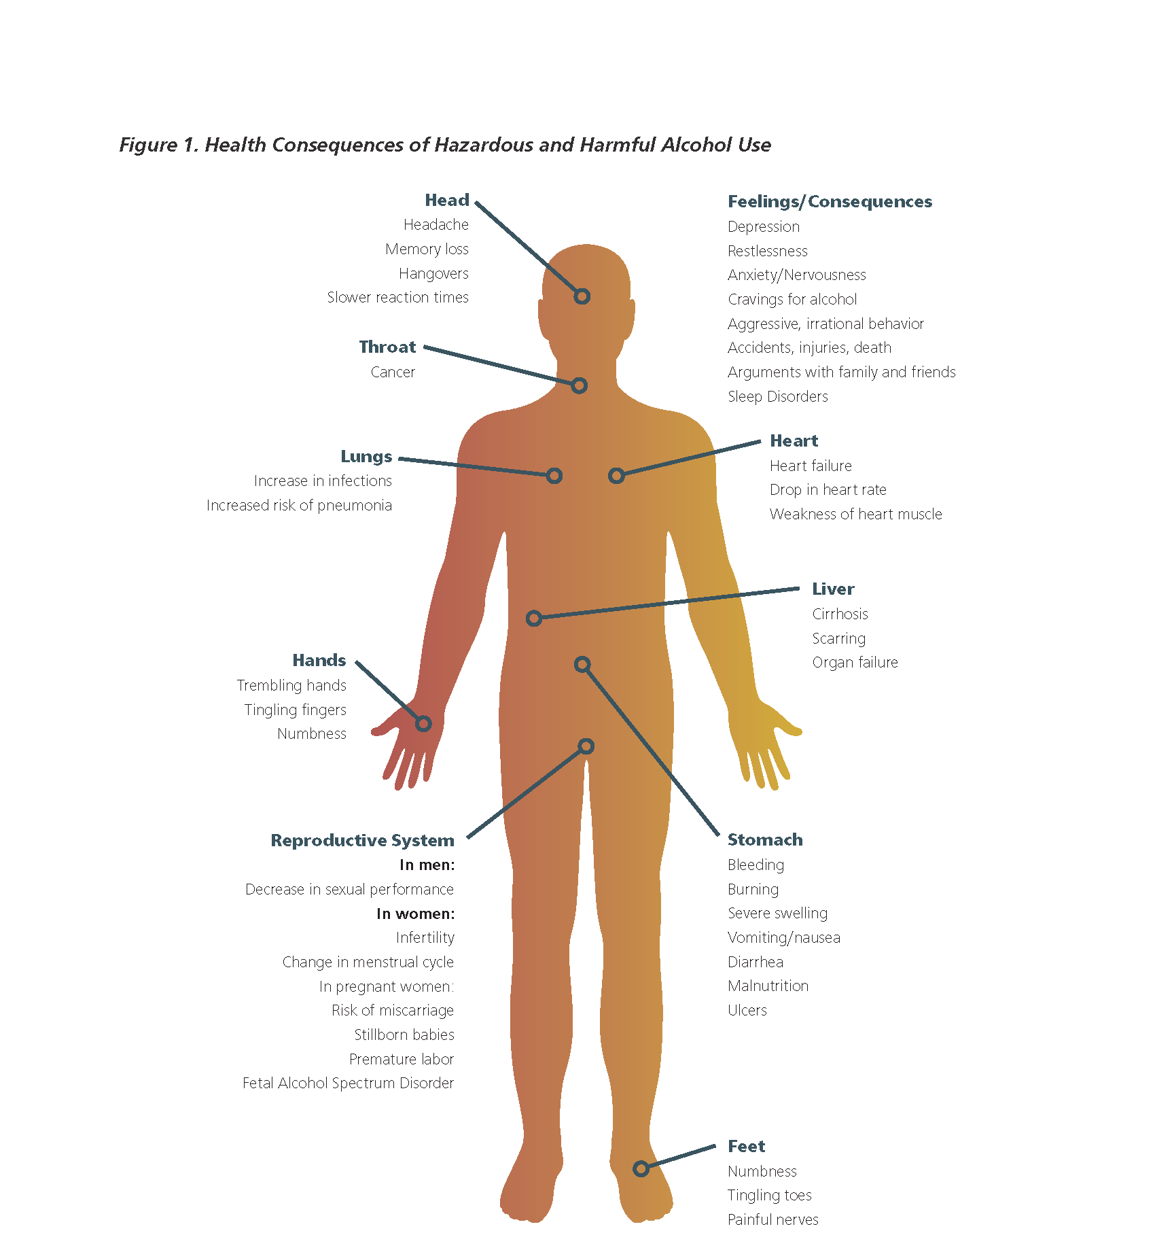

Source: Babor, T. F., Higgins-Biddle, J. C., & Robaina, K. (2017). USAUDIT—The Alcohol Use Disorders Identification Test, Adapted for Use in the United States: A Guide for Primary Care Practitioners. HHS Publication No. (SMA) pending. Rockville, MD: Substance Abuse and Mental Health Services Administration/Center for Substance Abuse Treatment.

Example- Risky Drinking Guidelines
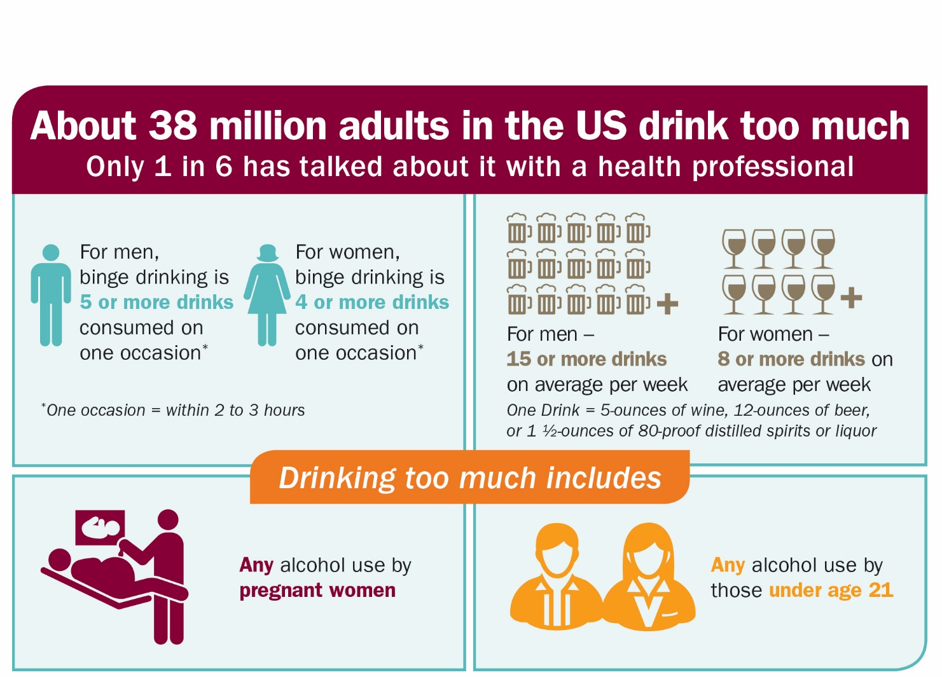

Source: CDC Vital Signs. January 2014. www.cdc.gov/vitalsigns. American Journal of Preventive Medicine, 2011: Volume 41.
Example- Types of Drinking

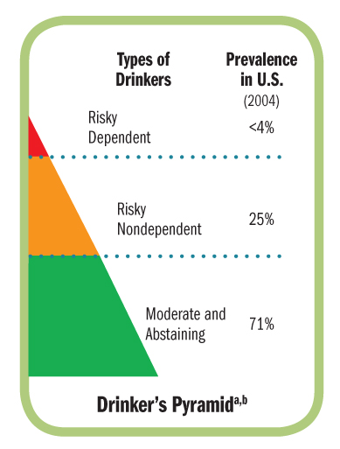

Source: Centers for Disease Control and Prevention. Planning and Implementing Screening and Brief Intervention for Risky Alcohol Use: A Step-by-Step Guide for Primary Care Practices. Atlanta, Georgia: Centers for Disease Control and Prevention, National Center on Birth Defects and Developmental Disabilities, 2014.

