Att D

[DATE]

Dear Dr. [LAST NAME],

The American College of Obstetricians and Gynecologists has sent you several emails requesting your participation in a short questionnaire to help us better understand how we can support our members and their patients in addressing Zika Virus.

Your feedback is important to help direct ACOG’s response to future infectious disease outbreaks. It is not necessary to review any extra materials prior to completing the questionnaire; please be as candid as possible. Individual responses are confidential, and data will be analyzed and reported in aggregate form only.

The questionnaire should take approximately 10 minutes to complete. This study is for evaluation purposes, and study participation is voluntary. You will not receive compensation for your participation. If you return the completed survey, we will take this as an indication that you have consented to participate.

**If you are retired or decline to participate in this study, please check the corresponding box below and return the survey blank.**

Please return the questionnaire in the enclosed prepaid envelope by [DATE]. If you have any questions, please contact Carrie Snead at 202-863-4998.

Thank you for your participation.

Sincerely,

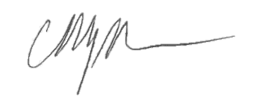

Christopher M. Zahn, MD

Col (Ret), USAF, MC

Vice President, Practice Activities

American College of Obstetricians and Gynecologists