[DATE]

Dear Mr./Ms. [LAST NAME],

ACOG’s Immunization Department sent you an email requesting your participation in the *Evaluation of Local Health Department Initiative* study. As of [DATE], we do not have a record of you completing or opting out of the survey.

We would appreciate if you would participate (or opt out) of the questionnaire, which should take approximately 15 minutes to complete. Your input is vital to the success of the study. If you complete the survey, we will take this as an indication that you have consented to participate.

You can complete the survey by clicking here [LINK]or by copying and pasting the following URL into your web browser:

[SURVEY URL]

If you wish to complete this survey by mail, please contact Carrie Snead at 202-863-4998.

**We will be sending you another email with a link to either complete or opt-out of this****study on [DATE].**

Thank you for your time and participation.

Sincerely,

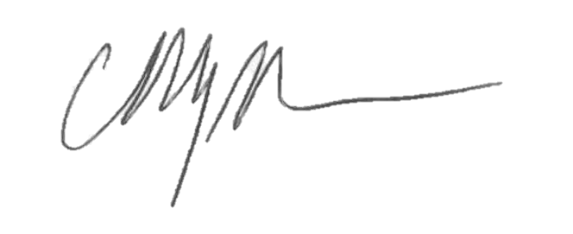

Christopher M. Zahn, MD

Col (Ret), USAF, MC

Vice President, Practice Activities

American College of Obstetricians and Gynecologists



[DATE]

Dear Mr./Ms. [LAST NAME],

ACOG’s Immunization Department has sent you multiple emails requesting your participation in the *Evaluation of Local Health Department Initiative* study. As of [DATE], we do not have a record of you completing or opting out of the survey.

We would appreciate if you would participate (or opt out) of the questionnaire, which should take approximately 15 minutes to complete. Your input is vital to the success of the study. If you complete the survey, we will take this as an indication that you have consented to participate.

You can complete the survey by clicking here [LINK]or by copying and pasting the following URL into your web browser:

[SURVEY URL]

If you wish to complete this survey by mail, please contact Carrie Snead at 202-863-4998.

**For your response to be recorded, please submit your completed survey by [DATE].**

Thank you for your time and participation.

Sincerely,



Christopher M. Zahn, MD

Col (Ret), USAF, MC

Vice President, Practice Activities

American College of Obstetricians and Gynecologists