Attachment 1: Screen shots of the BViewer© computer software used for the B Reader Examination
This software tool collects data in an electronic format as Attachment 2: CDC/NIOSH (M) 2.8: Radiograph interpretation form would when using the paper-based system.

Screen 1: Entry of examinee’s personal information establishes a link to their exam responses.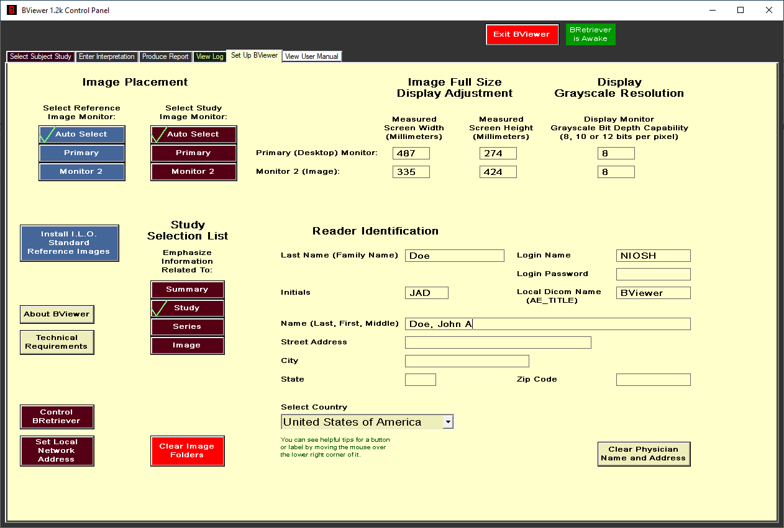

Screen 2 through 5 electronically capture an ILO Classification for each image in the exam.
